**Scenario**

An art museum owns a large volume of works of art. Each work of art is described by the title, type and size. Size can be composed of height, width and depth, depending on the type of art. Paintings will only have height and width, but sculptures will have a depth as well as weight. Each work of art also has a value associated with it, which is an assessed dollar value of each work.

A work of art is developed by an artist, but the artist for some works is unknown. An artist is described by a name, date of birth, and date of death if applicable. Only data about artists for works currently owned by the museum are kept in the database.

At any point in time, a work of art is either on display at the museum, held in storage, or on loan to another gallery. If on display at the museum, a work of art is also described by its location within the museum. If the work is on loan to another gallery, it is described by the name of the museum or gallery and the city. The museum wants to retain a complete history of loaning a work of art to other galleries, and each time a work is loaned, the museum wants to know the date the work was loaned and the date it was returned.

**Data Model**

Use the following tables to add the data.

Artist Information

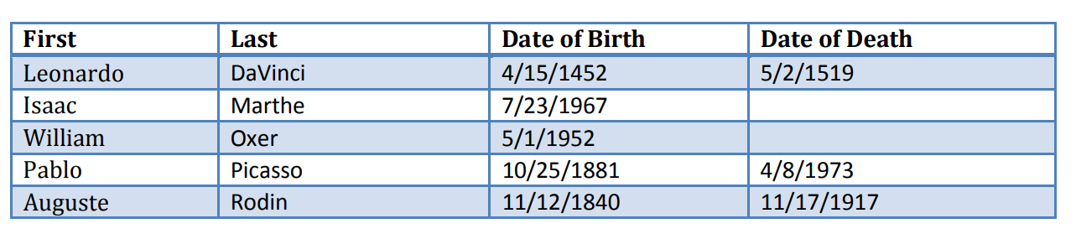

Art Works

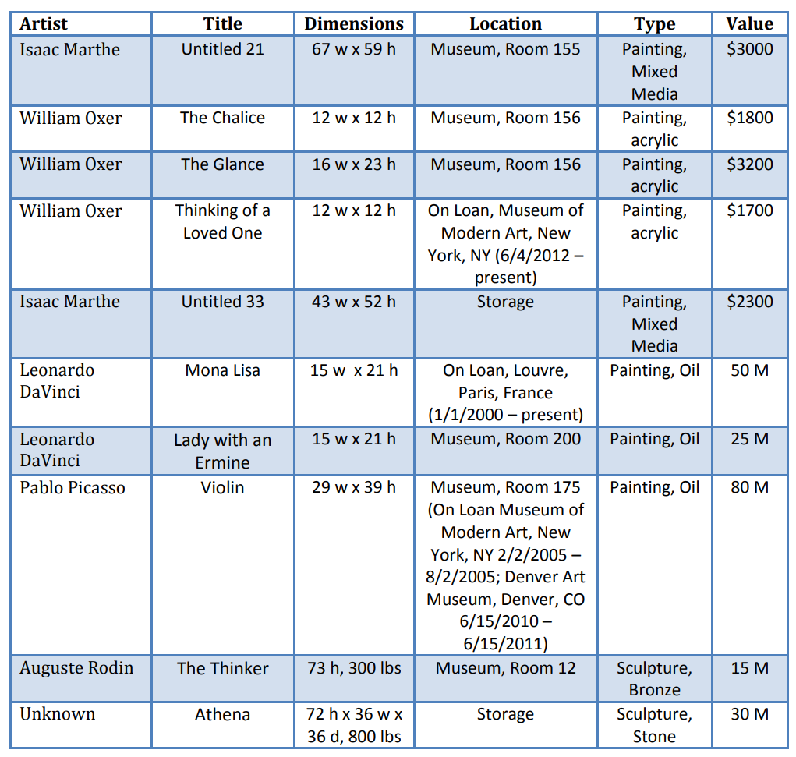

**Tasks**

1. Enter the data into the database according to the data model.

Tip: use provided ‘MongoDB_Data’ json file or insert commands in ‘MongoDB_Data’ file.

2. Count the number of works held by the museum by Leonardo da Vinci.

3. Set up an index on art type.

4. Add up values of all art works held by the museum created by Isaac Marthe.

5. Show all works of art, but limit the result set to 5 records.

6. Report a list of distinct artists in the database.

7. Show a list of artworks that have a value greater than 1 million.

8. Return all the artworks, but sort them by value.

9. Return all the artworks, the title of which contains the “un” string.

10. Add a data structure to the database that would allow you to keep track of the artwork loan

history. Include artwork artist, title, and an array containing the loan history.