**Neo4j**

1. Download Neo4J by going to <http://www.neo4j.org/download>.

A window will come up offering a free download of the desktop version.

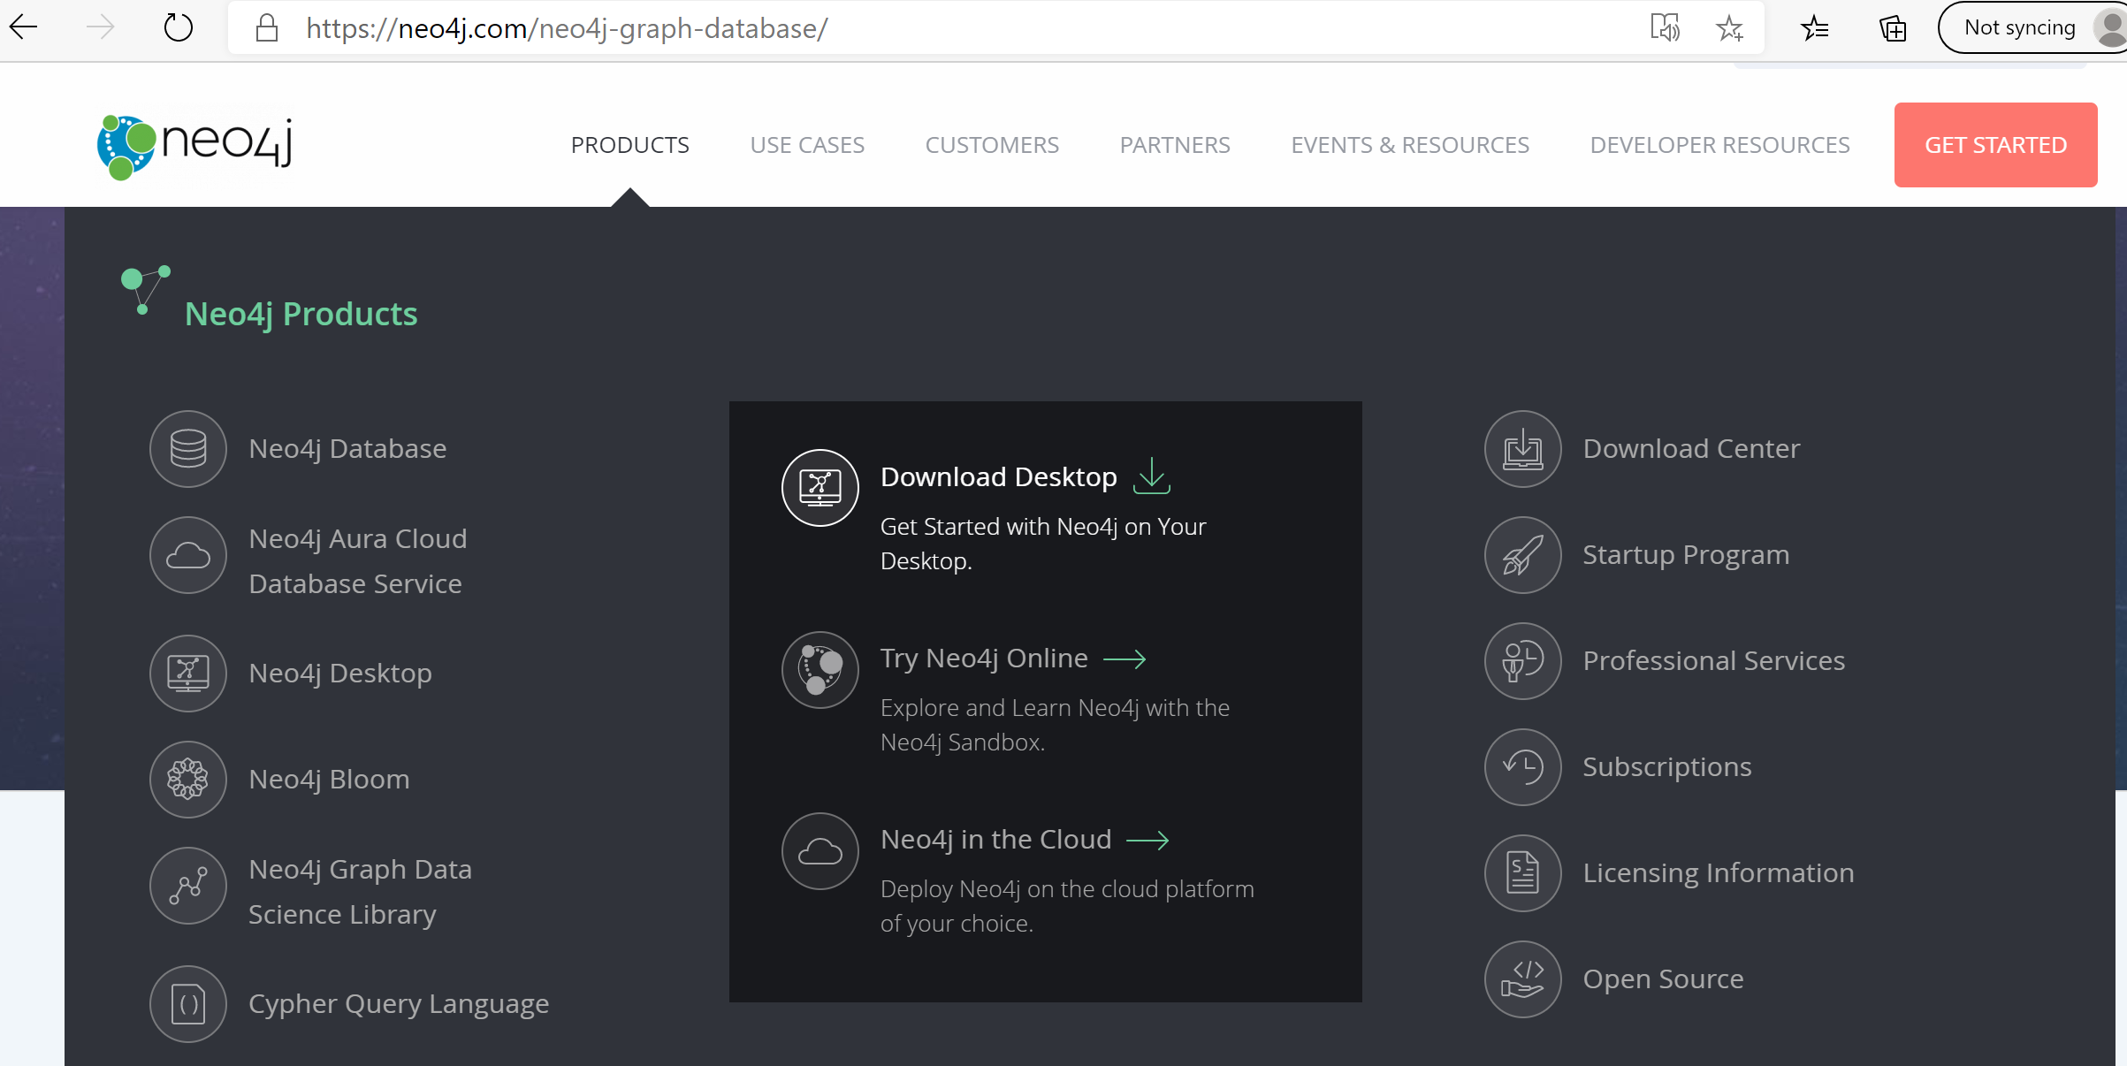

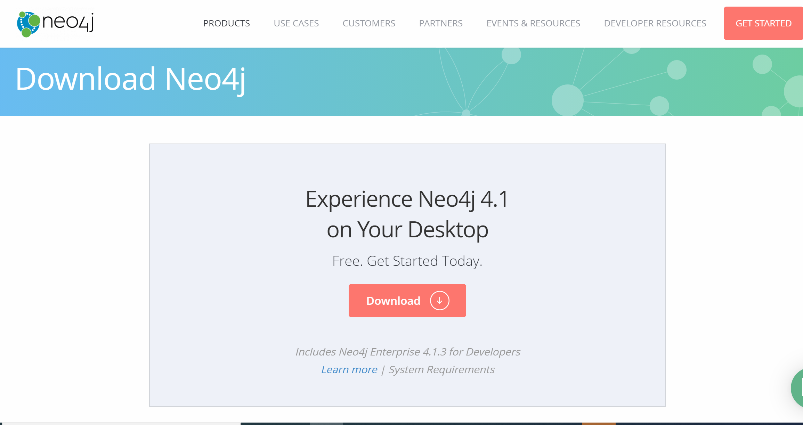

Double click on the downloaded exe file to start the install. Accept the license agreements. You will need to set up an account, which involves providing an e-mail address and a password. I recommend using the default installation options. Neo4j will start at the end of the install.

1. Click on New, make it a Local Database and name it PASS2020.

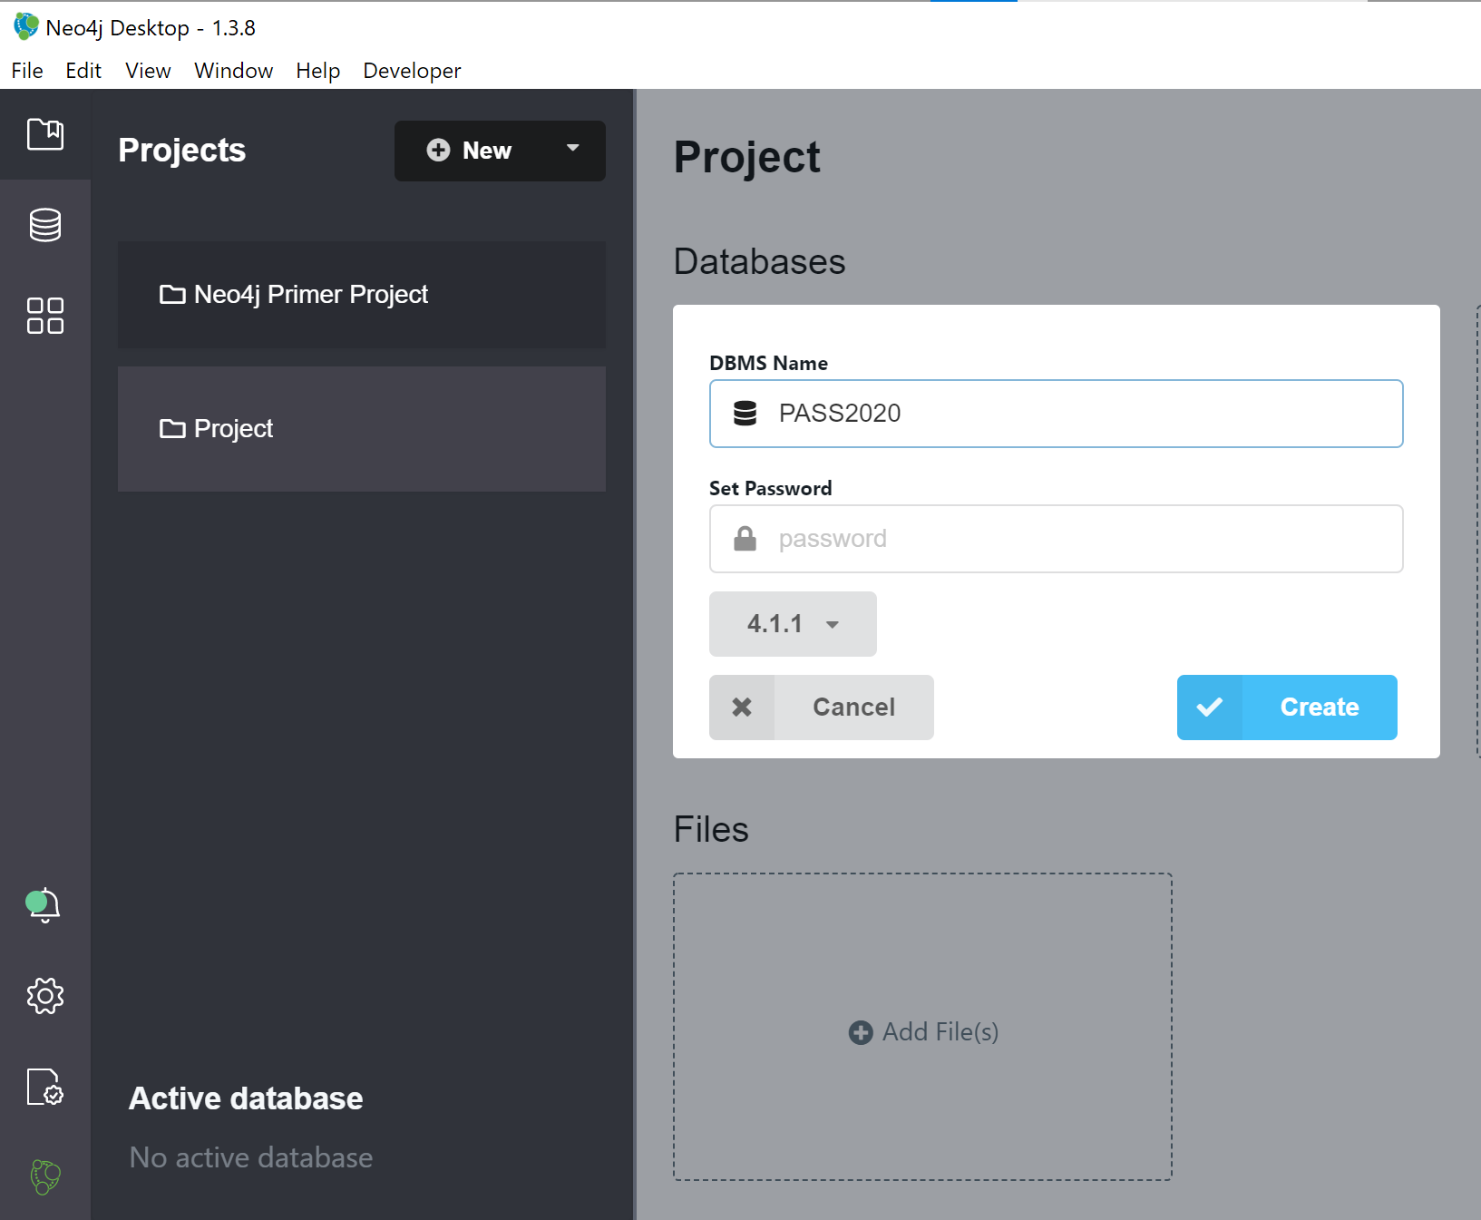

1. Click Start to start the database after it is created. Then click the Graph Apps on the left and click on Neo4J Browser.

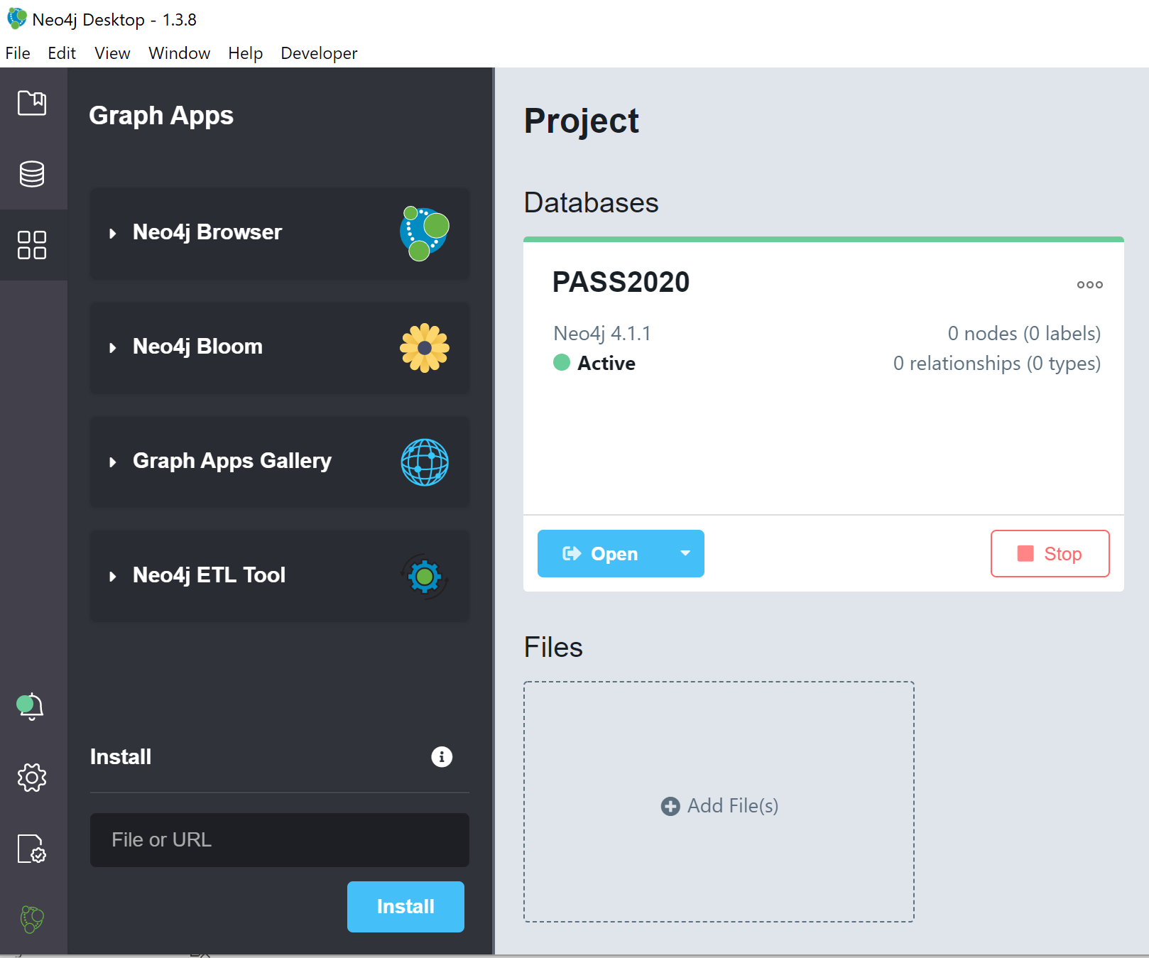

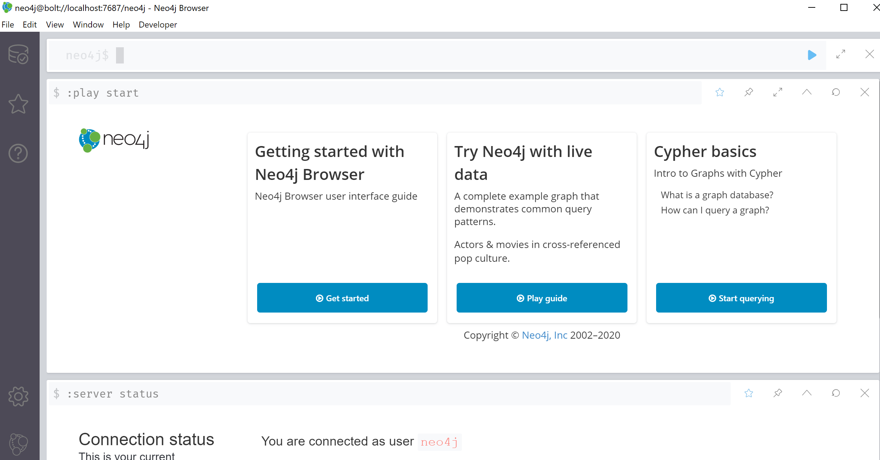

Congratulations, you are all set with Neo4J.