**Redis**

1. To download Redis go to: <https://github.com/dmajkic/redis/downloads> , and download the redis-2.4.5-win32-win64.zip. Once downloaded unzip the file. There will be a number of files and folders in the newly created folder, including 32bit and 64bit folders. Open the folder that corresponds to the type of your operating system. The important files for us will be redis-server.exe and redis-cli.exe.

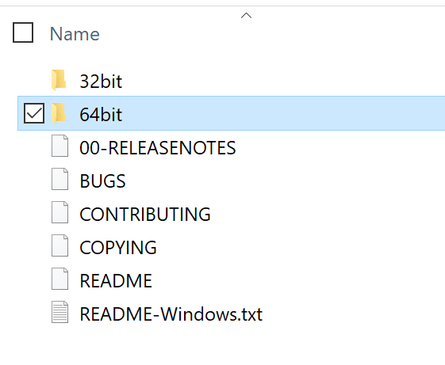

1. Double click on the redis-server.exe first. A command prompt like window will open.

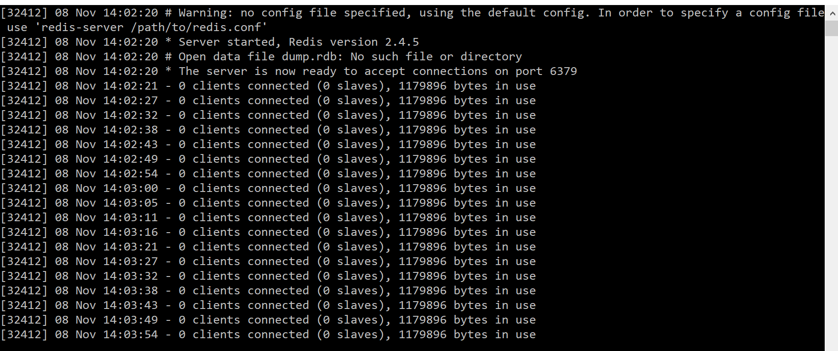

1. Double click on redis-cli.exe to start Redis command line interface.

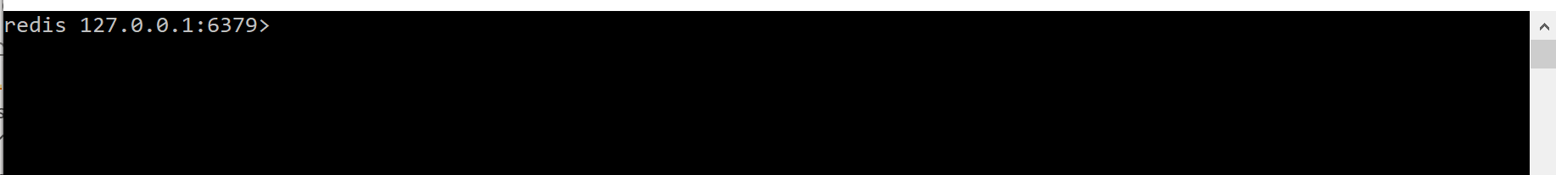

This is all you need to do for Redis at the moment, so you can use the close window button on the upper right corner to close the Redis client and the server. It is set up and ready to go!

Remember to start redis-server.exe and redis-cli.exe when you are ready to perform the lab.