**Scenario**

You started a digital library for your company. You have a contract with a number of publishers. You purchase the books from the publishers and add them to your digital library. From there your employees can borrow a book, via an iPad app you have written. The publishers allow only the number of employees to access a book concurrently that corresponds to how many copies you purchased. So, if you purchased 3 copies of a certain book, then only 3 employees can access the book concurrently. Only after a copy of the book is returned (which will render it deleted from the iPad app) can another employee borrow it.

- Store employee data - first name, last name, extension number, e-mail address.

- Store books the digital library owns, along with a number of available copies – use the title for a key and the number of available copies as a value; you will be modifying this value as people borrow the books and return them.

- Store information about employees and books they currently have checked out.

- Store employee “like” score for the book, so you can display the list of books by popularity.

Once an employee returns a book, they provide a score from 1 to 5, 5 being the best. Their score gets added to the previous total. (I know the scoring system is not perfect, as a book borrowed 5 times and getting a 1, and a book borrowed once getting a 5 will have the same score).

**Data Model**

Employee information

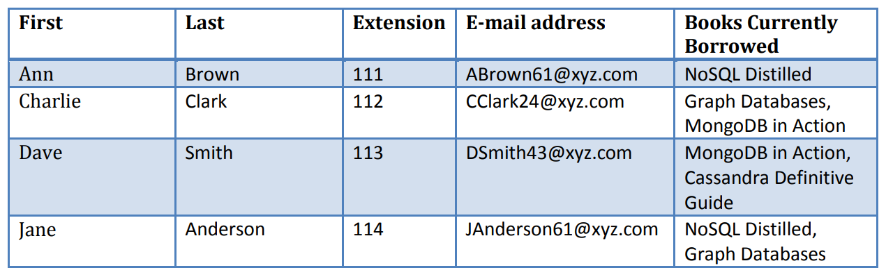

Books

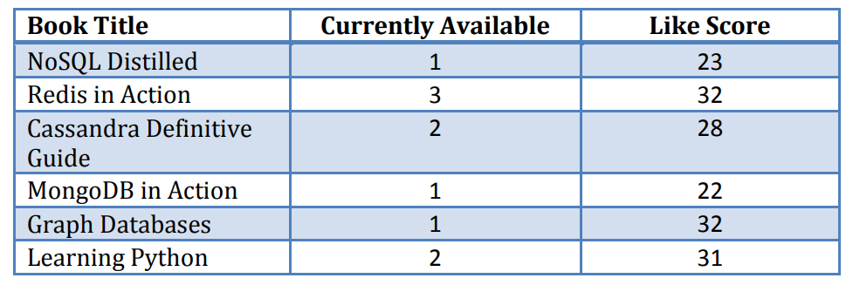

**Tasks**

1. Show the data structure for the database.

2. Enter the data in the tables above, into the database according to your designed data structure.

Tip: use provided ‘Redis_Data’ file.

3. Show e-mail addresses for Charlie Clark and Dave Smith.

4. Write a query that shows what books Dave Smith currently has checked out.

5. Show the top 3 ranked books.

6. Show how many books are available to be borrowed for the MongoDB in Action book.

7. Jane Anderson is returning the NoSQL Distilled book. She is assigning it a score of 4. Make all the necessary modifications to the database.

8. Ann Brown is borrowing the Redis in Action book. Make all the necessary modifications to the database.

9. Calculate how many total books are in your library available to be borrowed.

10. Provide information on how many books Charlie Clark has checked out.

Use pseudo code or write Python code if necessary. If you want to write everything in

Python, that is fine as well.