Matrikelnr. 557426, s0557466
- Write down your project vision.
Creating a picture entry which shows you photos including title, description, location, path and a date when the picture was created and updated.
- Write down your product backlog. Roughly prioritize it for business value. Don’t hesitate to write down as many stories as you want, you don’t have to implement them all.
- User sees overview of photos and their characteristics.
- Through a click button you can add photos and their characteristics.
- You can also edit the photos which are shown.
- User can edit and delete photos.
- Photos can be sorted by category.
- User can rate photos via like button.

- Pick a user story that you can implement with simple CRUD operations.
New pictures can be added including datapath, title, location and description.
- Draw a scribble for the screens involved.
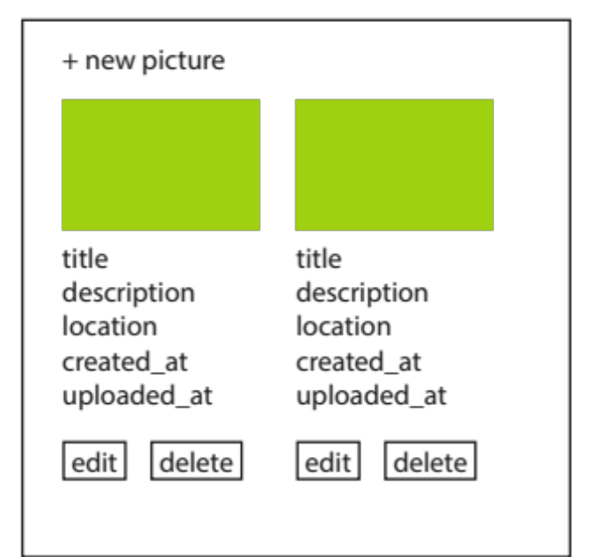
- Draw a first sketch of the data model that is suffient for this story.
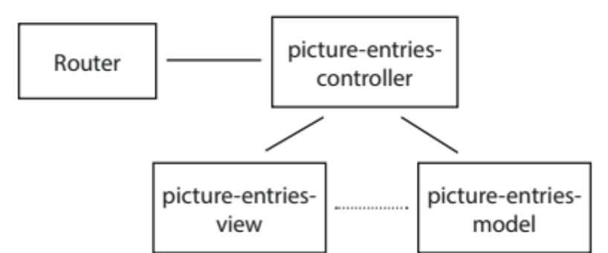

- Create a new rails application.

- Generate your first model/view/controller using rails generate scaffold

- Have a look at the generated html templates (find dem in app/views). Change and document one thing that makes sense within your application.
Adding upload feature instead of simple string entry.
- Next, pick a user story that requires to add a little bit of functionality to your app.

- Implement it by at least creating a new controller action and route by hand.

