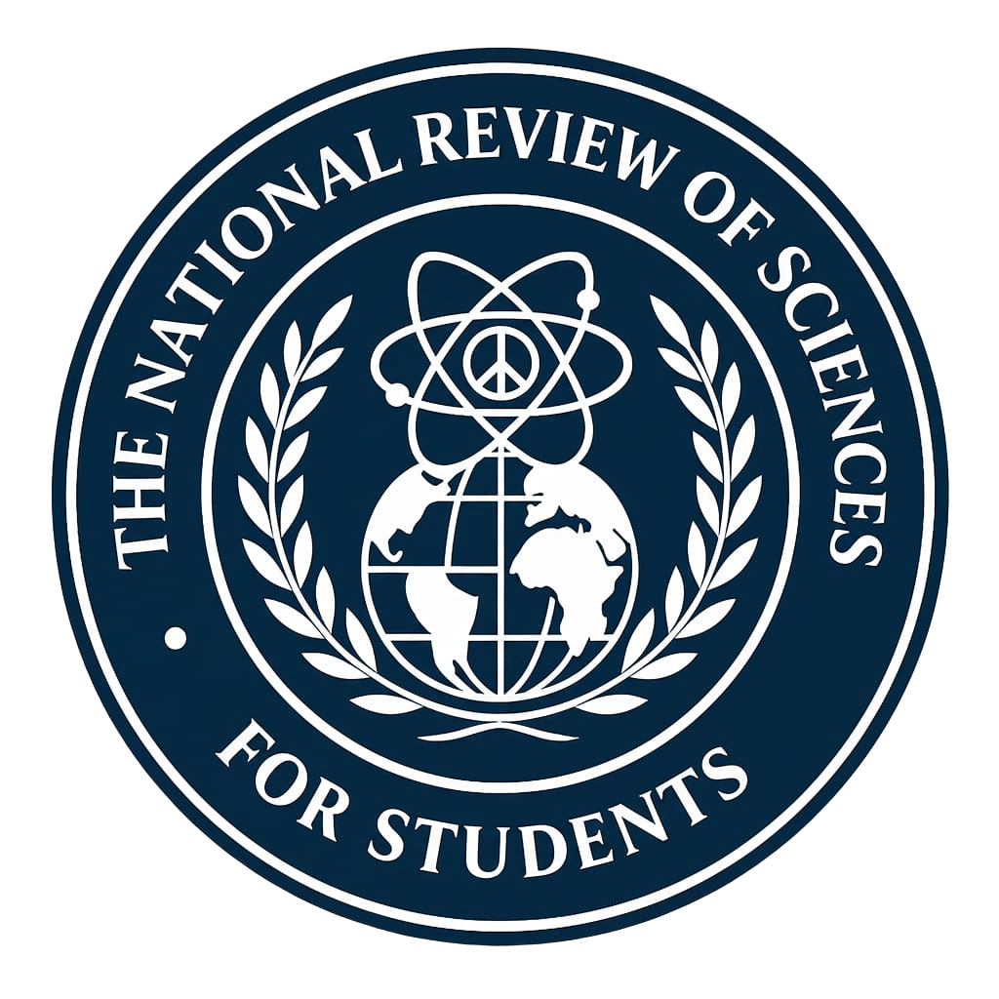 | PUBLICATION AGREEMENT  AND LEGAL GUARDIAN CONSENT  Official form for minor authors under applicable jurisdiction.

1. Identification of Parties
A. Legal Guardian Information
Full name of legal guardian:

Identification Document:

Relationship to author:

B. Minor Author Information
Full name of author:

Date of birth:

Current age:

Full title of submitted manuscript:

2. Declarations and Informed Consent
Through this document, in my capacity as legal guardian of the identified minor, I declare, consent, and expressly authorize the following institutional terms:
1. Legal Representation: I have full legal authority to grant this consent on behalf of the minor author. I have read, analyzed, and approved the complete content of the submitted manuscript.
2. Licensing and Open Access: I authorize the publication, reproduction, and distribution of the article in the National Review of Sciences for Students under the terms of the Creative Commons Attribution 4.0 International (CC-BY 4.0) license. I understand that this allows free access, use, and adaptation of the work by third parties, always guaranteeing recognition of the original authorship.
3. Personal Data Processing: I authorize the Journal to store, process, and manage the personal data provided in the submission form. This data is stored securely in a private database and is not publicly exposed. Only the necessary data for publication will be displayed, including the email provided in the form, therefore it is at the discretion of the author and guardian to choose it carefully. The author can edit their public profile on the website at any time.
4. Participation as Scientific Reviewer: In the event that the minor has affirmatively expressed their wish in the submission form, I expressly authorize them to be contacted and invited to participate as a peer reviewer for other works within their areas of knowledge.
5. Nature of the Agreement: I understand that the submission and potential publication do not entail any economic retribution or pecuniary obligation between the parties.
6. Right of Withdrawal: I understand that I have the inalienable right to withdraw this consent at any time before the manuscript reaches the production phase (effective publication), through formal notification to the email address contact@revistacienciasestudiantes.com.
3. Signatures and Ratification
Place of signature:

Date of signature:

Legal guardian's signature:

Contact email:

SPACE RESERVED FOR EDITORIAL TEAM
This block must remain blank. It will be completed by administration upon receipt of the document.
Submission ID: ___________________________________ Reception Date: ______________________________
Compliance Auditor: ____________________________________________________________

