<%SUMMARY%>

This Word layout template for Help & Manual defines the entire layout - front page, table of contents, chapter headings, keyword index.

To **customize this template**, use the original file ("Word-Template-A4.docx") from the H&M installation folder, make a copy of it, then tailor it with MS Word to your requirements. You **can use variables** in every place of the document. To insert a variable, insert a COMMENT field in Word, then type the variable name as the field content. Like the  field above this text.

Move on to the next page in this document to customize the table of contents (a placeholder for the real TOC later) and modify text and paragraph format of the chapter headings in the middle of this template. You might also want to change the numbering style.

**Important:** before you use the template for publishing in H&M, make sure that general page format and margins are set correctly. H&M will export images and tables to make them fit in the space available.

Revizto and EC Software GmbH

**[Type the company address]**

**[Type the phone number]**

**[Type the fax number]**

Revizto

**2017**

**Revizto User Guide**

Contents

<%CHAPTER_HEADING1%> 3

<%CHAPTER_HEADING2%> 3

<%CHAPTER_HEADING3%> 3

<%CHAPTER_HEADING4%> 3

<%CHAPTER_HEADING5%> 3

<%CHAPTER_HEADING6%> 3

# FAQ

1. - We let go a team member who owns a range of projects. How to transfer ownership?

|  |
| --- |
| - You have 2 options. One is to deactivate (and then delete) this user. Project ownership will be automatically assigned to the License Owner (SuperAdmin). The other option is to manually reassign project ownership before deactivating (and deleting) the user. |

1. - We let go the License Owner (SuperAdmin). How to transfer the license ownership?

|  |
| --- |
| - Note that only the License Owner can edit their own access level. You have to make sure that before leaving the company, employee who owns and manages Revizto license transfers their rights to another person. |

1. - My company operates in Canada and has partners in the UK. Both we and our partners have Revizto licenses. Yet, I cannot invite their users as Guests to collaborate in my projects. Why?

|  |
| --- |
| - In Revizto geographies are strictly divided in order to ensure maximum operation speed. Therefore, the Guest status (free collaboration access to members of other Revisto workspaces) is reserved to users within the same geography. To invite a collaborator from a team that has a license issues for another geography, you will have to create a fee-based Collaborator or Content Creator account. |

1. - We often get failures and errors while exporting our source files to Revizto. What to do?

|  |
| --- |
| - If your working folder is located on a network location, not on a local collaborator PC, try moving it to a local disk. Revizto uses SQL Light, therefore multiple requests to a remote folder can cause failures and errors. |

1. - We want to show the project to our colleagues/partners from another company, but they have no Revizto license. Also, we don’t want them to see our issues.

|  |
| --- |
| - You can use the Export to EXE option (the Project menu). Also, choose No in the Export Issues field to hide your issues. The resulting file will be accessible on any Windows x64 machine without Revizto. |

1. - I am currently using the French keyboard and cannot use the WASD viewer navigation option. Can I define other buttons as controls?

|  |
| --- |
| - No, you cannot customize control buttons, but you can use arrows instead of WASD. |

1. - I exported a model from Revit to Navisworks and then to Revizto. But I cannot see the entire model, only one element. What has happened?

|  |
| --- |
| - When exporting a Revit model to Navisworks (or importing it from Navisworks), pay attention to export/import settings. Your problem is likely to have been caused by exporting the first 3D view instead of the entire project. Note that you can also export your model directly from Revit to Revizto and use Navisworks to export clashes. |

1. I would like to to turn off the update feature. Is it possible?

|  |
| --- |
| - Yes, you can switch off the update feature. To do it, you have to go the registry and change the HKEY_CURRENT_USER\Software\Vizerra\Revizto\keyLastSkipVersion_h127002115 set the Value data field to 99999 (decimal value). The option may be useful, if you want to make sure that all local users have the same version. |

1. - I want to customize navigation mode, but Revizto would not save my settings. Every time I restart the application, I am back to defaults. Is there a remedy for it?

|  |
| --- |
| - User navigation settings are stored in the registry; the path is HKEY_CURRENT_USER/Software/Vizerra/Revizto. Normally, settings do not reset on their own. Yet, issues can occur if Revizto has no rights to save data in the registry location on your PC. Try removing the folder in the registry and relaunching Revizto. It is supposed to create the folder with default values and necessary rights to store user-defined settings. |

1. - Our company subcontracts some BIM work and we usually have several Revit files compiled into the same container project. We also use Revizto for collaboration and issue tracking. Do you recommend linking our source files in Revit and than creating a Revizto project from a single Revit source file, or appending additional .rvt files is better?

|  |
| --- |
| - In depends on your business process. From the viewpoint of export flow, it is better to first link your sources in Revit container project. Then you are less likely to get export and synchronization issues. On the other hand, it is possible to append each source file to a Revizto project separately, which is a better option, if each source is updated according to a specific time-line. You can than create export schedules for each of the source files and manage these schedules in Revizto Export Scheduler application. |

1. - I would like to change fonts for names of Rooms and other objects in the model. How can I do it?

|  |
| --- |
| - Currently, Revizto does not offer font modification functionality (or other advanced formatting options). |

1. - I would like to manage sheets of a shared project offline. How can I do it?

|  |
| --- |
| - To work offline, you have to load full cache of the project. |

1.  Can I remove a project from Revizto cloud?

|  |
| --- |
| Yes, after archving a project you can remove it form the Cloud altogether. |

1. I see that the product is updated frequently, but updates bother me and interrupt my work. Can I turn them off?

|  |
| --- |
| Yes, to turn the updates off, use option:  UPDATES_DISABLE="true".  msiexec "Revizto(x64)-4.5.40791.msi" UPDATES_DISABLE="true" |

1. To be continued

# Troubleshooting and Support

Addressing the Support Service

Before addressing the Support Service, please, read this section and the FAQ. If nothing helps, email to your support contact. Make sure to attach Revizto logs (compressed as .zip) for the relevant period from your working folder.

Known Issues and Solutions

Installation Troubles

Revizto uses Sentinel LDK Service to implement licenses. Components of this service may conflict with some anti-malware software. If you experience problems during installation, try turning your antivirus off temporary. You can also try

Corrupted model

A Revizto model can become corrupted due to some user actions or local software errors/failures. Than upload errors may occur (see example below).

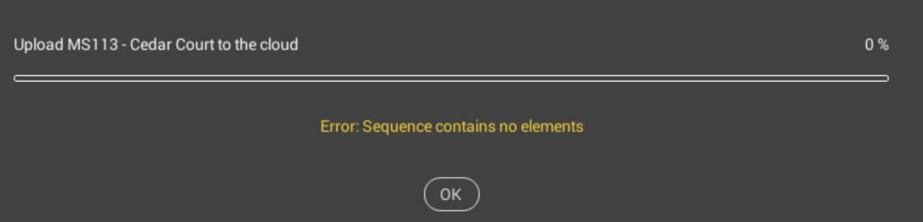

To remedy for it, we recommend to clear the model cache and to re-export a fresh version from the source software.

To clear cache:

1. Make sure that the model is not open in Revizto.
2. Open the list of projects in Revizto
3. Click the Edit button in the upper menu.
4. Click the yellow circle button displayed at the tile of the required project.
5. Choose the Clear Cache option. Confirm your action.

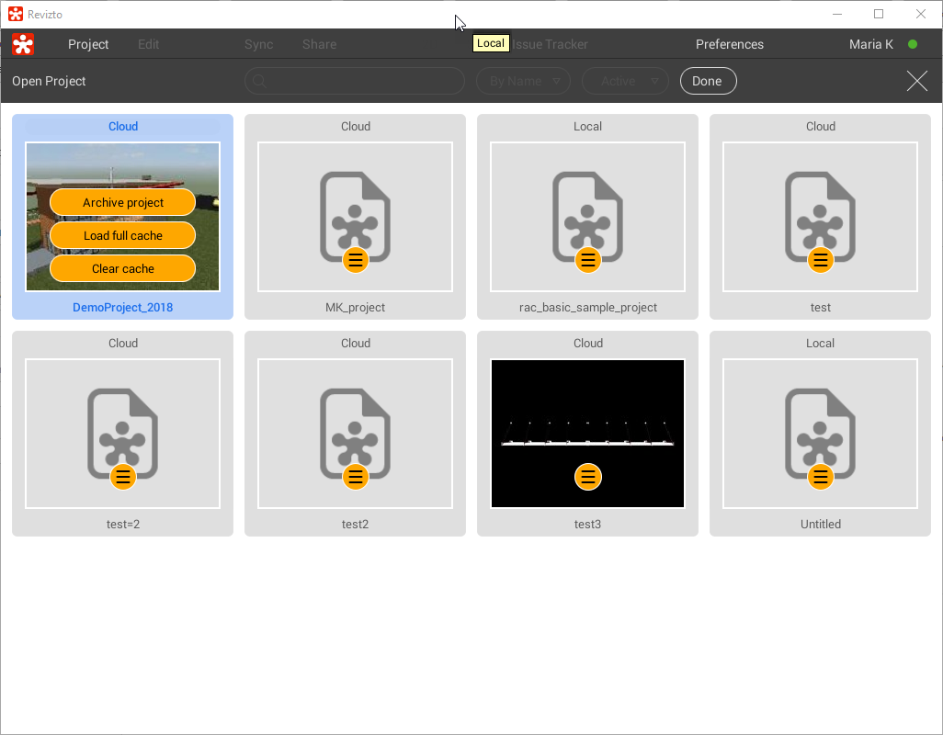

The project folder then disappears from the local working folder and you are free to create a fresh export without conflicts.

Failure to Download Model Updates

If users fail to check for model updates and get license invalidity messages, make sure that SSL inspection option is turned off on your firewall (or add Revizto servers to the exception list). If the problem persists, address the Support Service with your Revizto logs attached.

Cannot Launch ReviztoService. Application Will Be Terminated Error

If you get the message Cannot launch ReviztoService. Application will be terminated, try the following:

1. Launch the Task manager and kill ReviztoService.exe, if running.
2. Remove the .lock file in the local working folder.
3. Try running the application again.

Another option is defining the location of the working folder manually.

1. Create a folder in "My Documents" called "Revizto4" (if not there already).
2. Go to the local Windows registry, find the HKEY_CURRENT_USER\Software\Vizerra\Revizto4\WorkingFolder value. Note that you need local administrator rights to access the registry.
3. Change registry value of Working Folder to C:\Users\USERNAME\Documents\Revizto4 (Replace USERNAME with your current Windows username).
4. Try to launch Revizto.

Working Folder Migration Issues

When you change your working folder location, issues can occur due to various reasons (e.g. unstable Internet connection at the moment). There are two ways to resolve them.

If you do not have local data that you have to save:

1. Close Revizto and all Autodesk programs.
2. Launch the Task manager and make sure to kill all processes related to Revizto.
3. Open your initial (old) working folder and empty it.
4. Launch Revizto, go to Preferences and change the working folder. Make sure that the new folder is empty.

If you want to save your local changes:

1. Close Revizto and all Autodesk programs.
2. Launch the Task manager and make sure to kill all processes related to Revizto.
3. Open the Windows registry editor (enter regedit.exe in the search box by the Start menu).
4. Find the HKEY_CURRENT_USER/Software/Vizerra/Revizto4 folder. Change the Working folder value. Make sure to enter data in the same format. Note that you need local administrator rights to change the registry
5. Launch Revizto and check whether it works.

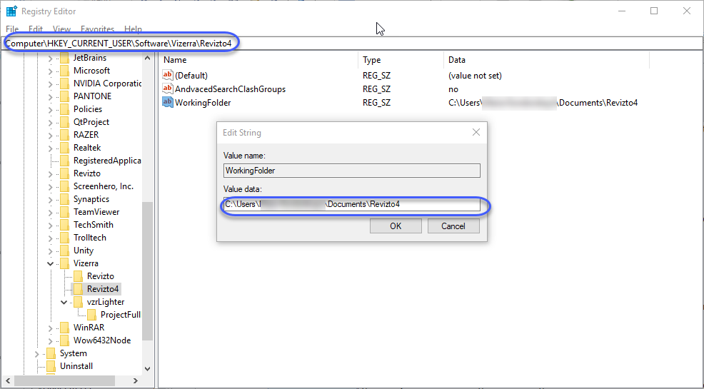

Modelling Error

Some basic BIM editors (e.g. early versions of SketchUP) only allow importing front faces of objects (e.g. walls). Therefore, when browsing a resulting Revizto model, you will not be able to "enter" a building (walls are most likely to be rendered as transparent from the inside). Also, if front/back planes were confused in the original file, in Revizto model objects with inverse planes may seem missing (basically, they will look transparent from the outside and visible from the inside). The remedy for it is checking sources before export (to avoid the issue, make sure to use clear front/back color coding in the source file to avoid confusions when creating your design).

Another option (not recommended) is using Revizto scene editor (Edit > Lighting and Materials) to copy the front face on the back. Click an object to select it in the editor. Material Properties dialog pops up. Click the Make button in the Double sided field. Repeat for all flawed planes. Note that we strongly discourage you from relying too much on this option as it doubles the size of Revizto model and has to be repeated after each export.

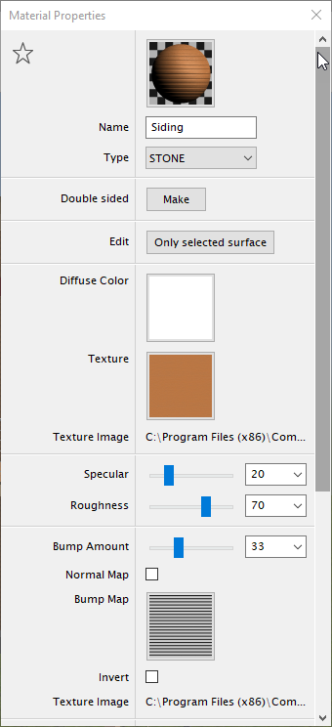

Sheet Misalign at Export

When exporting sheets from Revit make sure to export non-rotated sheets. Otherwise, Revizto will be unable to align them properly with the 3D view from the start. You will have to either re-export your source files or create overlays manually.

Sheets are not Exported from AutoCAD

To remedy for the issue re-export your source and try one of the following:

1. Click Select by the Export Sheet checkbox in the Export Options window. Make sure that 2D is duly included in the export, then proceed.
2. Make sure you are in the Paper space mode in AutoCAD before launching export.

For more details on exporting from AutoCAD, see the relevant section AutoCad/ArchiCad.

If the problem persists, contact the support service.

Disappearing Elements in Vive Mode

Some users may see that elements (valves, pumps) are missing when they walk in the model. Yet, they usually reappear when one gets closer to them. The problem usually appears in the Vive mode. The known cause for it is Revizto optimization. To maintain a specific frame rate, it has to dynamically unload some of the objects. This is true for both standard and VR viewer, but VR viewer is more resource intensive so it has to unload more to be responsive enough. Some users report that upgrading to SSD somewhat mitigates the problem.

Navisworks Clashes fail to Export

Make sure that you are not using the Reviewed status in Navisworks for issues that still may need some processing. According to current export rules (not available to users for change), this status is exported to Revizto as Closed.

Uploading Projects with Sheets beyond Server Upload Capacity

When you try to synchronize a project having more sheets that our cloud server can upload in one session you are likely to get an error message (see the image below).

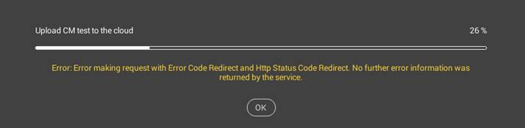

The project has more sheets than the server can upload in a session

Fortunately, there is a way out. Create a new empty project and upload it to the Cloud, than link source file (e.g. from Revit) to this project, export the model. Retry uploading data to the cloud. In this case Revizto can save intermediate results at the cloud and synchronization is facilitated.

Video Clip Issues

Some versions of Revizto may yield faulty videos with transparent objects. If you tend to get this issue, use the workaround: go to Preferences > Graphics and set the Fantastic mode. After that video should be exported fine.

Еxe/Mac Export Log-In Error

If you use MAC device and get an error trying to open an exported .app file (see the image below), make sure that the file is launched from the local drive vs. a network drive.

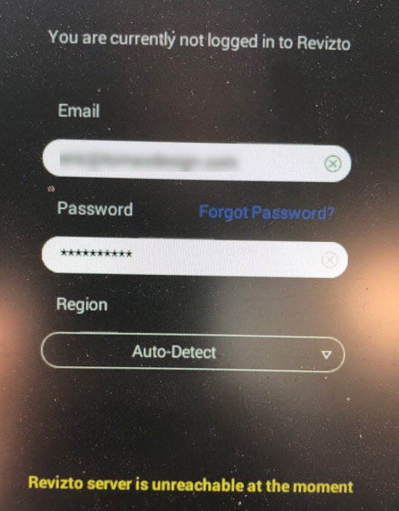

Keyword index

**No index entries found.**