GRC Framework LLM Generated Output Analysis/Metrics
In order to evaluate the performance and output quality of the selected LLMs process of the given task and relevant information. To gauge these, a three step evaluation process was developed to examine the individual outputs of 9 frameworks across two different papers, Scott & Scott, and Department of Education. This experiment was repeated using three separate LLMs as the model base. There are three total LLMs: Anthropic Claude, GPT 4.1, and Llama 4 Maverick. The evaluation process is as follows:
Stage 1: Individual Testing
One paper and a single framework are run through the GRC tool using a selected LLM as a base. This is repeated with the same paper and base LLM 9 times with each single framework.
- This is done for both papers
The corresponding GRC reports are then individually run through code that prompts a chosen LLM (Claude) once again (LLM as judge) along with the original paper text associated with the selected GRC report. This is repeated for every GRC report.
- The LLM judge remains the same.
1.1 Code Execution Logic
- Source Document Parsing: The script uses PyMuPDF (fitz) to extract the complete raw text from the original paper PDF, establishing the immutable ground-truth document context.
- Asynchronous LLM Judging: The script concurrently prompts the LLM judge (claude-sonnet-4-6) via API calls for every control in the GRC JSON file. It supplies the original paper text alongside the control's rationale, evidence quotes, gaps, and maturity rating (0–5).
- Programmatic Citation Verification: To prevent judge hallucinations on citation checks, the script runs a deterministic, sliding-window fuzzy string matcher (difflib.SequenceMatcher) comparing cited quotes against the raw PDF text.
1.2 Collected Metrics and Controls
In Governance, Risk, and Compliance (GRC), controls represent the individual policy requirements, safeguards, or administrative rules being audited (e.g., Access Control, Data Encryption, Policy Enforcement). The original GRC framework has a series of controls, and metrics are collected for each control instance:
The metrics the LLM judge and code pipeline are to determine by comparing the GRC framework report against the original corresponding paper text are as follows:
- Faithfulness (0.00 – 1.00): Measures whether claims in the score rationale and identified gaps derive strictly from the cited evidence quotes, penalizing ungrounded assertions or internal contradictions.
- Evidence Relevance (0.00 – 1.00): Measures how directly and genuinely the cited policy excerpts address the specific control requirement, penalizing generic or off-topic context.
- Score Consistency (0.00 – 1.00): Evaluates if the assigned maturity score (0–5 based on standardized GRC definitions like CMMI/COSO) is logically justified by the evidence strength and identified gaps.
- Gap Completeness (0.00 – 1.00): Assesses whether identified gaps accurately and comprehensively capture missing control requirements.
- Recommendation Quality (0.00 – 1.00): Measures whether recommendations are specific, actionable, and directly targeted at resolving identified control gaps.
- Evidence Groundedness (0.00 – 1.00): A deterministic, non-LLM score generated by the difflib code execution step to verify if cited evidence quotes actually exist in the source document.
Stage 2: Flat Population Consolidation
This stage consists of a pipeline that once again utilizes the earlier judge LLM (Claude). The pipeline extracts the data points from every individual control across all domains into a single, flat population pool.
2.1 Code Execution Logic
- Directory Processing: The script recursively scans designated target directories to parse all stage 1 evaluation outputs and corresponding GRC framework assessment reports (.json files).
- Statistical Calculation: It aggregates control-level metrics across entire populations to generate descriptive statistics (means, medians, standard deviations, and failure percentages).
- Artifact Generation: It uses matplotlib to render visual graphs and passes statistical summaries to claude-sonnet-4-6 to synthesize an executive narrative report.
2.2 Aggregated Data Points
- Continuous Metrics: The pipeline aggregates every individual control score across the entire run and divides by the total number of controls to calculate a single, true macro population mean.
- Categorical Maturity Values: The pipeline conducts a frequency count across the entire pool of controls to tally exactly how many requirements fell into each available maturity tier.

2.3 Graphs and Diagrams of the following are generated -
- Overall RAG Quality Score Bar Chart: Displays macro quality comparisons.
- Six-Dimension Averages Bar Chart: Shows population averages across all 6 metrics.
- RAG Quality Profile Radar Chart: Illustrates system strengths and dimensional balance.
- Weak Dimension Histograms: Tracks score variance and density for low-performing dimensions.
- Maturity Score Distribution Histogram: Maps the frequency of assigned maturity ratings.

Stage 3: Overall Metrics Table and Visualizations
This is the presentation layer. It performs no new downstream mathematical operations or secondary calculations. It instead takes the true population means and raw score distributions finalized in Stage 2 and inputs them into key visualizations and tables.
- The Master Evaluation Matrix Table: The macro population means calculated at the end of Stage 2 are transferred directly into a unified comparison grid to allow side-by-side performance tracking across different model runs.
- Radar Charts: The final dimension means from Stage 2 are mapped as fixed geometric coordinates along matching radial axes to visually illustrate each run's distinct performance profile.
- Performance Histograms: Rather than using summary averages, Stage 3 pulls the entire raw array of individual control scores compiled during Stage 2. It passes this complete array to the graphing library to accurately plot the exact distribution, density, and variance of the scores.
- Maturity Bar Charts: The categorical integer tallies compiled in Stage 2 (the total count of controls sitting at each specific maturity level) are used directly to dictate the heights of the bars on a grouped chart, visually highlighting the classification behavior of each model.
3.1 Master Evaluation Matrix (All Runs)
Rag Quality Report | Faithfulness | Evidence Relevance | Score Consistency | Gap Completeness | Rec Quality | Groundedness | OVERALL
Dept of Educ Anthrop | 0.863 | 0.626 | 0.818 | 0.825 | 0.856 | 0.997 | 0.831
Dept of Educ Gpt 4.1 | 0.810 | 0.556 | 0.714 | 0.727 | 0.784 | 0.955 | 0.758
Dept of Educ Llama 4 Mav | 0.805 | 0.553 | 0.716 | 0.726 | 0.789 | 0.965 | 0.760
Scott & Scott Anthrop | 0.861 | 0.657 | 0.830 | 0.834 | 0.872 | 1.000 | 0.842
Scott & Scott Gpt 4.1 | 0.825 | 0.625 | 0.750 | 0.744 | 0.805 | 0.981 | 0.789
Scott & Scott Llama 4 Mav | 0.827 | 0.620 | 0.744 | 0.745 | 0.802 | 0.979 | 0.786

3.2 RAG Quality Profiles (Radar Charts)
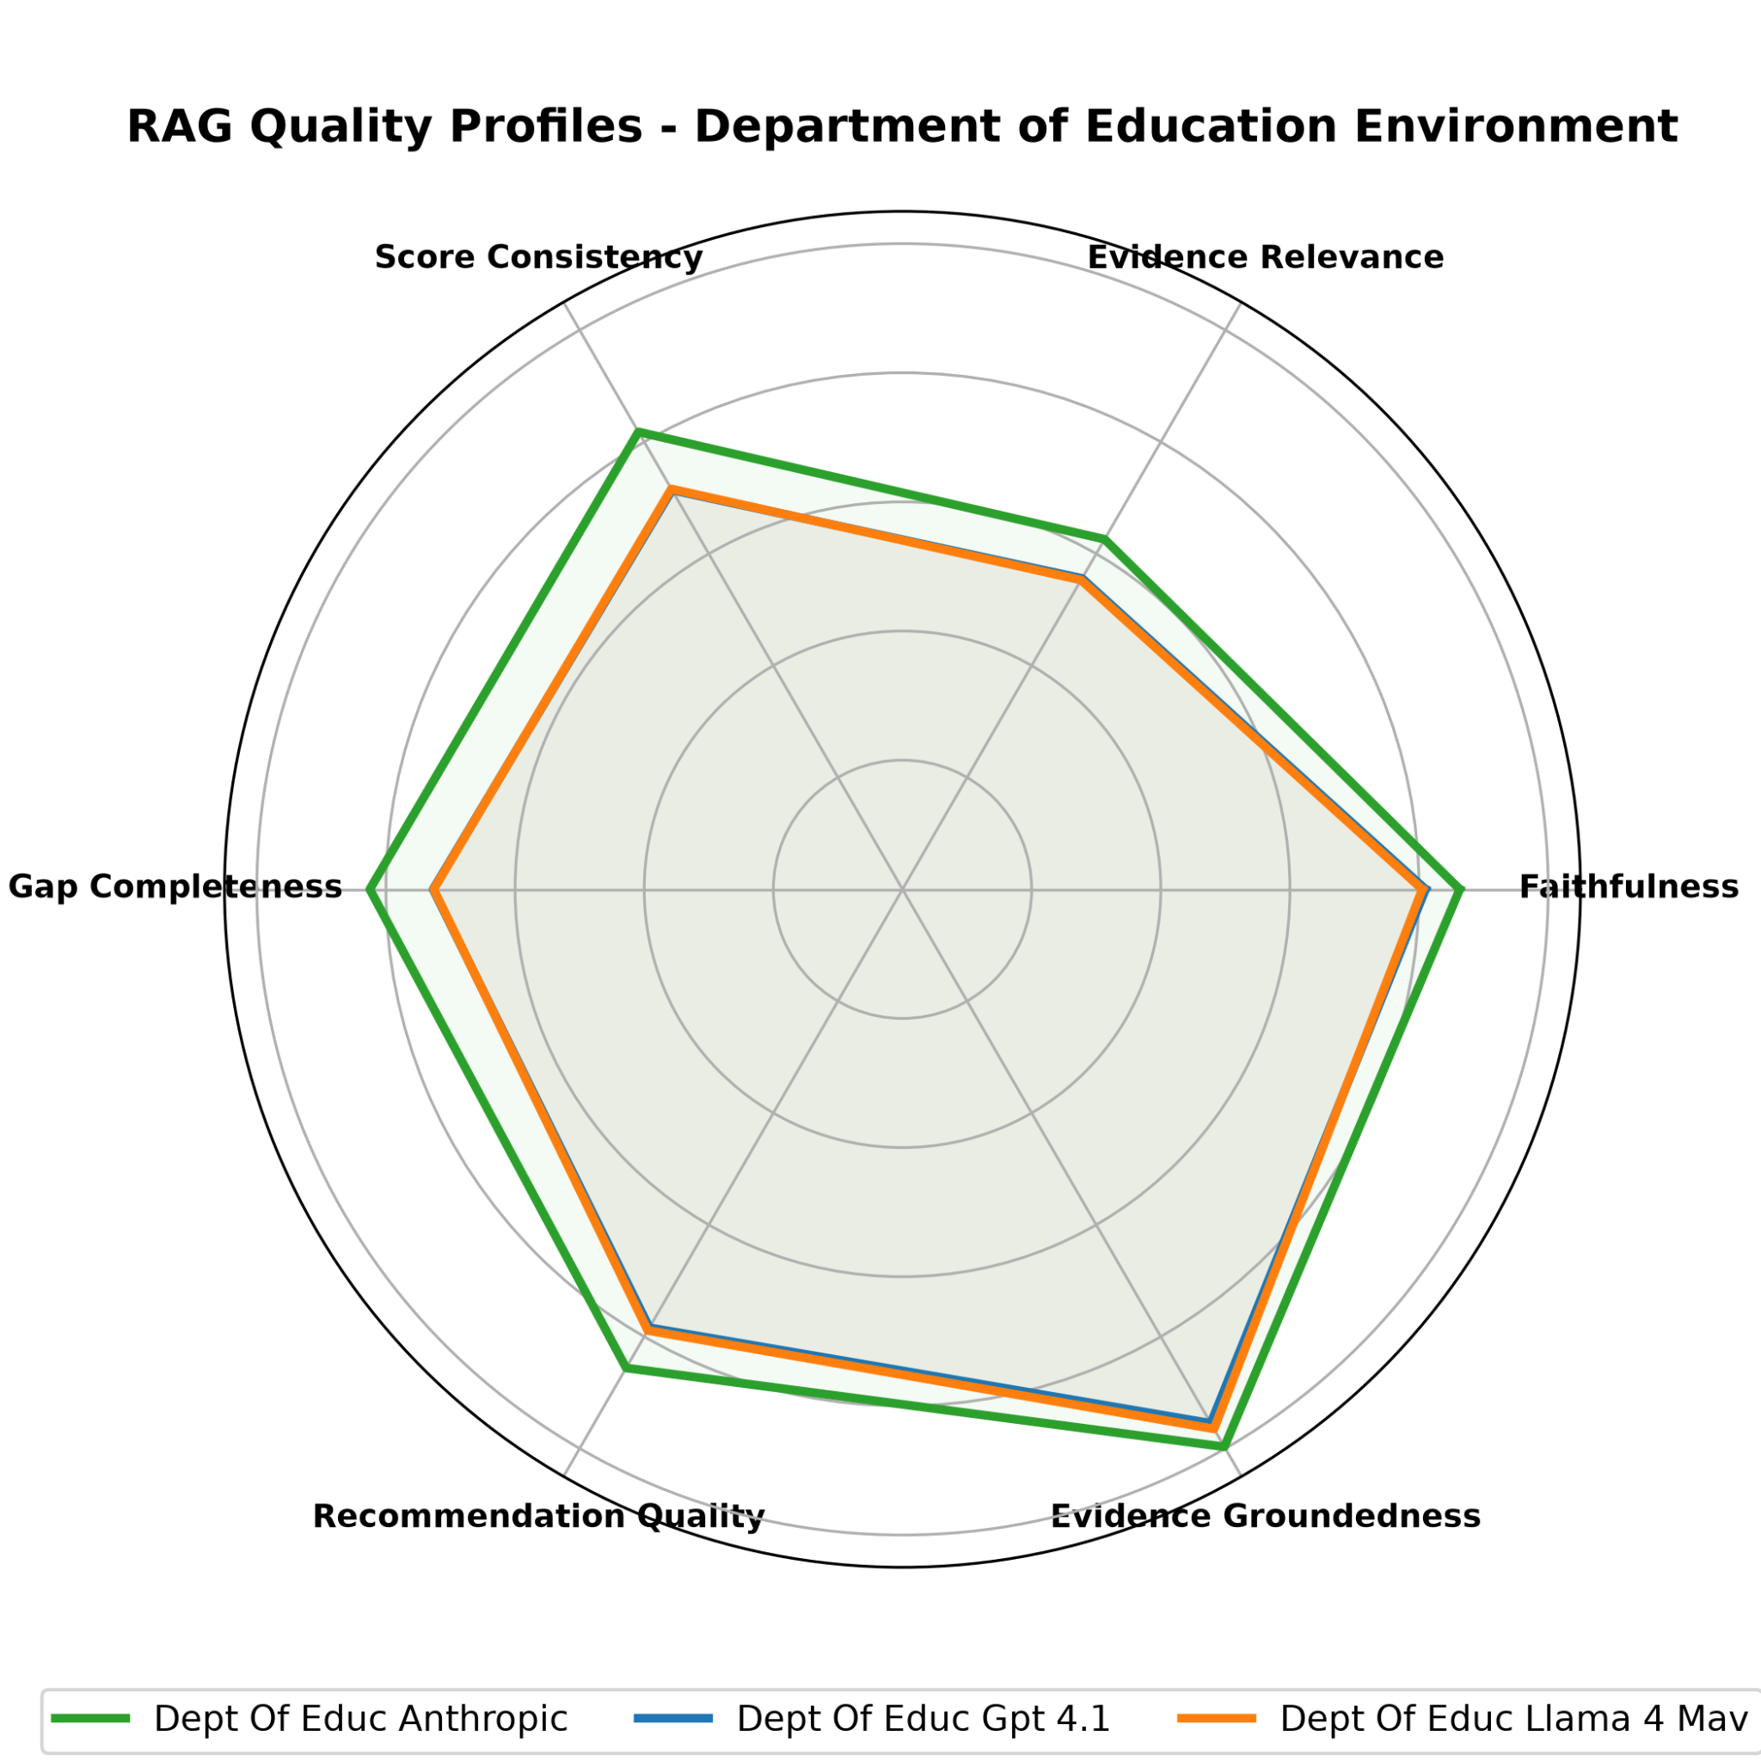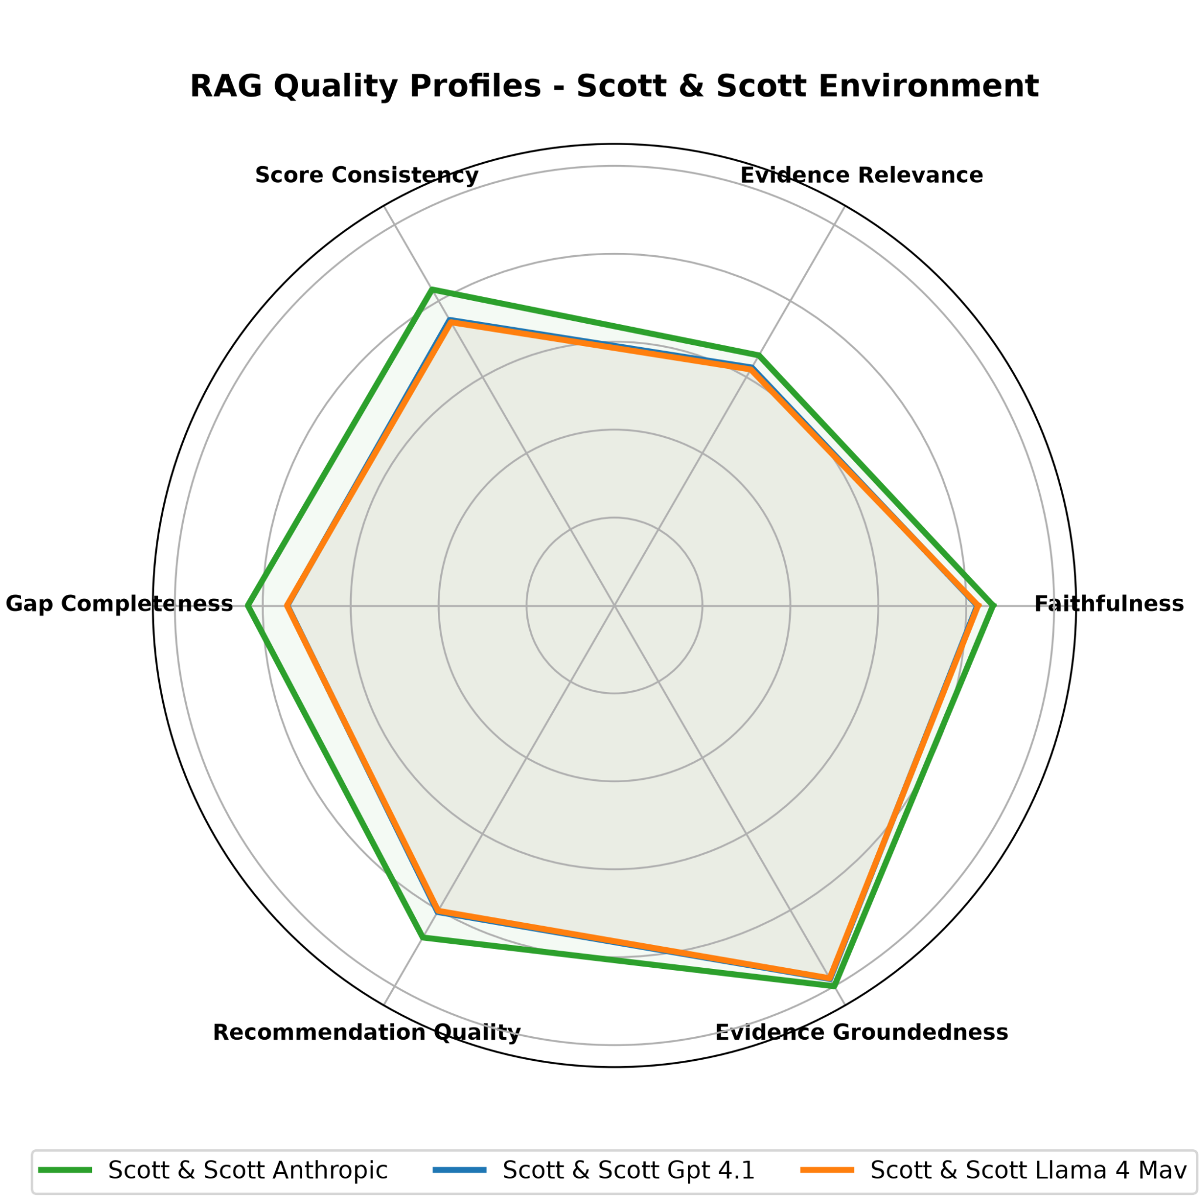
3.3 Evidence Relevance Histograms
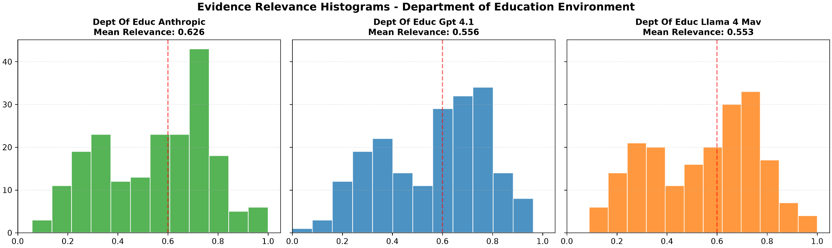
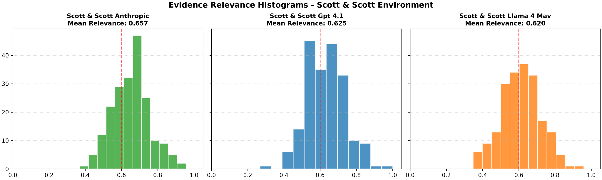

3.4 Maturity Score Distributions (Bar Charts)
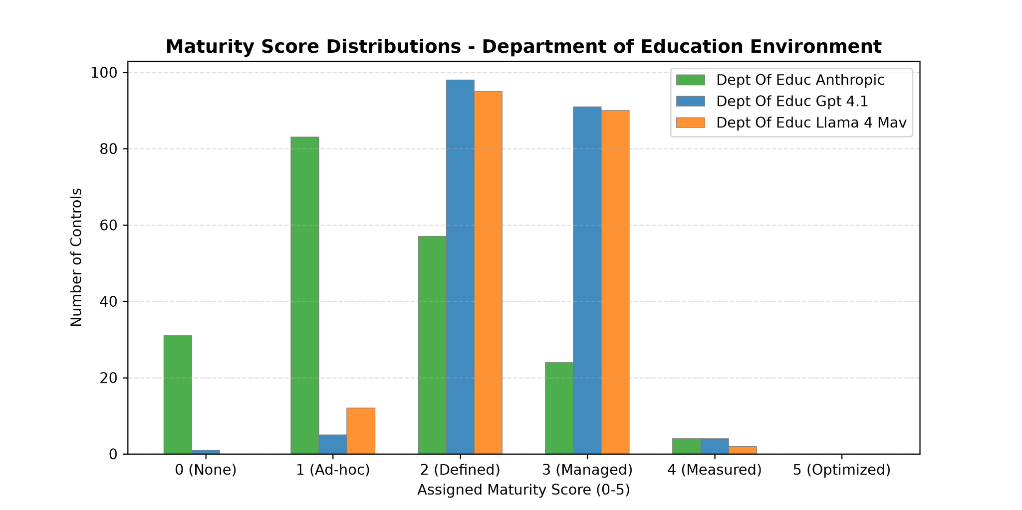
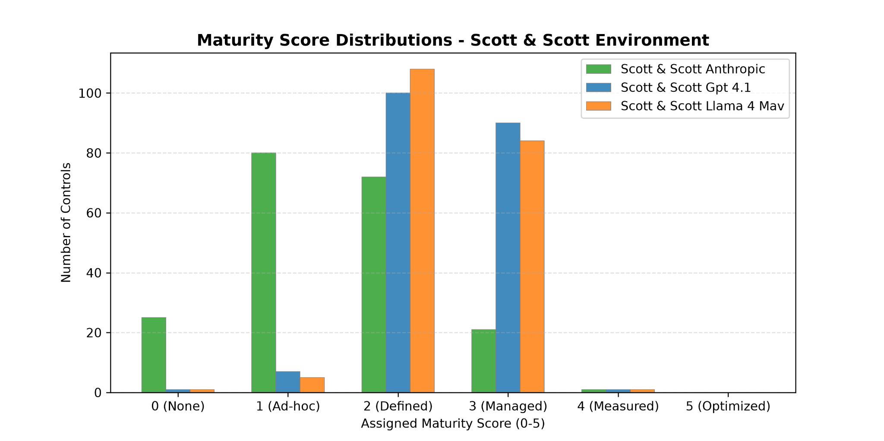
4. Results
4.1 Anthropic: Conservative and High-Precision Risk Mitigator
Across all assets, Anthropic exhibits a highly disciplined, risk-averse operational profile.
- Macro Performance: The matrix confirms Anthropic is the top-performing architecture, securing an Overall RAG score of 0.831 in the Department of Education evaluation and 0.842 in the Scott & Scott evaluation. It leads significantly in Faithfulness (0.863 and 0.861, respectfully) and achieves near-flawless Evidence Groundedness (0.997 and 1.000, respectfully).
- Retrieval Resilience: The Evidence Relevance Histograms highlight Anthropic's ability to maximize poor context. In the highly volatile Dept of Education environment (which forces a wide, bimodal distribution across all models), Anthropic pushes its mean relevance up to 0.626, significantly higher than its peers. In the more stable Scott & Scott environment, it creates a tight, highly efficient bell curve focused tightly around a 0.657 mean.
- Maturity Classification Behavior: The maturity distributions expose Anthropic's defining behavioral trait: strictness. While other models eagerly award passing grades, Anthropic heavily clusters its evaluations in 1 (Ad-hoc) and 2 (Defined) across both environments. It is the only model that aggressively flags failures, assigning over 20–30 controls to 0 (None). This proves that when context is weak or fragmented, Anthropic responds conservatively rather than guessing. Which is better than causing potential false positives.
4.2 GPT 4.1 & Llama 4 Mav: Over-Confident and Highly Volatile
GPT 4.1 and Llama 4 Mav operate with near-identical performance profiles, tightly tracking each other's metrics and overlapping almost completely on the radar charts. Both show a high vulnerability to retrieval noise and a dangerous tendency to over-classify compliance.
- Macro Performance: Both models lag behind Anthropic by roughly 6–8% across the board. From the Dept of Education paper evaluation, GPT 4.1 has an Overall RAG score of 0.758 and Llama 4 Mav with a score of 0.760. These Overall RAG scores are essentially bottlenecked by poor Evidence Relevance (0.556 and 0.553 respectfully).
- Sensitivity to Data Environment: The histograms show that these two models completely lose structural stability when an indexing environment is messy. In the Dept of Education evaluation, their relevance distributions flatten into volatile, bimodal shapes with massive sub-clusters down near the 0.2–0.4 range. In the Scott & Scott evaluation, the indexing environment stabilizes and the scores tighten into cleaner distributions with means rising back up to 0.625 and 0.620.
- Maturity Classification Behavior: The maturity bar charts reveal an alarming compliance risk: systemic over-confidence. Despite the histograms proving that GPT 4.1 and Llama 4 Mav are flooded with low-relevance retrieval chunks scoring below 0.4, both models overwhelmingly assign controls to 2 (Defined) and 3 (Managed). They almost completely refuse to assign a 0 (None) or 1 (Ad-hoc) score. This shows both architectures actively hallucinate compliance and generate false positives when given weak evidence.
4.3 Strategic Architecture Summary
- Anthropic is the more confident choice for the base LLM in the GRC tool development due to its high reasoning baseline and safe, conservative error-handling when documentation is missing or poor, reducing the chance of false positives and/or hallucinations
- GPT 4.1 and Llama 4 Mav require a highly optimized, clean upstream retrieval system to perform adequately. If deployed in a noisy data environment, their combined traits of low retrieval resilience and over-confident maturity labeling present a severe liability for automated compliance tracking.
5. Hallucinations
The active system uses an automated, LLM-driven (LLM-as-a-judge) pipeline to evaluate the collected framework GRC reports across two different papers using three different base LLMs. It isolates hallucinations by breaking the generated output into atomic claims and checking if they are supported, neutral, or contradicted by the retrieved context. It also identifies logic-level "compliance hallucinations" when a model outputs a high maturity score despite poor retrieval quality.
To detect and measure hallucinations within this evaluation framework, the analysis relies on a multi-layered combination of continuous distance metrics, semantic similarity evaluation, and cross-metric validation steps:
- Evidence Groundedness (NLI/Entailment): This metric directly measures factual alignment by treating the source text (chosen papers) as the premise and the model's generated response as the hypothesis. It calculates whether the response is fully supported by, neutral to, or contradicts the source text, serving as the primary guardrail against absolute fabrications.
- Faithfulness (Factual Consistency): This metric checks if the model introduced any outside information or made-up facts. It does this by breaking the model's answer into individual factual statements and checking each one directly against the provided source papers.
- Evidence Relevance vs. Maturity Classification Auditing: This step detects hallucinations by comparing evidence quality against the model's passing grades. If the retrieved source text is poor or off-topic, but the model still gives a high compliance score, the system flags it as a made-up passing grade.
- Cross-Metric Delta Verification: The pipeline analyzes the divergence between Evidence Relevance and Faithfulness. A significant negative delta (high faithfulness but low relevance) proves that while the model is technically "faithful" to the text it was given, it is hallucinating a broader compliance structure because the text itself does not address the control.
This analysis is entirely automated and LLM-driven (meaning a computer program uses an AI "judge" to grade the other AIs). There is no human reading through the answers to find mistakes.
The system catches and measures hallucinations using two main automated steps:
1. Breaking Down and Fact-Checking Sentences
To measure Faithfulness and Groundedness, the AI judge uses a simple math formula:
Step A (Extract): The judge takes the model's answer and breaks it down into a list of individual, single-fact statements.
Step B (Check): The judge looks at the retrieved documents and checks every single statement one by one. It marks each fact as either Supported (true according to the document) or Not Supported (made up).
Step C (Score): It calculates a final score based on the percentage of true facts. If a model makes 10 claims and 2 are invented, its score is 80%.
2. Catching "Faking It" with Math
The system also catches a specific type of hallucination called over-confidence without even reading the text:
- The system looks at the quality of the evidence retrieved.
- If the evidence quality is very low or completely irrelevant, the model should say "I don't know" or give a failing compliance score.
- If the model instead gives a high, confident passing grade despite having terrible evidence, the system automatically flags a compliance hallucination.

6. Alternative Hallucination Detection and Measurement
Evaluating language model compliance outputs via generative LLM-as-a-judge frameworks introduces significant operational friction: high inference costs, non-deterministic scoring, and generative leniency bias. Generative evaluators frequently rely on their internal parametric memory to rationalize missing context, failing to flag ungrounded compliance assertions.
To create a cost-effective, deterministic evaluation framework, we deploy a multi-tiered pipeline combining NLI Cross-Encoders ($P(\text{Entailment})$), Dense Vector Embeddings (Cosine Distance), and Named Entity Recognition (NER) Index Auditing.
6.1 Diagnostic Methodology & Operational Metrics
The metrics the deterministic code pipeline determines by comparing the GRC framework report against the original corresponding paper text are as follows:
- Overall Hallucination % (0.00 – 1.00): Measures the proportion of evaluated control rationales in a given run classified as hallucinations by calculating the population mean where Unfaithfulness Risk exceeds 0.50
- Unfaithfulness Risk (0.00 – 1.00): Measures sequence-level non-entailment using a DeBERTa-v3 NLI Cross-Encoder (1.0 - entailment_probability) to quantify the probability that a generated rationale contains ungrounded claims relative to the cited evidence snippet.
- Direct Contradiction Prob (0.00 – 1.00): Measures the exact probability (probs[0] from the DeBERTa-v3 softmax array) that a generated score rationale actively refutes or contradicts the source evidence text.
- Semantic Drift Risk (0.00 – 1.00): Measures global conceptual divergence by encoding both texts with MiniLM-L6 and calculating vector cosine distance (1.0 - cosine_similarity) between the source evidence and generated rationale.
- Fabricated Entities Count (Integer Count): Measures the total volume of invented named entities, technical frameworks, vendor names, or control codes (e.g., ID.AM-1) in the rationale by using spaCy NER and regex matching to flag terms absent from the source document text index.
6.2 Empirical Results
The experimental results across the test corpora (DeptEduc and Scott&Scott) reveal stark behavioral divergences across base LLM architectures when subjected to strict deterministic auditing:

Run Identifier | Overall Hallucination % | Unfaithfulness Risk | Direct Contradiction Prob | Semantic Drift Risk | Fabricated Entities Count
DeptEduc_Anthrop | 0.9397 | 0.8554 | 0.2917 | 0.4434 | 85
DeptEduc_GPT_4.1 | 0.9296 | 0.8611 | 0.2482 | 0.4559 | 26
DeptEduc_Llama_4_Mav | 0.9246 | 0.8748 | 0.2720 | 0.4477 | 27
Scott&Scott_Anthrop | 0.9799 | 0.9539 | 0.1720 | 0.4631 | 53
Scott&Scott_GPT_4.1 | 0.9598 | 0.9293 | 0.1148 | 0.4553 | 17
Scott&Scott_Llama_4_Mav | 0.9447 | 0.9259 | 0.1063 | 0.4549 | 20

6.3 Metric Interpretation & Architectural Insights
The cross-metric diagnostic steps analyze behavioral trends and failure modes across the deterministic evaluation pipeline:
- The Generative Leniency Gap (LLM-as-a-Judge vs. Deterministic NLI): This comparison contrasts AI judge scores against sequence-level entailment. While generative judges report hallucination rates of 12% to 25% by accepting plausible-sounding rationales, the deterministic pipeline reveals an Overall Hallucination % exceeding 92% because they approve claims even when source policies provide zero supporting evidence.
  - While the alternative evaluations pipeline removes the potential bias of a LLM judge, it has a blind spot: it treats smart rephrasing or professional summaries as "wrong" if the exact words aren't in the source text. Because of this strictness, the >92% overall hallucination score is calculated when it catches simple rewording right along with real made-up facts. However, the other metrics operate independently of sentence syntax, showing that the models rarely drift in macro-topic or contradict policy guidelines.
- Extrapolative Hallucination Auditing (Fabricated Entities vs. Model Alignment): This step isolates entity fabrication by cross-referencing extracted named entities against a normalized source document token index. Anthropic models produced 3.2 to 3.8 times more fabricated entities (85 in DeptEduc, 53 in Scott&Scott) than GPT-4.1 and Llama 4 Maverick (17 to 27). This indicates that while Anthropic models provide detailed outputs, they exhibit a significantly higher rate of ungrounded entity generation. This often includes introducing specific names, terms, or identifiers that are not found in the source text.
- Unfaithfulness Risk vs. Direct Contradiction Prob: This diagnostic evaluates the mechanism of hallucination by measuring the delta between non-entailment and explicit opposition. Across all runs, Direct Contradiction Prob remains low (10.6% – 29.2%), while Unfaithfulness Risk remains exceptionally high (85.5% – 95.4% ). These findings strongly indicate that base models rarely generate statements that directly refute source text. Instead, the data suggests hallucinations stem almost entirely from unsupported assumptions and plausible claims that lack grounded evidence in the provided policy context.
- Domain & Structural Sensitivity Auditing (Regulatory vs. Corporate Policy): This step measures how source document structure dictates model failure modes. Dense regulatory frameworks (DeptEduc) yielded higher Direct Contradiction Prob (27.1% mean), showing that tight, complex rules cause models to make direct logical flips. Conversely, looser corporate policies (Scott&Scott) produced lower Direct Contradiction Prob (13.1% mean) but higher Unfaithfulness Risk (93.6% mean). These structural variations suggest that the nature of the source text significantly alters model error distribution. This can lead to shifting outputs between direct logical divergence on strict regulations and high unfaithfulness on looser policy text.
- Macro-Topic Stability (Semantic Drift Risk Verification): This metric measures global conceptual divergence to verify whether hallucinations cause domain derailment. Across all architectures and datasets, Semantic Drift Risk remains tightly bounded between 0.4434 and 0.4631. This consistency suggests that base LLMs maintain strong macro-level topic alignment, and that compliance evaluation failure occurs almost exclusively at the micro-factual sequence and entity level.
6.4 Architectural Conclusions
Synthesizing the findings from the LLM-as-a-Judge RAG Quality framework and the deterministic NLI/NER Audit pipeline yields key architectural tradeoffs across the three model bases:
Anthropic (Conservative)
- Strengths: Leads overall RAG quality (0.831–0.842) and Faithfulness (0.861–0.863). Shows strong risk aversion by assigning low maturity scores (0–1) when evidence is weak, drastically reducing dangerous false positives.
- Deterministic Failure Mode (Extrapolative Fabrication): Driven by helpful alignment, it over-specifies by inventing non-existent technical terms, producing 3.2× to 3.8× more fabricated entities (53–85) than peers.
- Verdict: The best base LLM for GRC tools, provided an upstream NER/regex entity filter strips over-specified technical jargon.
GPT-4.1 & Llama 4 Maverick (Over-Confident)
- Strengths: Low named-entity fabrication counts (17–27 entities across runs).
- Deterministic Failure Mode (Implicit Assumptions & Noise Sensitivity): Lag in overall quality (0.758–0.789) due to poor retrieval resilience. When evidence is noisy, both models default to systemic over-confidence—frequently awarding passing scores (2–3) on ungrounded assumptions.
- Verdict: Unsuitable for standalone auditing. Require an extremely pristine retrieval environment to prevent false-positive compliance claims.
Methodological Limitations of Deterministic Auditing
When evaluating GRC report outputs via automated code pipelines, researchers must account for three structural evaluation constraints:
- The NLI Paraphrase Penalty: Cross-encoder models treat any expansion of source text as an ungrounded assumption. While this inflates raw unfaithfulness risk, companion metrics like Direct Contradiction and Semantic Drift confirm that this represents stylistic synthesis rather than factual divergence.
- Snippet Isolation vs. Global Document Context: Verifying rationales against isolated evidence quotes rather than the entire raw PDF text index can occasionally penalize valid cross-references to other multi-page sections of the document.
- Divergent Definitions of "Hallucination": Generative judges measure semantic plausibility (does this sound like a reasonable audit finding?), whereas deterministic pipelines measure literal string/entailment compliance (is every noun and verb explicitly proven by the adjacent quote?).

