GRC Framework LLM Generated Output Analysis/Metrics
In order to evaluate the performance and output quality of the selected LLMs process of the given task and relevant information. To gauge these, a three step evaluation process was developed to examine the individual outputs of 9 frameworks across two different papers, Scott & Scott, and Department of Education. This experiment was repeated using three separate LLMs as the model base. There are three total LLMs: Anthropic Claude, GPT 4.1, and Llama 4 Maverick. The evaluation process is as follows:
Stage 1: Individual Testing
One paper and a single framework are run through the GRC tool using a selected LLM as a base. This is repeated with the same paper and base LLM 9 times with each single framework.
- This is done for both papers
The corresponding GRC reports are then individually run through code that prompts a chosen LLM (Claude) once again (LLM as judge) along with the original paper text associated with the selected GRC report. This is repeated for every GRC report.
- The LLM judge remains the same.
1.1 Code Execution Logic
- Source Document Parsing: The script uses PyMuPDF (fitz) to extract the complete raw text from the original paper PDF, establishing the immutable ground-truth document context.
- Asynchronous LLM Judging: The script concurrently prompts the LLM judge (claude-sonnet-4-6) via API calls for every control in the GRC JSON file. It supplies the original paper text alongside the control's rationale, evidence quotes, gaps, and maturity rating (0–5).
- Programmatic Citation Verification: To prevent judge hallucinations on citation checks, the script runs a deterministic, sliding-window fuzzy string matcher (difflib.SequenceMatcher) comparing cited quotes against the raw PDF text.
1.2 Collected Metrics and Controls
In Governance, Risk, and Compliance (GRC), controls represent the individual policy requirements, safeguards, or administrative rules being audited (e.g., Access Control, Data Encryption, Policy Enforcement). The original GRC framework has a series of controls, and metrics are collected for each control instance:
The metrics the LLM judge and code pipeline are to determine by comparing the GRC framework report against the original corresponding paper text are as follows:
- Faithfulness (0.00 – 1.00): Measures whether claims in the score rationale and identified gaps derive strictly from the cited evidence quotes, penalizing ungrounded assertions or internal contradictions.
- Evidence Relevance (0.00 – 1.00): Measures how directly and genuinely the cited policy excerpts address the specific control requirement, penalizing generic or off-topic context.
- Score Consistency (0.00 – 1.00): Evaluates if the assigned maturity score (0–5 based on standardized GRC definitions like CMMI/COSO) is logically justified by the evidence strength and identified gaps.
- Gap Completeness (0.00 – 1.00): Assesses whether identified gaps accurately and comprehensively capture missing control requirements.
- Recommendation Quality (0.00 – 1.00): Measures whether recommendations are specific, actionable, and directly targeted at resolving identified control gaps.
- Evidence Groundedness (0.00 – 1.00): A deterministic, non-LLM score generated by the difflib code execution step to verify if cited evidence quotes actually exist in the source document.
Stage 2: Flat Population Consolidation
This stage consists of a pipeline that once again utilizes the earlier judge LLM (Claude). The pipeline extracts the data points from every individual control across all domains into a single, flat population pool.
2.1 Code Execution Logic
- Directory Processing: The script recursively scans designated target directories to parse all stage 1 evaluation outputs and corresponding GRC framework assessment reports (.json files).
- Statistical Calculation: It aggregates control-level metrics across entire populations to generate descriptive statistics (means, medians, standard deviations, and failure percentages).
- Artifact Generation: It uses matplotlib to render visual graphs and passes statistical summaries to claude-sonnet-4-6 to synthesize an executive narrative report.
2.2 Aggregated Data Points
- Continuous Metrics: The pipeline aggregates every individual control score across the entire run and divides by the total number of controls to calculate a single, true macro population mean.
- Categorical Maturity Values: The pipeline conducts a frequency count across the entire pool of controls to tally exactly how many requirements fell into each available maturity tier.

2.3 Graphs and Diagrams of the following are generated -
- Overall RAG Quality Score Bar Chart: Displays macro quality comparisons.
- Six-Dimension Averages Bar Chart: Shows population averages across all 6 metrics.
- RAG Quality Profile Radar Chart: Illustrates system strengths and dimensional balance.
- Weak Dimension Histograms: Tracks score variance and density for low-performing dimensions.
- Maturity Score Distribution Histogram: Maps the frequency of assigned maturity ratings.

Stage 3: Overall Metrics Table and Visualizations
This is the presentation layer. It performs no new downstream mathematical operations or secondary calculations. It instead takes the true population means and raw score distributions finalized in Stage 2 and inputs them into key visualizations and tables.
- The Master Evaluation Matrix Table: The macro population means calculated at the end of Stage 2 are transferred directly into a unified comparison grid to allow side-by-side performance tracking across different model runs.
- Radar Charts: The final dimension means from Stage 2 are mapped as fixed geometric coordinates along matching radial axes to visually illustrate each run's distinct performance profile.
- Performance Histograms: Rather than using summary averages, Stage 3 pulls the entire raw array of individual control scores compiled during Stage 2. It passes this complete array to the graphing library to accurately plot the exact distribution, density, and variance of the scores.
- Maturity Bar Charts: The categorical integer tallies compiled in Stage 2 (the total count of controls sitting at each specific maturity level) are used directly to dictate the heights of the bars on a grouped chart, visually highlighting the classification behavior of each model.
3.1 Master Evaluation Matrix (All Runs)
Rag Quality Report | Faithfulness | Evidence Relevance | Score Consistency | Gap Completeness | Rec Quality | Groundedness | OVERALL
Dept of Educ Anthrop | 0.863 | 0.626 | 0.818 | 0.825 | 0.856 | 0.997 | 0.831
Dept of Educ Gpt 4.1 | 0.810 | 0.556 | 0.714 | 0.727 | 0.784 | 0.955 | 0.758
Dept of Educ Llama 4 Mav | 0.805 | 0.553 | 0.716 | 0.726 | 0.789 | 0.965 | 0.760
Scott & Scott Anthrop | 0.861 | 0.657 | 0.830 | 0.834 | 0.872 | 1.000 | 0.842
Scott & Scott Gpt 4.1 | 0.825 | 0.625 | 0.750 | 0.744 | 0.805 | 0.981 | 0.789
Scott & Scott Llama 4 Mav | 0.827 | 0.620 | 0.744 | 0.745 | 0.802 | 0.979 | 0.786

3.2 RAG Quality Profiles (Radar Charts)
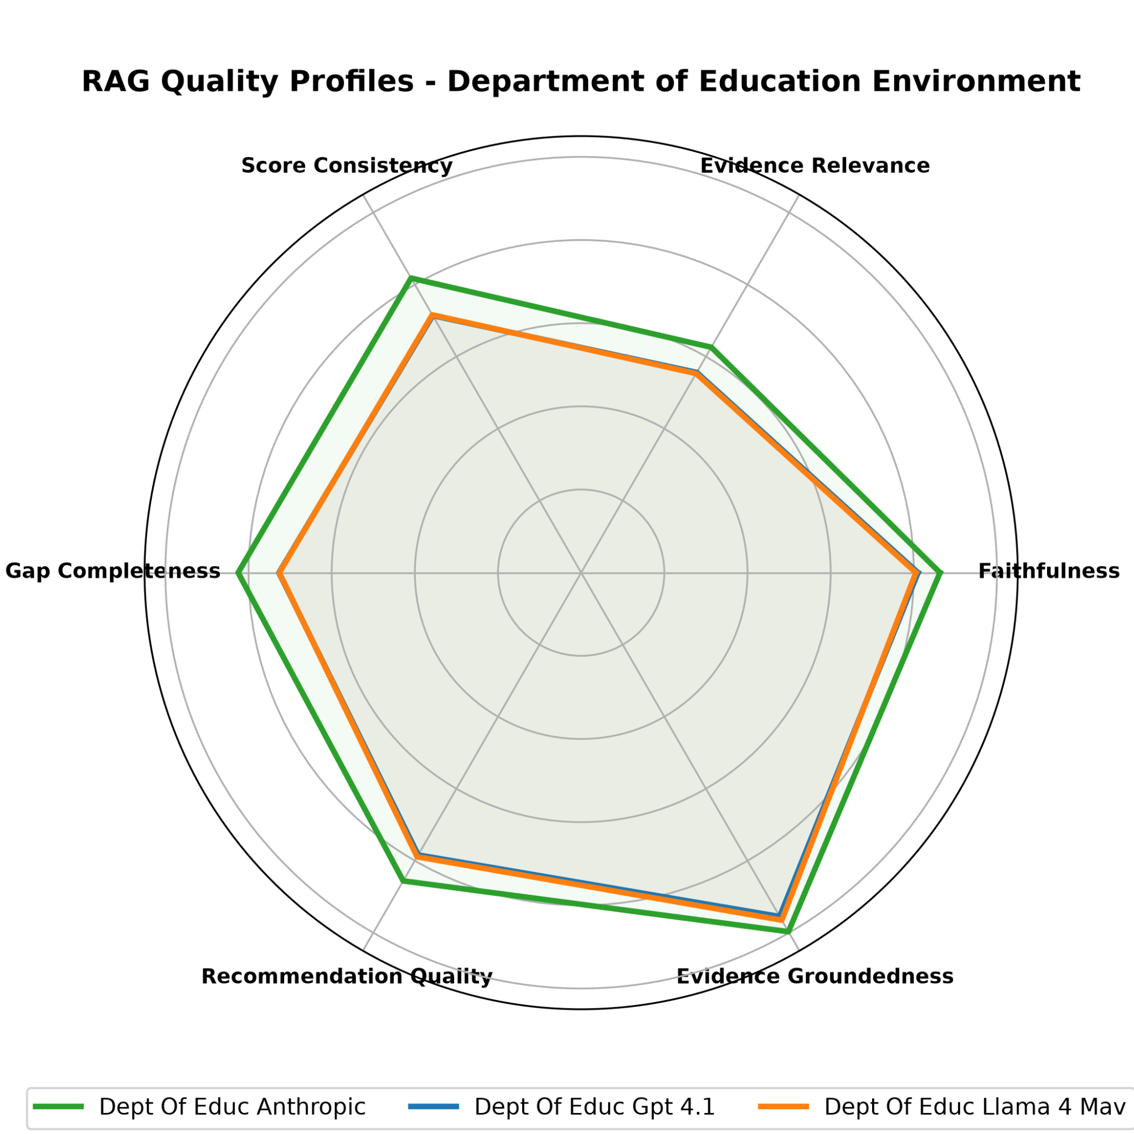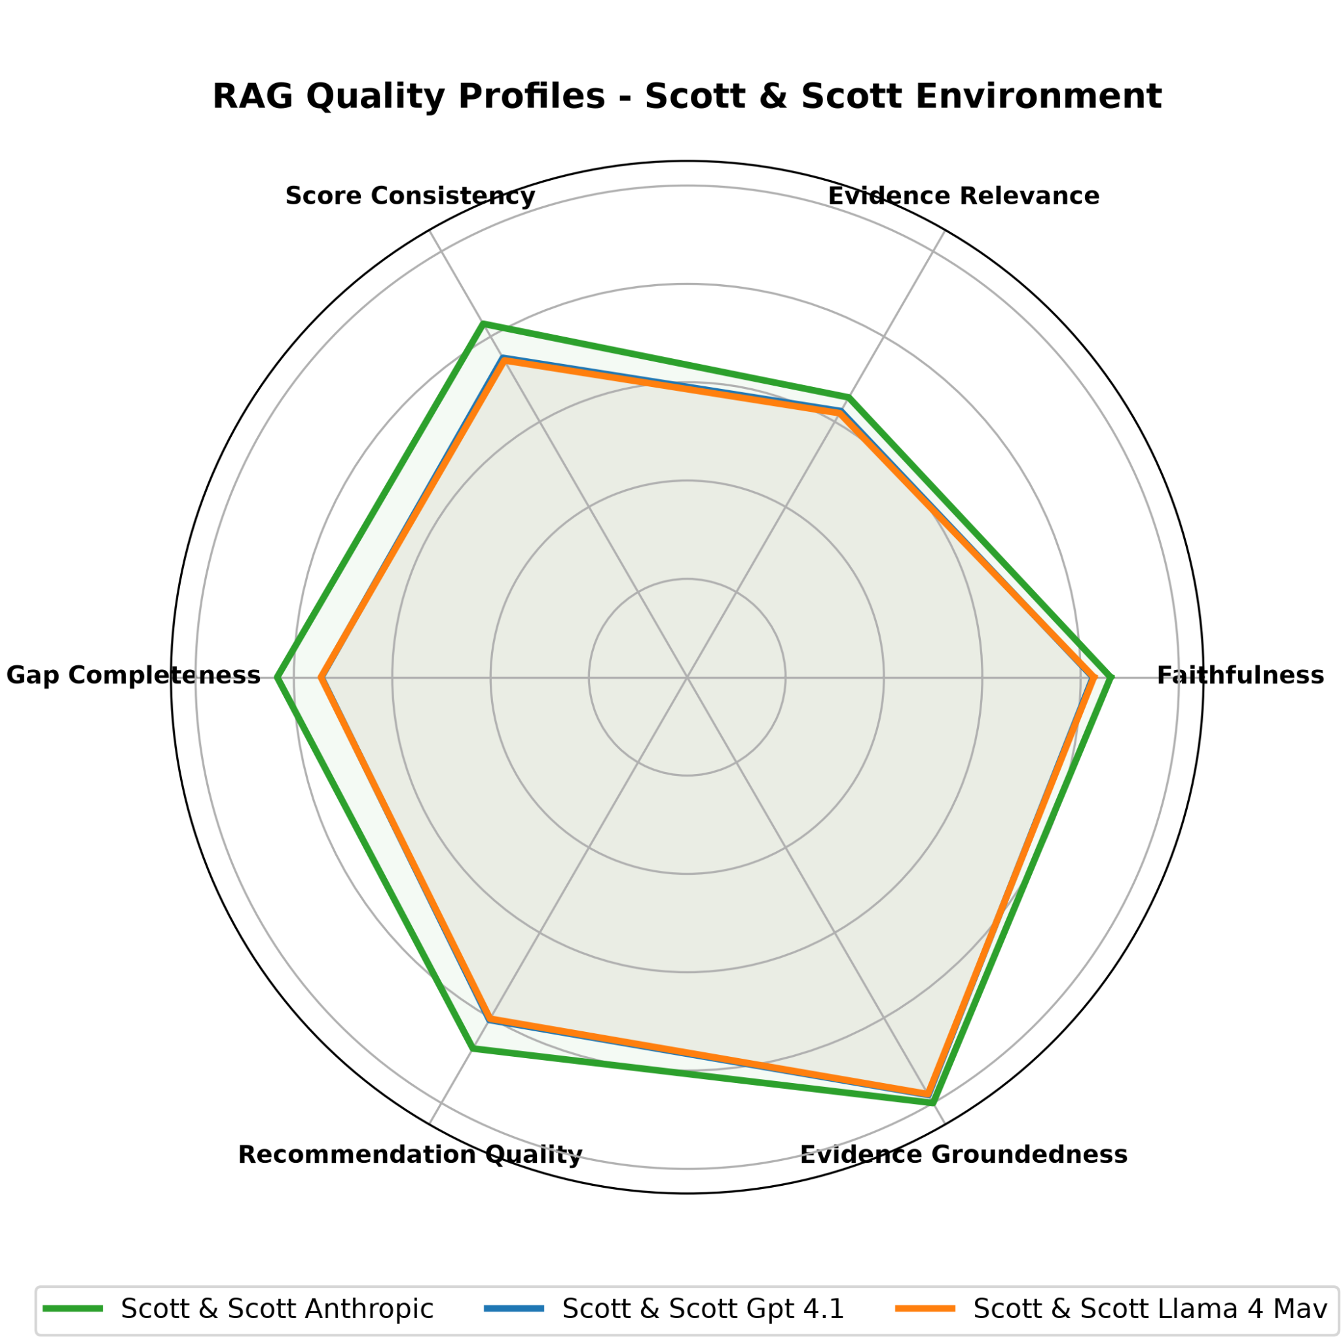
3.3 Evidence Relevance Histograms
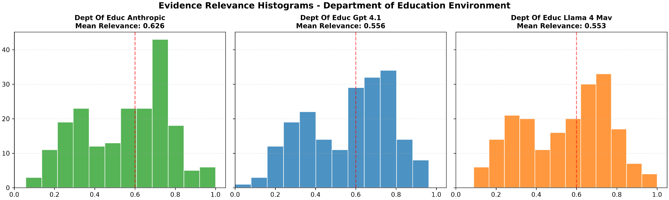
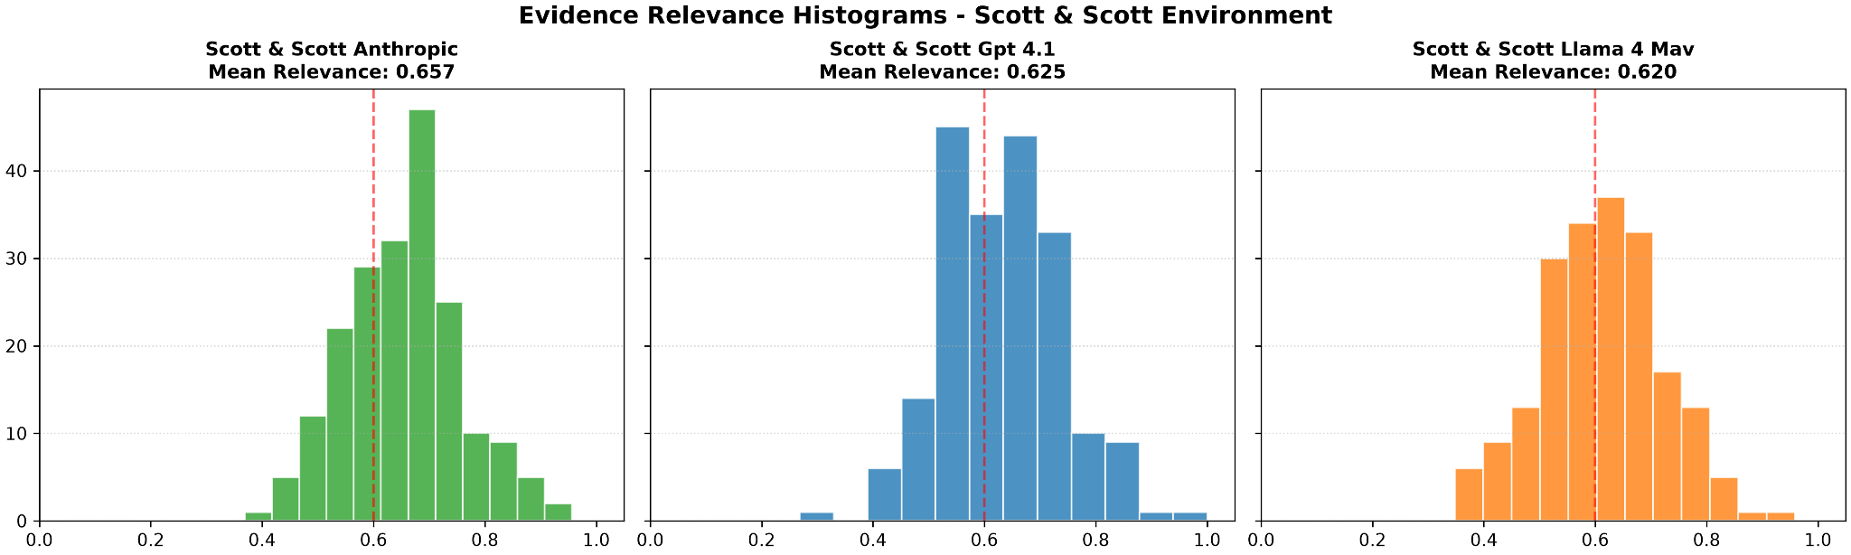

3.4 Maturity Score Distributions (Bar Charts)
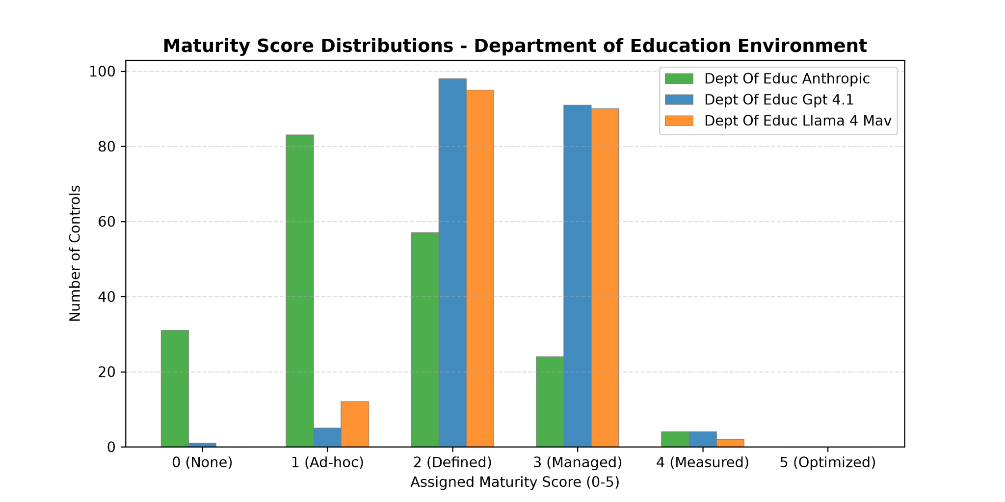
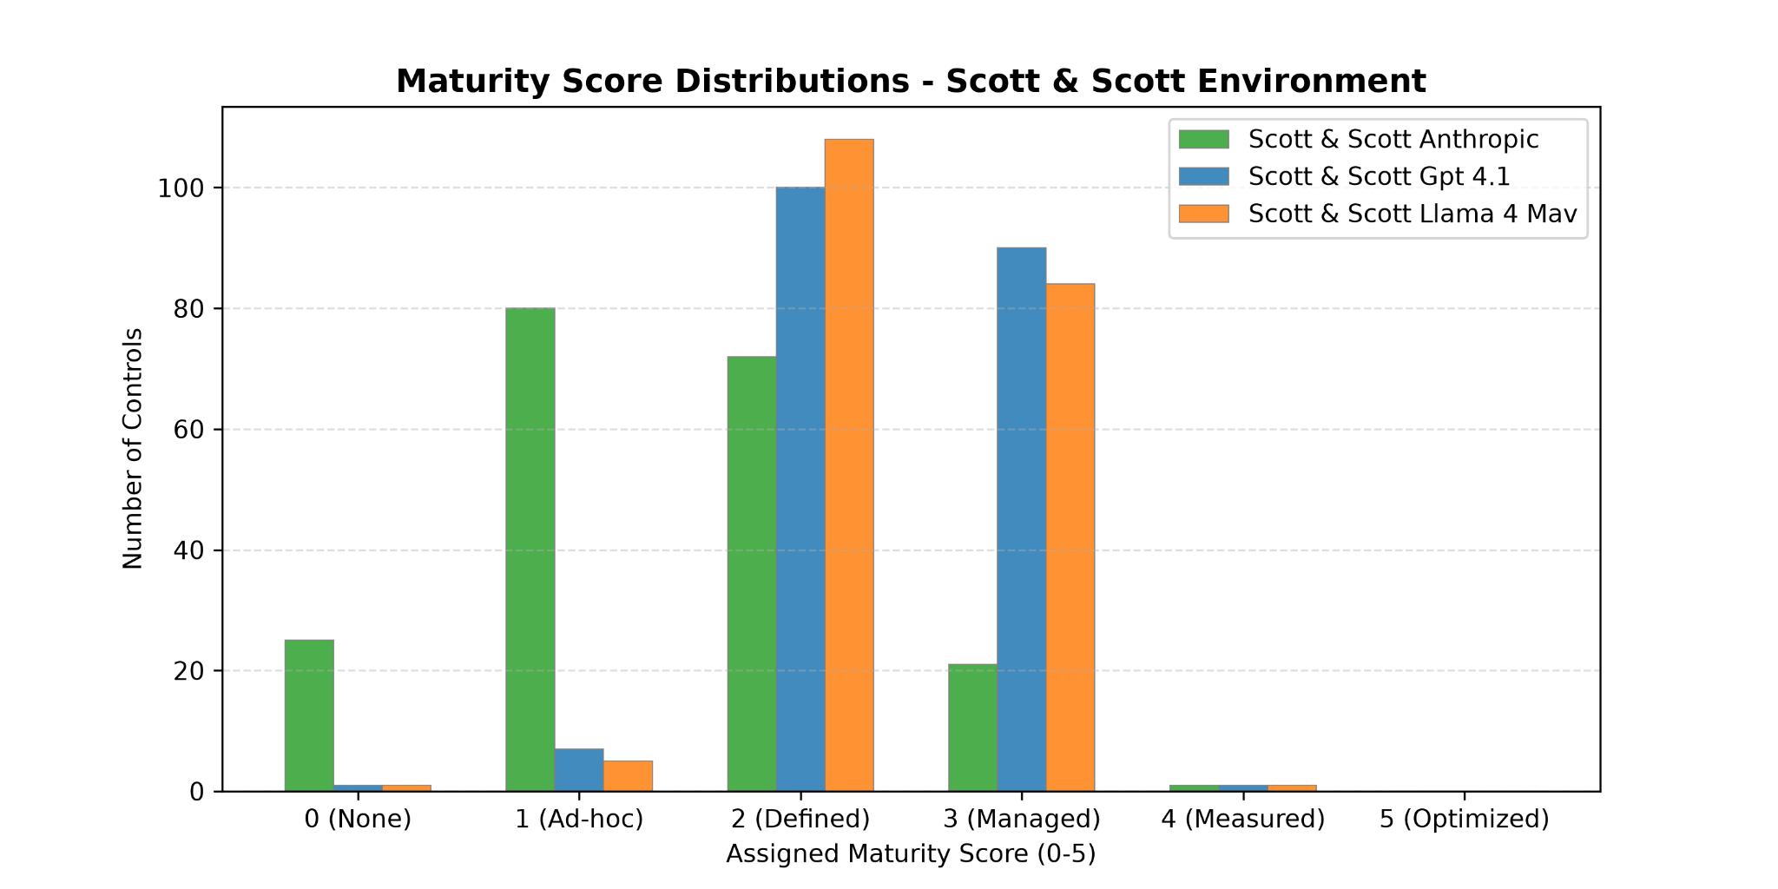
4. Results
4.1 Anthropic: Conservative and High-Precision Risk Mitigator
Across all assets, Anthropic exhibits a highly disciplined, risk-averse operational profile.
- Macro Performance: The matrix confirms Anthropic is the top-performing architecture, securing an Overall RAG score of 0.831 in the Department of Education evaluation and 0.842 in the Scott & Scott evaluation. It leads significantly in Faithfulness (0.863 and 0.861, respectfully) and achieves near-flawless Evidence Groundedness (0.997 and 1.000, respectfully).
- Retrieval Resilience: The Evidence Relevance Histograms highlight Anthropic's ability to maximize poor context. In the highly volatile Dept of Education environment (which forces a wide, bimodal distribution across all models), Anthropic pushes its mean relevance up to 0.626, significantly higher than its peers. In the more stable Scott & Scott environment, it creates a tight, highly efficient bell curve focused tightly around a 0.657 mean.
- Maturity Classification Behavior: The maturity distributions expose Anthropic's defining behavioral trait: strictness. While other models eagerly award passing grades, Anthropic heavily clusters its evaluations in 1 (Ad-hoc) and 2 (Defined) across both environments. It is the only model that aggressively flags failures, assigning over 20–30 controls to 0 (None). This proves that when context is weak or fragmented, Anthropic responds conservatively rather than guessing. Which is better than causing potential false positives.
4.2 GPT 4.1 & Llama 4 Mav: Over-Confident and Highly Volatile
GPT 4.1 and Llama 4 Mav operate with near-identical performance profiles, tightly tracking each other's metrics and overlapping almost completely on the radar charts. Both show a high vulnerability to retrieval noise and a dangerous tendency to over-classify compliance.
- Macro Performance: Both models lag behind Anthropic by roughly 6–8% across the board. From the Dept of Education paper evaluation, GPT 4.1 has an Overall RAG score of 0.758 and Llama 4 Mav with a score of 0.760. These Overall RAG scores are essentially bottlenecked by poor Evidence Relevance (0.556 and 0.553 respectfully).
- Sensitivity to Data Environment: The histograms show that these two models completely lose structural stability when an indexing environment is messy. In the Dept of Education evaluation, their relevance distributions flatten into volatile, bimodal shapes with massive sub-clusters down near the 0.2–0.4 range. In the Scott & Scott evaluation, the indexing environment stabilizes and the scores tighten into cleaner distributions with means rising back up to 0.625 and 0.620.
- Maturity Classification Behavior: The maturity bar charts reveal an alarming compliance risk: systemic over-confidence. Despite the histograms proving that GPT 4.1 and Llama 4 Mav are flooded with low-relevance retrieval chunks scoring below 0.4, both models overwhelmingly assign controls to 2 (Defined) and 3 (Managed). They almost completely refuse to assign a 0 (None) or 1 (Ad-hoc) score. This shows both architectures actively hallucinate compliance and generate false positives when given weak evidence.
4.3 Strategic Architecture Summary
- Anthropic is the more confident choice for the base LLM in the GRC tool development due to its high reasoning baseline and safe, conservative error-handling when documentation is missing or poor, reducing the chance of false positives and/or hallucinations
- GPT 4.1 and Llama 4 Mav require a highly optimized, clean upstream retrieval system to perform adequately. If deployed in a noisy data environment, their combined traits of low retrieval resilience and over-confident maturity labeling present a severe liability for automated compliance tracking.
5. Hallucinations
The active system uses an automated, LLM-driven (LLM-as-a-judge) pipeline to evaluate the collected framework GRC reports across two different papers using three different base LLMs. It isolates hallucinations by breaking the generated output into atomic claims and checking if they are supported, neutral, or contradicted by the retrieved context. It also identifies logic-level "compliance hallucinations" when a model outputs a high maturity score despite poor retrieval quality.
To detect and measure hallucinations within this evaluation framework, the analysis relies on a multi-layered combination of continuous distance metrics, semantic similarity evaluation, and cross-metric validation steps:
- Evidence Groundedness (NLI/Entailment): This metric directly measures factual alignment by treating the source text (chosen papers) as the premise and the model's generated response as the hypothesis. It calculates whether the response is fully supported by, neutral to, or contradicts the source text, serving as the primary guardrail against absolute fabrications.
- Faithfulness (Factual Consistency): This metric checks if the model introduced any outside information or made-up facts. It does this by breaking the model's answer into individual factual statements and checking each one directly against the provided source papers.
- Evidence Relevance vs. Maturity Classification Auditing: This step detects hallucinations by comparing evidence quality against the model's passing grades. If the retrieved source text is poor or off-topic, but the model still gives a high compliance score, the system flags it as a made-up passing grade.
- Cross-Metric Delta Verification: The pipeline analyzes the divergence between Evidence Relevance and Faithfulness. A significant negative delta (high faithfulness but low relevance) proves that while the model is technically "faithful" to the text it was given, it is hallucinating a broader compliance structure because the text itself does not address the control.
This analysis is entirely automated and LLM-driven (meaning a computer program uses an AI "judge" to grade the other AIs). There is no human reading through the answers to find mistakes.
The system catches and measures hallucinations using two main automated steps:
1. Breaking Down and Fact-Checking Sentences
To measure Faithfulness and Groundedness, the AI judge uses a simple math formula:
- Step A (Extract): The judge takes the model's answer and breaks it down into a list of individual, single-fact statements.
- Step B (Check): The judge looks at the retrieved documents and checks every single statement one by one. It marks each fact as either Supported (true according to the document) or Not Supported (made up).
- Step C (Score): It calculates a final score based on the percentage of true facts. If a model makes 10 claims and 2 are invented, its score is 80%.
2. Catching "Faking It" with Math
The system also catches a specific type of hallucination called over-confidence without even reading the text:
- The system looks at the quality of the evidence retrieved.
- If the evidence quality is very low or completely irrelevant, the model should say "I don't know" or give a failing compliance score.
- If the model instead gives a high, confident passing grade despite having terrible evidence, the system automatically flags a compliance hallucination.
6. Alternative Hallucination Detection and Measurement
Using LLM-as-judge can lead to potential bias or misrepresentation or calculation of evidence even with well detailed prompts and supporting analysis code. It can also have runtime effectiveness cost and high computation needs along with actual material cost. One alternative approach is to use a collection of non-generative LLM hallucination metric analysis methods.
To create an alternative evaluation pipeline, we created a multi-tiered pipeline combining Natural Language Inference (NLI) Cross-Encoders, Dense Vector Embeddings (Cosine Distance), and Named Entity Recognition (NER) Index Auditing.
6.1 Diagnostic Methodology & Operational Metrics
The metrics the deterministic code pipeline determines by comparing the GRC framework report against the original corresponding paper text are as follows:
- Overall Hallucination % (0.00 – 1.00): Measures the proportion of evaluated control rationales in a given run classified as hallucinations by calculating the population mean where Unfaithfulness Risk exceeds 0.50.
- Unfaithfulness Risk (0.00 – 1.00): Measures sequence-level non-entailment using a DeBERTa-v3 NLI Cross-Encoder (1.0 - entailment_probability) to quantify the probability that a generated rationale contains ungrounded claims relative to the cited evidence snippet.
- Direct Contradiction Prob (0.00 – 1.00): Measures the exact probability that a generated score rationale actively refutes or contradicts the source evidence text.
- Semantic Drift Risk (0.00 – 1.00): Measures global conceptual divergence by encoding both texts with MiniLM-L6 and calculating vector cosine distance (1.0 - cosine_similarity) between the source evidence and generated rationale.
- Fabricated Entities Count (Integer Count): Measures the total volume of invented named entities, technical frameworks, vendor names, or control codes (e.g., ID.AM-1) in the rationale by using spaCy NER and regex matching to flag terms absent from the source document.
6.2 Alternative Analysis Results
The metrics across the test corpora (DeptEduc and Scott&Scott) reveal behavioral trends across the different base LLM architectures analyzed using the alternative NLI pipeline:
Run | Overall Hallucination % | Unfaithfulness Risk | Direct Contradiction Prob | Semantic Drift Risk | Fabricated Entities Count
DeptEduc_Anthrop | 0.1909 | 0.1984 | 0.1352 | 0.4339 | 85
DeptEduc_GPT_4.1 | 0.1859 | 0.1908 | 0.0981 | 0.4593 | 26
DeptEduc_Llama_4_Mav | 0.1658 | 0.1789 | 0.1056 | 0.4449 | 26
Scott&Scott_Anthrop | 0.1959 | 0.1915 | 0.1355 | 0.4170 | 53
Scott&Scott_GPT_4.1 | 0.2010 | 0.1989 | 0.1439 | 0.4373 | 17
Scott&Scott_Llama_4_Mav | 0.1507 | 0.1639 | 0.1077 | 0.4370 | 20

6.3 Metric Interpretation & Architectural Insights
The steps analyze behavioral trends and failure modes across the deterministic evaluation pipeline:
- Generative Leniency Gap (LLM-as-a-Judge vs. Deterministic NLI): This comparison contrasts AI judge scores against sequence-level entailment. The alternative pipeline reveals an Overall Hallucination % tightly clustered between 15.0% and 20.1%. This aligns closely with the hallucination rates typically reported by the generative LLM judge (12% to 25%). The data demonstrates that the alternative NLI pipeline is successfully validating paraphrased, faithful outputs without inflicting an artificial "strictness penalty" for reworded text.
- Extrapolative Hallucination Auditing (Fabricated Entities vs. Model Alignment): This step isolates entity fabrication by cross-referencing extracted named entities against a normalized source document. Anthropic models produced 3.2 to 3.8 times more fabricated entities (85 in DeptEduc, 53 in Scott&Scott) than GPT-4.1 and Llama 4 Maverick (17 to 26). This indicates that while Anthropic models provide detailed outputs, they exhibit a significantly higher rate of ungrounded entity generation. This often includes introducing specific names, terms, or identifiers that are not found in the source text. However, it should be noted that more hallucinations are detected when LLM output uses alternative but equivalent wording to the source material.
- Unfaithfulness Risk vs. Direct Contradiction Prob: This diagnostic evaluates the mechanism of hallucination by measuring the delta between non-entailment and explicit opposition. Across all runs, Direct Contradiction Prob remains low (9.8% – 14.3%). On the other hand, Unfaithfulness Risk also remains low (16.3% – 19.8%). These findings strongly indicate that the base models are generally highly faithful to the source text, maintaining strong grounding in the provided context rather than relying on massive ungrounded assumptions or direct refutations.
- Document Impact: Government Rules vs. Company Policies: This step evaluates whether source document structure affects a model’s ability to output reliable reports. The data reveals no significant statistical divergence between the datasets. Dense regulatory frameworks (DeptEduc) yielded Direct Contradiction Prob (9.8% – 13.5%) and Unfaithfulness Risk (17.8% – 19.8%) that mirror those of the looser corporate policies (Scott&Scott) (10.7% – 14.3% Contradiction; 16.3% – 19.8% Unfaithfulness). This uniformity shows that the models maintain consistent behavioral stability regardless of the strictness or looseness of the underlying policy text.
- Going Vs. Staying on Topic: This metric measures global conceptual divergence to verify whether hallucinations cause domain derailment. Across all architectures and datasets, Semantic Drift Risk remains tightly bounded between 0.4170 and 0.4593. This consistency suggests that base LLMs maintain strong macro-level topic alignment, and that compliance evaluation failure occurs almost exclusively at the micro-factual sequence and entity level.
6.4 Architectural Conclusions
Several key architectural tradeoffs across the three model bases were found when analyzing the metrics gathered from both the LLM-as-judge approach and the non-LLM alternate analysis approach:
Anthropic (Conservative)
- Strengths: Leads overall RAG quality and Faithfulness. Shows strong risk aversion by assigning low maturity scores when evidence is weak, reducing false positives.
- Deterministic Failure Mode (Extrapolative Fabrication): Driven by helpful alignment, it over-specifies by inventing non-existent technical terms, producing 3.2× to 3.8× more fabricated entities (53–85) than peers.
- Verdict: The best base LLM for GRC tools, but some safe checks need to be put into place to ensure context is not being misrepresented.
GPT-4.1 & Llama 4 Maverick (Over-Confident)
- Strengths: Highly faithful to source text with remarkably low named-entity fabrication counts (17–26 entities across runs).
- Deterministic Failure Mode (Implicit Assumptions): Despite strong entailment metrics, both models exhibit slightly lower RAG quality due to poor retrieval resilience. When evidence is noisy, both models trend toward over-confidence. The models occasionally award passing scores on ungrounded assumptions.
- Verdict: Highly capable models, but they require a pristine retrieval environment to prevent false-positive compliance claims compared to Anthropic's innate risk-aversion.
Limitations
When evaluating GRC report outputs via automated code pipelines, researchers must account for the following structural evaluation constraints:
- The alternate analysis pipeline relies heavily on exact matches and any information that does not contain key words can be marked as hallucinations.
- A generative judge looks at the meaning of the text. If the model rewords a policy or summarizes it logically, the judge marks it as correct due to the idea that it sounds reasonable.
- NLI is extremely literal. It checks if the claim is mathematically proven by the premise. If the generated answer includes words, verbs, or concepts that aren't explicitly written in the cited text, it flags it as a hallucination.
- It should also be noted that the alternative pipeline input for the nli-deberta-v3-base is limited to 512 characters and so the first 1,500 characters of each document is used only.

References –
https://aws.amazon.com/blogs/machine-learning/detect-hallucinations-for-rag-based-systems/
https://www.braintrust.dev/articles/ai-hallucination-evaluations-metrics-methods-2026
https://arxiv.org/pdf/2303.08896
https://arxiv.org/pdf/2104.08663
https://arxiv.org/pdf/2309.15217
https://www.confident-ai.com/blog/llm-evaluation-metrics-everything-you-need-for-llm-evaluation
https://arxiv.org/pdf/1908.08960

