🧪 How to Set Up Your LT1 (HRTLND_LT1) Field in Intervals.icu
Step 1 — Add the Field to Your Athlete Settings
- Go to Athlete → Settings (top right gear icon).
- Scroll down to Custom Fields.
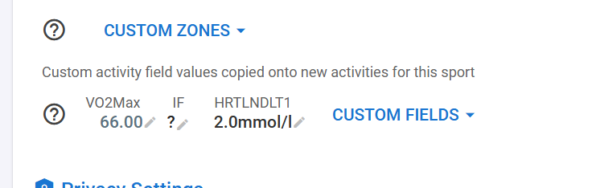

- Click the search icon 🔍 and type HRTLNDLT1.
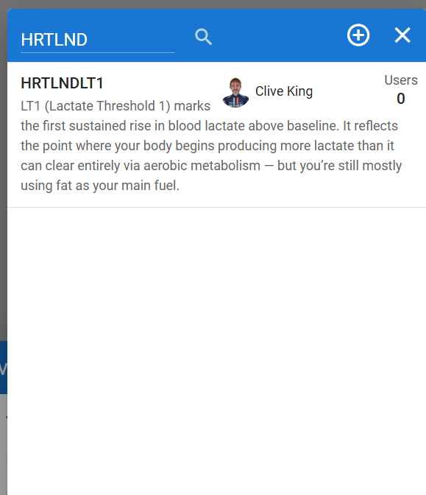
- Select HRTLNDLT1 (LT1 – Lactate Threshold 1) from the list.
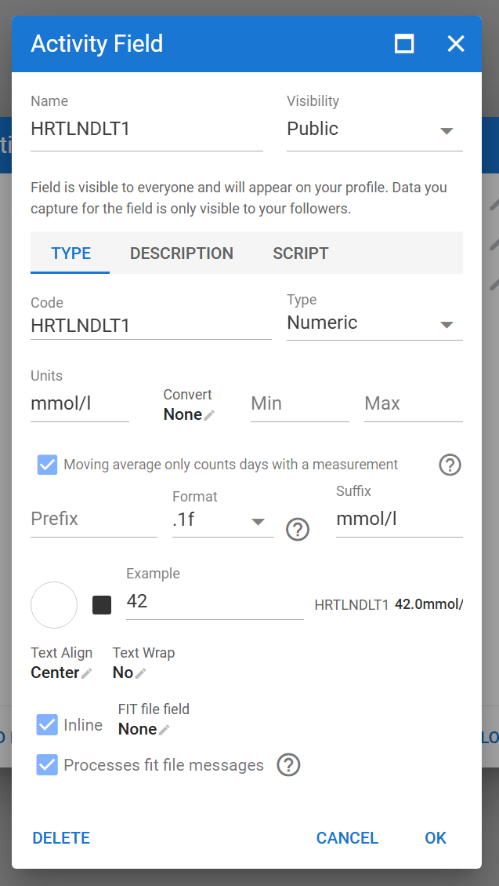
- Click OK
- Tick the checkbox ✅ to activate it.
- Click Close to save.
💡 You should now see “HRTLNDLT1” under your Custom Fields list.

Step 2 — Enter Your LT1 Value
- In the same Athlete Settings → Custom Fields, locate HRTLNDLT1.

- Enter your latest LT1 value in mmol/L (for example 2.0).
- Click Save ✓.
🧠 Typical LT1 range: 1.5 – 2.5 mmol/L
If you’re unsure, start with 2.0 mmol/L – the standard aerobic threshold.

Step 3 — Apply It to Activities
- Open one of your recent activities with power.
- Scroll to the bottom and click Custom▾.
- Tick HRTLNDLT1 to enable it for that activity.
- Refresh the page — your LT1 value will now appear automatically for all new activities.
✨ You can still override the value for a specific workout if you tested a new LT1 that day, but that only changes for that activity. To change the LT2 value for all future activities go to Athlete settings and custom fields and change value of HRTLND1 there.

Step 4 — Keep It Updated
Whenever you do a new lactate or endurance test, update your LT1 value in Athlete Settings → Custom Fields.
The new number will instantly flow into:
- Your future activities
- Your reporting pipeline (used in endurance-zone calibration)
⚙️ FTP acts as your LT2 anchor, while HRTLNDLT1 defines your aerobic base. Together, they shape your personalized endurance (Z2) range.

✅ Summary
Field | Example | Unit | Purpose
VO2Max | 66 | — | Your current aerobic capacity
HRTLNDLT1 | 2.0 | mmol/L | Aerobic threshold (top of easy endurance)
FTP | 300 | W | Functional Threshold Power (approx. LT2)

Inside the ChatGPT app – what does this mean?

🧪 Lactate Summary
🔍 Data Status
🧩 At this time we are using the generic lab model (Mader & Heck 1986):

📊 Your Lactate Metrics
Metric | Value | Meaning
Average lactate | 2.0 mmol/L | Represents aerobic threshold (LT1) level
Latest lactate | 2.0 mmol/L | Most recent data point used for calibration
Range (min–max) | 2.0 – 2.0 mmol/L | Flat, no variability detected
Samples detected | 1 | Just your profile default
Correlation with power | r = 0.0 (weak) | No measurable link to power yet
Lactate-power model | FTP-based fallback | Zones derived from FTP, not measured test (unless you updated these in Intervals post LT2)

⚙️ Threshold Calibration (Applied)
Threshold | Value | Description
LT1 | 2.0 mmol/L | Aerobic threshold — where lactate first rises above baseline. Equivalent to ~200 W for you.
LT2 | 4.0 mmol/L | Anaerobic threshold — near your maximal steady-state (~300 W).
Calibration source | FTP-based default | Standard lab defaults used.
Confidence | 0 % | Because correlation with power = 0.0 (no true data link).

🧠 Interpretation
- You’re training in a Z2-dominant aerobic base, which is ideal for lifting your LT1.
- Your fat oxidation efficiency (0.59) supports this — it’s close to the fat/carb crossover zone around LT1.
- No sign of threshold overload or excessive glycolytic work.
Essentially:
“You’re operating right around your aerobic threshold — exactly where your endurance engine grows strongest.”

🧭 Coach Recommendations
Goal | What to Do
Refine LT1 | Add a 30–40 min steady ride at 200–220 W, track HR stability and drift (< 5 %).
Refine LT2 | Do short threshold intervals (~300 W) and note HR — if it rises rapidly, your true LT2 is slightly lower.
Future improvement | Upload any lactate test file (.csv or .fit with mmol/L field) — the system will instantly replace FTP defaults with your real curve.

✅ Bottom Line
- Lactate data: available (1 point)
- LT1: 2.0 mmol/L (~200 W)
- LT2: 4.0 mmol/L (~300 W)
- Confidence: low (FTP-based)
- Next step: optional test upload for precision

