**Website Kalkulator BMI**

**Preparations and Submission Details**

* **The deadline** will be on Thursday in 2nd week at 23.59 (WIB)
* Link to submit the assignment [here](https://rebrand.ly/FCSWE-miniproject) (will be opened on Wednesday week 2)

**Introduction**

In this ten-day short course, you’ll learn all about becoming a software engineer, including the career path possibilities. We’ll also give you the opportunity to practice the main responsibilities of a software engineer as well!

Before you start...

1. Make sure you have downloaded **Visual Studio Code, Git** and have access to **Google Chrome**

**Mini Project Instructions**

As Software Engineer, you are asked to create a website of Kalkulator BMI with a Create a website using the mockup design below:

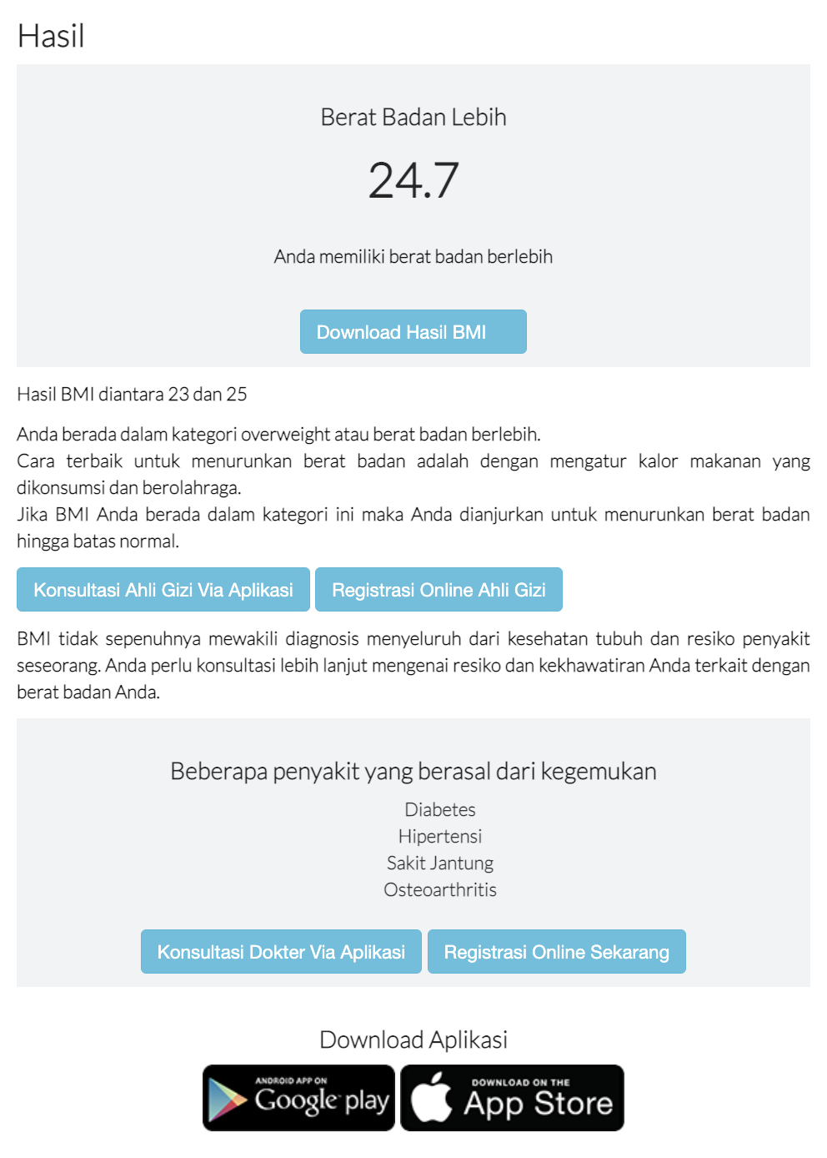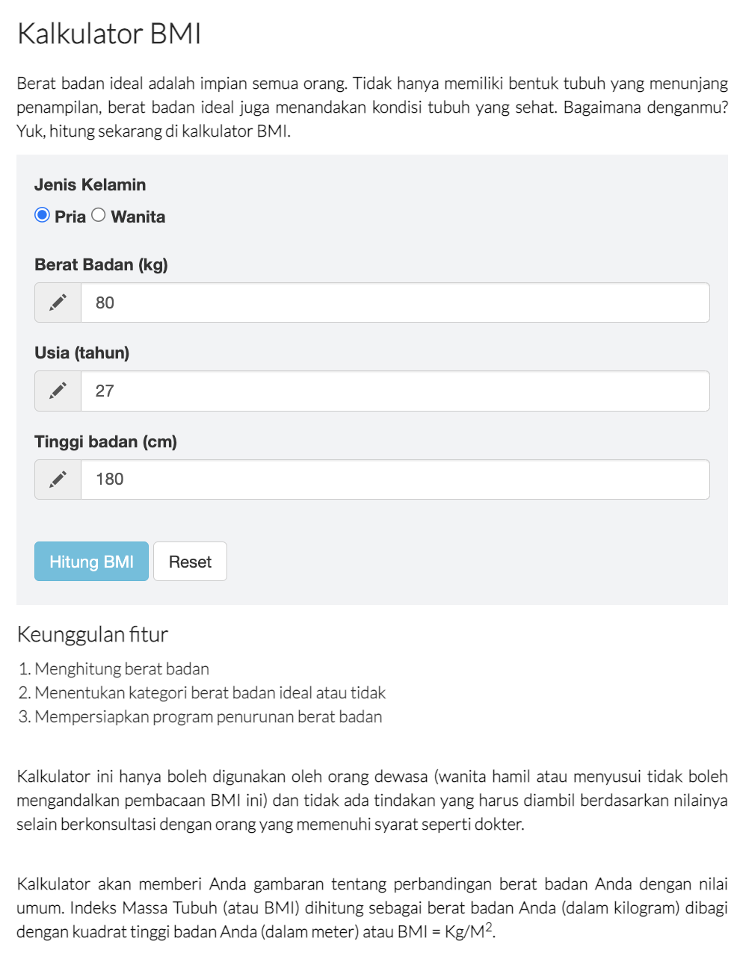

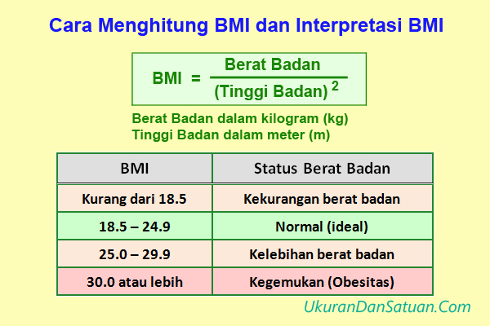

***Rumus BMI***

Workflow:

1. Design is only reference, you can improve for your own design but you must have the feature :

* Form Input BMI
* Display BMI Result (Laki-Laki/Wanita)
* Explanation the BMI Form & Result

1. Validate Input Form Hitung BMI
2. Create Logic For Hitung BMI with JavaScript
3. Kalkulator BMI and Hasil on the same page in web
4. Hasil BMI is display on website when submitted “Hitung BMI”
5. Use Comment to explain your JavaScript Code / other Code.
6. Put css files inside of the css/ folder
7. Put javascript files inside the js/ folder
8. After finish your website, upload Source Code in [GitHub Classroom](https://rebrand.ly/fcse-github) and publish the website in [GitHub Pages](https://pages.github.com/)
9. Submit URL repository and published website through dedicated [Typeform submission](https://rebrand.ly/FCSWE-miniproject) that will be opened on Wednesday week 2

Mandatory pages (*required*) :

1. index.html
2. style.css
3. script.js