Title:
Customer Churn Prediction Using Ensemble Machine Learning and Explainable AI
Author:
Raghav Sharma
B.Tech Computer Science Engineering (AI & ML)
Abstract
Customer churn is a major concern for banks and financial institutions, as losing existing customers directly impacts revenue and increases the cost of acquiring new clients. With the growing availability of customer data, machine learning techniques provide an effective way to analyze customer behavior and predict the likelihood of churn in advance. This paper presents an end-to-end machine learning system designed to predict customer churn risk in a banking environment using structured customer data.
The proposed system is built using the Kaggle Churn Modelling dataset, which contains demographic, financial, and behavioral information of 10,000 bank customers. A complete data pipeline is developed, including data cleaning, preprocessing, and feature engineering. Several domain-driven features such as balance-to-salary ratio, customer engagement indicators, and tenure-based ratios are introduced to enhance the predictive capability of the models.
Multiple machine learning algorithms are trained and evaluated, including Logistic Regression, Random Forest, and XGBoost. Based on performance comparison, a weighted ensemble model combining Random Forest and XGBoost is selected as the final solution. The ensemble model achieves strong predictive performance on unseen data, with an accuracy of 0.86 and a ROC-AUC score of 0.88, indicating a high ability to distinguish between churn and non-churn customers.
To ensure transparency and trust in predictions, explainable AI techniques are incorporated using SHAP (SHapley Additive Explanations) and Partial Dependence Plots. These methods provide both global and local interpretability, helping to understand how different features influence churn risk. Finally, the trained model is deployed through an interactive Streamlit-based web dashboard that allows real-time churn risk scoring, probability visualization, and what-if scenario analysis. The system demonstrates how machine learning can be effectively applied to support data-driven decision-making and proactive customer retention strategies in real-world business settings.
1. Introduction
In today’s highly competitive financial industry, customer retention has become a critical factor for long-term business success. Banks and financial institutions invest significant resources in acquiring new customers; however, retaining existing customers is often more cost-effective and leads to higher overall profitability. Customer churn refers to the situation where customers discontinue their relationship with a company and switch to a competitor or stop using the service entirely. High churn rates can result in revenue loss, reduced customer lifetime value, and increased operational costs.
Traditionally, banks have relied on manual analysis and rule-based systems to identify customers who are likely to leave. These methods often use simple heuristics such as low account balance or reduced transaction activity. While such approaches provide basic insights, they fail to capture complex relationships between multiple customer attributes. Customer behavior is influenced by a combination of demographic factors, financial patterns, and engagement levels, which makes churn prediction a challenging and multidimensional problem.
With the rapid growth of data collection and storage technologies, organizations now have access to large volumes of structured customer data. This has enabled the use of machine learning techniques for predictive analytics. Machine learning models are capable of learning hidden patterns from historical data and can provide accurate predictions for unseen cases. In the context of customer churn, machine learning allows businesses to move from reactive decision-making to proactive strategies, where high-risk customers can be identified in advance and targeted with personalized retention offers.
Several machine learning models have been applied to churn prediction in previous studies, including logistic regression, decision trees, random forests, and gradient boosting methods. While simpler models such as logistic regression offer interpretability, they often lack the ability to model complex nonlinear relationships. On the other hand, advanced models such as ensemble methods provide better performance but are often considered black-box models due to their lack of transparency. This creates a trade-off between predictive accuracy and interpretability, which is a significant concern in sensitive domains such as banking and finance.
In real-world business applications, it is not sufficient for a model to simply provide accurate predictions. Decision-makers also require explanations for why a particular customer is predicted to churn. Explainability is essential for building trust in machine learning systems, especially when these systems are used to influence important business decisions. Regulatory requirements and ethical considerations further emphasize the need for transparent and interpretable models in financial applications.
The objective of this project is to design and implement a complete, end-to-end machine learning system for customer churn prediction that balances predictive performance with interpretability. The system uses historical customer data to estimate churn probability and provides clear explanations for each prediction. In addition to model development, the project also focuses on deployment by building an interactive web-based dashboard that allows business users to assess churn risk in real time and perform scenario analysis.
This work demonstrates how machine learning, when combined with explainable AI techniques and user-friendly deployment, can serve as a practical decision-support tool for customer retention strategies. The proposed system aims to bridge the gap between academic machine learning models and real-world business applications by delivering a solution that is accurate, interpretable, and directly usable in operational settings.

2. Related Work
Customer churn prediction has been widely studied in the fields of data mining and machine learning due to its strong relevance in business analytics. Many researchers have explored different computational approaches to identify customers who are likely to discontinue a service, particularly in domains such as banking, telecommunications, and e-commerce. The primary objective of these studies is to develop predictive models that can help organizations reduce customer attrition and improve customer lifetime value.
One of the earliest and most commonly used techniques for churn prediction is logistic regression. Logistic regression is favored for its simplicity and interpretability, as it provides a probabilistic output and allows easy understanding of feature contributions. Several studies have demonstrated that logistic regression performs reasonably well for churn prediction when the relationship between features and target variable is relatively linear. However, its performance often degrades when dealing with complex, nonlinear patterns commonly present in real-world customer data.
To overcome these limitations, tree-based models such as decision trees and random forests have been extensively applied. Decision trees offer a more flexible structure and can model nonlinear relationships effectively. Random forests, which are ensembles of multiple decision trees, further improve prediction accuracy by reducing overfitting and variance. Research has shown that random forests consistently outperform traditional linear models in churn prediction tasks due to their ability to handle feature interactions and complex data distributions.
In recent years, gradient boosting methods such as XGBoost have gained popularity for churn modeling. XGBoost is known for its high predictive power and efficiency, and it has been successfully applied in several customer analytics studies. Boosting-based models iteratively improve predictions by focusing on misclassified samples, leading to superior performance compared to individual classifiers. However, these models are often considered black-box systems, making it difficult to interpret the underlying decision logic.
Ensemble learning techniques, which combine multiple machine learning models, have also been explored in the literature. Ensemble approaches aim to leverage the strengths of different algorithms to achieve more robust and accurate predictions. Studies indicate that weighted combinations of models such as random forests and gradient boosting classifiers can provide improved generalization performance and reduce prediction errors.
Despite the success of advanced machine learning models, model interpretability remains a critical challenge. In response to this, explainable AI (XAI) methods have been introduced to make black-box models more transparent. Techniques such as SHAP (SHapley Additive Explanations) and Partial Dependence Plots have been widely adopted to explain feature contributions and model behavior. These methods enable both global and local explanations, allowing stakeholders to understand how different variables influence churn predictions.
Overall, existing research highlights the effectiveness of ensemble models for churn prediction, while also emphasizing the importance of interpretability in business applications. This project builds upon prior work by integrating ensemble machine learning with explainable AI techniques and deploying the system in a real-time interactive environment, thereby bridging the gap between predictive performance and practical usability.

3. Dataset Description
The dataset used in this study is the publicly available Churn Modelling dataset obtained from Kaggle. The dataset represents customer information from a banking environment and is commonly used for research in customer churn prediction. It contains records of 10,000 customers, with each record describing the demographic, financial, and behavioral characteristics of an individual customer.
Each row in the dataset corresponds to a single customer, and the target variable is Exited, which indicates whether the customer has left the bank or not. The target is a binary variable, where a value of 1 represents a churned customer and 0 represents a retained customer. The dataset includes a mix of numerical and categorical features, making it suitable for applying both statistical and machine learning techniques.
The original dataset consists of the following key features: CreditScore, Geography, Gender, Age, Tenure, Balance, NumOfProducts, HasCrCard, IsActiveMember, and EstimatedSalary. In addition, some non-informative identifier columns such as RowNumber, CustomerId, and Surname are present in the raw dataset. These identifier features do not contribute to predictive performance and are therefore removed during preprocessing.
From a class distribution perspective, the dataset is moderately imbalanced, with a larger proportion of customers belonging to the non-churn class. Approximately 80% of customers are retained, while around 20% have churned. This reflects a realistic business scenario, where the majority of customers typically remain with the organization, and only a smaller fraction choose to leave.
The dataset provides a comprehensive view of customer behavior by combining financial attributes such as balance and salary with engagement-related attributes such as activity status and product usage. This diversity of features enables the model to learn meaningful patterns related to customer loyalty and attrition. Due to its structured nature and real-world relevance, the dataset is well-suited for building and evaluating predictive models for customer churn analysis.

4. Methodology
This section describes the complete methodology followed to build the customer churn prediction system. The methodology consists of data preprocessing, feature engineering, model training, and ensemble learning. Each stage of the pipeline is designed to ensure data quality, improve predictive performance, and maintain interpretability of the final model.

4.1 Data Preprocessing
The first step in the methodology involves preprocessing the raw dataset to prepare it for machine learning models. The original dataset contains several identifier columns such as RowNumber, CustomerId, and Surname. These attributes do not provide any meaningful information for churn prediction and were therefore removed from the dataset.
Categorical variables such as Geography and Gender were encoded into numerical form to make them compatible with machine learning algorithms. Numerical features such as CreditScore, Age, Balance, and EstimatedSalary were retained as continuous variables. To ensure that features with large numerical ranges do not dominate the learning process, feature scaling was applied where required using standard normalization techniques.
The dataset was then split into training and testing sets using a stratified sampling approach, with 80% of the data used for training and 20% reserved for testing. Stratification ensures that the proportion of churned and non-churned customers remains consistent across both sets, which helps in obtaining reliable evaluation metrics.

4.2 Feature Engineering
Feature engineering plays a crucial role in improving the performance of machine learning models by creating informative features from existing data. In this project, several domain-driven features were introduced based on customer financial behavior and engagement patterns.
The engineered features include:
- Balance-to-Salary Ratio: Represents the proportion of customer balance relative to their estimated salary, indicating financial engagement.
- Products per Tenure: Captures how many products a customer uses relative to their time with the bank.
- Engagement-Product Interaction: Combines activity status with product usage to reflect customer involvement.
- Tenure-Age Ratio: Models the relationship between customer age and length of association with the bank.
- Is Zero Balance: Indicates whether the customer maintains a zero account balance.
- Is Senior: A binary feature representing whether the customer is above a certain age threshold.
- Multi Product: Identifies customers holding more than one banking product.
These engineered features help the model capture deeper behavioral patterns that are not directly visible from the raw attributes. By incorporating these features, the model is able to better distinguish between high-risk and low-risk customers.

4.3 Model Training
Multiple machine learning models were trained and evaluated to identify the most suitable approach for churn prediction. The models considered include:
- Logistic Regression
- Random Forest
- XGBoost
Logistic Regression was used as a baseline model due to its simplicity and interpretability. Random Forest was selected as a strong non-linear classifier capable of handling feature interactions. XGBoost was included as a powerful gradient boosting algorithm known for high predictive accuracy.
Each model was trained on the same training dataset and evaluated on the test dataset using standard performance metrics such as accuracy, precision, recall, F1-score, and ROC-AUC. Hyperparameter tuning was applied to tree-based models to optimize performance.

4.4 Ensemble Learning
To further improve prediction performance and robustness, an ensemble approach was adopted. The final system combines the predictions of the Random Forest and XGBoost models using a weighted averaging strategy. The ensemble model computes churn probability as a weighted combination of probabilities from both base models.
Different weight combinations and classification thresholds were evaluated to identify the optimal configuration. The best ensemble configuration was selected based on F1-score and ROC-AUC performance. This ensemble approach helps reduce model bias and variance while leveraging the strengths of both algorithms.
The final ensemble model serves as the core predictive engine of the system and is used for real-time churn risk scoring in the deployed application.

5. Results and Evaluation
This section presents the experimental results obtained from the trained machine learning models and evaluates their performance on unseen test data. The primary objective of the evaluation is to measure how accurately the models can distinguish between churned and non-churned customers and to assess their practical usability in a real-world business context.
The dataset was divided into training and testing sets using an 80:20 stratified split. All models were trained on the same training data and evaluated on the same test data to ensure a fair comparison. Several standard performance metrics were used, including accuracy, precision, recall, F1-score, and ROC-AUC. These metrics provide a comprehensive understanding of model performance, especially in a classification problem with moderate class imbalance.
Among the individual models, Logistic Regression served as a baseline and demonstrated reasonable performance but was limited in capturing complex non-linear patterns. Random Forest and XGBoost showed significantly improved results due to their ability to model feature interactions and non-linear relationships. However, the best overall performance was achieved using a weighted ensemble model combining Random Forest and XGBoost.
The final ensemble model achieved the following performance on the test dataset:
Metric | Value
Accuracy | 0.86
Precision | 0.74
Recall | 0.58
F1-score | 0.65
ROC-AUC | 0.88
The accuracy score indicates that the model correctly classifies 86% of the customers. Precision reflects that 74% of customers predicted as churners actually leave the bank, which is important for minimizing unnecessary retention costs. Recall represents the model’s ability to identify actual churners, and a value of 0.58 suggests that more than half of the true churn cases are successfully detected. The F1-score balances precision and recall, making it a reliable metric for imbalanced classification problems. The ROC-AUC score of 0.88 demonstrates a strong ability of the model to separate churned and non-churned customers across different classification thresholds.
In addition to these metrics, a confusion matrix was analyzed to understand the distribution of correct and incorrect predictions. The confusion matrix reveals that the model performs well in identifying non-churned customers while also maintaining a reasonable detection rate for churned customers. Although some churn cases are missed, this trade-off is acceptable in practical scenarios where the objective is to focus on high-confidence churn predictions.
Overall, the results indicate that the ensemble model provides robust and reliable performance for customer churn prediction. Compared to individual models, the ensemble approach improves generalization and reduces the risk of overfitting. The evaluation confirms that the proposed system is suitable for real-world deployment and can effectively support data-driven customer retention strategies.

6. Explainability
In real-world business applications, especially in domains such as banking and finance, model interpretability is as important as predictive accuracy. While complex machine learning models such as Random Forest and XGBoost provide strong performance, they are often considered black-box models because their internal decision-making process is not easily understandable. This lack of transparency can reduce trust in predictions and limit practical adoption.
To address this challenge, explainable artificial intelligence (XAI) techniques were incorporated into the proposed system. The primary objective of explainability in this project is to provide insights into how different features influence churn predictions, both at a global level across the entire dataset and at a local level for individual customers.
SHAP (SHapley Additive Explanations) was used as the main explainability technique. SHAP is based on cooperative game theory and assigns each feature a contribution value that represents its impact on the model’s prediction. One of the major advantages of SHAP is that it provides consistent and theoretically sound explanations, making it suitable for complex ensemble models.
At the global level, a SHAP summary plot was generated to visualize the overall importance of features across all predictions. The summary plot highlights key drivers of churn, such as customer age, account balance, number of products, activity status, and engineered behavioral features. These insights help identify which factors most strongly influence customer attrition at a population level.
In addition, a SHAP feature importance bar plot was used to rank features based on their average contribution to predictions. This visualization provides a clear and intuitive understanding of the most influential variables in the model. It enables business stakeholders to focus on the most critical factors when designing retention strategies.
For local explainability, SHAP waterfall plots were generated for individual customers. These plots break down a single prediction into positive and negative contributions from each feature. This allows decision-makers to understand why a specific customer is classified as high-risk or low-risk, which is essential for personalized customer engagement and targeted interventions.
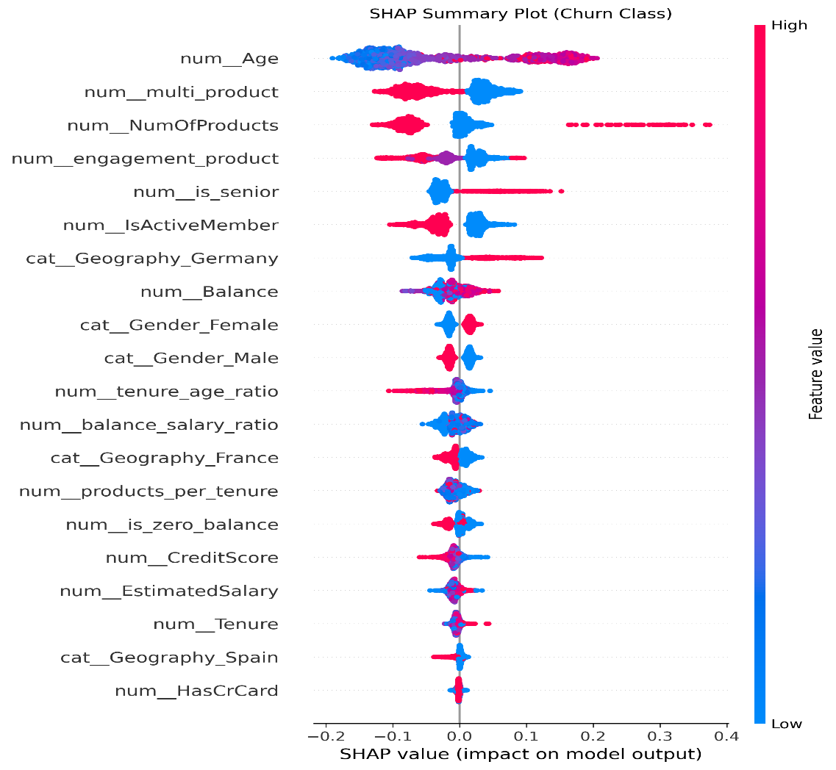
Figure 1: SHAP summary plot showing the global impact of features on churn prediction.

To further support interpretability, Partial Dependence Plots (PDP) were used to analyze the relationship between key features and churn probability. PDPs show how the predicted churn risk changes as a single feature varies while keeping other features constant. The PDP analysis revealed meaningful trends, such as increasing churn probability with higher customer age, lower engagement levels, and extreme account balance values.
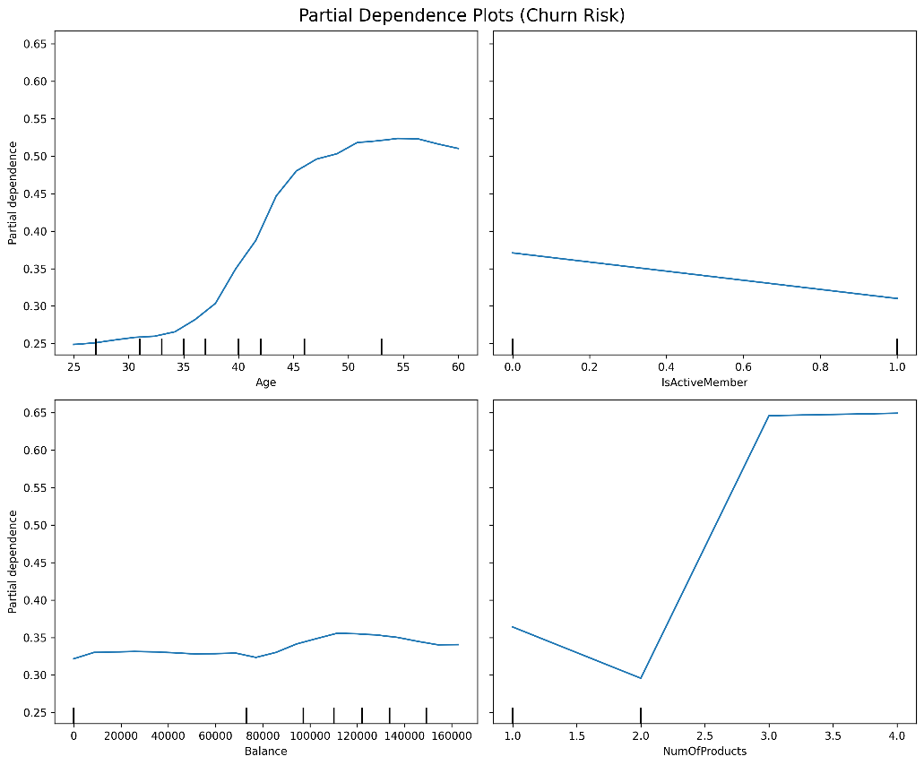
Figure 2: Partial Dependence Plots showing the effect of key features on churn probability.

By combining SHAP and Partial Dependence Plots, the proposed system achieves both global and local interpretability. This dual-level explainability ensures that the model’s behavior is transparent, trustworthy, and aligned with business understanding. The integration of explainable AI significantly enhances the practical usability of the churn prediction system and makes it suitable for deployment in real-world financial decision-making environments.

7. Deployment
In addition to model development and evaluation, the proposed churn prediction system was deployed as an interactive web-based application to demonstrate its practical usability in real-world scenarios. Deployment plays a crucial role in bridging the gap between theoretical machine learning models and actual business applications, as it allows non-technical users to interact with the system and obtain actionable insights.
The final ensemble model was deployed using Streamlit, a lightweight Python-based framework for building data-driven web applications. Streamlit was chosen due to its simplicity, rapid development capabilities, and seamless integration with machine learning pipelines. The trained model, along with preprocessing and feature engineering logic, was serialized and loaded into the application for real-time inference.

Figure 3: Churn risk calculator interface of the deployed web application.

The deployed web dashboard provides multiple functionalities designed for business users. The primary component is a Churn Risk Calculator, where users can input customer attributes such as credit score, age, balance, product usage, and activity status. The system then outputs the predicted churn probability along with a risk classification label (low, medium, or high risk).
To enhance interpretability and user interaction, the dashboard also includes a probability visualization bar that visually represents churn risk, making it easier for users to understand model output. Furthermore, a What-If Scenario Simulator was implemented, allowing users to modify selected input features and observe how changes in customer behavior affect churn probability. This feature is particularly useful for exploring potential retention strategies and understanding the sensitivity of predictions.
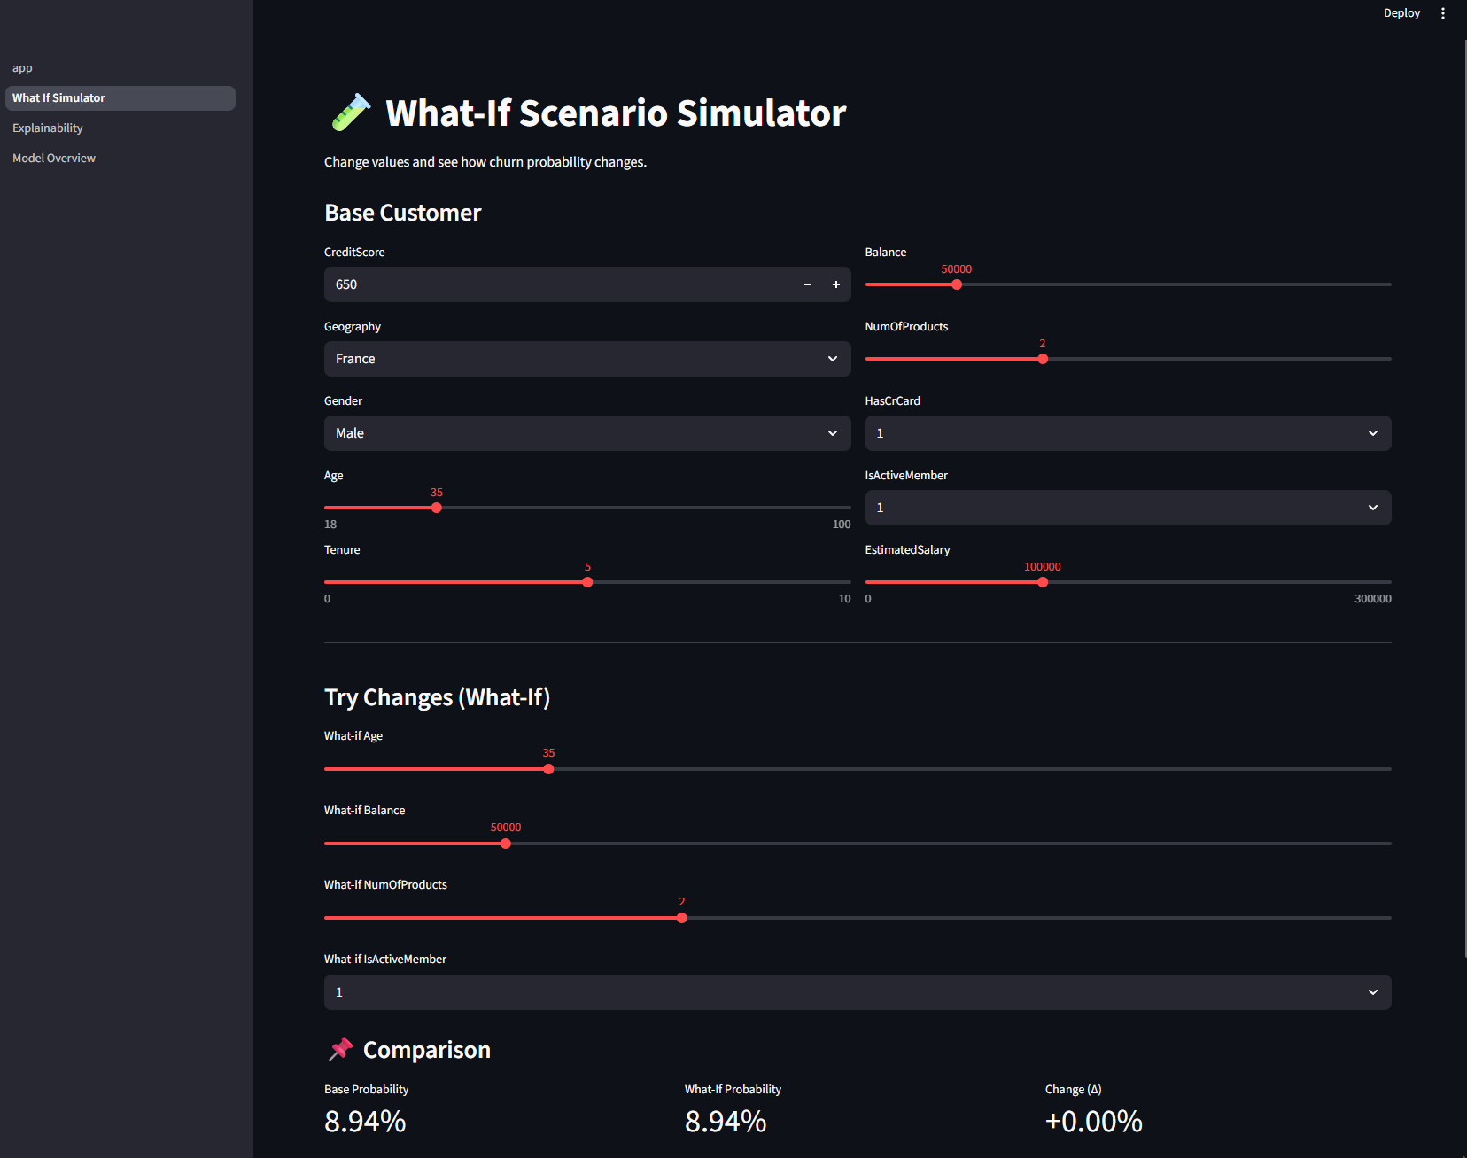
Figure 4: What-if scenario simulator for analyzing churn probability changes.

An additional Explainability page is included in the dashboard, where SHAP plots and Partial Dependence Plots are displayed. These visualizations provide transparency into the model’s decision-making process and help users interpret both global trends and individual predictions.
The deployment of the system demonstrates that the proposed model is not only theoretically sound but also practically implementable. By providing a real-time, interactive interface, the solution enables data-driven decision-making and can be easily adapted for integration into enterprise systems. This end-to-end deployment significantly enhances the real-world value of the project and highlights its applicability in operational business environments.

8. Conclusion and Future Work
This paper presented an end-to-end machine learning system for predicting customer churn in a banking environment. The objective of the project was to design a solution that not only delivers accurate predictions but also provides interpretability and practical usability for real-world decision-making. Using structured customer data, multiple machine learning models were trained, evaluated, and compared, leading to the selection of a weighted ensemble model combining Random Forest and XGBoost.
The experimental results demonstrate that the ensemble model achieves strong predictive performance, with a ROC-AUC score of 0.88 and an overall accuracy of 0.86 on unseen data. These results indicate that the proposed system is effective in distinguishing between churned and non-churned customers and can serve as a reliable tool for customer retention strategies. In addition to predictive performance, the integration of explainable AI techniques such as SHAP and Partial Dependence Plots ensures transparency and trust in the model’s predictions, which is particularly important in financial applications.
A key contribution of this work is the deployment of the model through an interactive Streamlit-based web dashboard. The deployed system allows users to perform real-time churn risk scoring, visualize prediction probabilities, and explore what-if scenarios by modifying customer attributes. This deployment highlights the practical relevance of the project and demonstrates how machine learning models can be transformed into usable business tools.
Despite the promising results, there are several directions for future improvement. The current system operates on static historical data; future work may include real-time data integration from operational databases. Additionally, techniques such as model calibration, fairness analysis, and cost-sensitive learning can be explored to further enhance business effectiveness. Continuous model monitoring and drift detection mechanisms can also be implemented to maintain performance over time as customer behavior evolves.
Overall, this project illustrates how ensemble machine learning, explainable AI, and interactive deployment can be combined to create a complete and practical churn prediction system. The proposed solution not only achieves strong technical performance but also aligns with real-world business requirements, making it a valuable contribution to applied machine learning in customer analytics.

