Optimizing Gait Abnormality with A Multilayered Convolutional Neural Network Using Enhanced Feature Extraction

¹Anushka Tripathi,^{2*} Dr. Manoj Kumar ,³Disha Chakraborty, ⁴Saloni Chaurasia,⁵ Raghav Sharma , ⁶Anchal Kumar
Department of Computing Science Engineering and Artificial Intelligence
anushkatripathi2022@vitbhopal.ac.in¹
manojkumar@vitbhopal.ac.in²
dishachakraborty2022@vitbhopal.ac.in³
salonichaurasia2022@vitbhopal.ac.in⁴
raghavsharma2022@vitbhopal.ac.in⁵
anchalkumar2022@vitbhopal.ac.in⁶
^{1,2,3,4,5,6} VIT Bhopal University
^{1,2,3,4,5,6} Bhopal-Indore Highway, Kothrikalan, Sehore, Madhya Pradesh 466114.
Corresponding Author : manojkumar@vitbhopal.ac.in

Abstract:
Gait abnormalities are crucial indicators of underlying health issues. Traditionally, clinical gait assessment relies on video analysis, pressure mats, or a combination of both. This paper explores the application of Artificial Intelligence (AI) for gait abnormality prediction using ground reaction force (GRF) data. We leverage a curated subset, specifically chosen for this study, from the large-scale GaitRec dataset encompassing measurements from various patients . Machine learning (ML) and deep learning (DL) models are employed to level healthy controls - individuals with gait disorders based on their GRF patterns. The aim of our research is to create an accurate model for predicting the gait abnormality among people by using various factors including center of pressure (CoP), ground reaction forces and the metadata of the individuals. We employed k-nearest neighbors (KNN), support vector machine (SVM), Logistic Regression (LR) model, and deep learning models like CNN(Convolutional Neural Networks) for classification tasks. We propose a novel deep learning architecture, specifically designed to enhance feature extraction, and improve classification accuracy. The efficiency of the proposed model was rigorously evaluated through a fivefold cross-validation approach, attaining outcome of 95.57%. Our results indicate that our model significantly enhances the automatic categorization of abnormal gait patterns, presenting a promising advancement towards automated gait disorder diagnosis.
Keywords : Gait abnormality, GRF , CNN, KNN,LR, SVM.

Introduction:
One of the most prevalent natural and universal human behaviors is walking. However, from an analytical standpoint, it is also one of the most intricate actions. Different human body components collaborate to achieve this. To assess patients' ailments, aid in rehabilitation, and direct treatment, physiotherapists, orthopaedists, and neurologists have studied human movement in great detail . Walking is a common activity in daily life and simultaneously a highly complex one. It engages all levels of the nervous system and many components of the musculoskeletal system as well as the cardiorespiratory system. Age, character, and mood all have a vast impact on someone's gait sample. Socio-cultural factors also play a function: those who stay in big towns, for example, stroll loads faster than people who live in rural areas. among a while of 60 and sixty-nine, approximately 10% of human beings have gait and stability disorders, even as the ones over 80 years antique have more than 60% [1,2]. a person's first-class of life and stage of personal independence can be severely impacted by using gait impairments. additionally, stability and gait troubles may be a precursor to falls, the leading reason of great injuries within the elderly. The self-selected walking speed carefully correlates with man or woman lifestyles expectancy in aged humans, making taking walks a sensitive indicator of ordinary fitness. Underdiagnosis and insufficient assessment of gait issues and falls are not unusual.
Axial motor signs are typically not as properly documented in scientific reports as other factors of the neurological examination because of physicians' lack of education in assessing gait. Neurological situations like sensory or motor impairments, orthopedic troubles like osteoarthritis and skeletal deformities, and scientific situations like heart failure, breathing insufficiency, peripheral arterial occlusive sickness, and obesity are all factors that contribute to gait disorders. In older human beings, gait disorders usually have a couple of reasons, which include bad imaginative and prescient, frontal gait sickness resulting from vascular encephalopathy, impaired proprioceptive feature in polyneuropathy, and osteoarthritis of the hips or knees [2]. The careful clinical observation of the affected person's gait as well as a neurological and orthopedic examination primarily based on the affected person's records are all additives of the evaluation of gait issues. those components manual the selection of any important and appropriate ancillary diagnostic approaches.

The primary aim is to determine what alters a person's walking pattern, which is important in fields like impact evaluation, health, and identity verification. Walking data can be gathered through sensors worn on the body. Vision-based systems, which utilize cameras, collect walking information from afar without needing the person's involvement. In medical contexts, analyzing how individuals walk helps in diagnosing and monitoring conditions that affect their movement, leading to increased use of automated systems [3,4].

Various sensors offer detailed insights into walking patterns. Ground sensors, for instance, measure the force or pressure beneath the feet but are limited to specific areas and provide restricted classification data. Some companies use foot pressure data for identification, a method distinct from cameras. Measuring Ground Reaction Force (GRF) enables doctors to describe movement objectively and assess walking performance. Force plates are used to measure forces exerted by standing or moving bodies. Walking can reveal mental health issues like depression, dementia, intellectual disabilities, and physical issues such as joint deformities. Comprehensive assessments of daily activities are crucial for planning rehabilitation and therapy. Walking maintains balance through repetitive movements. A typical walking cycle starts and ends with the same foot striking the ground, divided into stance (foot on the ground) and swing (leg in the air) phases, with tasks like ipsilateral and contralateral foot movements [5,6,7,8,9].

Literature Review:

Table 1 : Comparative study of different work done in this domain

Objective | Methods Used | Results | Future Work | Refer.
Access the strengths and weaknesses of studying how people walk to understand things like walking activities, events, disorders, uneven walking, and neurological problems. | ML | Behavior recognition precision rates: 85% to 100%  Incident identification precision rates: 95% - 98%  The accuracy for spotting asymmetry is between 80% and 85%. For recognizing walking problems related to the nervous system, the accuracy ranges from 67% to 96%. Devices called accelerometers, used to detect movement, have accuracy rates between 85% and 95%. | Future gait analysis requires real-time surveillance, diagnostics, and tests, facilitating healing and providing information to medical professionals and patients. | [8,10]
AI-GRF patterns to differentiate between healthy controls and gait abnormalities. | DL-GaitRec-Net | SVM (89.998%), Naïve Bayes (55.244%), KNN (91.296%), proposed architecture 91.624% | Future investigations will focus on expanding the range of the research by incorporating more affected groups and enhancing classification precision as well as multiclass gait impairment categorization. | [1]
Examine how well computer vision - ML systems can identify different gait patterns associated with falls on level terrain. | SVM, KNN, LSTM, CNN | - The SVM (~94.9%) had the most elevated exactness within the classification of walk designs, taken after by KNN (~94.0).  - Precision _CNN 87.6 ± 7.50%.  - LSTM 83.6 ± 5.35%. | Future research would involve clinical studies employing this sensor system to identify the distinctions between the gait conditions of flat-fallers and non-flat-fallers for gait pattern recognition. . | [11,12]
An accumulation of powerful deep learning characteristics in Kernel Extreme Learning Machine. The suggested framework is made up of a sequence of steps. | A number of deep learning methods, particularly concentrating on effective feature selection, have been recently introduced for this objective; however, their accuracy is quite limited. | Kernel Extreme Learning Machine attained accuracy exceeding 96%. | In the future, the intention will be to investigate more promising strategies and assess additional perspectives of the CASIA B dataset. | [13]
The goal of this study is to create a neural network that can forecast future gait angles at steady speeds by analyzing gait data from several participants. | Levenberg Marquardt method | The participant whose data were used to develop the model had the lowest reported accuracy, 97.39%, whereas the individual whose data were not used to construct the model had the lowest accuracy, 96.54%. | Introducing a novel method for predicting gait data to serve as a reference during the development of prostheses and orthoses, in addition to validating gait data throughout biomechanical rehabilitation. | [14]
The purpose of the current study was to investigate individual walking patterns. | Artificial neural networks (DL) and support vector machines (SVM) | - Class with a high precision exceeding GRF 95. 4%  - 99. 9% (full-body joint angles  - 99. 9% (lower-body joint angles). | Biomechanical gait analysis and facilitating automatic classifications of neurological disorders and abnormal gait conditions useful in clinical assessments. | [15]
to help patients predict and avoid an imminent freeze incident by enabling the early identification of Freezing of Gait (FoG) through brain activity. | The researchers suggest a feasible system that may be implemented in everyday life to track gait and anticipate FoG occurrences. | The anomaly-focused models enabled the researchers to forecast 71. 3% of all 184 FoG episodes, with an average prediction lead time of 4. 2 seconds prior to the FoG event. | Future research would concentrate on examining the influence FoG prediction and the commencement of rhythmic cueing on gait performance during such instances. | [16]
Machine-learning framework for detecting specific diseases in individuals with Neurological and Neuromuscular Diseases (NND) or Juvenile Idiopathic Arthritis (JIA) through the analysis of gait data. | RF,SVM,MLP | RF, SVM, and Multi-Layer Perceptron (MLP) reached 100% classification accuracy.  The boosting algorithm reached a classification accuracy of 96. 4%. | Concentrate on pinpointing essential features in the human motion data to improve the existing method and facilitate the detection of specific diseases. | [9]
This investigation focuses on the estimation of human walking parameters by using sequential key point data extracted from 2-D videos. | BI-LSTM, CNN | The test accuracy for the Bi-LSTM model was noted as 98. 81%, while the CNN model achieved a test accuracy of 97. 06%. | For upcoming efforts, novel hybrid features could be developed to enhance the accuracy of gait recognition. Moreover, data augmentation could be implemented using algorithms such as generative adversarial networks, which might also aid in improving accuracy. | [20]
Create ML algorithms that leverage inertial sensors to precisely evaluate the fall risk in individuals who have experienced a stroke. Determine the most effective sensor configurations and clinical evaluation methods. | LR,SVM,RF | - LR,SVM both reached accuracy rates between 71-86%.  - RF _91% | Future studies could highlight the significance of collecting a more extensive and diverse dataset to enhance the dependability and relevance of the proposed system. Exploring advanced machine learning frameworks, such as transformers, could enhance both accuracy and interpretability. Integrating real-time capabilities on wearable devices, along with feedback mechanisms, may empower users to take an active role in managing their fall risk. | [21]
This study investigates the categorization of gait phases into five subphases using machine learning methods with two separate training strategies. | In the first strategy, a stratified random sampling method was employed, allocating 80% of the data from each subphase for training and 20% for testing. The second strategy involved training with data from 80% of the participants and assessing with data from the remaining 20%. | RF surpasses the other ML algorithms (99.2%) with similar results for both strategies. With a minor enhancement, the second strategy outperforms KNN , LR, Decision Tree (DT), and SVM regarding performance (∼91%). At approximately 77. 7%, Naive Bayes (NB) shows significantly poorer performance. | To enhance the generalizability of subject-specific gait analysis systems, upcoming research could focus on collecting and analyzing a broader variety of datasets. | [22]
In this research, the utilized model is iSPLInception, a deep learning architecture inspired by Google's Inception-ResNet design, which not only reaches better predictive accuracy but also uses fewer device resources. | iSPLInception -DL | The iSPLInception with outcome of 95.09% was better from others. | In upcoming projects, the approach will be to use subject-independent techniques, for assessing each dataset. | [23]
The text examines how walking movements and timing details, gathered using OpenPose—a free video tool for posture estimation—compare to data obtained from a 3D motion system. This study involves healthy individuals walking on solid ground and focuses on specific patterns observed from the side view. | OpenPose | The typical error when measuring the timing of walking patterns was 0.01 seconds, and for measuring step lengths, it was 0.018 meters. | Future studies will look into using pose estimation to better understand human walking and will offer insights and advice for applying it effectively in the future. | [24]

2.1 Gait Abnormalities and their Impact:
Past studies show that People with diabetes often hurt their feet when walking, likely because of the pressure and forces on their feet. - Nerve damage, known as neuropathy, can change how feet function, affecting walking. Issues like stroke, Parkinson’s disease, and problems with muscles and bones can lead to unusual walking patterns. Walking difficulties increase the risk of falling, limit mobility, and reduce quality of life [25].

2.2 Existing Gait Abnormality Detection Techniques:
    - Common approaches for gait analysis, includes:
      - Pressure mats: Capture plantar pressure distribution during walking.
      - Motion capture systems: Track body segment movements using sensors.
        - Electromyography (EMG): Measures muscle activity during gait [17].
    - However, these techniques also have some limitations: They are expensive, making them unaffordable and not accessible to all sections of society.

2.3 Machine Learning Techniques for Gait Abnormality Detection:
- The specific techniques we had implemented in our work includes:
  - K-Nearest Neighbors (KNN): KNN classifies data points based on their similarity to labeled examples.
  - Support Vector Machine (SVM): SVM creates a hyperplane to separate data points belonging to different classes.
  - Logistic Regression: Logistic regression is an algorithm used to predict one of two possible outcomes, such as yes or no. It works by calculating the probability that a given input belongs to one of these categories. Unlike linear regression, which forecasts continuous values like height or temperature, logistic regression provides probabilities and uses a set threshold to determine the category of the input. This method is particularly effective when the relationship between the data and the outcome is straightforward and can be easily separated, even when viewed in more complex dimensions.
  - Convolutional Neural Network (CNN): Basic architecture of CNNs, includes convolutional layers, dense layers, pooling layers, and activation functions. CNNs are particularly suited for image and video analysis tasks like gait recognition[12,15,17].
Automated gait abnormality detection offers a promising avenue for improved healthcare. Machine learning techniques like KNN, SVM, and CNNs demonstrate the potential for objective and accurate identification of gait abnormalities. Existing research provides a strong foundation, but opportunities remain to explore specific gait patterns and the effectiveness of these techniques on various data sources. This paper aims to address deep learning approaches on gait abnormality with high precision and accuracy . By employing a combination of machine learning techniques, we hope to contribute to the development of more robust gait analysis tools, ultimately improving patient care through objective and efficient abnormality detection.
- Proposed Methodology and Dataset Used :

3.1 Dataset description :
The data used in this work is sourced from a public medical gait database known as ‘gaitrec’. This includes 10 datasets and we have obtained a new dataset by merging all these datasets on the basis of the unique subject id. Also, metadata has been included to provide context and facilitate detailed analysis. It can be concluded from figure 2 that the dataset contains a variety of components, including unique identifiers for people, sessions, and tests. It also includes measurements for vertical force projections, mediolateral force projections, anteroposterior force projections, and center of pressure measurements. The metadata includes class labels for gait classification, subject demographics such as gender, age, body weight, and BMI, trial conditions such as footwear, walking speed, readmission status, and session type, and data partitioning indicators for training, balanced training, and test sets. This dataset contains a broad range of features that may be used to analyze gait patterns, allowing for the construction, and testing of ML and deep learning models that can differentiate between healthy and abnormal gait. Figure 3 shows the summary of the datasets used and the basis on which they were merged.
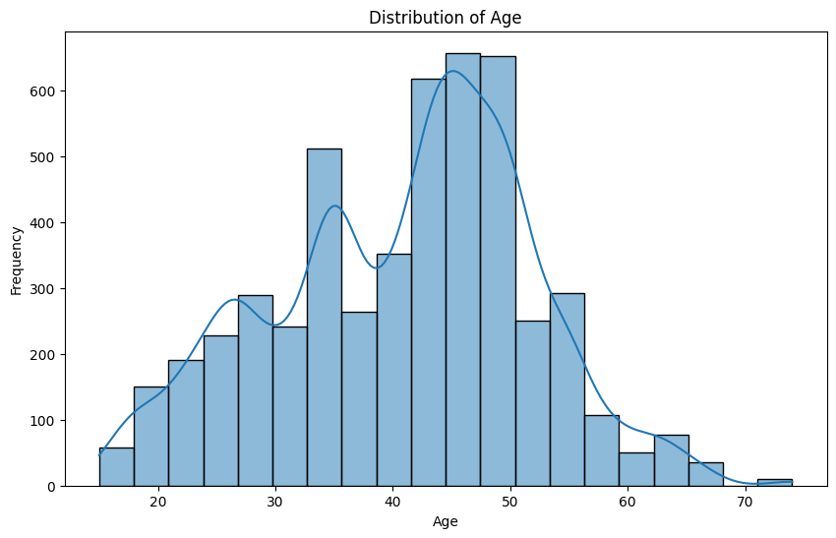

Figure 1: Distribution of Age

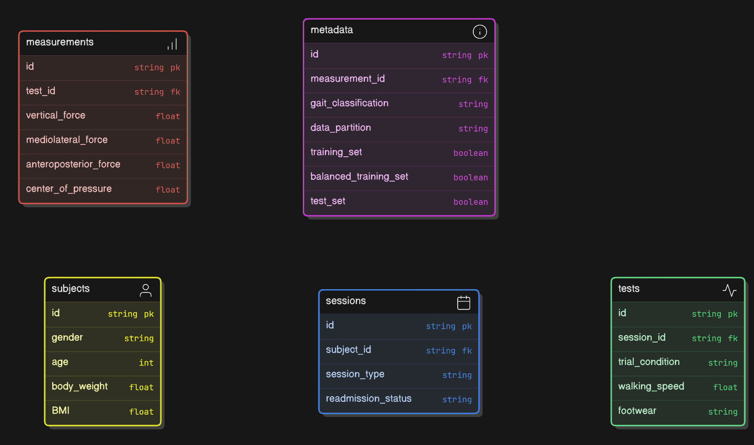

Figure 2: Dataset Overview

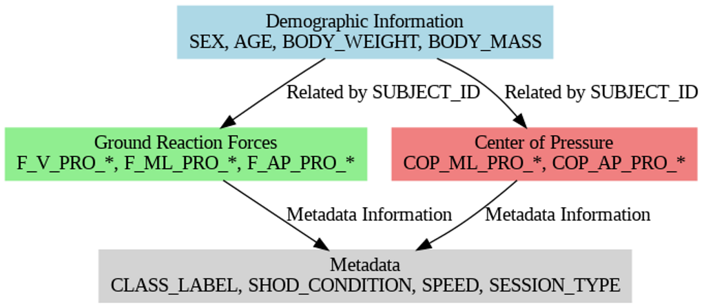
Figure 3: Dataset Description
Maximum data obtained was of ages 35 and 50 which can be seen in Figure 1. The first peak in the histogram is at 35 and the second peak is at 50. Individuals above age 60 are less and so are the individuals below age 20.

3.2 Data Preprocessing:
The initial step involved merging 10 different gaitrec dataset. From each dataset 10 columns were taken. As it is clear from figure 3 these datasets were mapped on the basis of some common coloumns. Each dataset had Subject id, session id and trial id columns common and hence the new dataset obtained was on the grounds of these common factors. Also, the metadata which provided additional context and categorization for each trial, including demographic information and specific conditions under which the data was collected was also included into the new merged dataset. Each of these datasets were previously pre-processed, hence no preprocessing was done. The unwanted fields such as height, orthopedic insole, shoe size was removed during merge process. The merging was carefully done to preserve the originality of data.

3.3 Proposed methodology

Classification Algorithm
Four classification algorithms were used: KNN, SVM and Logistic Regression and Multi-layered CNN. All these were applied and then their accuracies were compared. SVM is used for classification and regression problems, primarily for categorization difficulties. SVM recognize the ideal boundary, or hyperplane, for classifying data, using parameters like C=0.1 and kernel='sigmoid'. The KNN algorithm is a non-parametric classification method that assigns new cases to categories that are most similar to existing ones[3]. The algorithm is highly dependent on the value of k, and the most optimal value for k neighbors is 100, providing the highest accuracy without overfitting. Logistic regression is used for binary classification, using a sigmoid function and a set of parameters for gait analysis. The parameters for gait analysis include penalty='l2', C=1.0, solver='saga', and max_iter=1000. The l2 penalty is Ridge Regularization, C is the inverse of regularization strength, and C=1.0 is the default value. Solver is the optimization algorithm used, and'saga' supports the 'elasticnet' penalty, useful for large datasets.
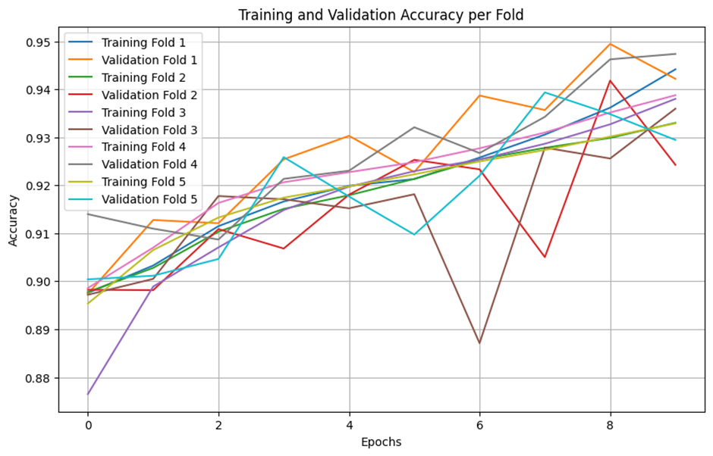
Figure 4: 5-Fold Cross-Validation of CNN Model

Multi-layered CNN Architecture :
Convolution Neural Network( CNN), is a deep feed-forward network with an astounding capacity for better conception than networks with fully connected layers. It is able to efficiently relate effects and learn veritably abstract attributes. Artificial neurons are arranged in numerous layers to form convolutional neural networks. The weighted total of several inputs and outputs of a trigger value is determined by artificial neurons, which are mathematical functions that approximate the functions of their biological counterparts. Before applying CNN on dataset, we had reshaped each feature vector in our dataset which was originally one dimensional and convert it into 2 dimensional. This transformation is performed to ensure compatibility with the input requirements of Conv2D layer, which accepts 2D data. The CNN has the first layer as a Conv2D with 16 filters of size 3x3 applied to input data. It is a fundamental operation for capturing local spatial patterns in the input data using convolution operation. We have added one hidden layer and the activation function used in this layer is ReLU which adds non-linearity to a neural network helping it learn complex patterns. Always performing padding: set to 'same' so that output dimensions match the input by zero-padding. After the convolutional layer is a MaxPooling2D with a pool size of 2x2. This layer will be doing down sampling by choosing the maximum value for each 2x2 region in the feature maps. Max pooling reduces the spatial dimensions of the feature maps, keeping only the most prominent features and hence reducing computational complexity. The pooling operation gives translation invariance, increasing the model's stability in response to slight shifts in input data..
After the max-pooling layer, a Flatten layer is used to turn these 2D feature maps into 1D vectors. This is so that this higher level and abstract information, which has been extracted by the convolutional layers, can be accepted and processed by the dense layers at the end of the network. These flattened vectors are then fed into a fully connected, or dense, layer comprising 64 units. This layer is very important for learning complex representations from these high-level features. ReLU serves as the activation function for this layer and helps capture nonlinear relations within the data. At last dense layer with one unit is used in the model. The sigmoid activation function applied to this last layer is relevant for binary classification tasks. The sigmoid function gives, as its output, a probability value between 0 and 1, indicative of the likelihood that the input gait pattern either belongs to the category 'healthy' or 'pathological'. Figure 4 shows the 5-fold cross validation of the CNN model.
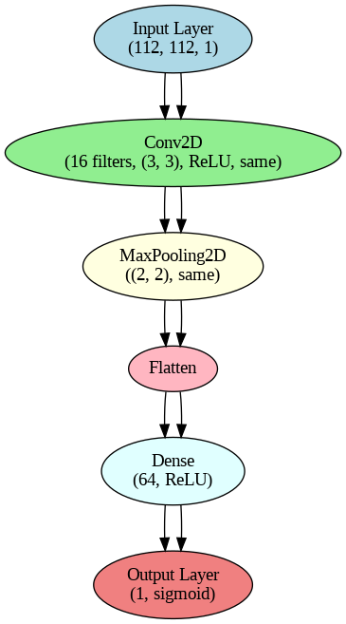
Figure 5: Proposed Multilayered CNN Architecture
The figure 5 above shows the architecture of the CNN model. The model consists of multiple layers including 2-D Convolution layer(Conv2D), MaxPooling2D layer, Flatten Layer and Dense Layer. The Conv2D layer applies 16 convolutional filters of size 3x3 to the input data. The activation function used is ReLU (Rectified Linear Unit), and padding is set to 'same' to preserve the input dimensions. After applying ‘same' padding and a pool size of 2x2, a max pooling layer was employed to down sample the feature maps after the convolutional layer. This allowed for the retention of the most important features while decreasing the spatial dimensions. The flattened layer then converted the 2D feature maps into 1D vectors, which were then transmitted to the dense layers. A fully connected layer with 64 units and ReLU activation was used to learn complex representations. The final dense layer was a single unit with sigmoid activation, which was ideal for binary categorization of gait patterns (healthy vs. pathological).

3.4 Complexity Analysis
The proposed CNN model consists of convolution layer maxpooling layer and 2 dense(fully connected ) layers. To analyze the computational complexity of the model for an input feature map with dimensions H×W×C ,
Conv2D Layer: The computational complexity is O(K² ⋅ C ⋅ C_{out} ⋅ H ⋅ W), where- K indicates the size of the kernel, C represents the number of input channels, and Cout denotes the number of filters.
MaxPooling Layer: The complexity is O(H_{out} ⋅ W_{out} ⋅ C_{in} ⋅ K²), with H_{out} and W_{out} being the reduced spatial dimensions as a result of pooling.
Dense Layers: The complexity associated with dense layers is O(N_{in} ⋅ N_{out}), where N_{in} and N_{out} indicate the number of inputs and outputs, respectively. When these factors are combined, the primary computational complexity is influenced by the Conv2D layer, which scales as 𝑂(𝐻⋅𝑊⋅C_{in} ⋅C_{out}), especially for larger input sizes. This highlights the significance of optimizing convolutional processes for practical uses that involve high-resolution inputs.
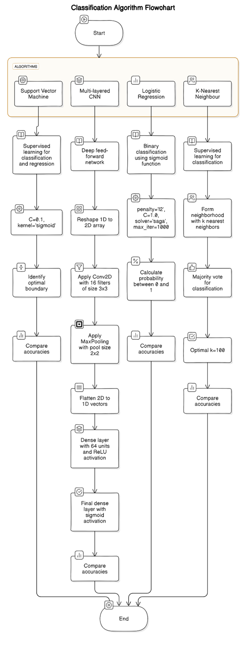
Figure 6: Flow Chart of Different Models Used in Work

Results and Discussion:
Various models were evaluated, including SVM, neural networks, DT to determine the most effective model for our dataset. Figure 6 shows the detailed flow of the algorithms used. The multi-layered CNN achieved a test accuracy of approximately 95.57%, outperforming other models like K-Nearest Neighbors (90.29%), Support Vector Machine (87.66%), and Logistic Regression (90.94%). Table 2 shows the performance metrics of the models that were applied. These metrics were calculated on the basis of confusion matrix of the models as shown in figure 8,9,10,11. This demonstrates the CNN's superior capability in capturing complex gait patterns and making accurate predictions. Table 3 demonstrates a comparative analysis of the accuracy of different machine learning models used in the "Base" and "Proposed" approaches. In the base work, the SVM obtained the highest accuracy with 89.998%, and KNN and CNN had slightly higher accuracies at 91.296% and 91.624%, respectively. However, the Naïve Bayes model showed the worst performance with only 55.244%, which proved that it was not suitable for the task. Improvements in model design and methodology were found in the proposed work. The Multilayered CNN achieved the highest accuracy of 95.57%, which outperformed all models in both the base and proposed approaches.

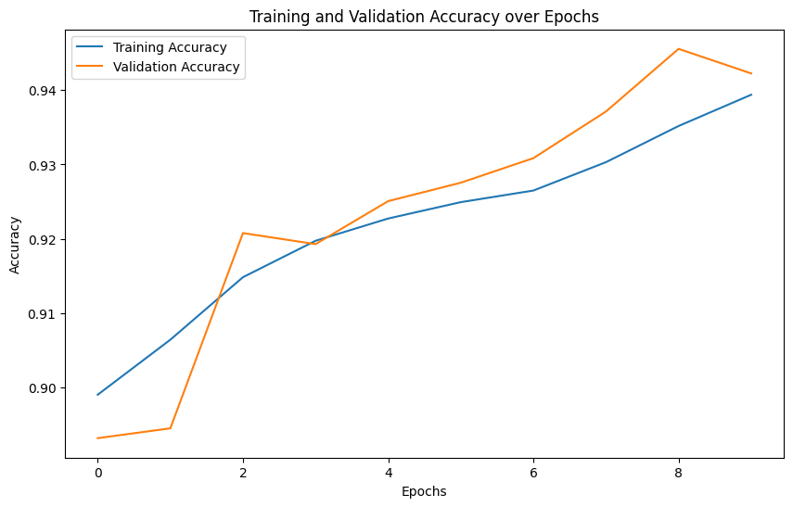

Figure 7 Training and Validation Accuracy of Proposed Model

Table 2 Performance Metrics of Models in Work
Performance metrics | Models Used
Performance metrics | KNN | SVM | Logistic Regression | Proposed CNN
Accuracy | 0.9021 | 0.8761 | 0.9095 | 0.9557
Precision | 0.9074 | 0.9236 | 0.9092 | 0.9672
F1-Score | 0.9483 | 0.9318 | 0.9529 | 0.9755
Recall | 0.9931 | 0.9402 | 0.9988 | 0.9839

The figure 7 above illustrates the training and validation accuracy over 10 epochs. This shows the improvement in the performance of the CNN model over time by minimalizing overfitting.

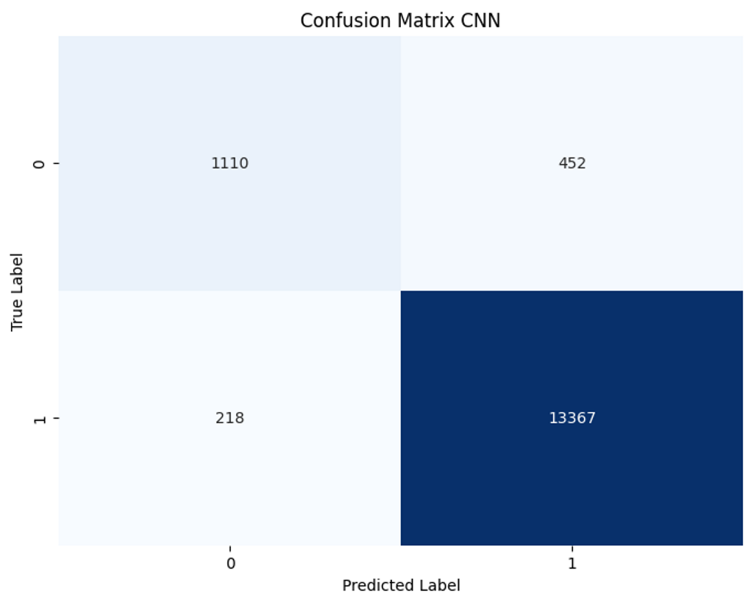

Figure 8 Confusion Matrix: CNN model
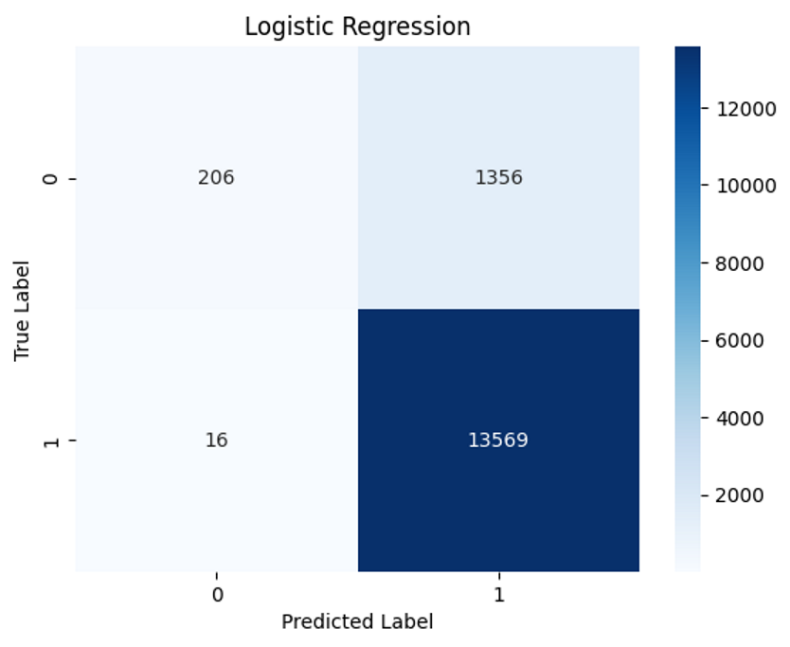
Figure 9 Confusion Matrix: Logistic Regression
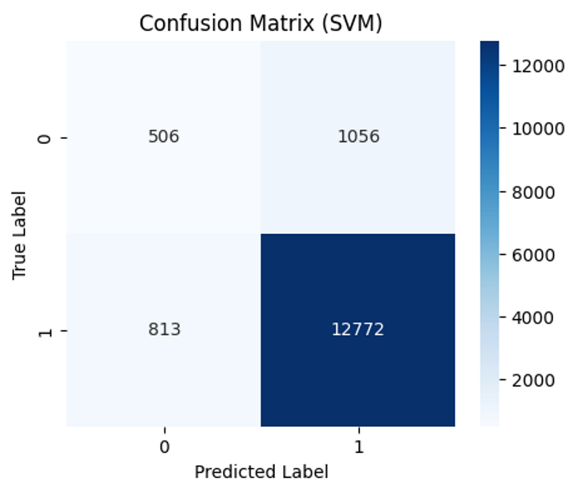

Figure 10 Confusion Matrix: SVM
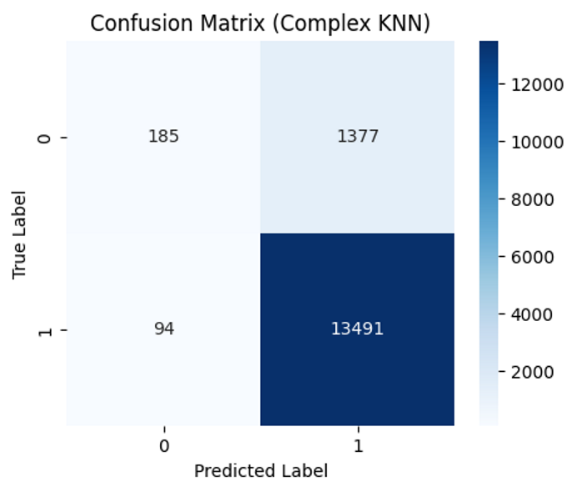

Figure 11 Confusion Matrix: KNN
Table 3 Comparative Data of Proposed Work with Base Work
Work | Models and Accuracy | Ref.
Base | SVM: 89.998%  Naïve Bayes: 55.244%  KNN: 91.296%  CNN: 91.624% | [1]
Proposed | KNN: 90.288 %  SVM:87.66%  LR: 90.94%  Multilayered CNN : 95.57%

Conclusion and Future Work :
In conclusion, this work successfully developed a predictive model for gait abnormalities that leverages state-of-the-art machine learning techniques. The model demonstrates significant potential in improving early detection and intervention strategies. The results showed high accuracy and robustness, making the model a valuable tool for clinicians. Future work will focus on refining the model, expanding the dataset, and integrating the system into clinical practice. Additionally, efforts will be directed towards enhancing the model's interpretability and user-friendliness to ensure it can be effectively utilized by healthcare professionals. The study not only contributes to the field of gait analysis but also opens new avenues for research and development in medical diagnostics. By addressing current limitations and exploring new methodologies, this research lays the groundwork for future innovations in predicting and managing gait abnormalities. The integration of this model into healthcare systems holds the promise of transforming patient care by enabling proactive and personalized treatment plans.

References :
- Pandey C, Roy DS, Poonia RC, Altameem A, Nayak SR, Verma A, Saudagar AKJ. GaitRec-Net: A Deep Neural Network for Gait Disorder Detection Using Ground Reaction Force. PPAR Res. 2022 Aug 22;2022:9355015. doi: 10.1155/2022/9355015. PMID: 36046063; PMCID: PMC9424014.
- Horsak, B., Slijepcevic, D., Raberger, AM. et al. GaitRec, a large-scale ground reaction force dataset of healthy and impaired gait. Sci Data 7, 143 (2020).
- Guo, Gongde, et al. "KNN model-based approach in classification." On The Move to Meaningful Internet Systems 2003: CoopIS, DOA, and ODBASE: OTM Confederated International Conferences, CoopIS, DOA, and ODBASE 2003, Catania, Sicily, Italy, November 3-7, 2003. Proceedings. Springer Berlin Heidelberg, 2003.
- Alzubaidi, Laith, et al. "Review of deep learning: concepts, CNN architectures, challenges, applications, future directions." Journal of big Data 8 (2021): 1-74.
- P. Patil, K. S. Kumar, N. Gaud and V. B. Semwal, "Clinical Human Gait Classification: Extreme Learning Machine Approach," 2019 1st International Conference on Advances in Science, Engineering and Robotics Technology (ICASERT), Dhaka, Bangladesh, 2019, pp. 1-6, doi: 10.1109/ICASERT.2019.8934463.
- Md Nazmul Islam Shuzan a b, Muhammad E.H. Chowdhury b, Mamun Bin Ibne Reaz a, Amith Khandakar b, Farhan Fuad Abir c, Md. Ahasan Atick Faisal c, Sawal Hamid Md Ali a, Ahmad Ashrif A. Bakar a, Moajjem Hossain Chowdhury a b, Zaid B. Mahbub d, M. Monir Uddin d, Mohammed Alhatou, Machine learning-based classification of healthy and impaired gaits using 3D-GRF signals ,Biomedical Signal Processing and Control, Volume 81, 2023, 104448.
- Pirker, Walter & Katzenschlager, Regina. (2016). Gait disorders in adults and the elderly: A clinical guide. Wiener klinische Wochenschrift. 129. 10.1007/s00508-016-1096-4.
- Alfayeed, Sk Md, and Baljit Singh Saini. "Human gait analysis using machine learning: A review." 2021 International Conference on Computational Intelligence and Knowledge Economy (ICCIKE). IEEE, 2021.
- Joyseeree, Ranveer, Rami Abou Sabha, and Henning Mueller. "Applying machine learning to gait analysis data for disease identification." Digital Healthcare Empowering Europeans. IOS Press, 2015. 850-854.
- Katoulis, Evangelos C., et al. "Gait abnormalities in diabetic neuropathy." Diabetes care 20.12 (1997): 1904-1907.
- Figueiredo, Joana, Cristina P. Santos, and Juan C. Moreno. "Automatic recognition of gait patterns in human motor disorders using machine learning: A review." Medical engineering & physics 53 (2018): 1-12.
- Chen, Biao, et al. "Computer vision and machine learning-based gait pattern recognition for flat fall prediction." Sensors 22.20 (2022): 7960.
- Khan, Muhammad Attique, et al. "Human gait analysis for osteoarthritis prediction: A framework of deep learning and kernel extreme learning machine." Complex & Intelligent Systems (2021): 1-19.
- Alharbi, Abdullah, et al. "Human Gait Analysis and Prediction Using the Levenberg‐Marquardt Method." Journal of Healthcare Engineering 2021.1 (2021): 5541255.
- Horst, Fabian, et al. "Explaining the unique nature of individual gait patterns with deep learning." Scientific reports 9.1 (2019): 2391.
- Mazilu, Sinziana, et al. "Prediction of freezing of gait in Parkinson's from physiological wearables: an exploratory study." IEEE journal of biomedical and health informatics 19.6 (2015): 1843-1854.
- Nguyen, Khang, et al. "Human gait analysis using hybrid convolutional neural networks." Journal of Computer Science and Cybernetics 39.2 (2023): 125-142.
- Gul, Saba, et al. "Multi-view gait recognition system using spatio-temporal features and deep learning." Expert Systems with Applications 179 (2021): 115057.
- Pataky, Todd C., et al. "Gait recognition: highly unique dynamic plantar pressure patterns among 104 individuals." Journal of The Royal Society Interface 9.69 (2012): 790-800.
- Hamid, Shahzaib, et al. "A sequential-data approach for human gait parameter estimation and surgical event inference." IEEE Access (2024).
- Abdollahi, Masoud, et al. "Fall risk assessment in stroke survivors: a machine learning model using detailed motion data from common clinical tests and motor-cognitive dual-tasking." Sensors 24.3 (2024): 812.
- Mekni, Amal, Jyotindra Narayan, and Hassène Gritli. "Multi-Class Gait Phase Recognition using Machine Learning Models with Two Training Methods." 2024 15th International Conference on Computing Communication and Networking Technologies (ICCCNT). IEEE, 2024.
- Ronald, Mutegeki, Alwin Poulose, and Dong Seog Han. "iSPLInception: an inception-ResNet deep learning architecture for human activity recognition." IEEE Access 9 (2021): 68985-69001.
- Stenum J, Rossi C, Roemmich RT (2021) Two-dimensional video-based analysis of human gait using pose estimation. PLoS Comput Biol 17(4): e1008935. https://doi.org/10.1371/journal. pcbi.1008935
- Monica, K. M., and R. Parvathi. "Efficient Gait Analysis Using Deep Learning Techniques." Computers, Materials & Continua 74.3 (2023).

