Revvi — Brand Direction
For Mark's review · Style reference: navigatoraiadvisory.com

1. Recommended direction
Purple + Navy + Poppins / Inter — Dark-led
Purple #7B3DFF and Navy #0D162B are taken directly from the existing Revvi logo direction.
Dark-led, not left neutral — the navy hero reads substantially more premium and makes the purple CTA stand out. Purple is used sparingly (buttons, small highlights, icons, active states) rather than as a dominant fill colour; navy and white carry most of the page. Green is reserved for measurable positive outcomes only — savings, revenue recovered, calculator results — never used as a general brand colour.

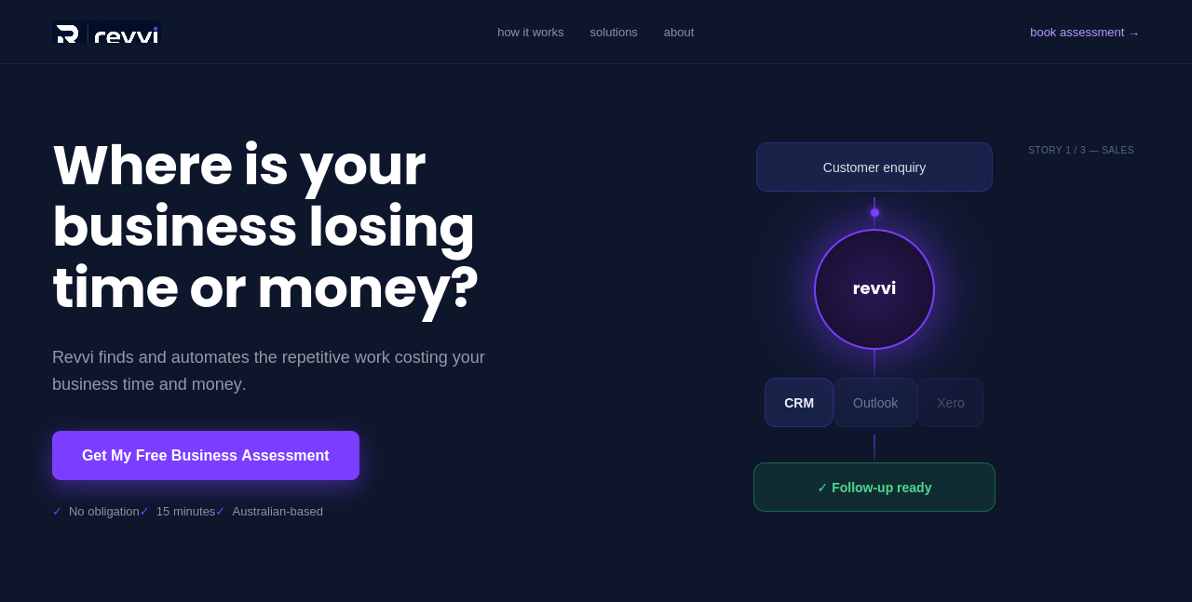

Hero shows an animated workflow (Customer enquiry → Revvi → CRM / Outlook / Xero → Follow-up ready) rather than a robot or generic AI image — this is the single biggest upgrade from earlier drafts, and explains what Revvi does in seconds. Frame shown is one moment from a 3-story rotating loop — full behaviour specified in Part 1a below.

1a. Hero animation — how it should actually move
Motion
- A small glowing dot travels the path: Customer enquiry → Revvi → systems → result. Not everything appears at once.
- Systems activate sequentially, not simultaneously — e.g. CRM lights up first, then Outlook, then Xero — matching the order Revvi actually processes the work.
- Revvi's centre node is the obvious engine: larger than the other nodes, strongest glow, gains brief extra intensity as the packet passes through it.
Pacing
- One full story ≈ 6–8 second loop. Gentle and premium, not a flashing demo — this is ambient motion sitting behind a headline, not the main event.
- Every ~7 seconds, the whole diagram transitions to the next story rather than looping the same one indefinitely.
Three rotating stories
- 1. Sales — Customer enquiry → Revvi → CRM + Outlook → "Follow-up ready"
- 2. Finance — Supplier invoice → Revvi → Xero → "Ready for approval"
- 3. Operations — New job → Revvi → CRM + Project system → "Team notified"
Within ~20 seconds the hero quietly demonstrates all three Revvi service pillars — Sales, Finance, Operations — without a word of copy.
Wording
- End-state label varies per story (above) rather than a fixed "Done automatically" — that phrase slightly undercuts the human-control message elsewhere on the site.
Brand icons
FLAG: using real Xero/Outlook/CRM logos would read faster than text labels, but needs a trademark/usage check before committing — logos are simple text placeholders until confirmed.

Story rotation preview
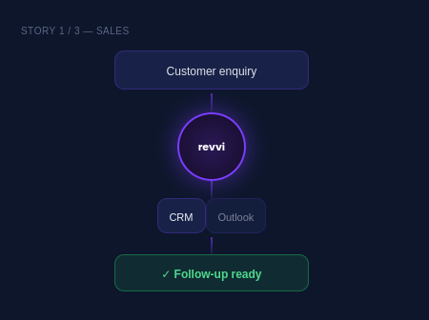 | 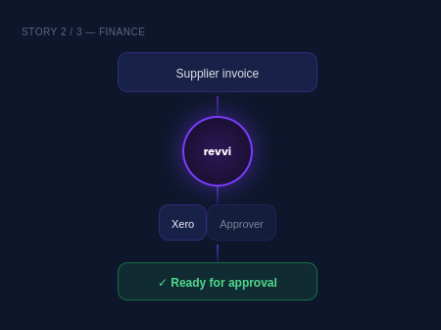 | 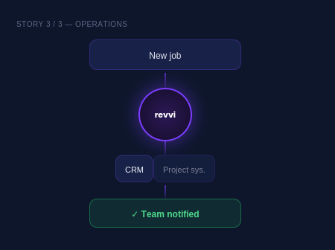

2. Colour alternatives
Purple (recommended)
Primary  #7B3DFF | Success green  #1F9E5A | Background  #F1EBFF

Blue (alternative)
Primary  #2409AD | Success green  #1F9E5A | Background  #EAE7F9

Blue is professional but reads more generic B2B/software — a safe choice, not a distinctive one. Green is unchanged either way; it's tied to savings/results, not brand identity.
Additional neutral — for light sections instead of lavender everywhere
Off-white / warm grey  #F8F9FB | Soft lavender (CTA only)  #F1EBFF

Rhythm down the page: navy hero → white solutions → soft grey calculator → navy security → white process → soft lavender CTA → navy footer. See the full example in Part 4.
Dark-led only from here — the earlier light/white hero option has been dropped since dark-led is the confirmed direction (Part 1).
Purple   | Blue  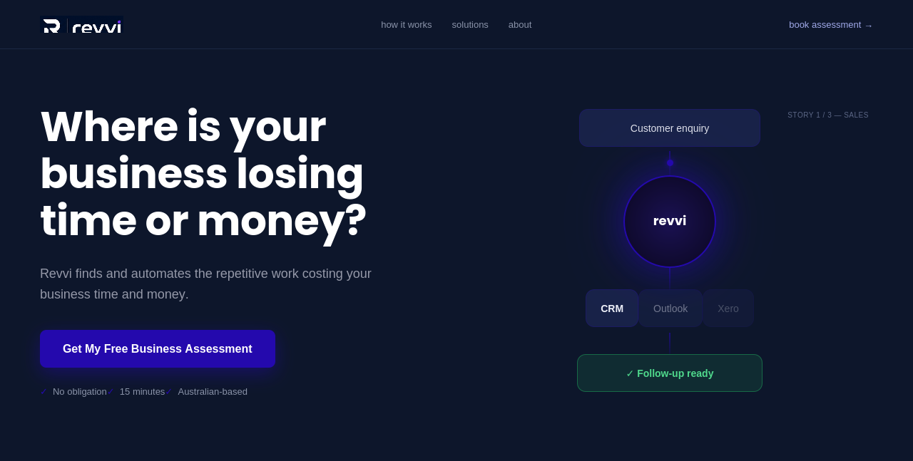

3. Typography alternatives
Rule once confirmed: Poppins for headings only, Inter for everything else (body copy, buttons, nav, labels) — kept strict, not mixed within the same hierarchy.
Option A — Poppins (headings) + Inter (recommended)
Where is your business losing time or money?
Revvi finds the repetitive work, manual processes and missed follow-ups costing your business time and money.
Modern, geometric, confident — closest match to Navigator's own look and to a technology-enabled business.

Option B — Lora (headings) + Inter (body)
Where is your business losing time or money?
Revvi finds the repetitive work, manual processes and missed follow-ups costing your business time and money.
Serif headline reads credible, but leans the brand slightly towards financial/advisory consulting rather than a technology business.

Option C — Work Sans (headings) + Inter (body)
Where is your business losing time or money?
Revvi finds the repetitive work, manual processes and missed follow-ups costing your business time and money.
Neutral and safe, but the least distinctive of the three — lowest brand recognition value.

4. Website application
Full page rhythm — navy hero with subtle glow, shadowed cards, icons on the solution cards, a connecting line through the process steps, and marked placeholders for real photography/graphics once sourced. Rounded cards for content blocks, open full-width bands so it doesn't read as a generic templated SaaS site.
Purple
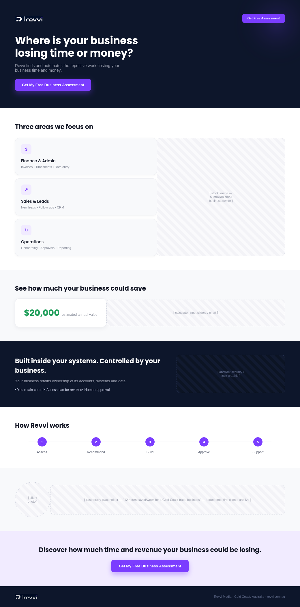

Blue
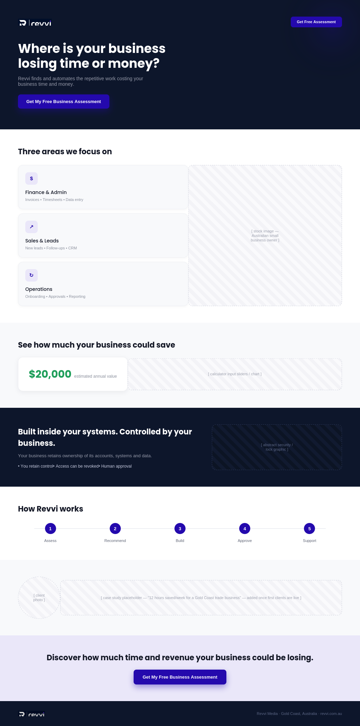

5. What I need you to approve
Direction: Dark-led (see Part 1) — not put forward as a choice, since the light/white hero option has already been dropped.
1. Primary colour: Purple (recommended) / Blue
2. Typography: Poppins + Inter (recommended) / Lora / Work Sans
Once confirmed, I'll apply this direction across the full website. Recommended hero visual: 3-story rotating workflow animation (Sales / Finance / Operations, specified in Part 1a), ready to build once colour and typography are locked in.

