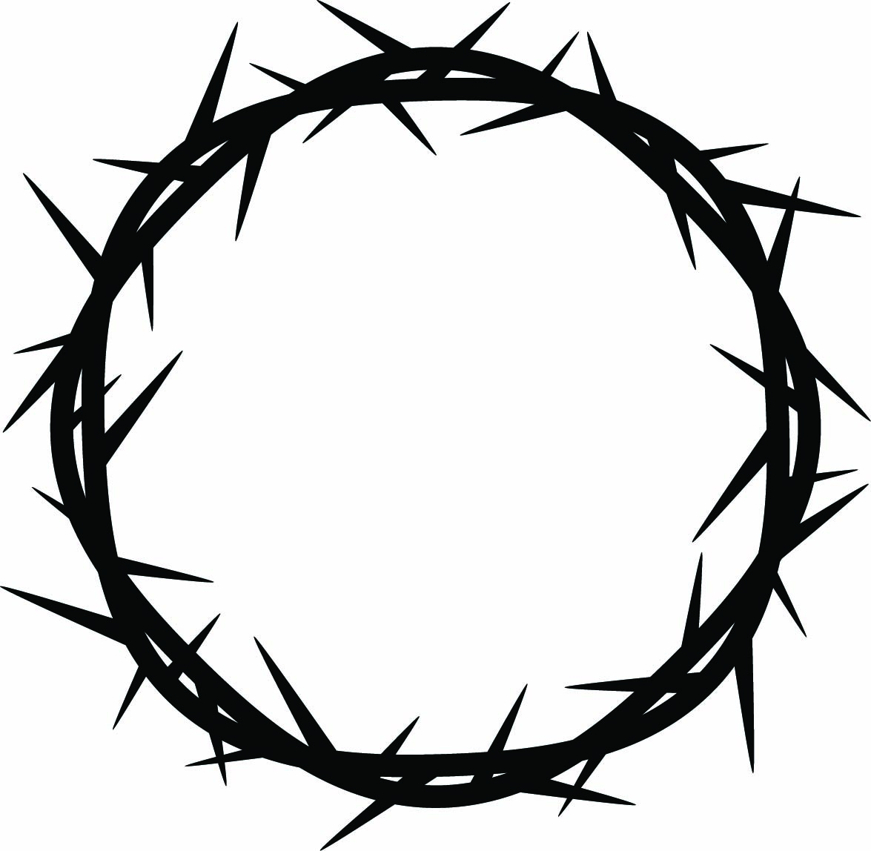

{{DATE}} | {{SERVICE_TIME}}

Welcome

{{TITLE OF DAY}}
{{SUBTITLE}}
The Good Friday Liturgy  On Good Friday the Church gathers to remember again our Lord’s sacrifice on the Cross for our sakes and for the sake of the world. This is a solemn, reflective, and powerful service.  Everything you need to participate is in the bulletin. If you have any questions, please ask one of the clergy or the volunteers passing out bulletins. | Reconciliation of a Penitent: After the Congregation has dispersed at the end of the service, the Priest will be available at the altar rail for the sacrament of Reconciliation of a Penitent for those individuals who desire it. This rite can be found on pg. 448 of The Book of Common Prayer. Please wait in the Narthex until it is your turn to come forward.
Invite Involve Instruct Inspire

