
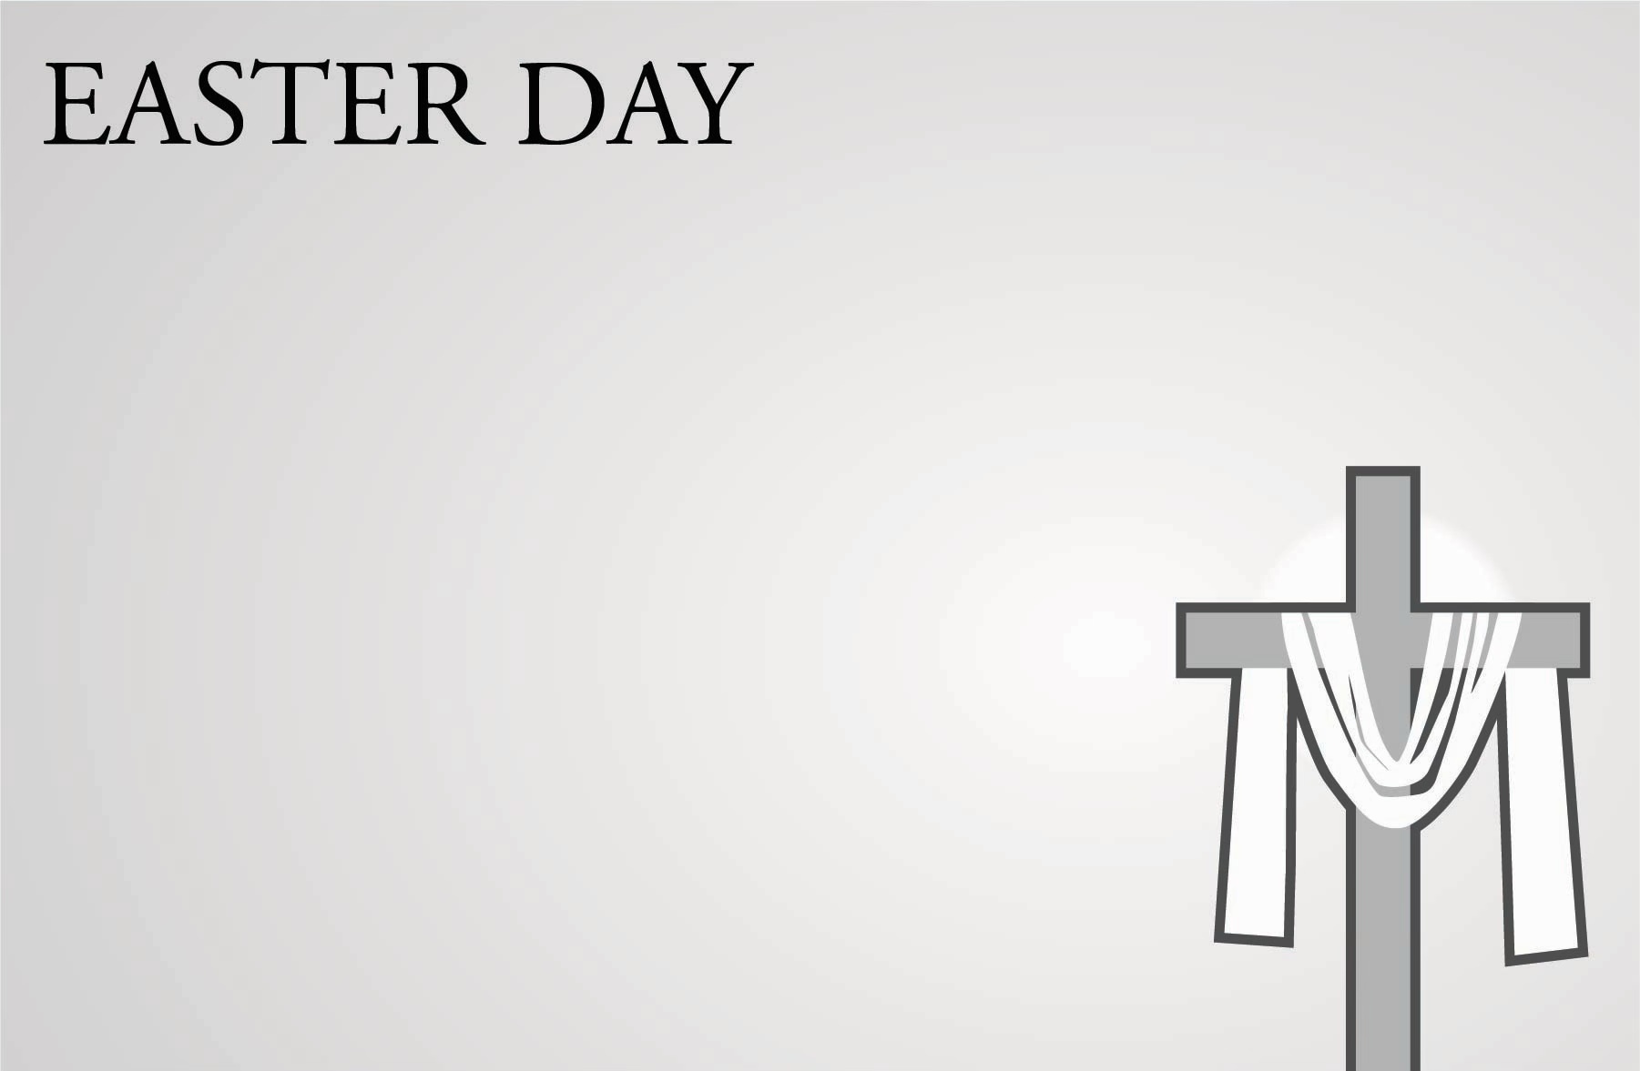
GOOD FRIDAY
Stations of the Cross – 7:30 am Downtown McKinney & 11:30 am at St. Andrew’s
Early Christian pilgrims to the Holy Land made it a practice to visit the places of Jesus’ Passion. Stations of the Cross follows this custom, with each station highlighting the events of Christ’s passion. Downtown McKinney: Meet at Dr. Glenn Mitchell Memorial Park (corner of Church and Louisiana) at 7:30 am as we walk the stations through downtown McKinney. At St. Andrew’s: Meet in the Garden Chapel at 11:30 am for Station of the Cross on the front lawn prior to the Good Friday liturgy.

Good Friday Solemn Liturgy – 12 noon in the Great Hall
Good Friday is the solemn remembrance of Christ’s death on the Cross. The service includes the reading of the Passion Gospel from John, the Solemn Collects, a Good Friday sermon, and concludes with veneration of the Cross. 12:00 noon.
Good Friday for Families – 5 pm in the Great Hall
Journey through Holy Week as a family (Palm Sunday through Good Friday) with worship and a shared meal. Nursery care available for children ages 0–3.
EASTER DAY
Easter Sunrise - 6:30 am at the Garden Chapel
With elements of the Easter vigil, including the new fire, accompanied by acoustic music, this beautiful liturgy will begin while it is mostly dark and end in the full brightness of Easter morning. The Easter Sunrise service takes place at the outdoor Garden Chapel (on the front lawn). In case of rain, service will be cancelled – check online.
The Great Easter Egg Hunt - 10 am (between services)
The “Great Hunt” will hop into action at 10 am in the front lawn. Don’t forget to bring your Easter baskets to collect all those eggs!
Easter Day Services - 8 am, 9 am and 11 am
The joy-filled celebration of Christ’s resurrection on Easter morning.

