Head 3D-Print (Final Fixes)

Overall goal: simplify and enhance workflow

1. Eliminate “Import OBJ” option

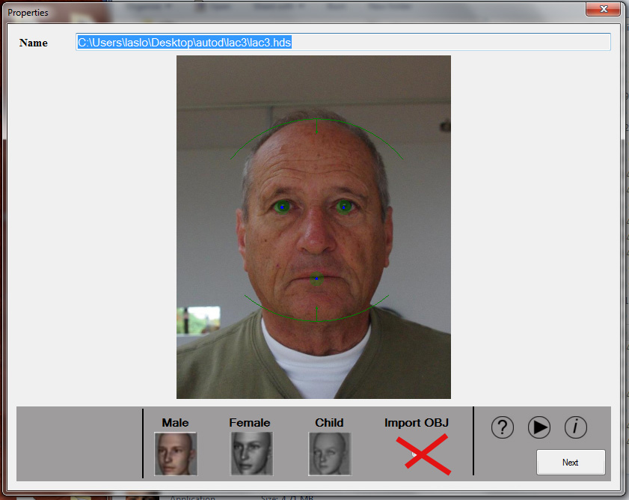

$50

1. In Autodots Tab the outline dots SHOULD NOT BE ABLE TO CHANGE SHAPE. These dots (see red dots in picture) should only be able to adjust texture map.

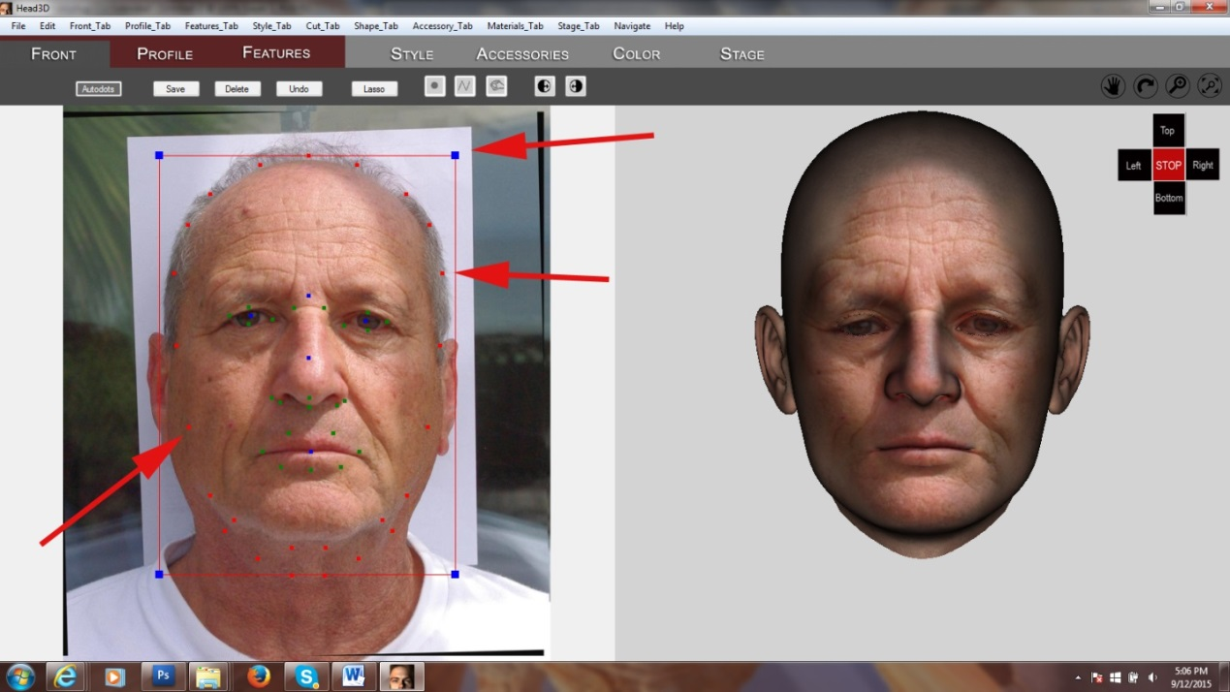

$50

1. New tab system. 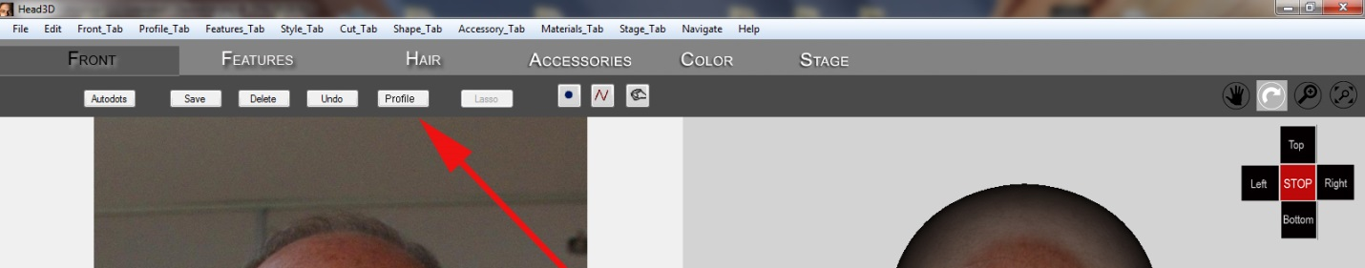

Eliminate “Profile” as a tab and add it to “Front” as an optional button. - Reason – further simplifying workflow. (We will supply new jpg files for tabs).

$100

1. New way to handle profile with the addition of profile picture option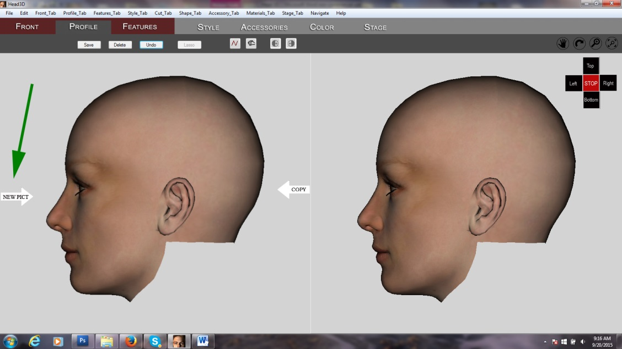

When “New Pict” is pressed, modified selection dialog appears.

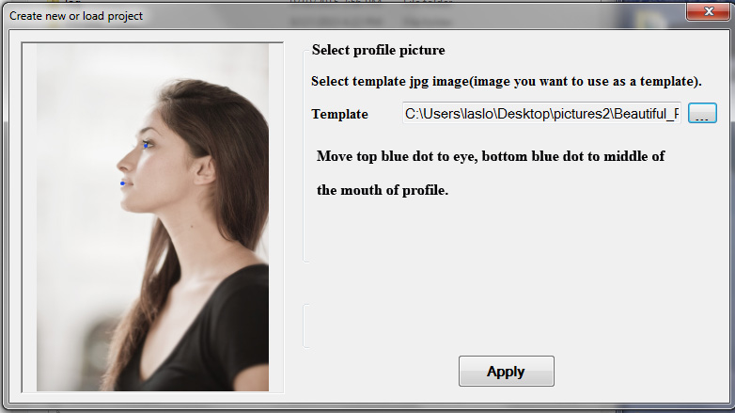

After “Apply”, next dialog shows selected picture and two blue dots (one for mouth and one for eye) and picture rotated. User to adjust two dots if needed. 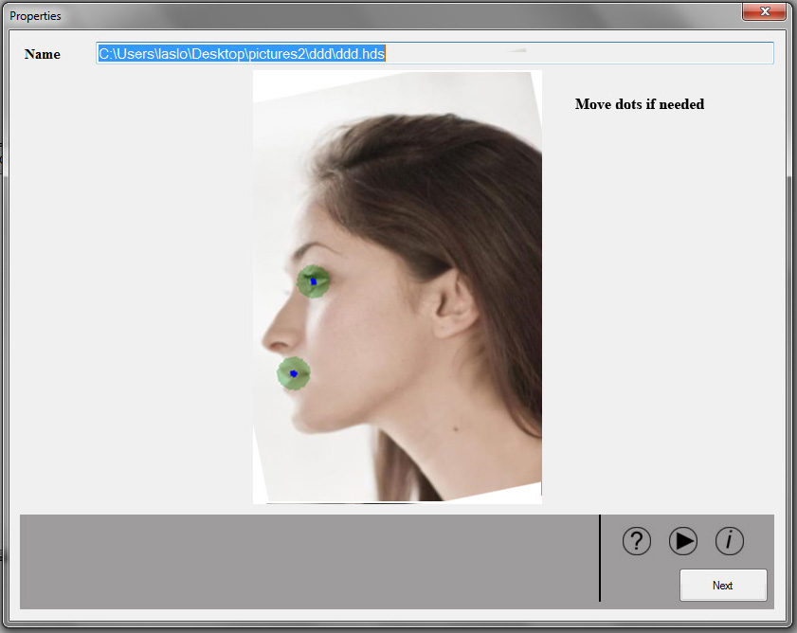

These two dots fix the size and the rotation of profile picture to be identical of the 3D head as they transfer to next screen (below). 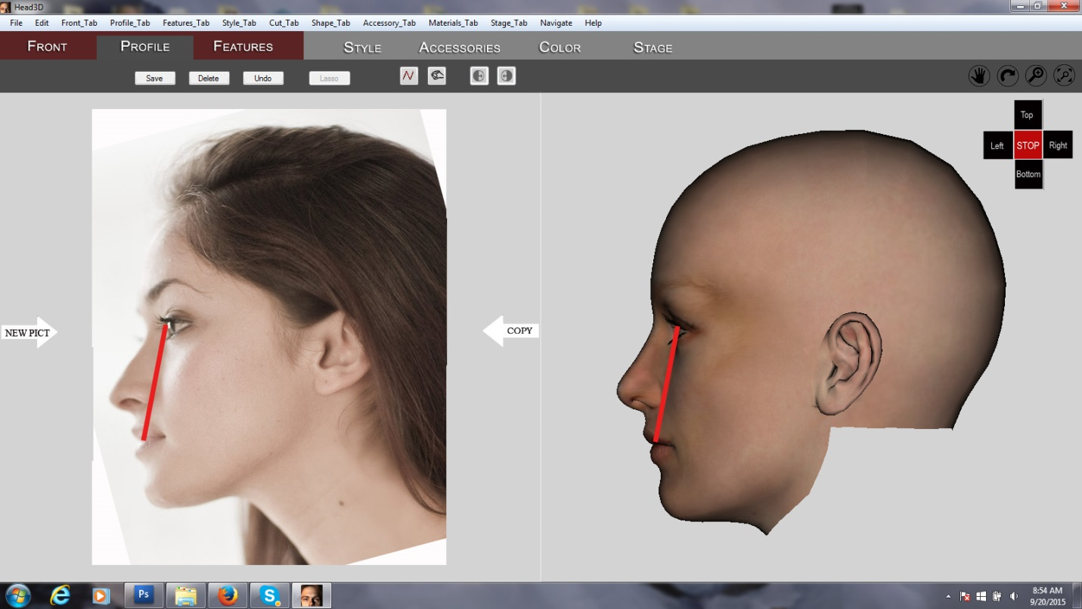

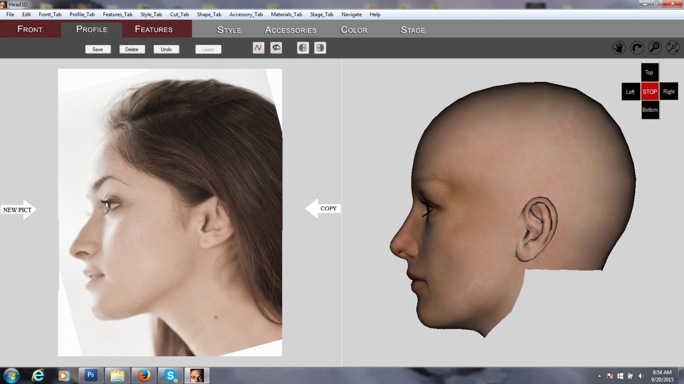

$350

1. There’s a problem with wrinkle under the nose. It happens when the user changes things in “Front” tab and so the outline no longer reflects the shape of the profile (see below).

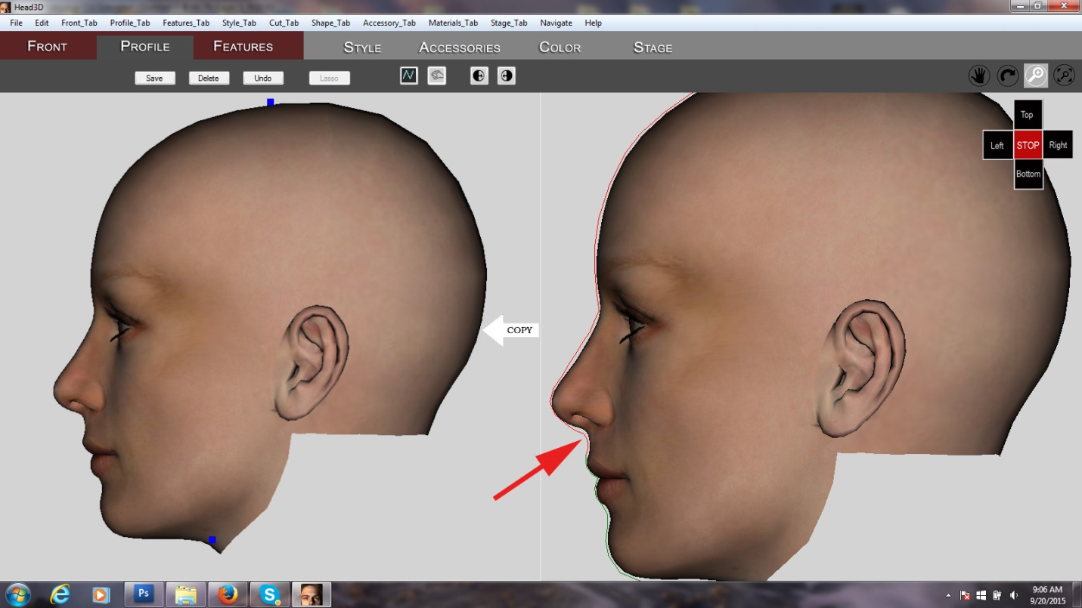

The result is a wrinkle under the nose

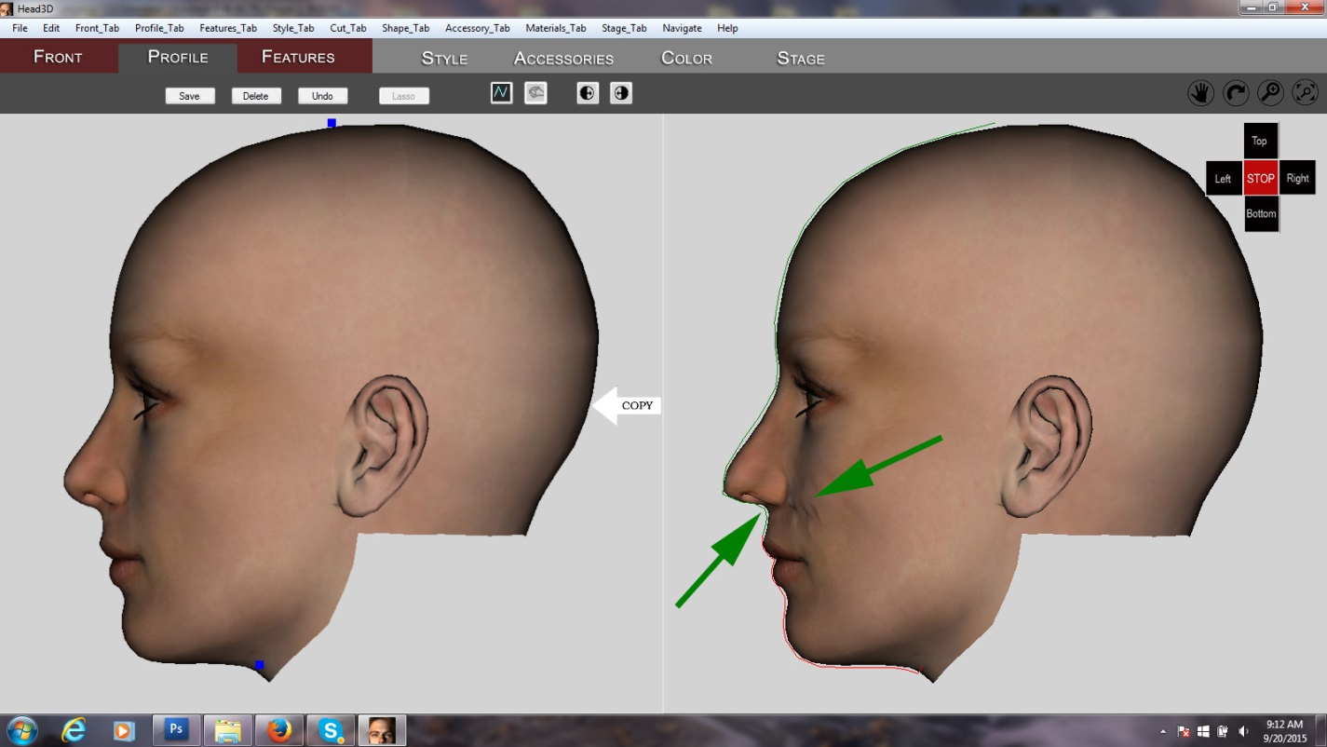

Not sure how to fix this.

Maybe make a break between the two lines (upper profile and lower profile) further up?

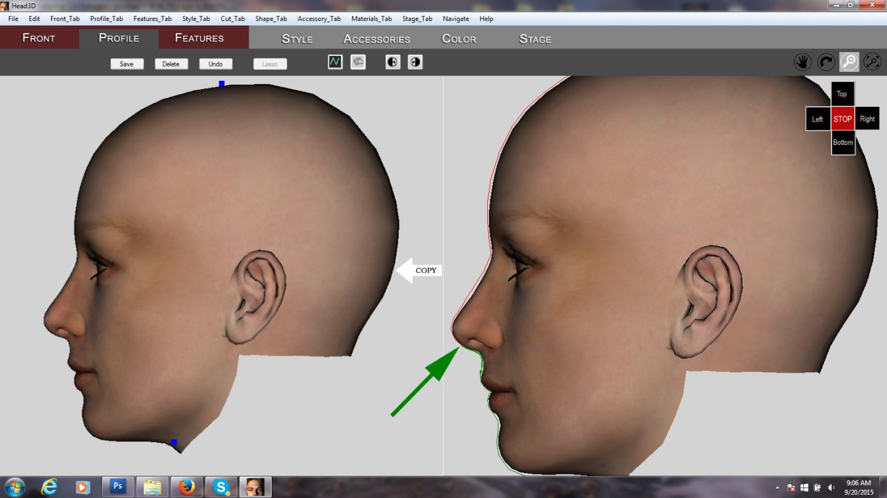

$150

1. Need a color picker and brush on the “Color” tab.

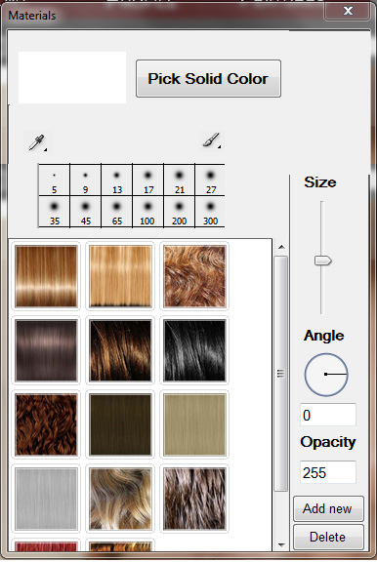

The color picker is used to pick colors from either the original photo or the 3D head. The picked color would appear then in the white square next to the “Pick Solid Color” button. 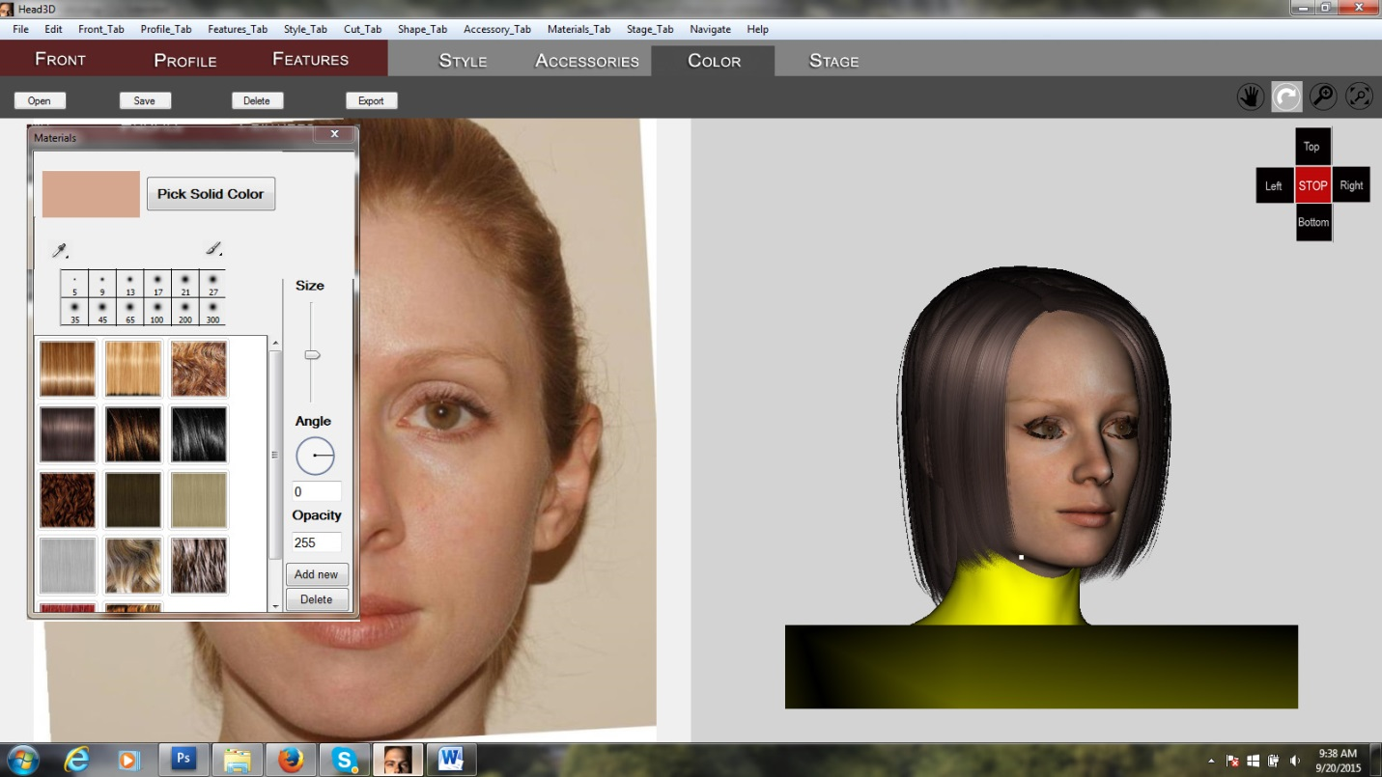

The brush (with size selection) is used to fill in areas on the head ( see example below where such tool is needed).

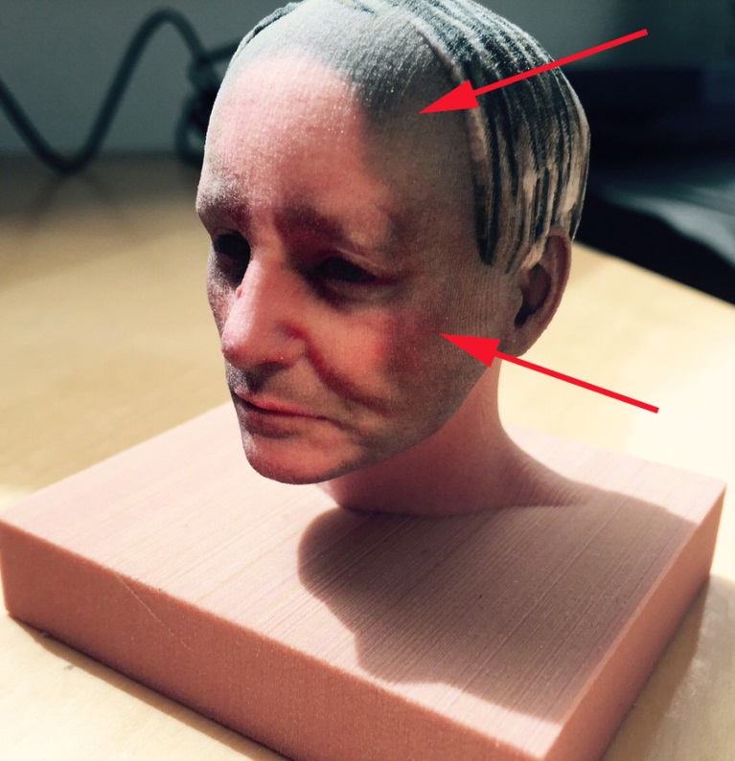

$250

1. Output in Stage Tab gets an additional button: “Color 3D Print”

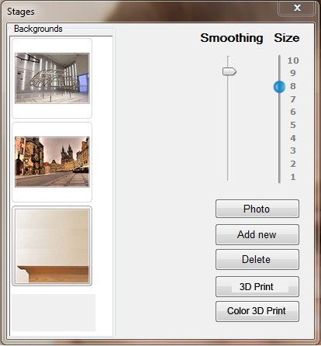

This “Color 3D Print” button will do three things:

1. Export a Collada (Dae) file into the SmoothedModelTextures folder.
2. Places also the tempHaarImage and ProfileImage files in the same folder
3. Compresses ALL files in this folder into a single zip file

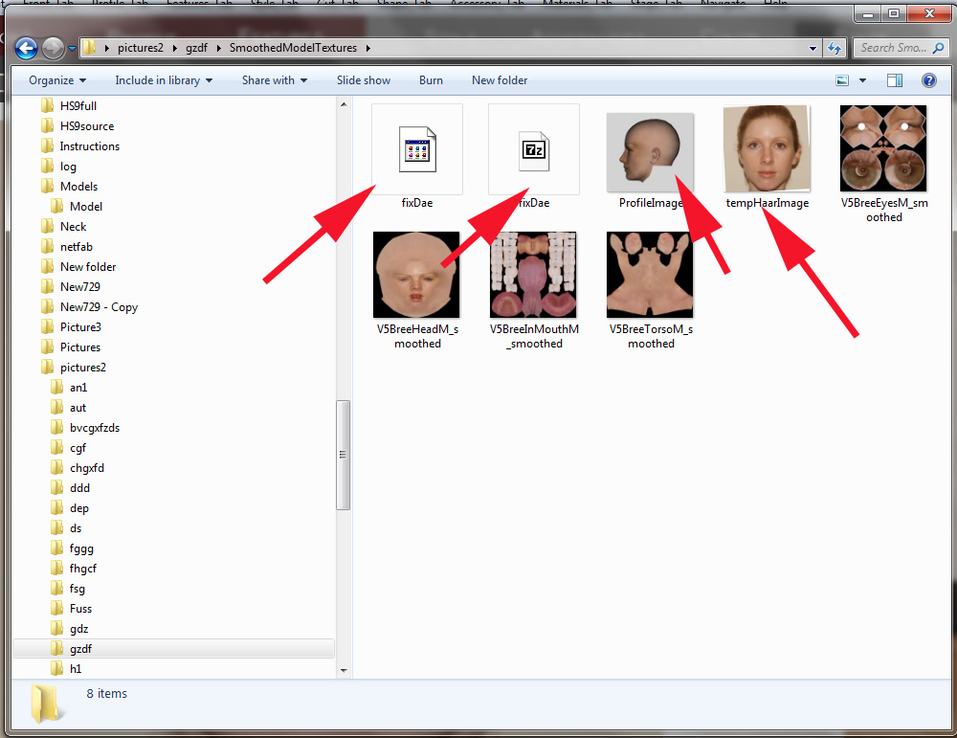

(I think it will be relatively easy since we already save in dae format. The difference here is that ALL objects (head, hair, accessories are part of this dae file).

$150