10.26 FIXES

Artem, we have two distinctly different products for two distinctly different audiences: amateurs (PrintAhead) and professional 3D modelers (HeadShop). The current product is HeadShop 11, aimed at 3D modelers who want to work in DAZ Studio.

1. Need to put back Autodots. This should allow corrections for chin and nose shapes.
2. Need NOT to mirror eye texture.
3. Mirror left/right should work (user should be able to turn on/off mirror function)
4. Profile function should work

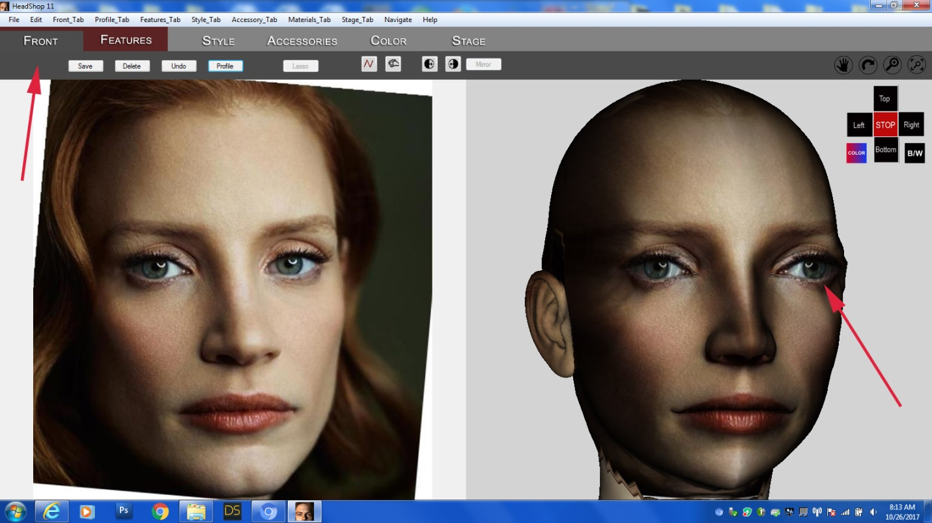

In addition:

1. If the head is straight (as below), there is no need to default mirror.

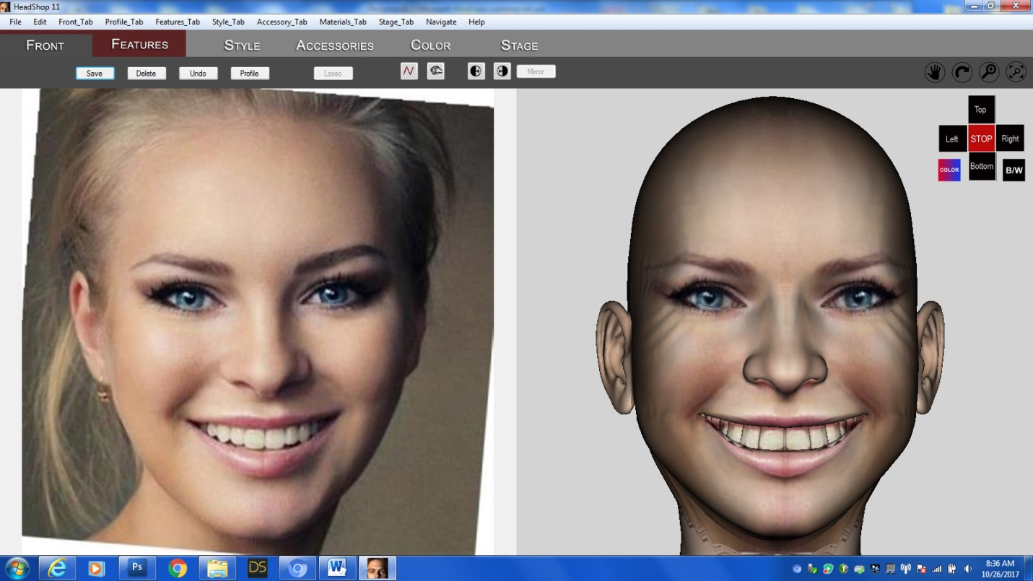

1. If the head is turned side by more than 25 degrees, we should display Error message saying that the head is turned sideways more than 25 degrees.

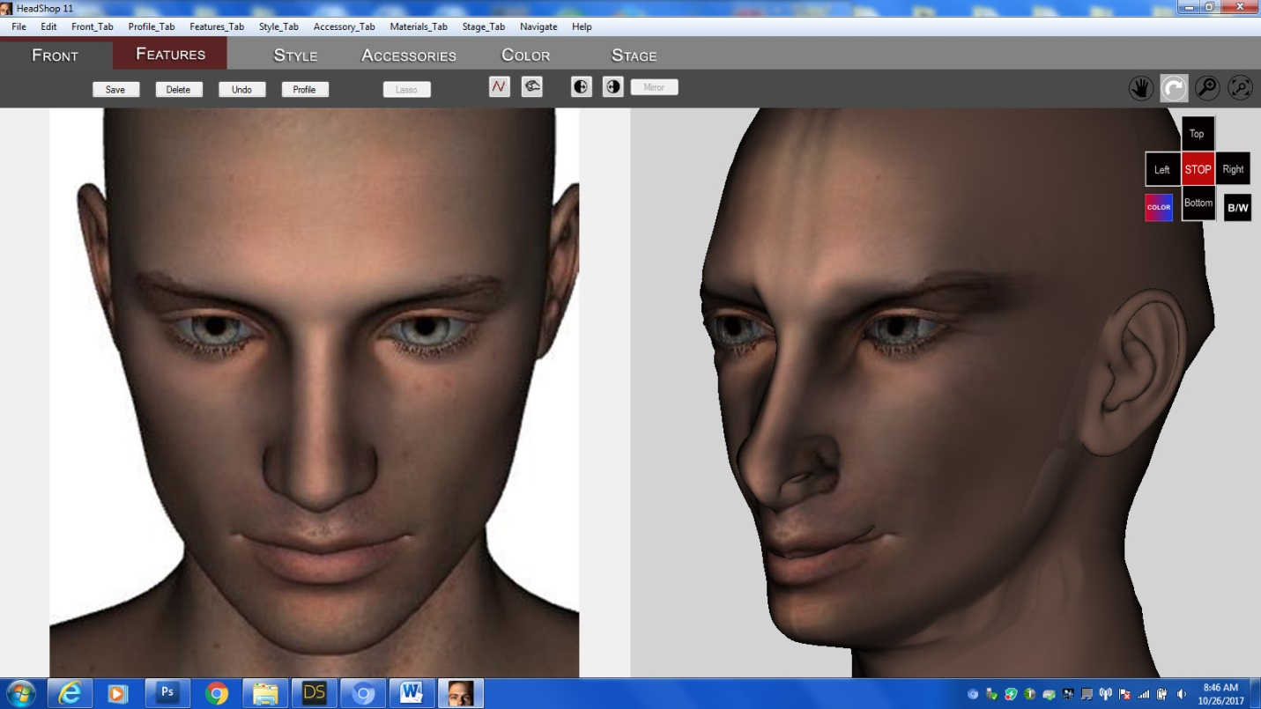

1. If the head is turned up or down more than 10 degrees, Error sign should say the head is turned up/down more than 10 degrees. (This is a problem and in the next version

we should also add the rotation around z axis to overcome this limitation)

1. Stage tab: Error opening library dialog

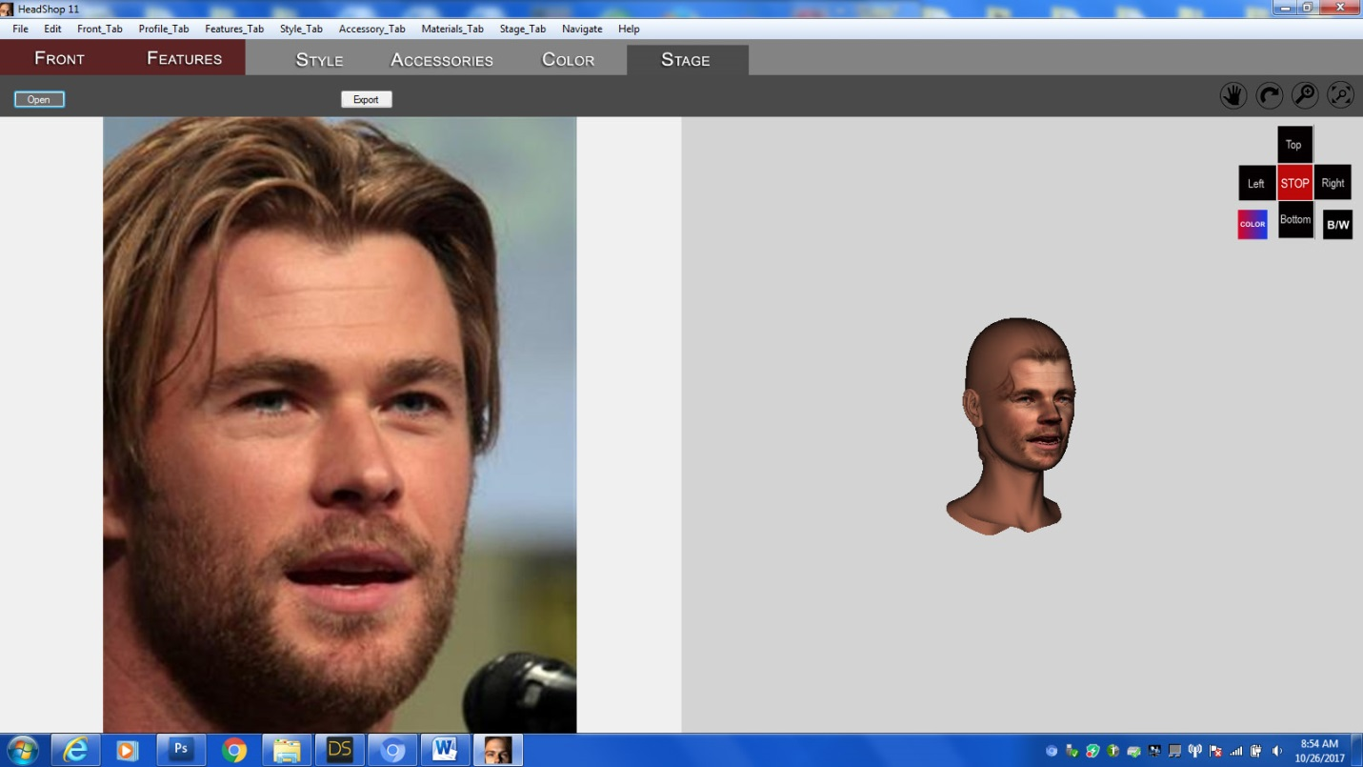

1. When pushing Export, only head needs to export (not the neck, hair, etc) as this will simply export back to DAZ Studio.
2. All texture needs to be default exported at 4096x4096. It is the new standard for DAZ Studio