6.1.17

PrintAhead.Online

FINAL FIXES AND ADJUSTMENTS ($400)

Artem,

With input from beta tests we have a set of fixes and improvements.

Since some of these are bug fixes and some design changes, I propose that we put an overall price for all fixes, rather than trying to break out what are bugs and what are changes.

1. Main page design change. For easier user interaction (which step is first and what is next) we should make minor changes to the layout. Also, an added line to indicate that the process may take 1-2 minutes.

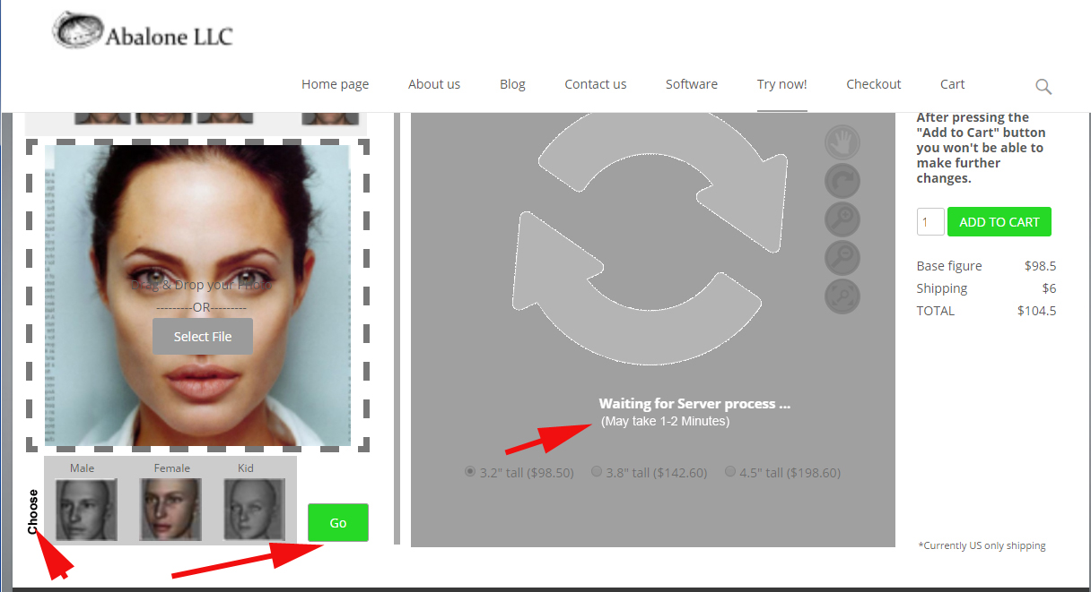

1. Age Screen design change: a display of the original photo so that the user has a reference when making age, weight or smooth changes.

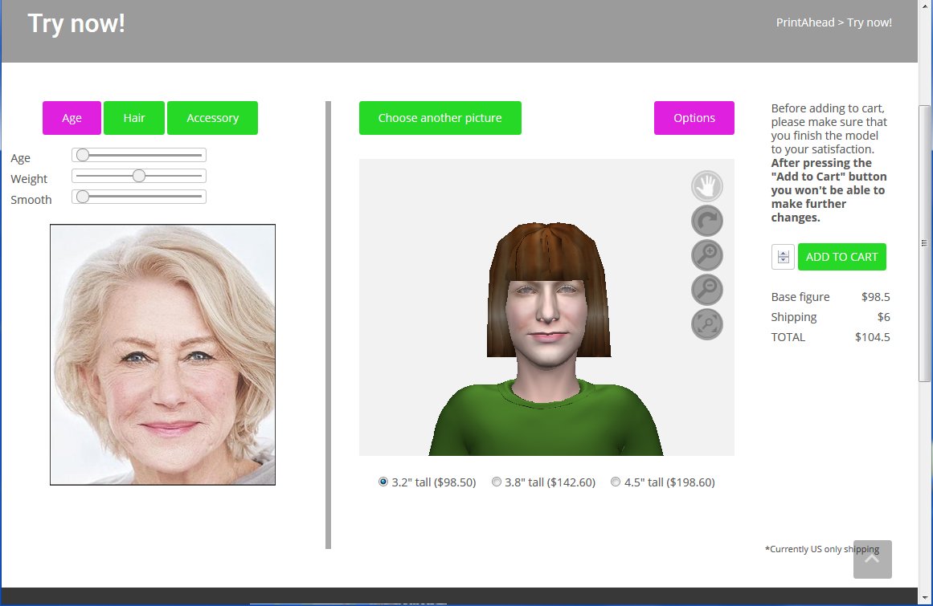

1. Bug Fix: Dragging a picture on Main Page does not work: when dragging an image, a new window opens

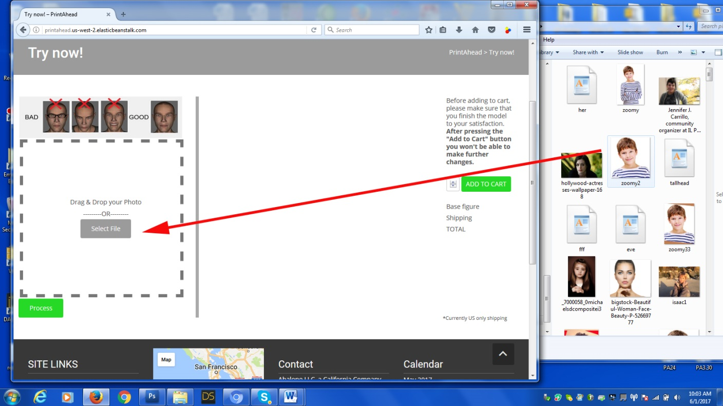

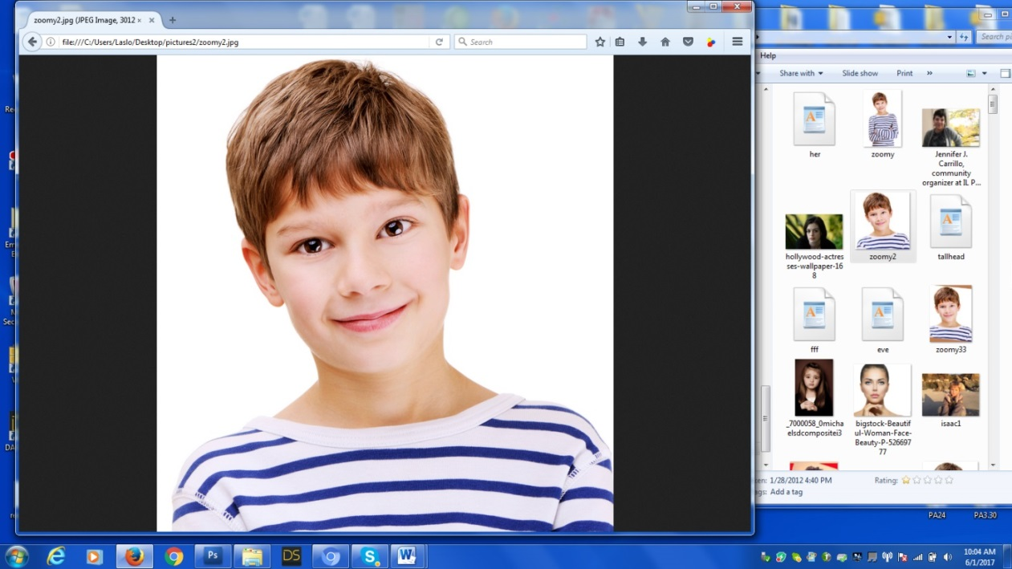

1. Compensation for tilting is not satisfactory. (see example below). Please check that it works for tilts greater than 5 degrees.

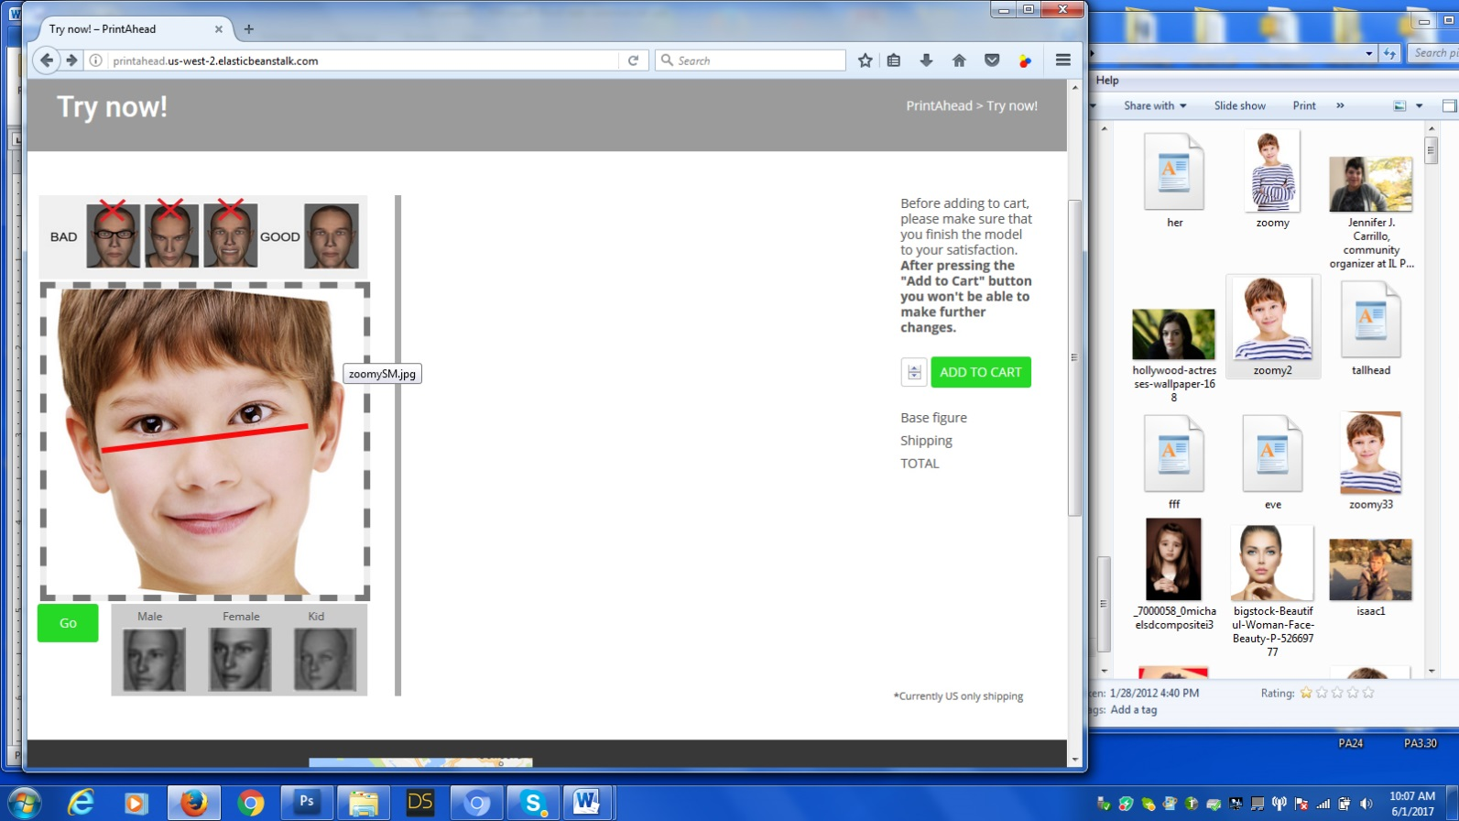

1. Bug: when selecting a new picture and pressing “Process”, the previous picture shows up again.
2. Bug: Same problem for “Select Another Picture”. Previous selection shows up.
3. Improvement: Forehead is cleaned up, but maybe a little more can be done. User has no way of fixing residual texture.

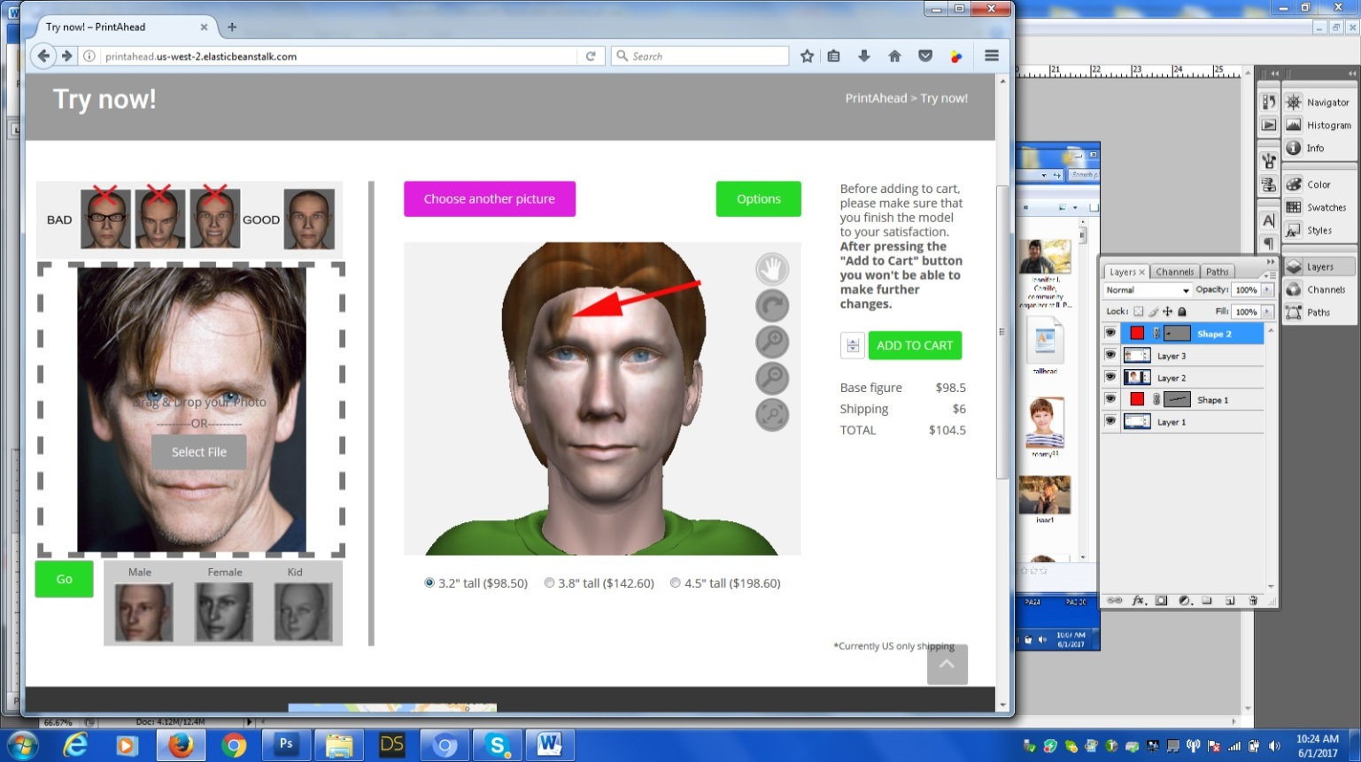

1. Bug: Clicking multiple items (for example a shirt and a color) may crash the app. It is unavoidable that users will do this. We need to find a way to line up next task.

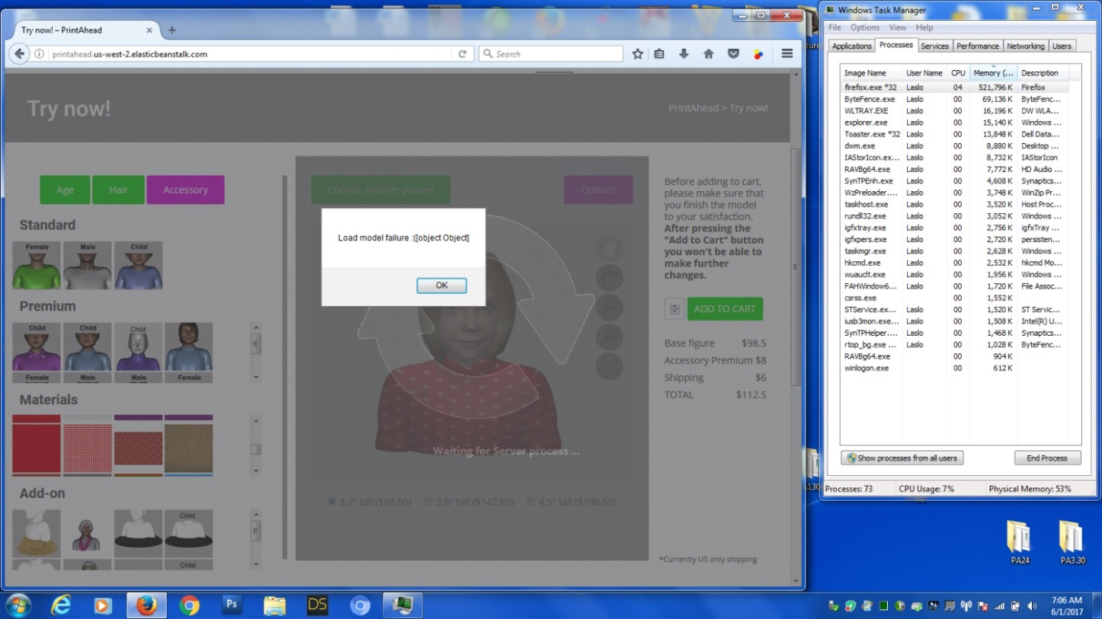

1. New feature: Adult and child sizes are different. Currently I have labeled hair, shirt and pedestal as “Child” to distinguish it from adults. There’s another, more elegant way to do this:

When user selects “Child”, and next screen clicks on a hair, say 12, then app automatically selects a variant called 12C. If user selects a shirt style, for example CM, then the app selects CC. Basically the same item ending with C.

1. The issue with Add-ons. The problem is that if user wants to select a shawl or a baseball hat or an glasses (still coming), that choice should not erase any other add-on like the pedestal or anything else. Coloring add-ons is the same as with others; whatever item is highlighted will be colored.

Other news: Seems like we made improvements in the memory issue. Web guy will investigate three.js lights and camera settings to see if we can improve on the displayed image quality.

This is all for the moment.