1. Nose issue ($0)

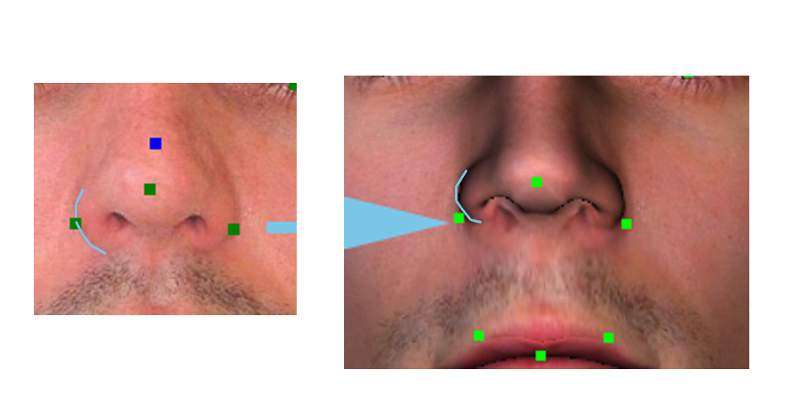

The problem is that while Luxand measures the 2 dots in the middle of the curve, your model applies it to the bottom. Therefore all nose are slightly higher than they should be. It is an easy fix as you should simply move the 2 dots on the model higher to be the same as Luxand.

1. **Not Okay. All the other points are clearly labeled Child Adjustment. Please do not change woman, it was the only thing that was already perfect.**

Child Adjustment. ($50) The reason why we need to adjust the top arc is that children have different head aspects than grown- ups.

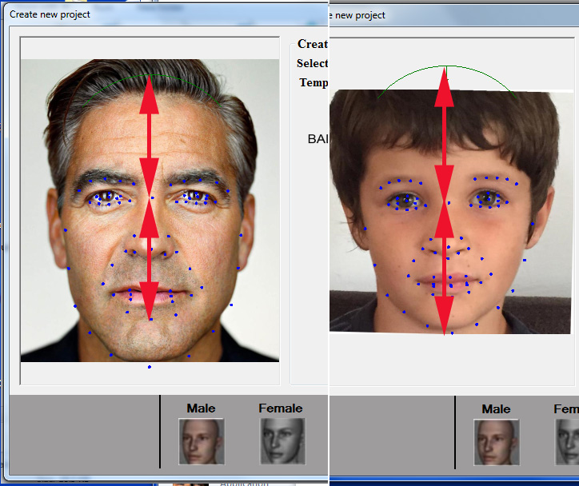

The top arc for Children should be the same distance as the distance from the middle (eyelevel) as the chin.

Eye dot sticking out. ($50)

The problem is that children look weird because the dot of the outside of the eyes is placed in the same z-distance as the inside.

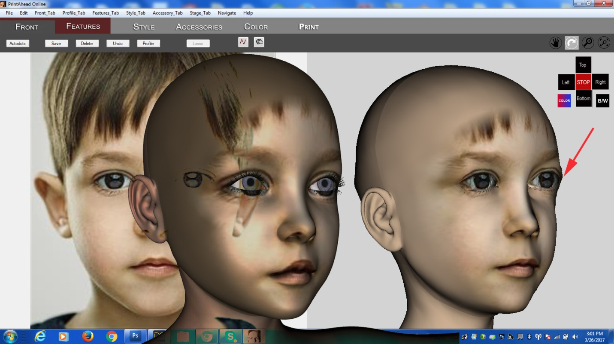

Solution: please move back the eye dot (indicated by arrow) in the z direction, until it looks like the head in the middle.

