PrintAhead 3.0 (Online) PRD PHASE 1 ($1300)

Objective: simplify and enhance app, make it online-friendly. Also, completely automate/improve texture selection, auto hair color, eliminate Color tab. The overall architecture is below.

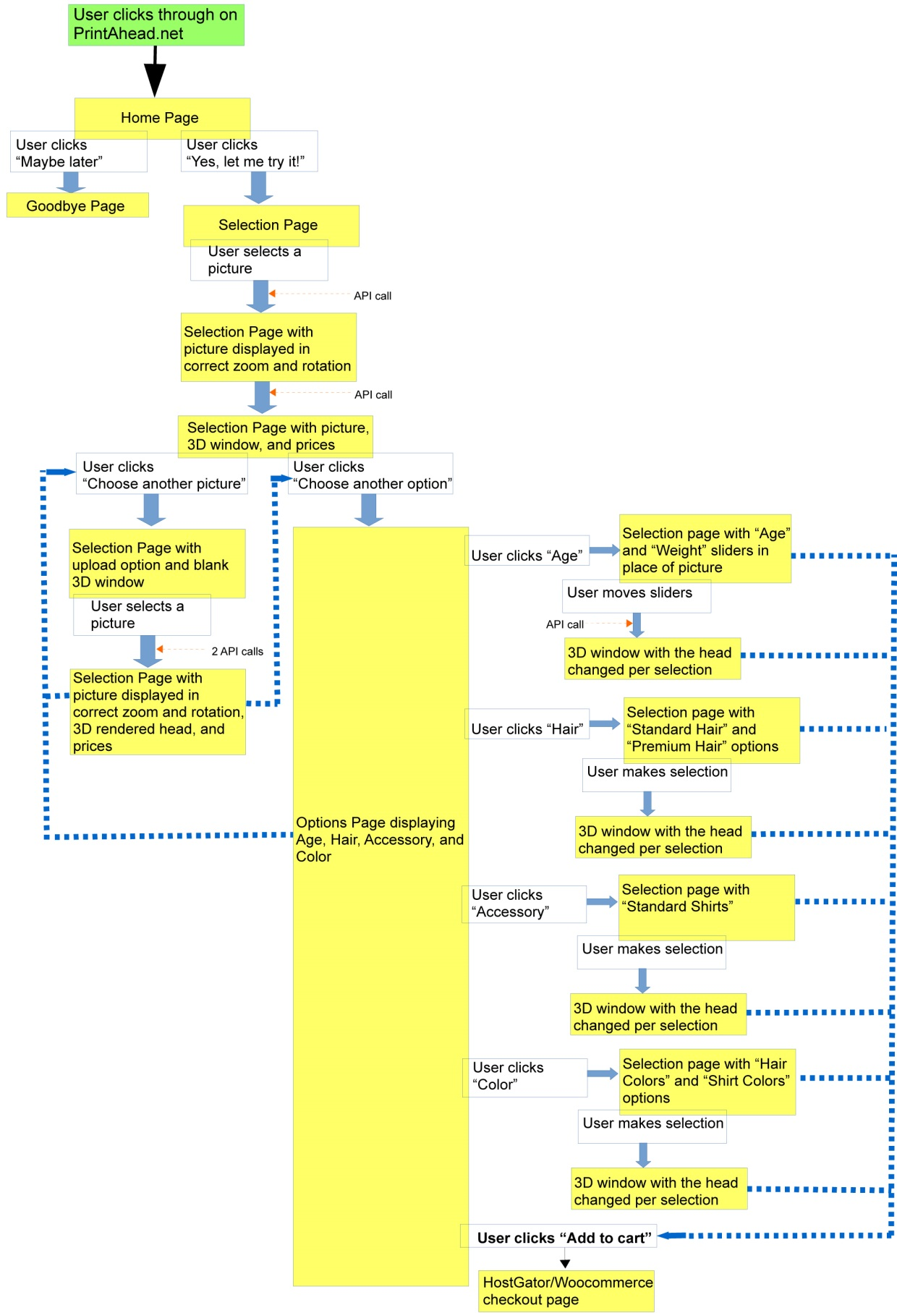

Phase 1. We will complete a proof of concept for Phase 1 as follows:

1. Laslo to sign up for Azure, provide sign-in info to Artem
2. Artem to place and modify PrintAhead so that application will interact with web page.

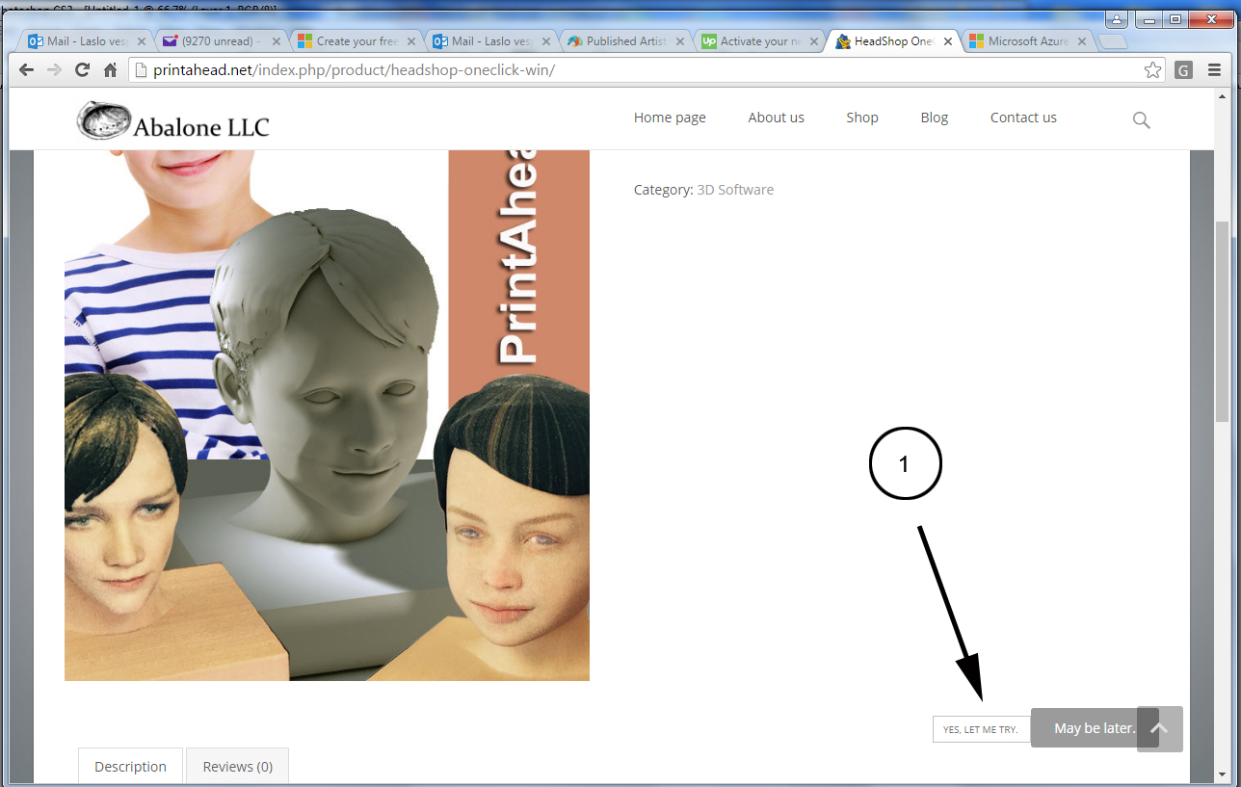

Step 1. “Let’s Try” button-click sends API command to cloud and starts application (equivalent of double-clicking on desktop app icon).

Step 2. On next page, user will browse for a picture. Once picture is choose, API will send the picture to application (equivalent of loading picture in desktop app).

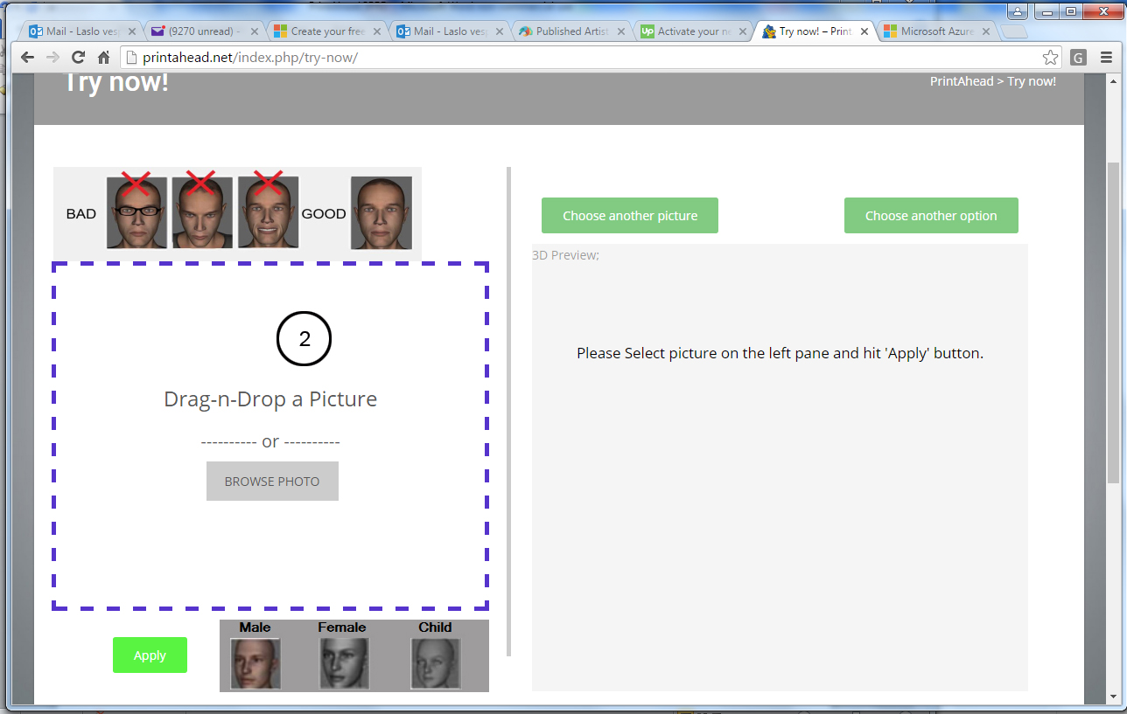

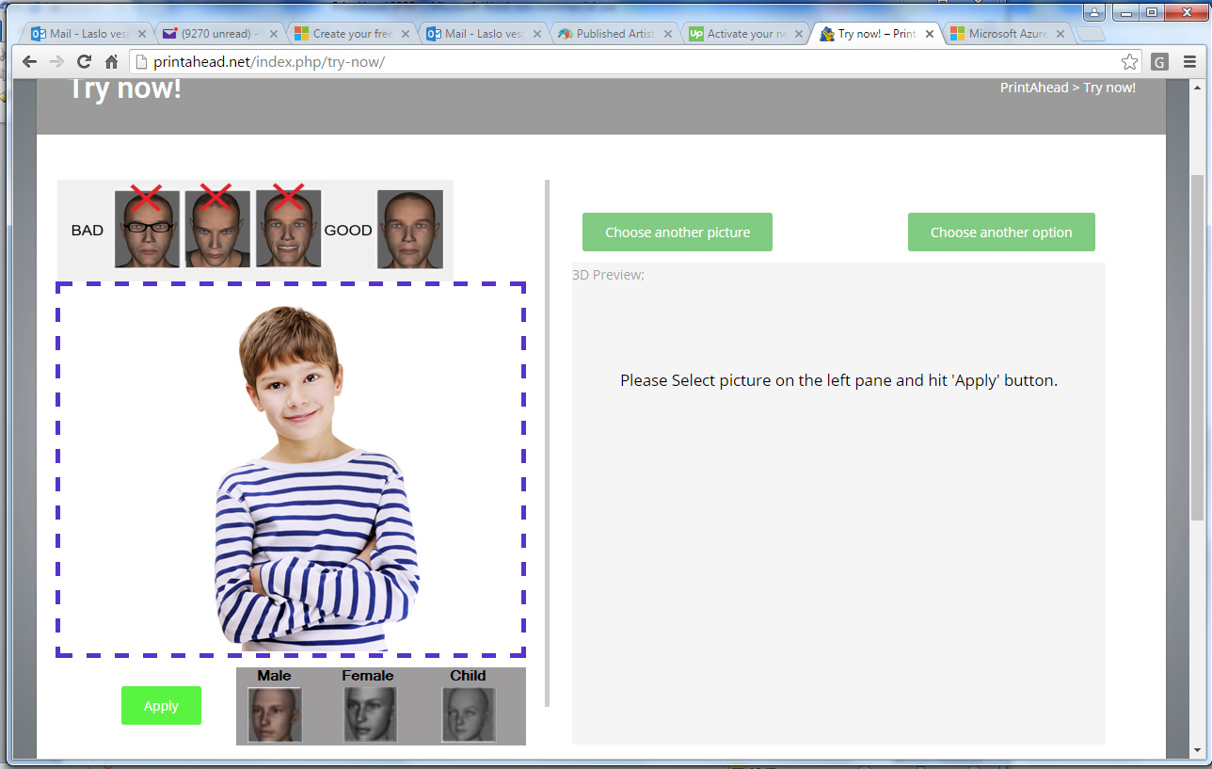

Step 3. Following this application will rotate/crop image and places a temp file “tempProjectImage” into the temp folder on the FTP site. Web page is to pick up and display “tempProjectImage” on page. User will select gender and push “Apply”.

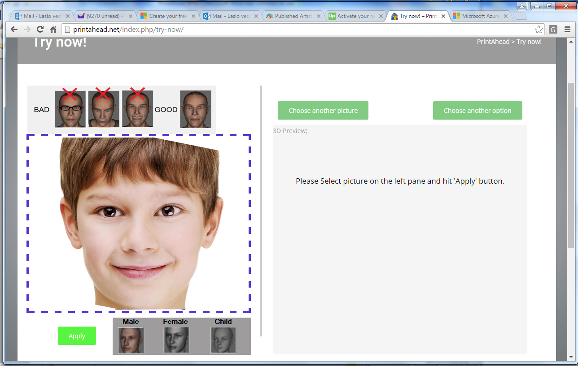

Step 4. “Gender” and “Apply” buttonclick is sent to could app for processing. Once 3D OBJ view is generated, “tempOBJ” is placed in the FTP temp folder. Web page is looking for tempOBJ and will display in the 3D viewer.

NOTE!: Application needs to be amended to display head with default “kidHair” and default “kidShirt”.

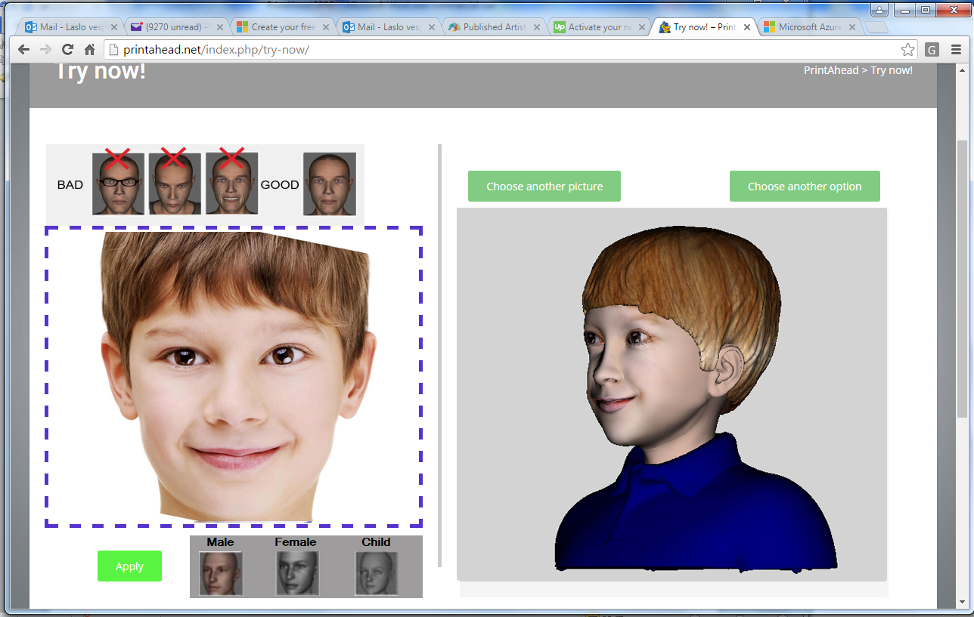

Phase 2. ($550)

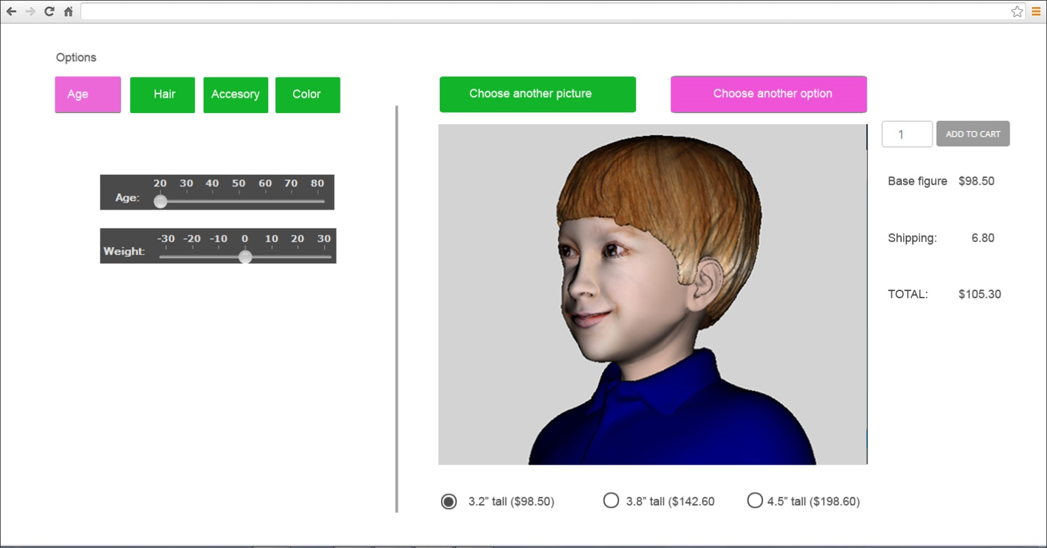

At this stage customer has two options:

1. “Add to Cart” and checkout
2. Choose another option. If user clicks on “Choose another option”, options appear. First option is “Age”. User can move sliders to add age or add/reduce weight. Slider action is sent back to cloud app and results in changes to “temp.OBJ”. New “temp.OBJ” is sent back to web screen.

Hair. When User wants to change hair styles, clicks on the Hair tab.

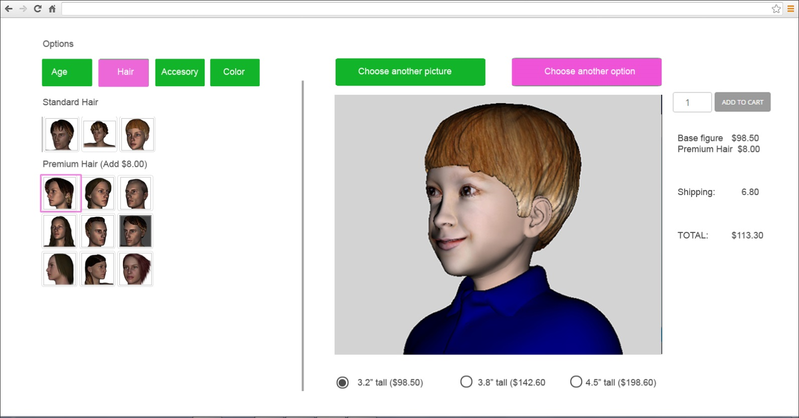

Standard hair loads from Syle/Standard folder, premium hair loads from Style/Premium folder. If user clicks on a hair, it automatically changes the hair (no dragging). If premium, price adds on the right to the total.

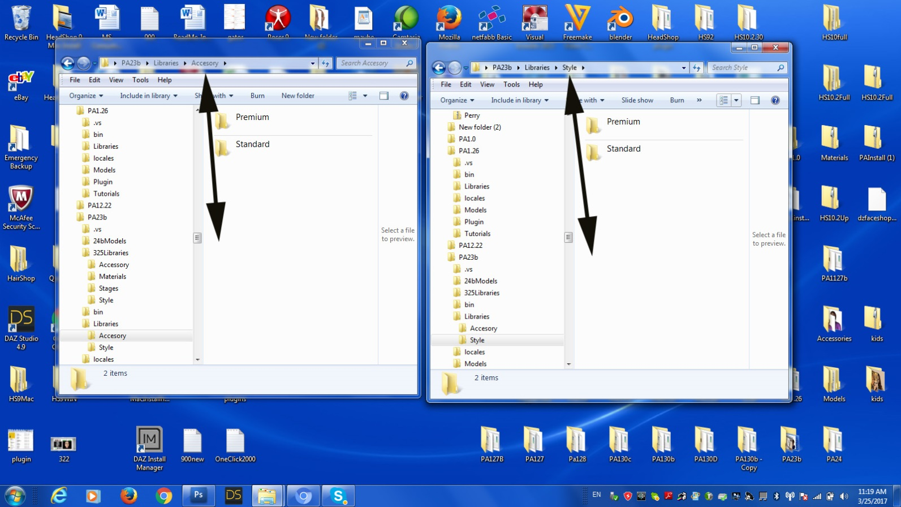

Accessories. Same as hair. Standard accessories loads from Accessory/Standard folder, premium accessories load from PAccessory/Premium folder. If user clicks on a accessory, it automatically changes the accesory (no dragging). If premium, price adds on the right to the total.

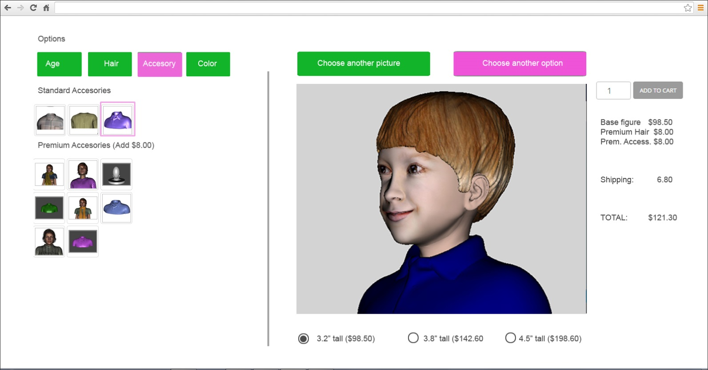

Last tab is color. User can click on a hair color (no charge) to change color of the hair. User can click on accessory color to change pattern on accessory.

