PRE-BETA CHANGES

Artem,

I had a very important meeting regarding PrintAhead, where it was suggested that we do some changes prior to going beta. Here are the changes to consider:

1. **Pre-qualification of pictures**. ($150) Users still have a hard time to decide whether a picture is going to work or not. Many don’t understand the concept of a head being turned sideways or up/down.

I wonder if we can use Luxand to “pre-qualify” or reject pictures based on this criteria. Since you have already addressed this issue in the HS11 project (head turned away), we can use the code to warn if picture is turned more than 5% or to reject a picture if it is turned more than 10%

Horizontal turn

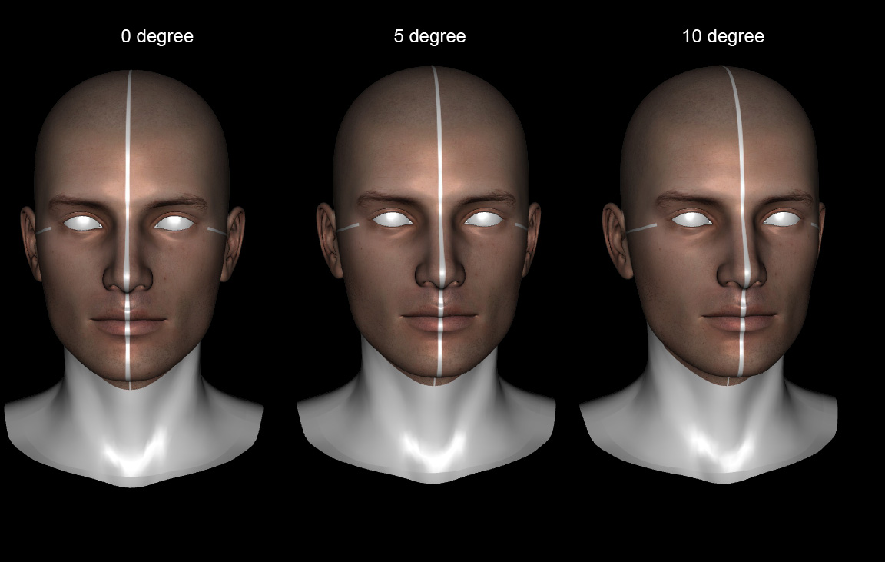

Vertical turn

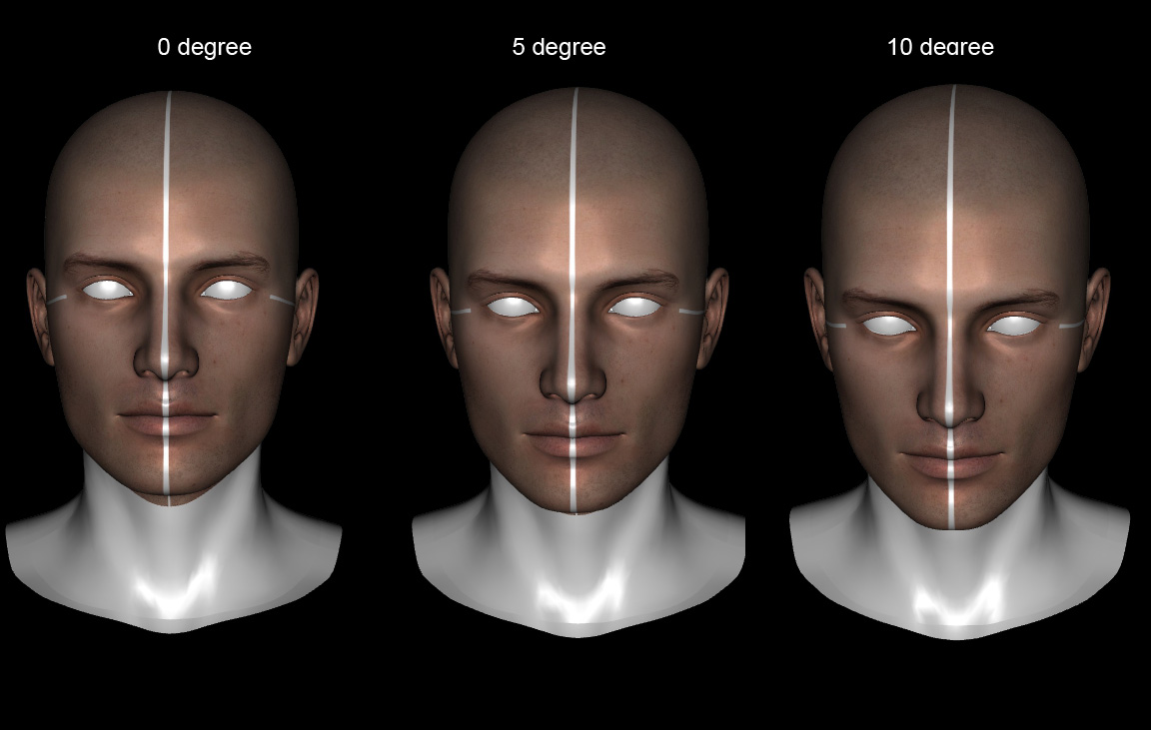

In Case of 5-10%, a yellow warning

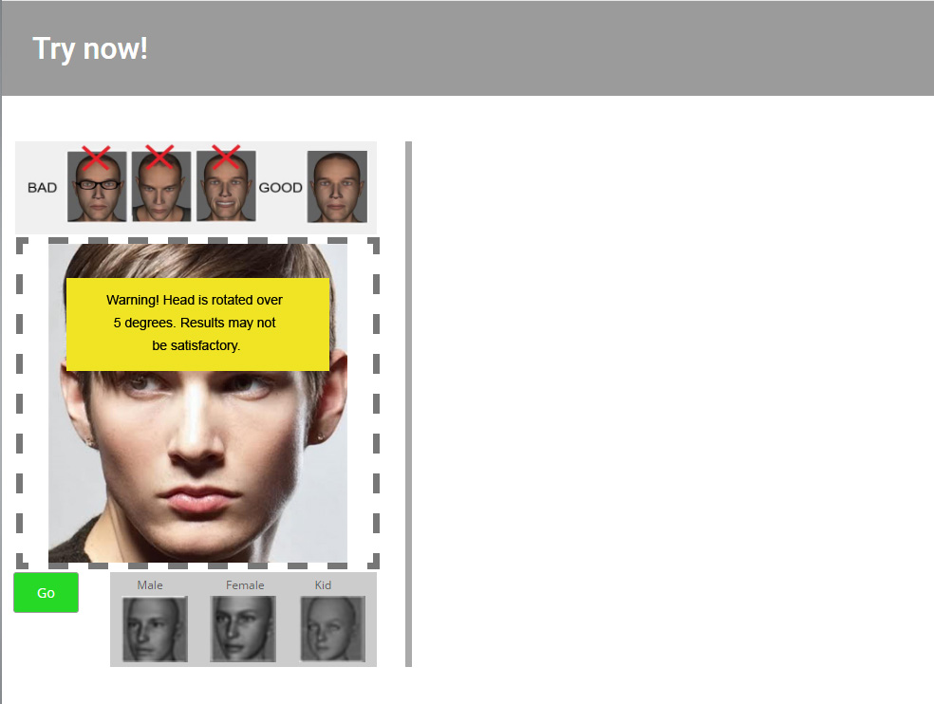

In case of more than 10% a red warning (picture will not load).

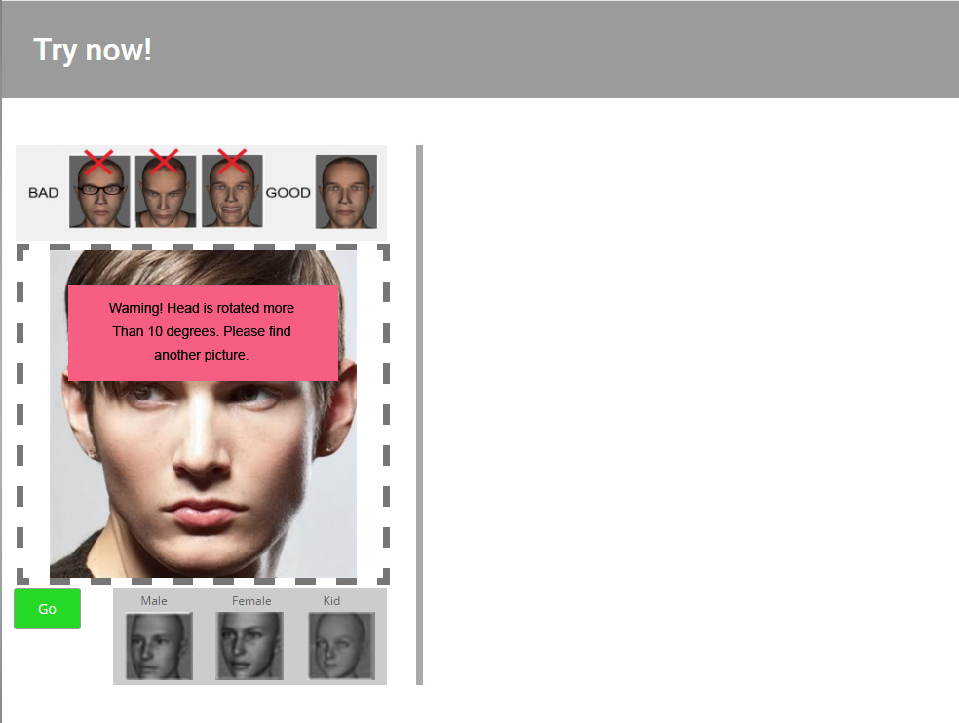

**Various smaller fixes ($150)**

1. **Forehead texture**: there is a problem that hair texture carries over to the 3D head and creates artifacts on forehead. The simple solution is to lower to upper portion of the mask we use to just above the eyebrows.

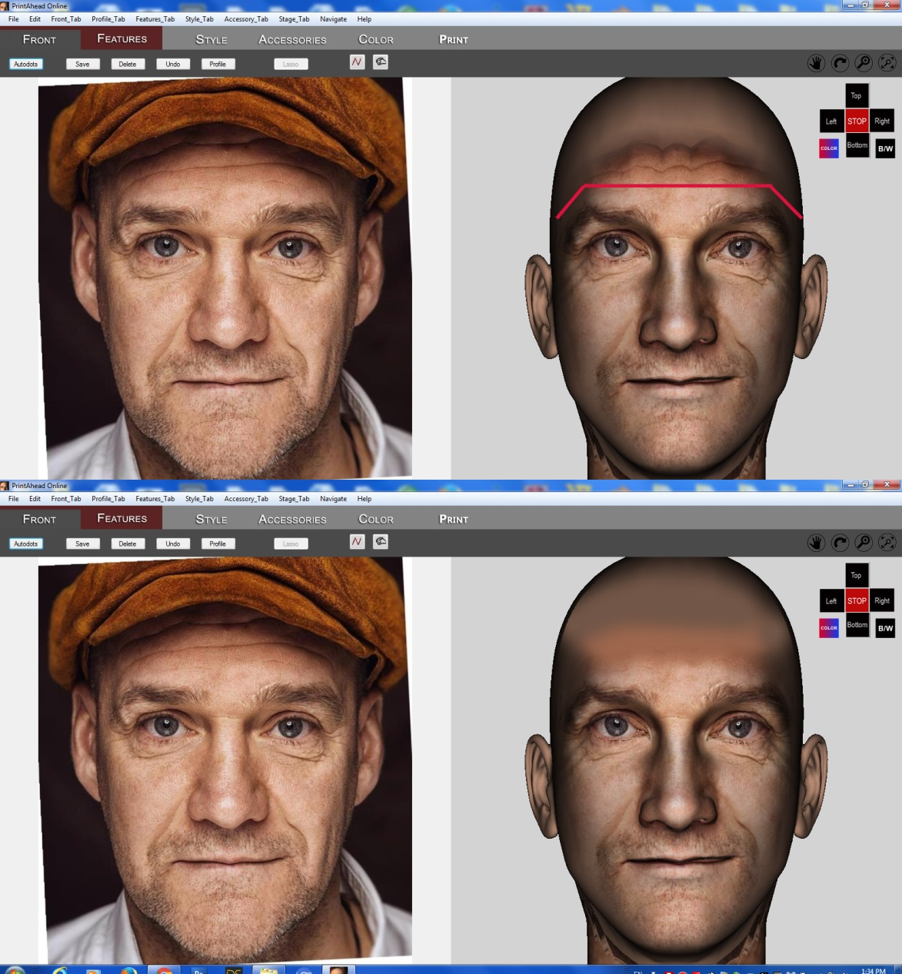

1. When initial picture loads (Process button pressed), we need the spinning wheel to tell customer that we are processing picture).
2. The background and lighting in the 3D window is not very good (I know that this is how we got it). I wonder if there is code to adjust lighting and change background color to light gray.
3. Rename “Choose other option” to “Options”.
4. IMPORTANT: we need to solve the issue of choosing multiple selections (for example, pressing hair, hair color and shirt without waiting while the spinning wheel still spins) and not crash the system.