Detailed Design Document

Project 7 - International Darth Vader

## Sponsor: Pierce Freelon - Blackspace

## Technical Mentor: Bobby Compton

# Team

### Christopher Woedy

### Rachel Williams

### Anthony Gill

### Logan Adams

ECE 484 - May 2nd, 2016

TABLE OF CONTENTS

1. Introduction ……………………………………………………………...………………….…Pg. 3

1.1 Background ……………………………………………………………...………...….… Pg. 3

1.2 Roles and Responsibilities …………………………………………...…..…..….….… Pg. 3

1.3 Cost Estimate …………………………………………………………...…..…….….… Pg. 4

1.4 Project Timeline ………………………………………………………...…….......….… Pg. 4

1. Product Requirements .………………………………………………...…………....…….…Pg. 6

2.1 User Interaction Feature ..……………………………………………...………...….… Pg. 6

2.2 Size, Weight, Look, & Feel ..…………………………………………...………...….… Pg. 7

2.3 System Behavioral Features ...………………………………………...………...….… Pg. 7

2.4 Required Documentation ….....………………………………………...………...….… Pg. 7

2.5 Maintenance Requirements ....………………………………………...………...….… Pg. 8

2.6 Compatibility Constraints ….....………………………………………...………...….… Pg. 8

2.7 Cost Constraints ……………....………………………………………...………...….… Pg. 8

2.8 Design Constraints …………....………………………………………...………...….… Pg. 8

2.9 Interface Constraints ……….....………………………………………...………...….… Pg. 9

1. System Drawings ……...…………………………………………………...………....…….…Pg. 9
2. Use Case & Operational Diagrams .…………………………………...…………....…….…Pg. 11
3. System Block Diagrams …………....…………………………………...…………....…….…Pg. 12

5.1 Darth Vader ………....……….....………………………………………...………...…… Pg. 12

5.2 Server …….………....……….....………………………………………...………....…… Pg. 13

5.3 Client ……..………....……….....………….……………………………...………...……. Pg. 14

1. Design Challenges …….…………....…………………………………...…………....…….…Pg. 15

6.1 Darth Vader Design Challenges ...……………………………………...………...….… Pg. 15

6.2 Server System Design Challenges ..…………………………………...………...…….. Pg. 17

6.3 Mobile Client Design Challenges ….…….……………………………...………...….… Pg. 18

1. System Design Alternatives ..……....…………………………………...…………....…….…Pg. 19

7.1 Design Brainstorming ………….....……………………………………...………...….… Pg. 19

7.2 Design A ……………..………….....……………………………………...………...….… Pg. 19

7.3 Design B ....…………..………….....……………………………………...………...….… Pg. 20

7.4 Design C ……………..………….....……………………………………...………...….… Pg. 21

7.5 Design Advantages & Disadvantages ..………………………………...………...….… Pg. 22

1. Component Selection Alternatives ....…………………………………...…………....…….…Pg. 23

8.1 Microcontroller …………….…….....……………………………………...………...….… Pg. 23

8.2 Wi-Fi Module ..…………….…….....……………………………………...………...….… Pg. 24

8.3 Selected Components ..….…….....……………………………………...………...….… Pg. 25

1. Subsystem Block Diagrams …….......…………………………………...…………....…….…Pg. 25

9.1 Wi-Fi …………………....….…….....……………………………………...………...….… Pg. 25

9.2 Audio ...………………....….…….....……………………………………...………...….… Pg. 26

9.3 Storage ………………....….…….....……………………………………...………...….… Pg. 27

9.4 Power Supply ………....….…….....……………………………………...………...…..… Pg. 28

9.5 Interface ………....….…….....……………………….…………………...………...…..… Pg. 29

9.6 Server Application ….…….....……………………….…………………...………...…..… Pg. 30

9.7 Server Storage ….………......……………………….…………………...………...…..… Pg. 31

9.8 Server Administration …........……………………….…………………...………...…..… Pg. 32

9.9 Mobile Application …….........……………………….…………………...………...…..… Pg. 33

1. Preliminary User Interface Design .....…………………………………...…………....…….…Pg. 34

10.1 Darth Vader …….........…………….……………….…………………...………...…..… Pg. 34

10.2 Server ………..….........…………….……………….…………………...………...…..… Pg. 36

10.3 Mobile Client ...….........…………….……………….…………………...………...…..… Pg. 37

1. Software Design Documentation. .....…………………………………...…………....……..…Pg. 38

11.1 Darth Vader System Software ...….……………….…………………...………...…..… Pg. 38

11.2 Server System Application Software ….………….…………………...………...…..… Pg. 39

11.2 Mobile Client Application Software ….…...……….…………………...………...…..… Pg. 40

1. Preliminary Mechanical Enclosure Design ..…………………………...…………....……..…Pg. 41

# 1. Introduction

**Objective:** The objective is to create an International Darth Vader social music education tool to inspire, educate, and diversify students for approximately $150 before

Friday, December 4th, 2016.

### 1.1 Background

The International Darth Vader product is a social music education tool designed to spark creativity in students around the world. By using the International Darth Vader product, students will be introduced to other cultures, thoughts, and feedback that will encourage critical thinking with a diversified approach. The device will work by linking up with the cloud through a broadcasted Wi-Fi connection. Through the cloud, the International Darth Vader will be able to download voice, music, and media clips from the server backend. Audio data pulled from the server will be determined by user specified tags and downloaded by recency. The backend will receive this audio data from mobile clients and store the information locally until requested by the International Darth Vader product. After a certain period of time, the server backend will store these files in a server-side archive.

### 1.2 Roles and Responsibilities

This section provides a brief overview of the roles and responsibilities for the International Darth Vader project. Each team member will be entrusted to accomplish these responsibilities within set expectations and deadlines. Moving forward, team members will ensure that each system not only works independently, but also as a symbiotic whole to the overall system architecture.

* Christopher Woedy
  + Project Management
  + Communications
  + Systems’ Qualification/Debug
* Rachel Williams
  + Mobile Application Development
  + Matlab Audio Simulation
* Anthony Gill
  + System Hardware
  + Embedded System Programming
  + Mechanical Packaging
* Logan Adams
  + Server Administration
  + Server System Programming
  + Database Structuring
  + Networking

### 1.3 Cost Estimate

This section gives an overall cost estimation and analysis of the International Darth Vader Project. This section includes components used for the project's design and different system implementations.

| Part Name | Price per Part (Approximation) |
| --- | --- |
| Darth Vader | $94.97 |
| Raspberry Pi 3 | $35.00 |
| Power Supply | $10.00 |
| Battery Holder | $3.00 |
| AA Batteries | $1.25 |
| Speaker | $7.65 |
| Audio Amplifier | $3.95 |
| MicroSD Card | $5 |
| Total: | $ 160.82 |

Figure 1: Cost Estimation Table

Additional Costs: An additional cost of the project is the utilization of Amazon Web Services to host the backend of the project’s embedded and mobile systems. This cost has yet to be determined and will be accessed through a American Underground’s Google For Entrepreneurs services.

### 1.4 Project Timeline

This section provides a timeline and Gantt chart overview of the International Darth Vader Project’s plan. The first timeline gives an overview of the overall scope of the plan. The first Gantt chart depicts the planning structure that was utilized throughout Senior Design I. The second Gantt chart illustrates the projected project plan during the course of Senior Design II. Although subject to change, this is a broad overview of the intended schedule to follow for the remainder of the project in order to meet expectations.

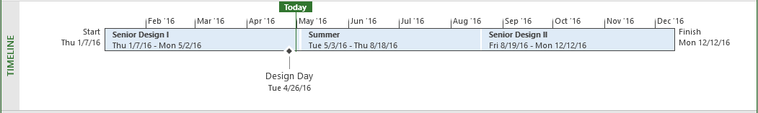

Figure 2: Project Timeline

| **Gantt Chart Color Key** | |
| --- | --- |
| **Green** | Semester / Class |
| **Yellow** | Documents |
| **Blue** | Overall System |
| **Purple** | Server System |
| **Orange** | Mobile Client |
| **Sage** | Embedded System |
| **Red** | Milestone |
| **Grey** | Buffer Time |

Figure 3: Gantt Color Coding

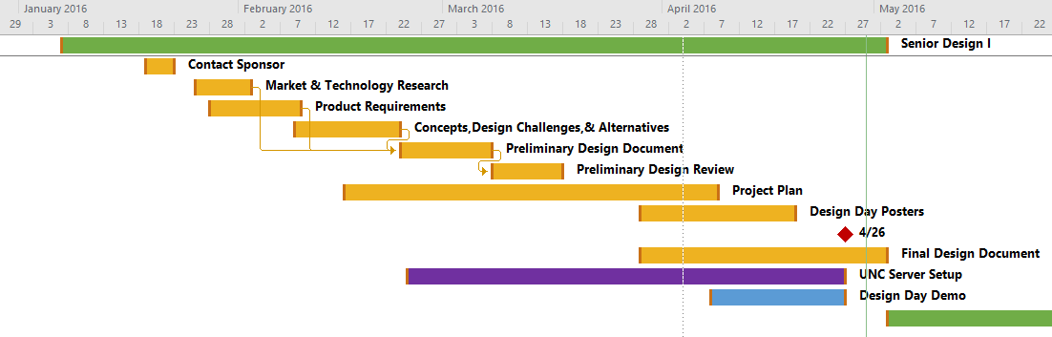

Figure 4: Senior Design I Gantt Chart

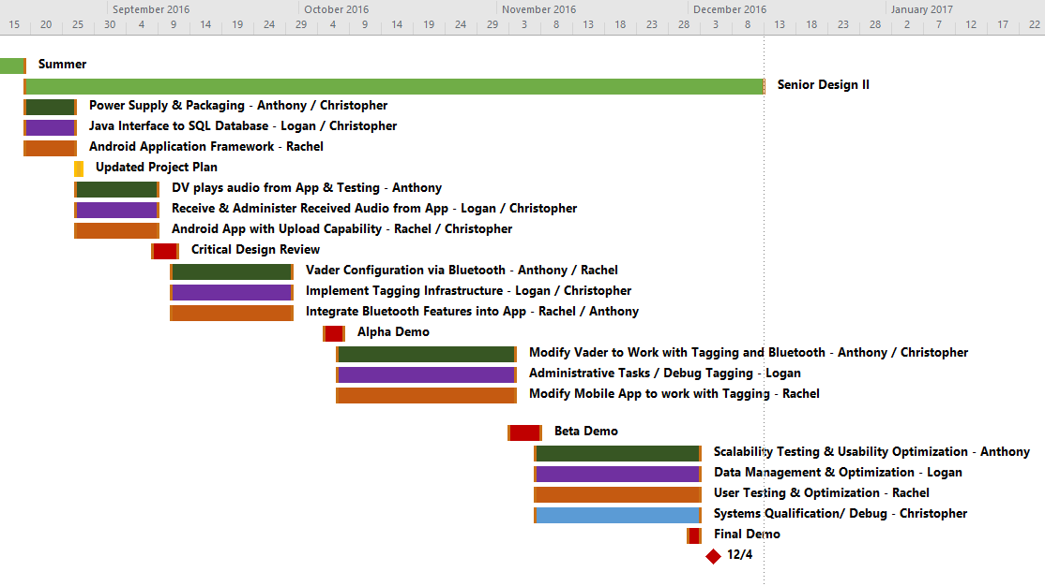

Figure 5: Senior Design II Gantt Chart

See uploaded project file for detailed analysis of above Gantt charts.

# 2. Product Requirements

This section discusses the product requirements for various different aspects of the International Darth Vader product. Product requirements that have changed since the preliminary design document are marked in *dark red*.

### 2.1 User Interaction Features

This section details the list of user interaction requirements for the Darth Vader product. The list of features is provided in a numerical list below with each list item giving a description of the provided requirement.

1. The system shall connect to a Wi-Fi router to communicate with a backend server.
2. The system shall be able to play-back 15 seconds of voice and music uploaded from a client session.
3. The system shall be easy to configure and connect to a network. Network configuration will be tested by Pierce’s focus groups (students) to determine the ease of the process.
4. The system shall use an Android application for user input.
5. The backend server application shall support an archive feature for stored sound clips.
6. The backend server application may be adaptable to physical memory upgrades. If a new hard drive is added to the server, the application may be able to hand different hardware configurations.
7. The database shall support a tagging system for clip filtering and administration.
8. A client shall be able to upload voice and audio clips to the server backend.

### 2.2 Size, Weight, Look, & Feel

This section details the list of size, weight, look, and feel requirements for the Darth Vader product. The list of features is provided in a numerical list below with each list item giving a description of the provided requirement.

1. The system shall be housed in a Darth Vader figurine.
2. The system shall be light enough to be carried by one person (i.e. less than twenty-five pounds).

### 2.3 System Behavioral Features

This section details the list of system behavior requirements for the Darth Vader product. The list of features is provided in a numerical list below with each list item giving a description of the provided requirement.

1. The system shall interface with 802.11 a/b/g/n WiFi network connections.
2. The system shall have four replaceable AA batteries to help address areas with electricity limitations.
3. The system shall be able to be switched off to save power when not used or transported.
4. The system may have high quality audio playback (~3 watt speaker upgraded over Darth Vader figure’s current speaker).

### 2.4 Required Documentation

This section details the list of documentation requirements for the Darth Vader product. The list of features is provided in a numerical list below with each list item giving a description of the provided requirement.

1. The system shall have setup documentation.
2. The system shall have usage documentation.
3. The system shall have support and troubleshooting documentation if it needs to be serviced by the user.
4. The product shall have documentation detailing instructions and interaction between client, cloud, and product.

### 2.5 Maintenance Requirements

This section details the list of maintenance requirements for the Darth Vader product. The list of features is provided in a number list below with each list item giving a description of the provided requirement.

1. The system shall be easily and minimally maintenanced. This will be verified by a test group.
2. The system shall have simple diagnostic programs to verify system integrity.

### 2.6 Compatibility Constraints

This section details the list of compatibility requirements for the Darth Vader product. The list of features is provided in a numerical list below with each list item giving a description of the provided requirement.

1. The system shall be compatible with common IEEE 802.11 a/b/g/n network standards.
2. The system shall be compatible with Android mobile platform.
3. The system may be compatible with other platforms (i.e. iOS, Windows, UNIX, etc.).
4. The backend server application shall be compatible with a UNIX based operating system.
5. The backend server application may be compatible as a Windows server application.

### 2.7 Cost Constraints

This section details the list of cost constraints for the Darth Vader product. The list of features is provided in a numerical list below with each list item giving a description of the provided requirement.

1. The product shall be under $50 excluding the Darth Vader figurine.
2. The client phone app shall be free to download.

### 2.8 Design Constraints

This section details the list of design constraints for the Darth Vader product. The list of features is provided in a numerical list below with each list item giving a description of the provided requirement.

1. The design and implementation shall refrain from severely altering original Darth Vader appearance, retaining the shape and structure.

### 2.9 Interface Constraints

This section details the list of interface constraints for the Darth Vader product. The list of features is provided in a numerical list below with each list item giving a description of the provided requirement.

1. The client interface shall be simple and straightforward so that it can easily be used by people of all ages. This will be verified by Pierce’s test student group.
2. The interface shall be accessible on the Android mobile platform.
3. The backend shall be easily managed from the server application. This will allow sound clip approval or removal from the server system at runtime.

# 3. System Drawings

This section features the overall system drawing of the International Darth Vader project. This figure is designed to illustrate the basic and general functionality to someone who has never seen the project before. The system drawing shows the major components housed inside the Darth Vader system to give a general overview of the types of functionality it will have. There is a cloud image representing connection to the backend server system for audio download. In the bottom right corner, the phone is demonstrating that the Darth Vader system is primary controlled by the phone as well as the audio upload features that are part of the phone platform as well.

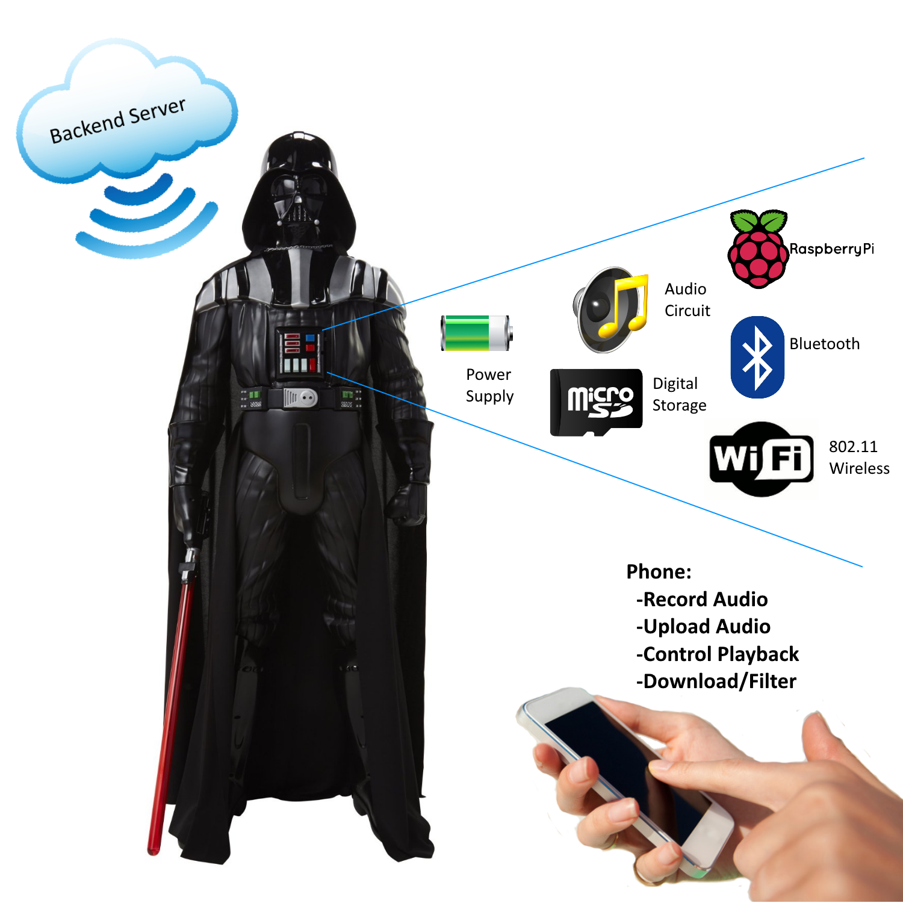

Figure 6: System Drawing

# 4. Use Case & Operational Diagrams

This section summarizes the operation of the systems with relation to the users and administrators. The high-level diagrams below show how different types of people are supposed to interact with the device. The first diagram illustrates functional flow of the device using graphics to help demonstrate the action performed. The system administrator manages the back end database, configures the system, and determines when the system will be made available to students. Students may then power on the device, upload audio, download audio, and playback from the system.

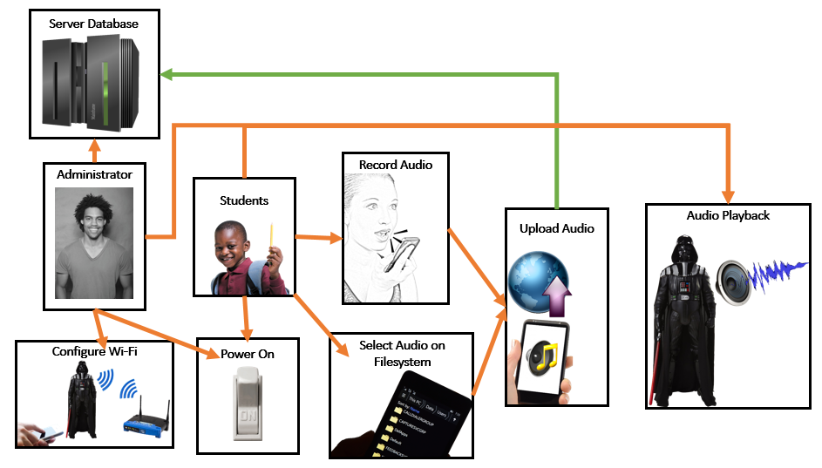

Figure 7: Graphical Use Case Diagram

The next chart illustrates a similar concept as the graphical use case diagram; however, this chart puts an emphasis on process flow and less of an emphasis on the action performed.

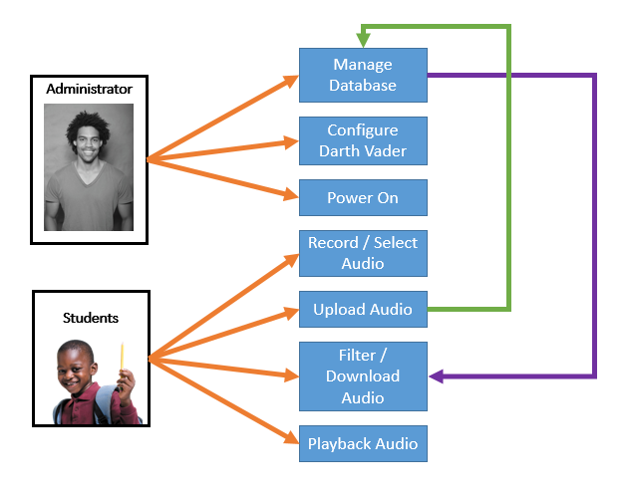

Figure 8: Use Case Process Flow Diagram

# 5. System Block Diagrams

This section displays and analyzes block diagrams and system architecture of the various components of the overall Darth Vader system. Each section details a high-level system with a brief description and system diagram.

### 5.1 Darth Vader

The Darth Vader system is designed to be the primary implementation of the project’s functionality. The Darth Vader system will download the uploaded audio clips and metadata tags from the server system. Once downloaded to the Darth Vader system, users can then scroll through available clips for playback. Playback will allow for both original clip and Darth Vader audio modulation of the clip. The Darth Vader system will also retain the original functionality of the Darth Vader figurine.The diagram below illustrates an overview of the Darth Vader system using block representation.

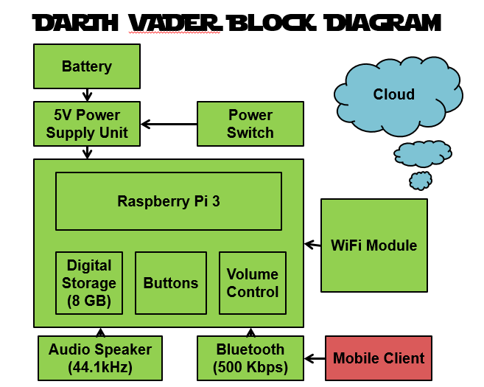

Figure 9: Darth Vader System Block Diagram

### 5.2 Server

The server system will be dedicated to storing audio clips received from the client, uploading these clips to the Darth Vader system, and administration of the received client data. The server system will hold the network addresses of all available Darth Vader systems to allow clients to forward data to any Darth Vader system displaying an online status acknowledgement. The system will be manageable by an administrator to modify or remove any unwanted content. Audio clips will be uploaded and managed by tags. Each tag associated with a clip will be treated as a keyword for filtering. Darth Vader systems will be able to pull these audio clips by their associated tag and recency. The diagram below illustrates an overview of the server system using block representation.

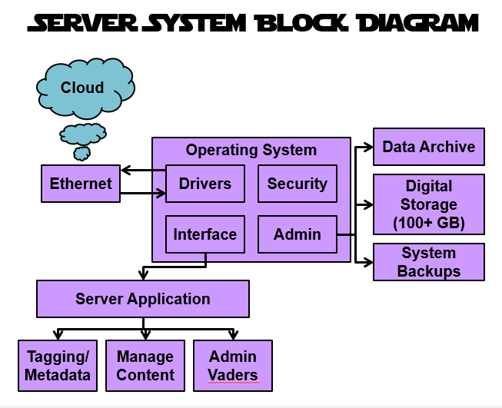

Figure 10: Server System Block Diagram

### 5.3 Client

The client system will be the primary method to uploading audio clip data for users. This system is essential for users to upload clips to the server from any location. The mobile client application will either make use of the mobile device’s integrated microphone to create new audio clips or upload existing audio clips from the device’s file system. Utilizing this method allows the Darth Vader to be a classroom’s hub to global inspiration and ideas. The diagram below illustrates an overview of the mobile client system using block representation.

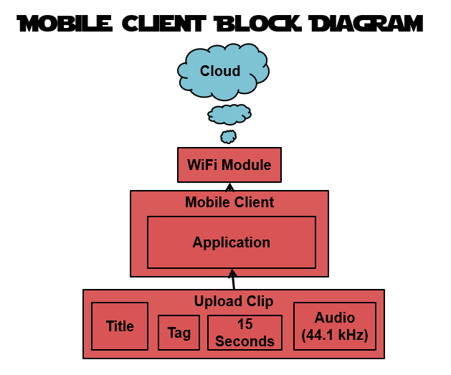

Figure 11: Mobile System Block Diagram

# 6. Design Challenges

This section includes highlights and discusses each of the different design challenges for the three primary system diagrams. Each design challenge is outlined with a color-coded square to make them easily identifiable.

### 6.1 Darth Vader Design Challenges

Below is the image of the Darth Vader system diagram with outlined design challenges:

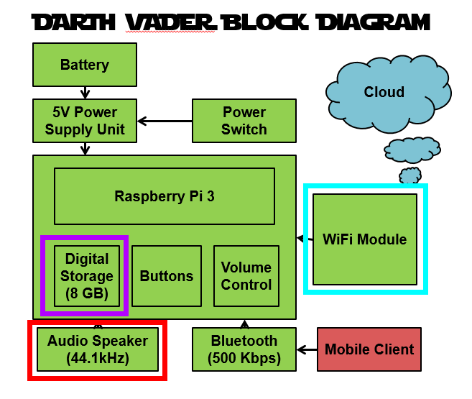

Figure 12: Darth Vader System Design Challenges

* **Wi-Fi Module (Blue)**: The Wi-Fi module may present a configuration challenge as the Darth Vader system does not have a good way to enter text based data. This will present a challenge because the Wi-Fi module will need string data to be configured to different SSID’s and to enter security keys for these devices. An alternative would be link to the device via Bluetooth to configure Wi-Fi settings depending on Bluetooth availability.
* **Audio System (Red)**: The audio system will present difficulty of upgrading the current speaker system on the device.
* **Digital Storage (Purple)**: Addition of digital storage may be a challenge as the device will need to be configured to accept an external memory device. The digital storage will need to be large enough to hold many audio files locally.

### 6.2 Server System Design Challenges

Below is the image of the server system diagram with outlined design challenges:

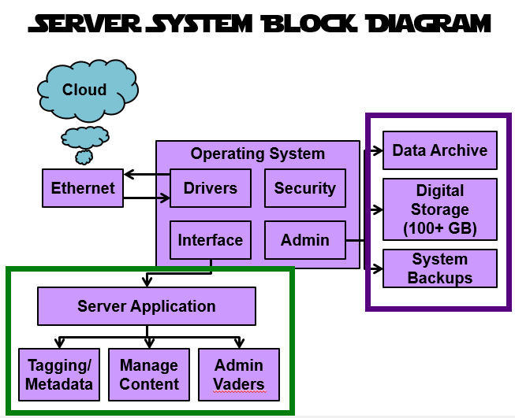

Figure 13: Server System Design Challenges

* **Digital Storage (Purple)**: The server will need to have ample storage for saving audio data. Archive may need to implement compression algorithm to save storage space on the server when preserving old files on the database.
* **Server Application (Green)**: The server-side application will need to have code that opens network connections for multiple clients from various parts of the world. The application will also need administrative features such as content removal.

### 6.3 Client Design Challenges

Below is the image of the mobile client system diagram with outlined design challenges:

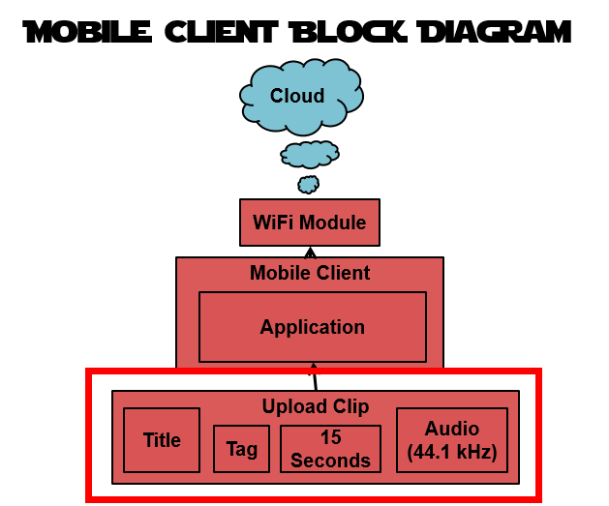

Figure 14: Mobile Client Design Challenges

* **Interface Audio Device & Audio Modulation (Red)**: Working, interfacing, and uploading audio files will be challenging as it will be necessary to learn and apply digital signal processing. This will also require access to the mobile client’s audio hardware for recording and playback. It will also be neccesary to implement the ability to apply filters and modulate audio clips before upload to the server system.

# 7. System Design Alternatives

### 7.1 Design Brainstorming

In order to effectively create a system design overview, the team first had to brainstorm potential design ideas. This process involved breaking down the International Darth Vader system, mobile client system, and server system into their core components for analysis as well as identifying the major challenges and concerns of designing the components of each system. However, not every design was successful. This section details a couple different potential designs highlighting the positives and negatives of each design. These designs focus on the high-level systems and how they interact with each other before breaking the system down into components.

### 7.2 Design A

The first design involved theorizing the possibility of each Darth Vader hosting as its own server. The benefit of this would be that it would cut down on the costs of hosting and managing a separate server system. Unfortunately, this ended up being a “wouldn’t it be cool” approach as the design’s cons significantly outweighed its pros. The design would have required that the Darth Vader system draw much more power and would not be able to operate without being plugged in. Another major drawback is that the system would need to have a 99.98% internet uptime which would remove the wireless aspect of the product. Because the device is intended to store and playback media, the system would need access to a vast array of digital storage. Thus, the design was eventually scrapped as it would make the expected product requirements for the project unattainable.

Below is the system diagram for Design A: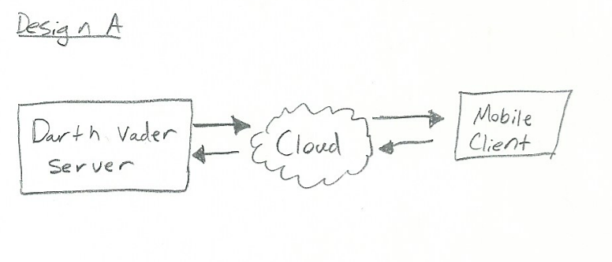

Figure 15: Design A High-Level Diagram

### 7.3 Design B

Realizing that the server system would need to be separated from the Darth Vader system, discussion began on how the Darth Vader system would inevitably connect to the internet. The immediate and obvious choice was through Wi-Fi, but this raised the question: how would the device be configured to connect to a wireless network? One interesting thought was, what if it didn’t need to be configured at all? The idea of the Darth Vader system piggybacking off the mobile client’s internet access was then considered. The benefit of this method was that the device would have a simplistic bluetooth pairing process and then would be ready for use. However, there were several drawbacks to this approach. The Darth Vader system would require a mobile device in order to use it properly. Mobile phone security might restrict access to low-level hardware like Wi-Fi and Bluetooth modules. This design was eventually scrapped because it did not align with Pierce’s expectations for the Darth Vader system to connect independently to Wi-Fi.

Below is the system diagram for Design B: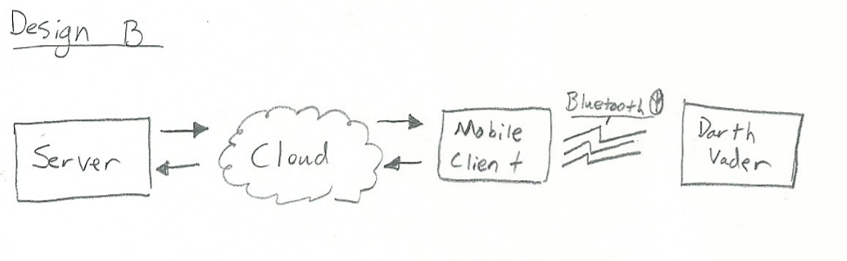

Figure 16: Design B High-Level Diagram

### 7.4 Design C

Learning from the mistakes of previous designs, another concept was pieced together which is believed to fit Pierce’s expectations as well as the design requirements. The chosen design for the project utilized a mobile client that would upload content to a backend server. Once approved by the server and requested by the Darth Vader system, the content would be sent over the internet to the Darth Vader system. The Darth Vader system would be linked to the internet via Wi-Fi and store content locally for playback. This implementation had the server as a central data point where the client would upload the data and the Darth Vader module would download it. This also creates simplicity on data throughput aka client uploads, Vader downloads.

Below is the system diagram for Design C: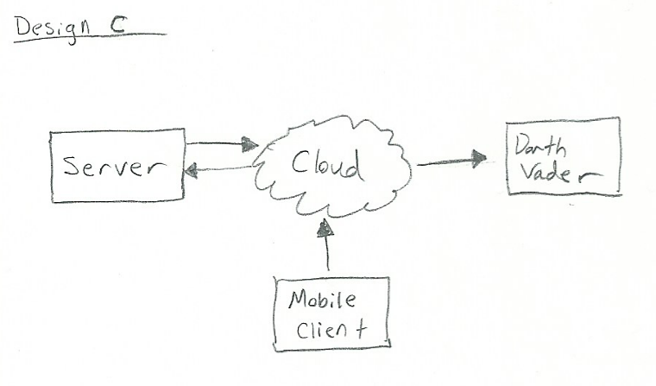

Figure 17: Design C High-Level Diagram

### 7.5 Designs Advantages & Disadvantages

The chart below details the pros and cons of Design A, B, and C in relation to specified product requirements.

| Product Requirement | Design A | Design B | Design C |
| --- | --- | --- | --- |
| System shall connect to the cloud to communicate with a backend server | CON - Vader would need to meet a high uptime and have a major increase in power consumption if acting as a server. | CON - Vader will require a mobile phone for connectivity. | PRO - Server’s, Client’s, and Vader’s internet connections are independent. Vader doesn’t rely on client. |
| The product shall be under $50 excluding Vader figure. | PRO - Cut overall cost by not having to operate and maintain a separate server system  CON - Vader’s overall product cost would increase. | PRO - Bluetooth modules for connectivity are generally cheaper than most WiFi modules | PRO - Meets Pierce’s design expectations.  CON - WiFi modules are more expensive than bluetooth modules. |
| The system shall be able to play-back up to ten 15 seconds clips of voice and music uploaded from a client session. | PRO - Vader would hold all the clips locally.  CON - Vader would need to house a significant amount of storage. | PRO - Local stored clips downloaded from server.  CON - Requires client to download from server | PRO - Local stored clips downloaded from server from Vader’s own WiFi connection. |

Figure 18: Comparison Table of System Designs

# 8. Component Selection Alternatives

This section discusses the component selection process and the alternative part considerations for the Darth Vader subsystems.

### 8.1 Microcontroller

The microcontroller is a crucial component of the Darth Vader system as it is the core to the various Darth Vader systems including the interface, storage, Wi-Fi, and audio subsystems. After a significant amount of research and comparison of different available microcontroller units, the Raspberry Pi 3 was ultimately selected. The table below details a list of the advantages and disadvantages of three microcontrollers that were considered prior to selecting the Raspberry Pi 3.

|  | Intel Edison | Raspberry Pi 2 | MSP430 |
| --- | --- | --- | --- |
| Pros | * Integrated Wi-Fi * Integrated Bluetooth * Integrated Digital Storage - 4GB Flash * Expandable MicroSDHC memory slot * Compute power to handle audio processing * C, C++, Python, NodeJS, HTML5, and Wolfram language availability * 1GB RAM * 3.3V - 4.5V @ <1W Power Consumption * Built Into Custom PCB * Designed for IOT | * Cheaper ~$35 * Quadcore ARM processor * Expandable MicroSDHC memory slot * Window 10 IOT/ Linux Distribution * C, C++, Java, Perl, Ruby, Squeak language availability * Large User Support | * Ultra-low power * Low cost * Team experience with development on MSP430 platform |
| Cons | * Expensive ~$50 | * No integrated Wi-Fi, expandable via USB dongle * 5V * 600mA (~3W) * Power Consumption * Revolves around user having an external screen and keyboard | * Only programmable in C/C++ * Time/Difficulty to implement * Wi-Fi implementation challenge |

Figure 19: Comparison Table of Microprocessors

Originally, the Raspberry Pi 3 had not been released; thus, it had not been considered as the preferred board for the project. After weighing the available microcontrollers at the time, the Intel Edison was determined to be the best fit for the project. While the older Raspberry Pi 2 could be used for IOT development, it lacked a dedicated Wi-Fi module which is an integral part of the project. The form factor of the Raspberry Pi was not modifiable like the Edison which created a potential risk for packaging of the module inside the Darth Vader. The Intel Edison had support for MatLab which could be utilized for digital signal processing and audio modulation. The Edison also had onboard Bluetooth which opened up the possibility of using a mobile device to interface with the Darth Vader system.

Upon the release of the Raspberry Pi 3, it was quickly determined that it had significant advantage over the Intel Edison, resulting in the Raspberry Pi 3 being utilized for the project instead. The biggest pros that the Edison had over the Raspberry Pi 2 was Wi-Fi and Bluetooth. However, the Edison was significantly more expensive.

### 8.2 Wi-Fi Module

As previously mentioned, the Raspberry Pi 3 was not initially on the market at the start of the product. Thus, initial research began with the integrated Intel Edison Wi-Fi compared to the Raspberry Pi 2’s standalone Wi-Fi dongle. One of the primary trade-offs between the Intel Edison and Raspberry Pi 2 was the difference between the integrated versus nonintegrated Wi-Fi module. This is a primary aspect to the decision making process considering the importance of the Wi-Fi module for the overall system. Below is a pros and cons list for the two different Wi-Fi options.

|  | Intel Edison Integrated Wi-Fi | Raspberry Pi Wi-Fi Dongle |
| --- | --- | --- |
| Pros | * Additional documentation to interface with integrated Wi-Fi module. * More robust wireless development tools | * Huge community of developers to tap into * Raspberry Pi is known for simplicity |
| Cons | * Less documentation due to more recent release | * Additional Costs to purchase Wi-Fi Dongle |

Figure 20: Wi-Fi Comparison Table

### 8.3 Selected Components

This section details the currently selected components for the International Darth Vader in the list below.

* Raspberry Pi 3 Model B
* BattBorg Power Supply with OKI78SR DCDC converter
* Mini Pushbutton Switch COM-00097 RoHS
* Star Wars 48" Darth Vader Motion Acitvated Light Sound Battle Buddy
* AS04004PR-R SPEAKER 4 OHM 3W 86DB
* Adafruit Mono 2.5W Class D Audio Amplifier - PAM8302

|  |  |
| --- | --- |

# 9. Subsystem Block Diagrams

This section details the subsystems and their corresponding block for the International Darth Vader product.

### 9.1 Wi-Fi

The Darth Vader system will house a Wi-Fi module subsystem in order to connect to an 802.11 wireless internet connection. This will allow the microprocessor to interface to the server platform through the internet to download audio clips to the local board. This subsystem is essential to the overall platform design because it allows the system to be truly global through the cloud. The wireless module will receive and send data to the system’s microprocessor. Utilizing system code, the microprocessor will be programmed to command the Wi-Fi module to the appropriate specifications. This process will be controlled from the mobile client via bluetooth. The mobile client application will connect to the Darth Vader system and configure the Darth Vader’s WiFi module using a graphical interface. The Raspberry Pi 3 comes with an integrated Wi-Fi and Bluetooth module.

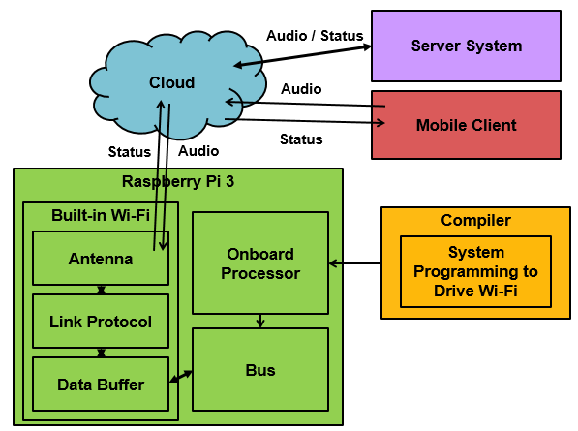

Figure 21: Wi-Fi Subsystem Block Diagram

### 9.2 Audio

The Darth Vader audio subsystem will be used to playback audio stored in the system’s digital storage device. This audio will be downloaded from the server platform which handles long-term storage and management. Audio playback will be initialized by the user through one of the interface buttons or Bluetooth Mobile control. Once initiated, the onboard microprocessor will execute instruction sets to feed the audio to a digital-to-analog converter through one of the board’s ports. This port will be fed to the systems speaker circuit for audio playback.

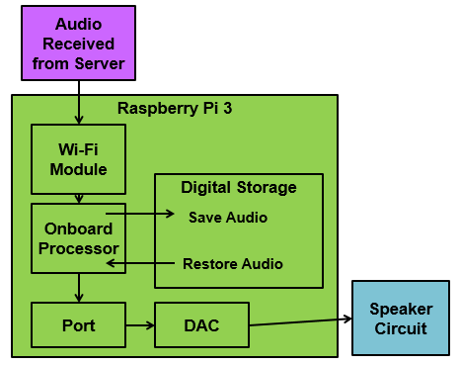

Figure 22: Audio Subsystem Block Diagram

### 9.3 Storage

The system requires a digital storage subsystem to save a handful of audio clips locally to the device. The server platform will store a vast majority of the overall audio clips while the Darth Vader system will house a couple of duplicate clips from the server database. This will allow the Darth Vader system to quickly access and playback audio while the server platform stores all the clips uploaded. When a new clip is uploaded to the Darth Vader system, the least recently uploaded clip will be added to the server’s archive to save server storage space.

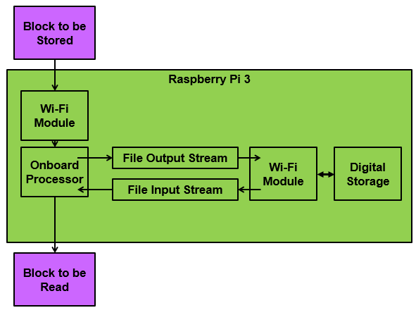

Figure 23: Storage Subsystem Block Diagram

### 9.4 Power Supply

The Darth Vader system requires a power supply subsystem in order to deliver energy to the several components within the system. The processor, board, storage, Wi-Fi module, audio system and I/O devices will require power in order to function properly. This subsystem is important to address the overall system’s general mobility requirement as well as the need to power the system.

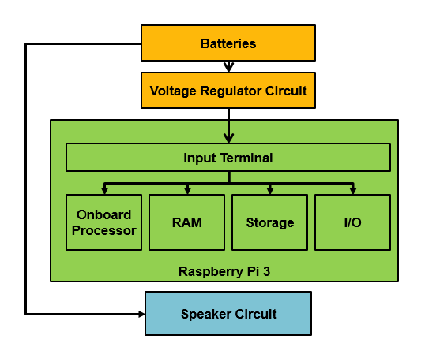

Figure 24: Power Supply Subsystem Block Diagram

### 9.5 Interface

The interface subsystem allows users to interact with the device driving system output. User input will be sent to the microprocessor to determine the appropriate output, i.e. audio playback, cycle clip list, or check for new clips. For example, a user may use the “cycle button” to cycle through a list of available clips and then press the select/play button once finding the appropriate clip. Once pressed, the clip will be staged and played through the device’s audio subsystem. Without the ability to interact with users, the system would not be able to effectively share inspiration and culture from global audio uploads.

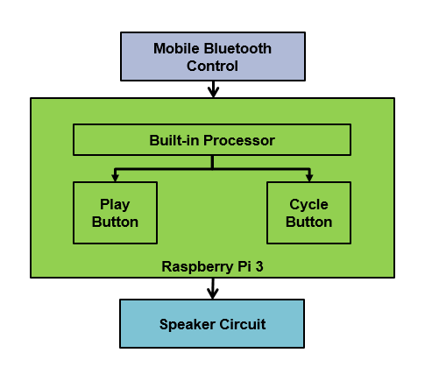

Figure 25: Interface Subsystem Block Diagram

### 9.6 Server Application

The server application will run the underlying code that saves, stores, loads, and pushes data within the overall Darth Vader system. This process will be primarily automated so uploaded clips will automatically be downloaded and stored to the server. After approval, clips will be automatically uploaded and accessible on Darth Vader systems. An administrator will be able to interface with the server platform to approve uploaded content, manage stored content, and create/edit/remove existing tags.

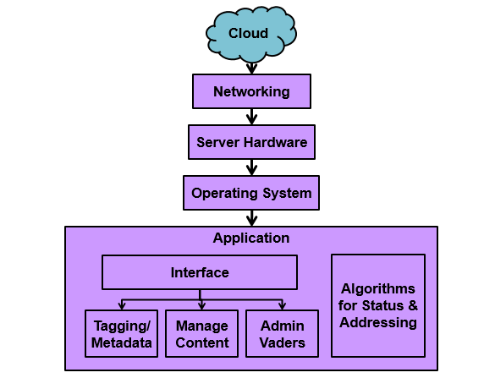

Figure 26: Server Application Subsystem Block Diagram

### 9.7 Server Storage

The server system will hold all uploaded data from mobile clients and thus will need a vast array of available storage. Data will come into the server from both clients and Darth Vader systems. Depending on the type of data received, the data will either be immediately processed or stored back to the server storage. When a stored clip is approved by an administrator, the clip will be read in from storage, packaged for network delivery, and automatically pushed to the Darth Vader client. Archives can be accessed and managed by an administrator.

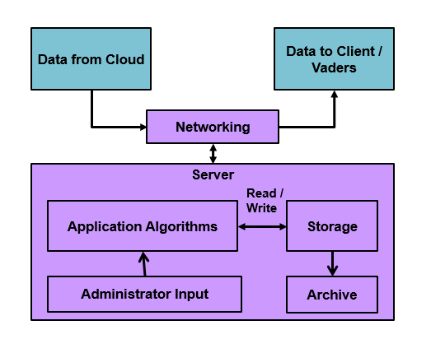

Figure 27: Server Storage Subsystem Block Diagram

### 9.8 Server Administration

Any server system requires a certain level of administration. It is important to be able to address functionality, performance, security, and backup concerns. These aspects will be handled primarily by the operating system through third party applications or operating system features. These automated processes will be initially configured by system administrators to ensure automation is setup correctly correctly.

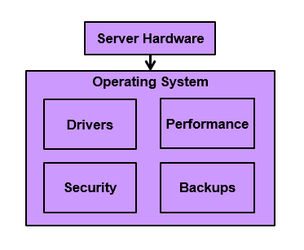

Figure 28: Server Administration Subsystem Block Diagram

### 9.9 Mobile Application

The mobile client application will be used for global users to upload clips to available Darth Vader systems. The mobile application will link to the server to upload the recorded audio or files. Metadata tags will be attached to the audio clip during the upload so that they may be filtered later. The server will organize these clips based on time, tag, and explicit indicator. The client application will make use of the mobile system’s integrated microphone to read in audio for upload. Once audio is stored locally, the client application will upload said audio to the server utilizing the mobile system’s integrated Wi-Fi or Cellular modules. Again recorded audio may be substituted by local audio files.

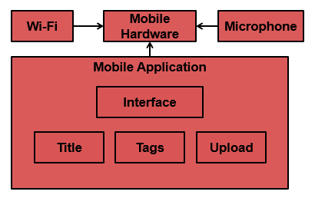

Figure 29: Mobile Application Subsystem Block Diagram

# 10. Preliminary User Interface Design

This section details the preliminary user interface designs for the Darth Vader system, server application software, and mobile client application.

### 10.1 Darth Vader

In this section an overview is given of the preliminary design for the Darth Vader system’s interface and a basic description of user interaction with the system. The figure below shows the preliminary button user interface for the chest plate of the Darth Vader System. The physical buttons will be used to interact with the Darth Vader when a Bluetooth-enabled device is unavailable to control the Darth Vader system’s advanced functionality.

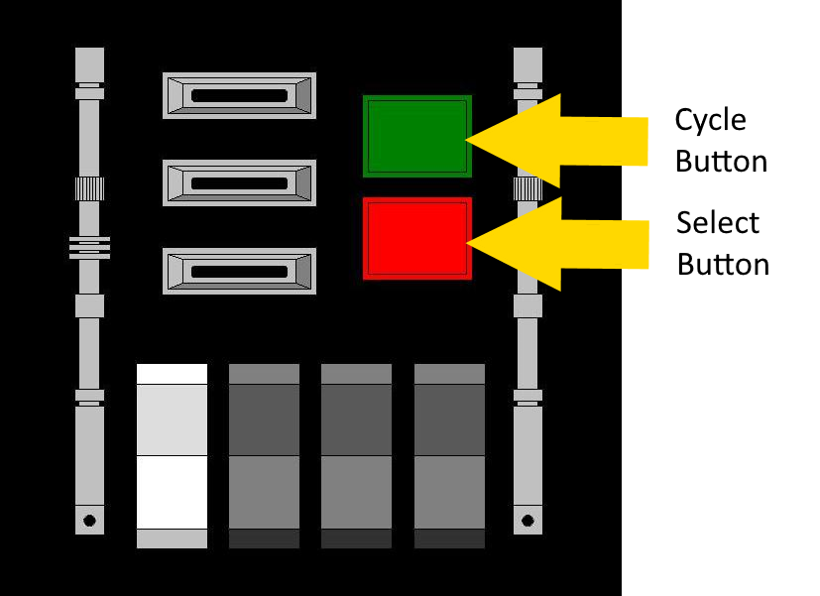

Figure 30: Darth Vader User Interface

The chest plate will be composed of two buttons. One button will allow the user to cycle through each of the available audio files saved to the local system. The other select/play button acts as a way for the user to select an audio file. When the select/play button is pressed the Darth Vader system will playback the audio clip.

For advanced functionality, the Darth Vader system will be controlled via Bluetooth through the mobile phone application. Bluetooth control will allow users to request audio based on tags and other metadata from the server. Once downloaded, the mobile application will be populated with a list of audio clips stored on the local Darth Vader system. The mobile application may then be used to playback audio clips on the Darth Vader client instead of having to cycle and play using the physical buttons.

### 10.2 Server

This section analyzes the server system’s application and user interface. The figure below shows the preliminary user interface for the server application for the Darth Vader System. On the left hand side of the graphic, there is a list of the available Darth Vader Systems indicating the online acknowledgement status. This list will be automatically updated by an application driven timeout table and will be used to validate Darth Vader systems. The “Ping DV System” button can be used to manually check if a Darth Vader system is live. On the right hand side of the application is the “Database Viewer” showing data entries in the database. In this preliminary design a list of all available data entries is present. However, as more progress is made on the server application, it will implement an assortment of administration, filtering, sorting, and management tools alongside the Database Viewer. Each data entry may be edited or removed by uses the selection buttons below.

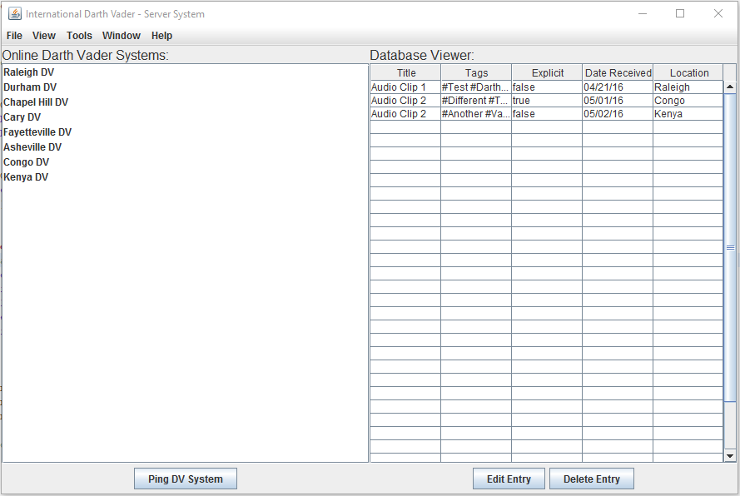

Figure 31: Server Application User Interface

### 10.3 Mobile Client

This section details the current preliminary user interface for the Darth Vader mobile application. The figure below shows the graphical user interface for the upload portion of the mobile application for the Darth Vader System.

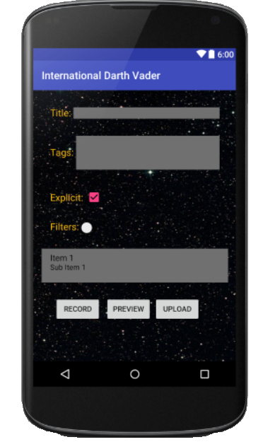

Figure 32: Mobile Client Graphical User Interface

This interface features areas for the user to give their media a title and associate it with specific subjects or “tags”. These tags will be used to organize media in the database and allow Darth Vader systems to request uploads holding similar metadata. If applicable, the user can choose to mark their media as explicit so that children are not unexpectedly exposed to inappropriate material. If a user uploads explicit material without tagging the content as explicit, a system administrator can manually go into the server system and flag the content as explicit. The user can also choose to apply a filter to their media by enabling the “Filters” option and then selecting from a list of filters from a drop down menu. The buttons at the bottom allow the user to record an audio clip of no more than 15 seconds, preview that recording, and then upload the clip once the user has finished making any changes to the audio recording.

# 11. Software Design Documentation

This section gives an overview of the software used to drive the Darth Vader system, server system, and mobile client. Each system has a software flowchart to represent the way that logic will be handled programmatically.

### 11.1 Darth Vader System Software

This section details the Darth Vader System’s software logic. The figure below shows the logical progression of the software at runtime. At startup, the system first checks for proper Wi-Fi configuration. If the Wi-Fi is configured, the system then attempts to connect the Wi-Fi. If the system succeeds in a Wi-Fi connection, then the software progresses to the next state. Alternatively if the Wi-Fi has not been configured or if the Wi-Fi network is unavailable, the system goes into a standby state and waits proper Wi-Fi configuration. Once connected to Wi-Fi, the system first establishes a handshake with the server system to show that it is now online and available to receive information and enters a standby state. The system can be interrupted from the standby state by one of three basic user interactions; the cycle button, the select/play button, or a Bluetooth input command. Any of these three interacts will pull the system out of the standby state and cause it to perform the requested action for the user.

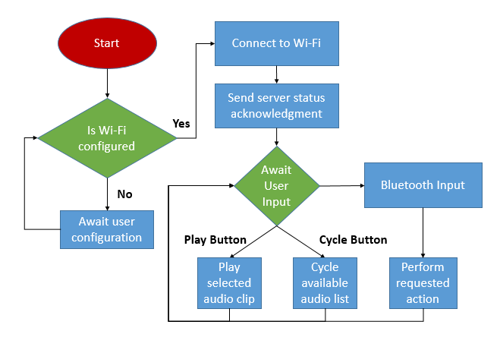

Figure 33: Darth Vader System Software Flowchart

### 11.2 Server System Application Software

This section details the Server System’s software logic. The figure below shows the logical progression of the software at runtime. At startup, the server application will go into an idle loop. This loop will be interrupted by one of several types of network interrupts. When a Darth Vader status acknowledgement packet comes in over the network, the server will update the Darth Vader timeout table to show that the Vader is online and available. If the Darth Vader’s certificate expires, then the server will send a status request to the last known address of the Vader. If the Server does not receive a response after three requests, the Vader will be removed from the availability list until the server receives a new status packet. If the system receives an audio request from a Darth Vader system, then the server will package the requested audio bundle by tags and recency and send them out to the requesting Vader system. Finally if the server receives an audio upload from a mobile client, then the server will process the uploaded audio and add the entry to the database.

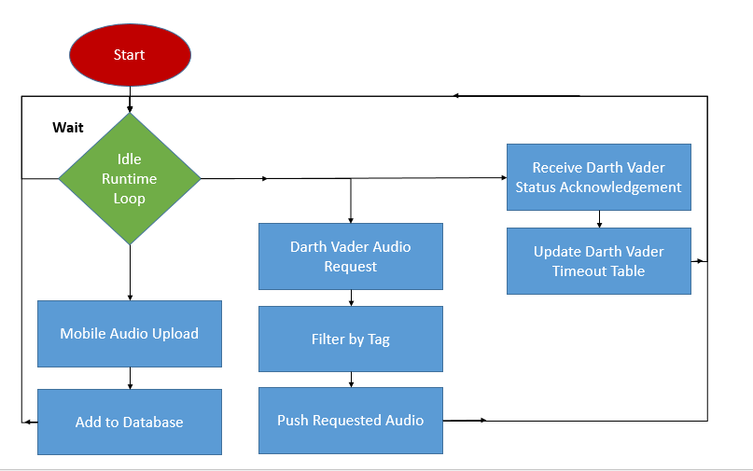

Figure 34: Server System Software Flowchart

### 11.3 Mobile Client Application Software

This section details the Mobile Client’s software logic. The figure below shows the logical progression of the software at runtime. Once the application has been opened, the user will be presented the startup audio upload screen where they may select audio, add tags/metadata, and upload audio. Before upload, the user will have to determine whether they want to apply an audio modulation filter to the selected audio to be uploaded.

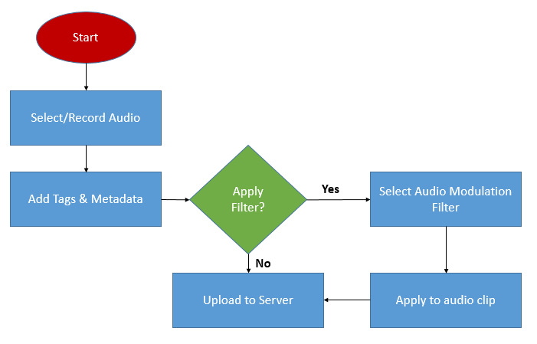

Figure 35: Mobile Client Software Flowchart

# 12. Preliminary Mechanical Enclosure Design

This section details the preliminary mechanical packaging of the Darth Vader system. The mechanical packaging will house primary components in the Darth Vader system. The image below represents the current outline of mechanical packaging and how it will integrate into the existing Darth Vader module. A 3D printed apparatus will be used to mount the Raspberry Pi, batteries, power converter, buttons, switch, and volume controls.

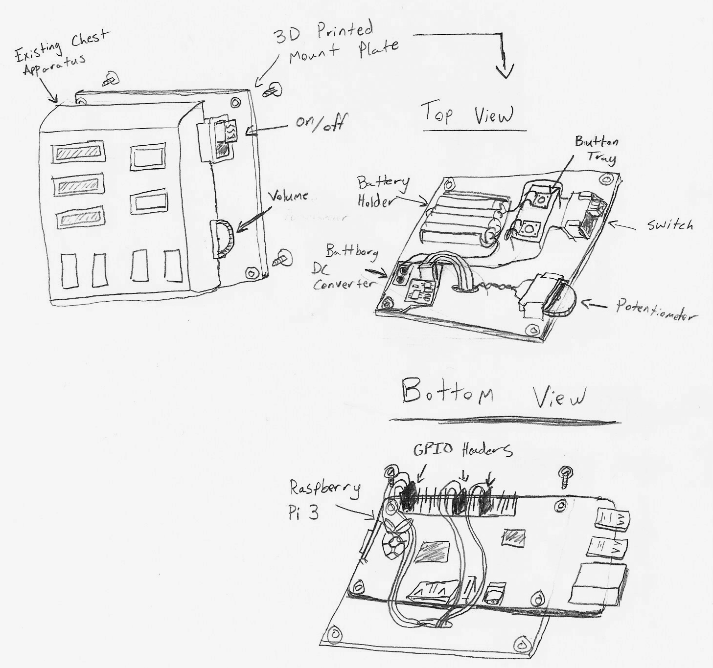

Figure 36: Preliminary Mechanical Packaging