Tugas 1

Algoritma Pemograman 3

Nama : Muhammad Faris Rasyid Raharjo

Kelas : 2IA22

NPM : 51422041

1. **Buatlah program tentang identitas diri (nama, npm, kelas, alamat, no_hp,email)**

Code:

IDENTIFICATION DIVISION.

PROGRAM-ID. IdentitasDiri.

ENVIRONMENT DIVISION.

DATA DIVISION.

WORKING-STORAGE SECTION.

01 MAHASISWA.

02 NAMA PIC X(50).

02 NPM PIC X(10).

02 KELAS PIC X(10).

02 ALAMAT PIC X(100).

02 NOHP PIC X(15).

02 EMAIL PIC X(50).

PROCEDURE DIVISION.

DISPLAY "======================================".

DISPLAY " Informasi Identitas Diri".

DISPLAY "======================================".

DISPLAY "Masukkan Informasi Identitas Diri:".

DISPLAY "--------------------------------------".

DISPLAY "Nama Mahasiswa: " WITH NO ADVANCING.

ACCEPT NAMA.

DISPLAY "NPM Mahasiswa: " WITH NO ADVANCING.

ACCEPT NPM.

DISPLAY "Kelas: " WITH NO ADVANCING.

ACCEPT KELAS.

DISPLAY "Alamat: " WITH NO ADVANCING.

ACCEPT ALAMAT.

DISPLAY "Nomor HP: " WITH NO ADVANCING.

ACCEPT NOHP.

DISPLAY "Email: " WITH NO ADVANCING.

ACCEPT EMAIL.

DISPLAY "--------------------------------------".

DISPLAY "Informasi Identitas Diri:".

DISPLAY "--------------------------------------".

DISPLAY "Nama: " NAMA.

DISPLAY "NPM: " NPM.

DISPLAY "Kelas: " KELAS.

DISPLAY "Alamat: " ALAMAT.

DISPLAY "Nomor HP: " NOHP.

DISPLAY "Email: " EMAIL.

DISPLAY "======================================".

STOP RUN.

Output:

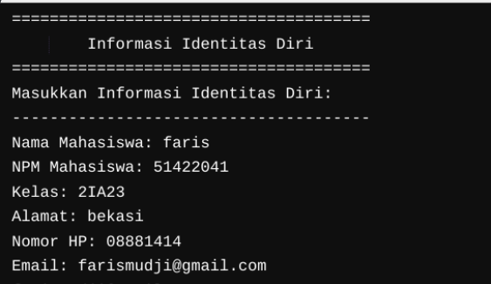

1. **Buatlah program Move, Add, Divide (BU 3), GO.. TO, GO.. TO..DEPENDING , Alter.**

Code :

IDENTIFICATION DIVISION.

PROGRAM-ID. KALKULATOR.

ENVIRONMENT DIVISION.

DATA DIVISION.

WORKING-STORAGE SECTION.

01 A PIC 9(4).

01 B PIC 9(4).

01 C PIC 9(4).

01 PIL PIC X.

PROCEDURE DIVISION.

DISPLAY "A : ".

ACCEPT A.

DISPLAY "B : ".

ACCEPT B.

DISPLAY "PILIH MENU: 1[+] 2[-] 3[*] 4[/] 5[Move]: ".

ACCEPT PIL.

PERFORM MENU-CHOICE.

STOP RUN.

MENU-CHOICE.

EVALUATE PIL

WHEN '1'

ADD A TO B GIVING C

WHEN '2'

SUBTRACT B FROM A GIVING C

WHEN '3'

MULTIPLY A BY B GIVING C

WHEN '4'

DIVIDE A BY B GIVING C

WHEN '5'

MOVE A TO C

DISPLAY "MOVE A TO C"

WHEN OTHER

GO TO PRINT-ERROR

END-EVALUATE.

DISPLAY "Hasil: ", C.

PRINT-ERROR.

DISPLAY "Pilihan tidak valid."

OUTPUT:

