電通二乙微處理器實驗 實驗結報

實驗名稱 | Lab4-四合一七段顯示器
組別 | 10 | 組員 | 謝曜陽

- 實驗目的
了解七段顯示器之顯示原理
1.共陰極與共陽極七段顯示器之不同?
2.如何讓七段顯示器顯示0-F?
3.如何控制四合一七段顯示器?
4.如何讓四合一七段顯示器 顯示四位數字?
- 實驗步驟
Arduino接好四合一七段顯示器之電路
四合一七段顯示器每隔0.3秒鐘會跳一個數字,從0000->0059->0100->跳至2359後歸零

於Pin6按鍵,按下後歸零顯示
於Pin17接一個按鍵,按下後倒數計時
- 程式碼
/* SevSeg Counter Example

Copyright 2017 Dean Reading

Licensed under the Apache License, Version 2.0 (the "License");
you may not use this file except in compliance with the License.
You may obtain a copy of the License at
http://www.apache.org/licenses/LICENSE-2.0

Unless required by applicable law or agreed to in writing, software
distributed under the License is distributed on an "AS IS" BASIS,
WITHOUT WARRANTIES OR CONDITIONS OF ANY KIND, either express or implied.
See the License for the specific language governing permissions and
limitations under the License.

This example demonstrates a very simple use of the SevSeg library with a 4
digit display. It displays a counter that counts up, showing deci-seconds.
*/

#include "SevSeg.h"
SevSeg sevseg; //Instantiate a seven segment controller object

void setup() {
byte numDigits = 4;
byte digitPins[] = {5,4,3,2};
byte segmentPins[] = {8,9,10,11,12,13,14,15};
bool resistorsOnSegments = false; // 'false' means resistors are on digit pins
byte hardwareConfig = COMMON_CATHODE; // See README.md for options
bool updateWithDelays = false; // Default. Recommended
bool leadingZeros = false; // Use 'true' if you'd like to keep the leading zeros

sevseg.begin(hardwareConfig, numDigits, digitPins, segmentPins, resistorsOnSegments, updateWithDelays, leadingZeros);
sevseg.setBrightness(90);
}

void loop() {
static unsigned long timer = millis();
static int deciSeconds = 0;

if (millis() - timer >= 10) {
timer += 10;
deciSeconds++; // 100 milliSeconds is equal to 1 deciSecond
if(deciSeconds%100==60)
{
deciSeconds+=40;
}

if (deciSeconds == 2359) { // Reset to 0 after counting for 1000 seconds.
deciSeconds=0;
}
sevseg.setNumber(deciSeconds, 3);
}

sevseg.refreshDisplay(); // Must run repeatedly
}
- 實驗結果及分析
一開始不知道是共陰極還是共陽極 初始的檢測用程式碼是共陽極 所以數字設成什麼都只是把電貫進去七段顯示器結果都是亮8888 後來改成CATHODE後就ok了
- 心得討論
如果是用四個單個的七段顯示器 那在實作拉線上會複雜很多
用4合1的就省去不少麻煩8個腳位控制燈亮的位子 4個控制另4個腳位代表要控制哪個七段顯示器
- 修正電路圖
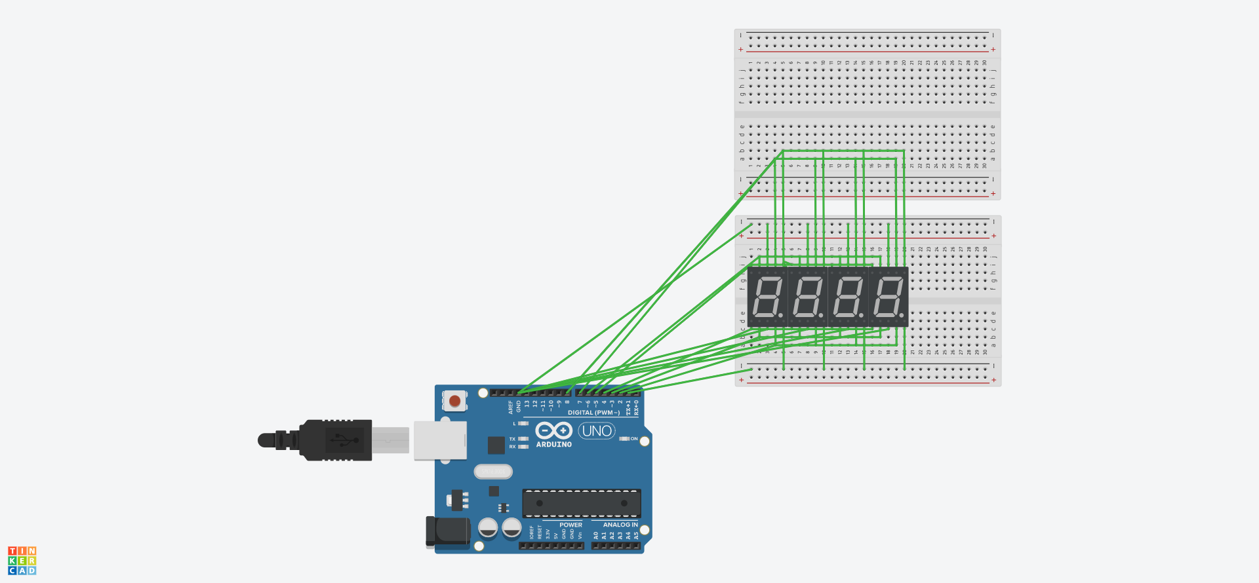
- 修正程式碼
/* SevSeg Counter Example

Copyright 2017 Dean Reading

Licensed under the Apache License, Version 2.0 (the "License");
you may not use this file except in compliance with the License.
You may obtain a copy of the License at
http://www.apache.org/licenses/LICENSE-2.0

Unless required by applicable law or agreed to in writing, software
distributed under the License is distributed on an "AS IS" BASIS,
WITHOUT WARRANTIES OR CONDITIONS OF ANY KIND, either express or implied.
See the License for the specific language governing permissions and
limitations under the License.

This example demonstrates a very simple use of the SevSeg library with a 4
digit display. It displays a counter that counts up, showing deci-seconds.
*/

#include "SevSeg.h"
SevSeg sevseg; //Instantiate a seven segment controller object

void setup() {
byte numDigits = 4;
byte digitPins[] = {5,4,3,2};
byte segmentPins[] = {8,9,10,11,12,13,14,15};
bool resistorsOnSegments = false; // 'false' means resistors are on digit pins
byte hardwareConfig = COMMON_CATHODE; // See README.md for options
bool updateWithDelays = false; // Default. Recommended
bool leadingZeros = false; // Use 'true' if you'd like to keep the leading zeros

sevseg.begin(hardwareConfig, numDigits, digitPins, segmentPins, resistorsOnSegments, updateWithDelays, leadingZeros);
sevseg.setBrightness(90);
}

void loop() {
static unsigned long timer = millis();
static int deciSeconds = 0;

if (millis() - timer >= 10) {
timer += 10;
deciSeconds++; // 100 milliSeconds is equal to 1 deciSecond
if(deciSeconds%100==60)
{
deciSeconds+=40;
}

if (deciSeconds == 2359) { // Reset to 0 after counting for 1000 seconds.
deciSeconds=0;
}
sevseg.setNumber(deciSeconds, 3);
}

sevseg.refreshDisplay(); // Must run repeatedly
}

