電通二乙微處理器實驗 實驗結報

實驗名稱 | Lab 06 –LCD 顯示器
組別 | 10 | 組員 | 謝曜陽

- 實驗目的
使用 Arduino LCD 程式庫, 於 16x2 LCD 顯示器上顯示特
定文字?
1. Arduino 與 LCD 如何接線?
2. 如何使用 LCD library?
3. 如何清除螢幕?
4. 如何顯示文字?

- 實驗步驟
1. Arduino 顯示自己的學號及英文姓名 (60 分)
2. 使用 PC 串列輸入, 所有 PC 輸入之文字皆顯示在
LCD 螢幕上 (40 分)
- 程式碼
#include <LiquidCrystal.h> // include the library code
LiquidCrystal lcd(12, 11, 5, 4, 3, 2); // initialize interface pins
void setup() {
lcd.begin(16, 2); // set up the LCD's number of columns and rows:
lcd.print("05051071 Ivan"); // Print a message to the LCD.
}
void loop() {
// set the cursor to column 0, line 1
// (note: line 1 is the second row, since counting begins with 0):
lcd.setCursor(0, 1);
lcd.print(millis()/1000); // print the number of seconds since reset:
}
---------------------------------------------------------------------------------------------------------
#include <LiquidCrystal.h> // include the library code
LiquidCrystal lcd(12, 11, 5, 4, 3, 2); // initialize interface pins
void setup() {
lcd.begin(16, 2); // set up the LCD's number of columns and rows:

Serial.begin(9600);
}

void loop() {
// when characters arrive over the serial port...
if (Serial.available()) {
// wait a bit for the entire message to arrive
delay(100);
// clear the screen
lcd.clear();
// read all the available characters
while (Serial.available() > 0) {
// display each character to the LCD
lcd.write(Serial.read());
}
}
}
- 實驗結果及分析
第一個實驗真正難的不是程式是接線 是焊接和排線
程式部份只要更改一小行就能做出來
- 心得討論
因為有一個部份是接可變電阻調整LCD顯示器亮度
一開始第一個一直沒顯示出來以為是空焊 或是線接錯
但是完全沒亮很怪 後來才發現是電阻值太大過不了電沒顯示出來
所以一開始應該把電阻值調低 不然卡這邊蠻冤的
修正電路圖

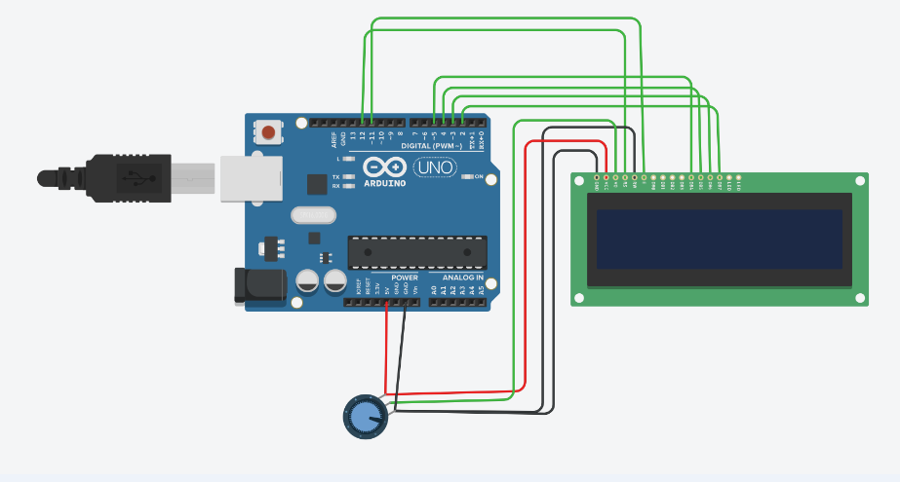
修正程式碼

#include <LiquidCrystal.h> // include the library code
LiquidCrystal lcd(12, 11, 5, 4, 3, 2); // initialize interface pins
void setup() {
lcd.begin(16, 2); // set up the LCD's number of columns and rows:
lcd.print("05051071 Ivan"); // Print a message to the LCD.
}
void loop() {
// set the cursor to column 0, line 1
// (note: line 1 is the second row, since counting begins with 0):
lcd.setCursor(0, 1);
lcd.print(millis()/1000); // print the number of seconds since reset:
}
---------------------------------------------------------------------------------------------------------
#include <LiquidCrystal.h> // include the library code
LiquidCrystal lcd(12, 11, 5, 4, 3, 2); // initialize interface pins
void setup() {
lcd.begin(16, 2); // set up the LCD's number of columns and rows:

Serial.begin(9600);
}

void loop() {
// when characters arrive over the serial port...
if (Serial.available()) {
// wait a bit for the entire message to arrive
delay(100);
// clear the screen
lcd.clear();
// read all the available characters
while (Serial.available() > 0) {
// display each character to the LCD
lcd.write(Serial.read());
}
}
}

