電通二乙微處理器實驗 實驗結報

實驗名稱 | Lab 03 –類比輸入
組別 | 10 | 組員 | 謝曜陽

- 實驗目的
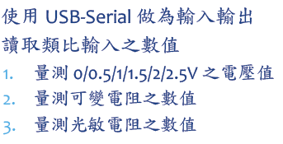
- 實驗步驟
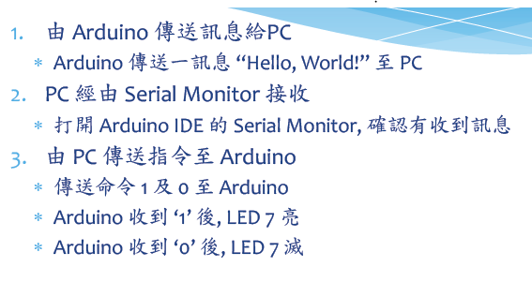
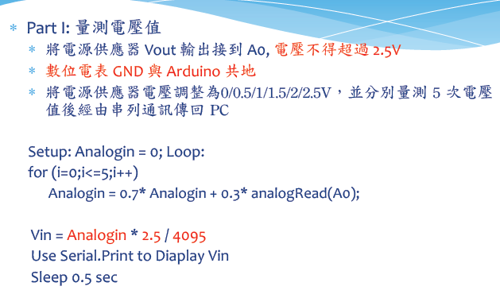
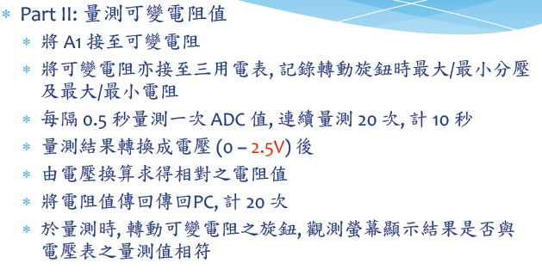
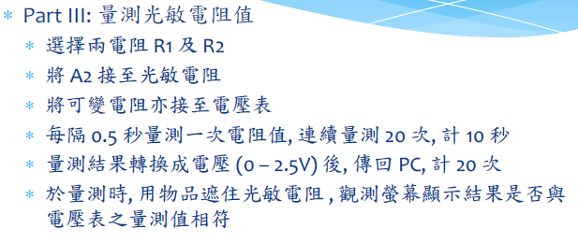

- 程式碼
const byte ledPin = 13;

void setup() {
Serial.begin(9600);
Serial.println("Hello,");
Serial.print("\tLED pin is:");
Serial.print(ledPin);
Serial.print("\nBYE!");
}

void loop() {
byte val;

if(Serial.available())
{
val = Serial.read();
if(val=='1')
{
digitalWrite(ledPin,HIGH);
Serial.print("LED ON");
}
else if(val=='0')
{
digitalWrite(ledPin,LOW);
Serial.print("LED OFF");
}
}
}
-------------------------------------------------------------------------------------------------------
float Analogin;
float k=0;

void setup()
{
Serial.begin(9600);
pinMode(14,INPUT);
}

void loop()
{
int i;
for (i=0;i<=5;i++)
{
Analogin = 0.7* Analogin + 0.3* analogRead(14);
k = Analogin * 2.5 / 4095;
Serial.println(Analogin);
Serial.println(k);
}
delay(500);

}
-------------------------------------------------------------------------------------------------------
const byte potPin=14;
float sensorValue;
float sensorVoltage;
float val;
float R1;
float R2;
float ResisterValue;

void setup()
{
Serial.begin(9600);
pinMode(potPin,OUTPUT);
ResisterValue = 1096600;
R1=0;
sensorValue=0;
sensorVoltage=0;
}
void loop()
{
int i;
float vin=2.5;
for (i=0;i<=19;i++)
{
sensorValue = 0.7* sensorValue + 0.3* analogRead(potPin);
}

Serial.print("AnalogReadÅªÈ:");
Serial.print(sensorValue);

sensorVoltage = sensorValue * 2.5 / 4095;
Serial.print("\t±À´ú¹qÀ£:");
Serial.print(sensorVoltage);

R1 = sensorVoltage*ResisterValue/vin ;
Serial.print("\t±À´ú¼Ú©i:");
Serial.println(R1);

delay(500);
}
-------------------------------------------------------------------------------------------------------
float val ;
float Vin =5;
float R=5000000;
float R1;
float sensorValue=0;
float sensorVoltage;
void setup()
{
Serial.begin(9600);
pinMode(15,OUTPUT);
}
void loop()
{
int i;

for (i=0;i<=5;i++)
sensorValue = 0.7* sensorValue + 0.3* analogRead(15);
sensorVoltage = sensorValue * 2.5 / 4095;
R1 = sensorVoltage * R / 2.5;
val = analogRead(15);
Serial.print("analogRead=");
Serial.print(val);
Serial.print("\tsensorVoltage=");
Serial.print(sensorVoltage);
Serial.print("\tR=");
Serial.print(R);
Serial.print("\tR1=");
Serial.println(R1);
delay(500);
}
- 實驗結果及分析
很成功 轉動可變電阻和照亮光敏電阻在螢幕的監控視窗上可以觀測到讀值變化 監控視窗輸入1和0也能確實控制LED亮滅
- 心得討論
學校的直流電源供應器很多都有問題
一開始用自己桌上的做 測出來問題一堆 還好一開始沒直接輸2.5V電源 有先從電表量過確定沒問題才接上 有人就是太信任電供7697直接燒毀 真的有夠慘
- 修正電路圖
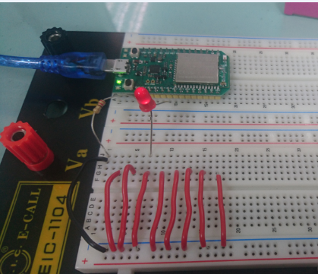

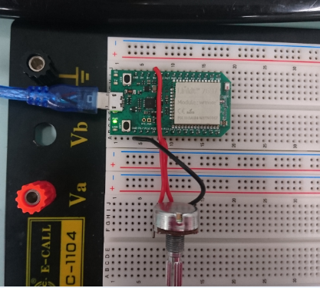

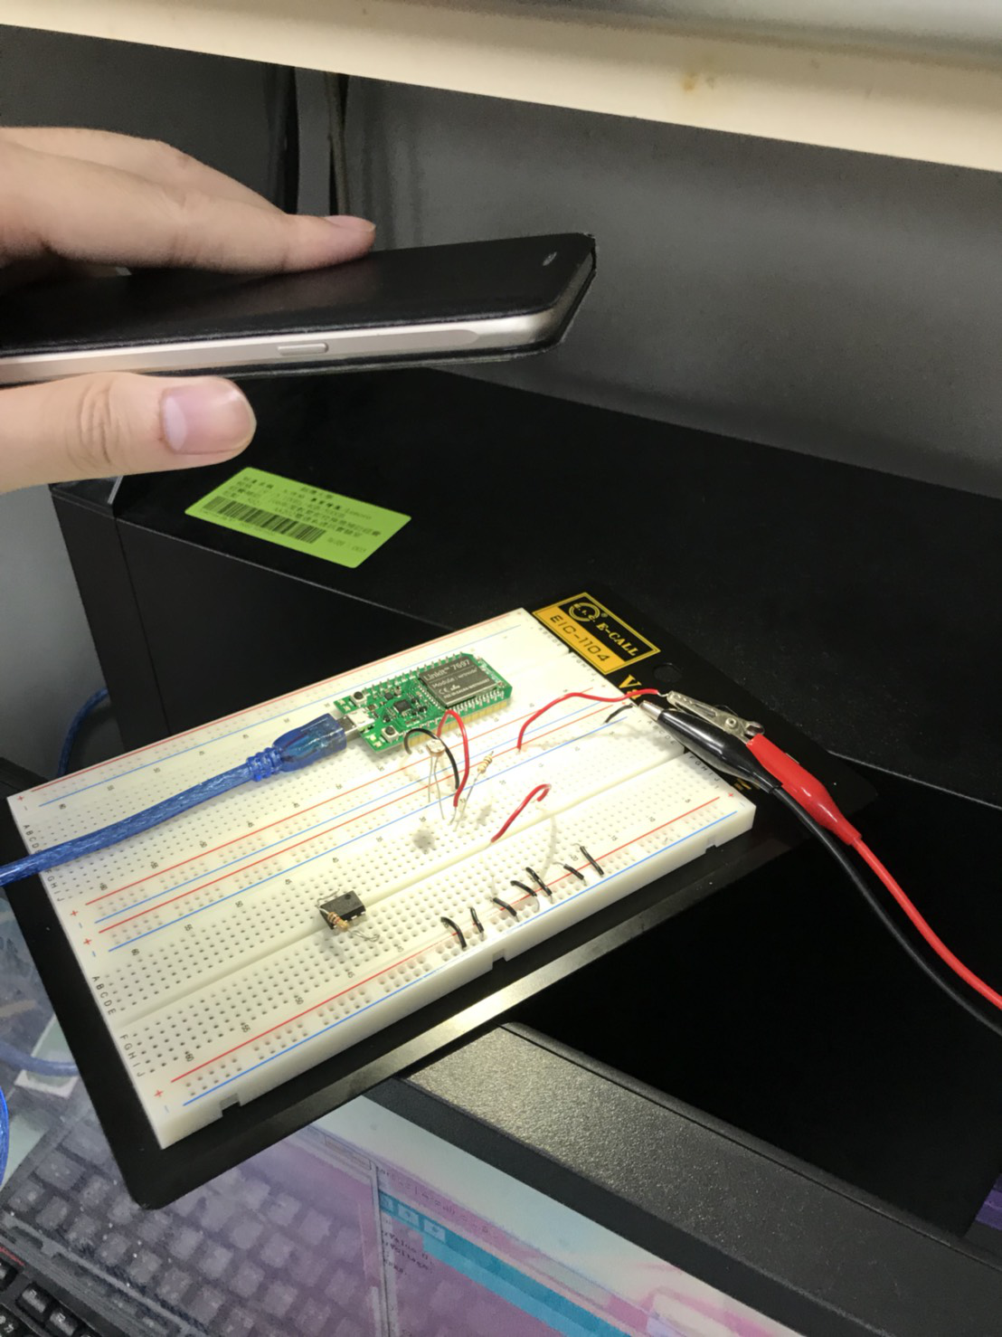

- 修正程式碼
const byte ledPin = 13;

void setup() {
Serial.begin(9600);
Serial.println("Hello,");
Serial.print("\tLED pin is:");
Serial.print(ledPin);
Serial.print("\nBYE!");
}

void loop() {
byte val;

if(Serial.available())
{
val = Serial.read();
if(val=='1')
{
digitalWrite(ledPin,HIGH);
Serial.print("LED ON");
}
else if(val=='0')
{
digitalWrite(ledPin,LOW);
Serial.print("LED OFF");
}
}
}
-------------------------------------------------------------------------------------------------------------
float Analogin;
float k=0;

void setup()
{
Serial.begin(9600);
pinMode(14,INPUT);
}

void loop()
{
int i;
for (i=0;i<=5;i++)
{
Analogin = 0.7* Analogin + 0.3* analogRead(14);
k = Analogin * 2.5 / 4095;
Serial.println(Analogin);
Serial.println(k);
}
delay(500);

}
const byte potPin=14;
float sensorValue;
float sensorVoltage;
float val;
float R1;
float R2;
float ResisterValue;

void setup()
{
Serial.begin(9600);
pinMode(potPin,OUTPUT);
ResisterValue = 1096600;
R1=0;
sensorValue=0;
sensorVoltage=0;
}
void loop()
{
int i;
float vin=2.5;
for (i=0;i<=19;i++)
{
sensorValue = 0.7* sensorValue + 0.3* analogRead(potPin);
}

Serial.print("AnalogReadÅªÈ:");
Serial.print(sensorValue);

sensorVoltage = sensorValue * 2.5 / 4095;
Serial.print("\t±À´ú¹qÀ£:");
Serial.print(sensorVoltage);

R1 = sensorVoltage*ResisterValue/vin ;
Serial.print("\t±À´ú¼Ú©i:");
Serial.println(R1);

delay(500);
}
-------------------------------------------------------------------------------------------------------------
float val ;
float Vin =5;
float R=5000000;
float R1;
float sensorValue=0;
float sensorVoltage;
void setup()
{
Serial.begin(9600);
pinMode(15,OUTPUT);
}
void loop()
{
int i;

for (i=0;i<=5;i++)
sensorValue = 0.7* sensorValue + 0.3* analogRead(15);
sensorVoltage = sensorValue * 2.5 / 4095;
R1 = sensorVoltage * R / 2.5;
val = analogRead(15);
Serial.print("analogRead=");
Serial.print(val);
Serial.print("\tsensorVoltage=");
Serial.print(sensorVoltage);
Serial.print("\tR=");
Serial.print(R);
Serial.print("\tR1=");
Serial.println(R1);
delay(500);
}

