Engineering Application Software Final Exam. Class:電通三乙Name:陳韋澔Student ID:05050032

- Function dir returns the contents of a specified directory. The dir command returns a structure array with four fields, as shown here:
>> d=dir(‘chap7’)
d=
36x1 struct array with fields:
name
date
bytes
isdir
where name contains the name of each file, date contains the last modification date for the file, bytes contains the size of the file in bytes, and isdir is 0 for conventional files and 1 for directories.

Write a function that accepts a directory name and path name and returns the total size of all files in the directory in bytes.
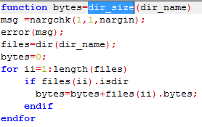
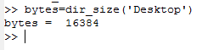

- Consider the following RC circuit, assume that there is no voltage or power in this circuit before time t=0. Calculate and plot the output 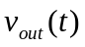 for the time 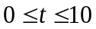
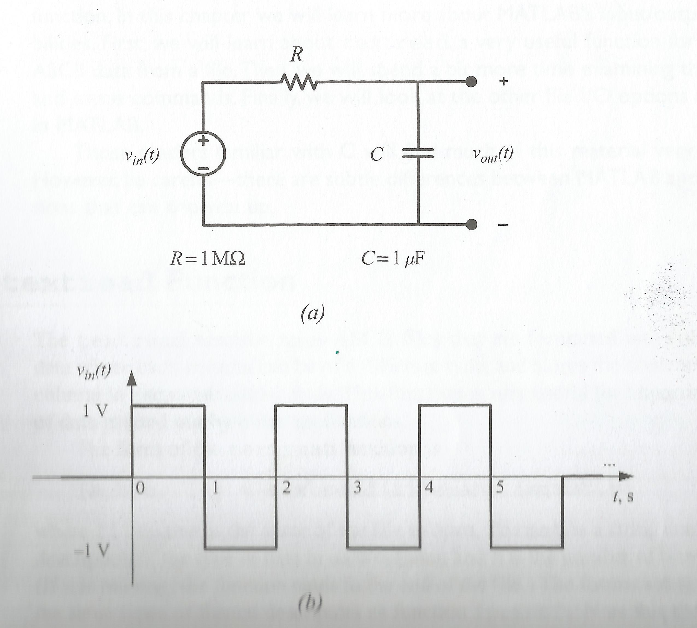
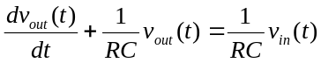

function yprime=fun2(t,y)
r=1e6;
c=1e-6;
lumda=1/(r*c);
yprime=lumda*vin(t)-lumda*y;
endfunction

function v=vin(t)
if t>=0 & t<=6
if mod(floor(t),2)==0
v=1;
else
v=-1;
endif
else
v=0;
endif
endfunction

clear all;close all;
hndl=@fun2;
tspau=[0 10];
yo=0;
[t,y]=ode45(hndl,tspau,yo);
plot(t,y);
grid on;

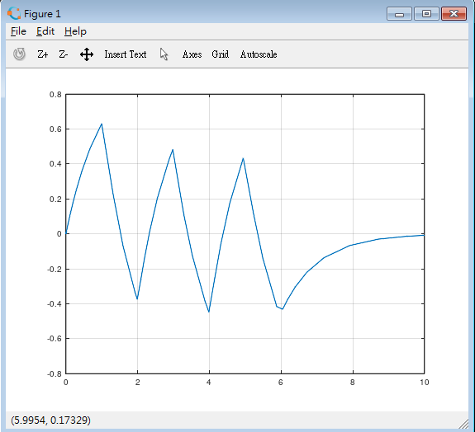
- Download the file “data.txt” from the Moodle and use textread( ) to load the data set into MATLAB.
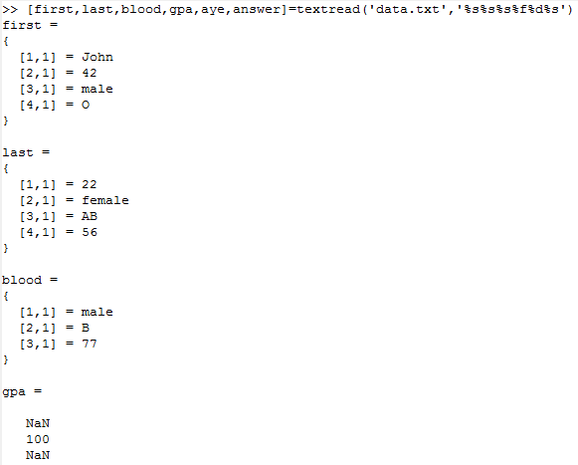
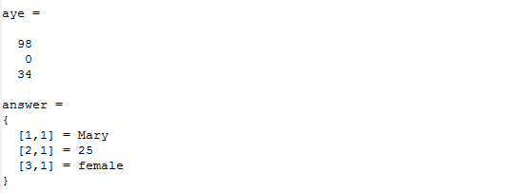
- Use fprintf( ) to create a table of square roots, squares, and cubes. The table will be displayed as shown here:
Number Square Root Square Cube
====== =========== ====== ====
1 1.0000 1 1
2 1.4142 4 8
3 1.7321 9 27
4 2.0000 16 64
5 2.2361 25 125
6 2.4495 36 216
7 2.6458 49 343
8 2.8284 64 512
9 3.0000 81 729
10 3.1623 100 1000
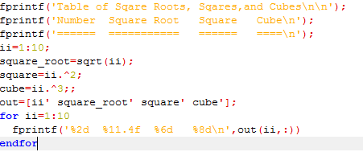
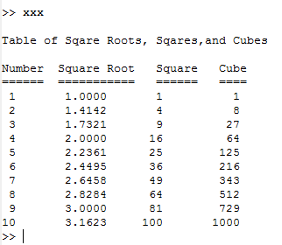
- (a) Use randn( ) to generate an array ‘out_array’ containing 10,000 random values, (i) open a formatted output text file ‘test.dat’ for writing (‘rt’), (ii) writes the data using fprintf( ) with format ‘%23.15e’, then (iii) close the file.
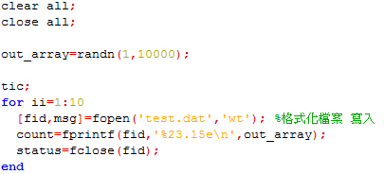
(b) Show the first five lines in the file ‘test.dat’
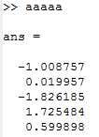

(c) (i) Open the formatted file ‘test.dat’ for reading (‘rt’), (ii) read the data back into an array ‘in_array’ using fscanf( ) with format ‘%f’ , then (iii) close the file.
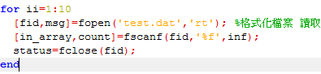

- 讀取'flanger.wav' ，將此音訊之振幅調高5倍；取樣率修改成原來的2倍，以subplot分別繪出左右兩聲道之音訊波形。
