# Assignment 10

2021110704 김다진

Schematic

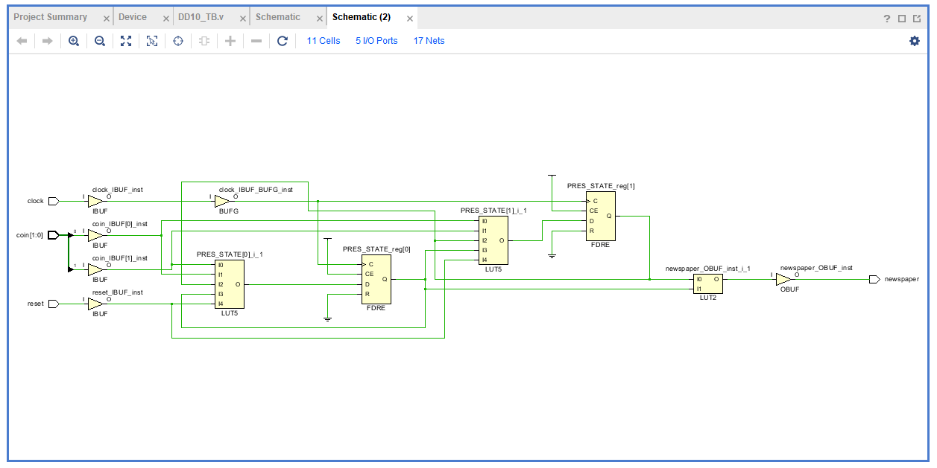

Report timing

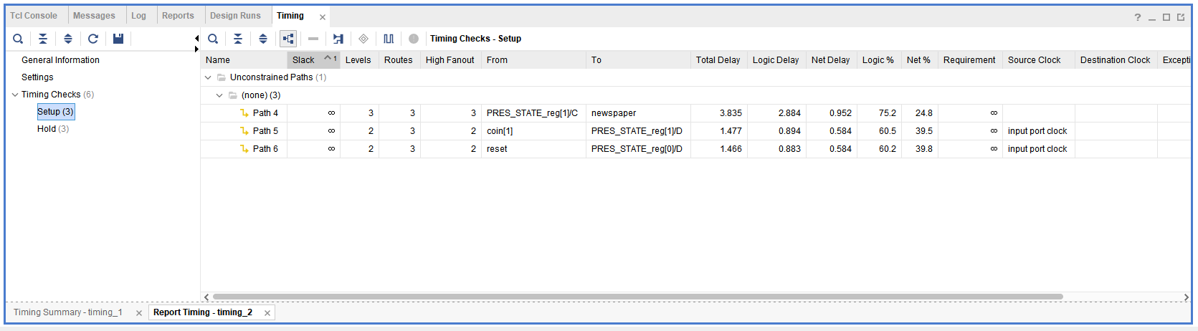

Report power

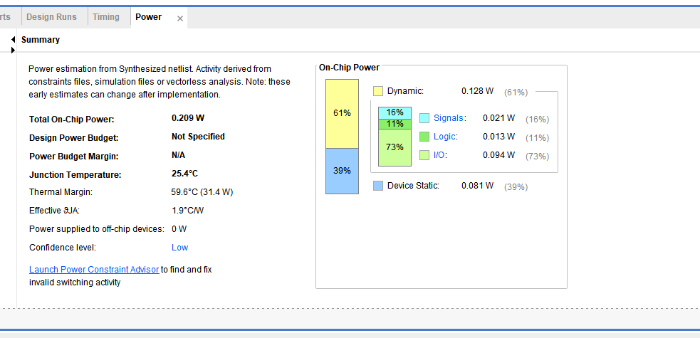

Behavioral simulation

