FamilyPulse — Figures & Tables
For copying into the shared team report
Each figure and table below is a normal Word image/table, not linked to anything else — click just above one, then shift-click just below it, copy, and paste it straight into the shared document at the matching section (see the label under each one).
If a paste ever comes through blank or broken, the same four images are attached separately as plain PNG files — use Insert > Picture in the shared document instead, it always works.

Figure 1 — System Architecture (goes in: Project Implementation)
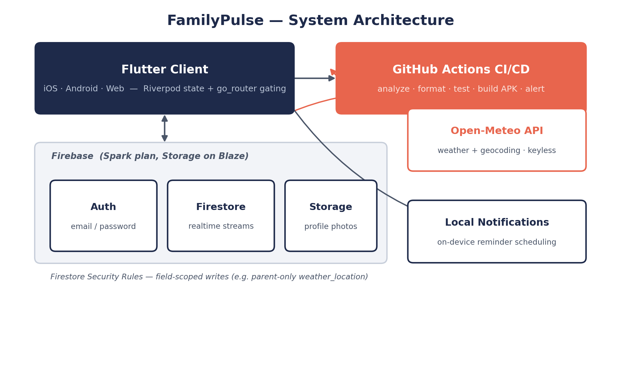
Figure 1. FamilyPulse system architecture — Flutter client, Firebase backend, CI/CD, and the keyless Open-Meteo weather integration.

Table 1 — Technology Stack (goes in: Project Implementation)
Tool | Purpose
Flutter 3.44.4 | Mobile + web UI framework
Dart 3.12 | Programming language
Firebase Auth | User login and registration
Cloud Firestore | Database — families, users, events, groups
Firebase Storage | Profile photo uploads
flutter_local_notifications | On-device event reminders
Open-Meteo (via http) | Weather forecast + geocoding — free, no key
Flutter Riverpod | State management
go_router | Navigation and auth/family-gated routing
flutter_localizations | English / Finnish / Swedish
GitHub Actions | CI/CD — analyze, format, test, build, alert
Table 1. Technology stack.

Figure 2 — Firestore Data Model (goes in: Project Implementation)
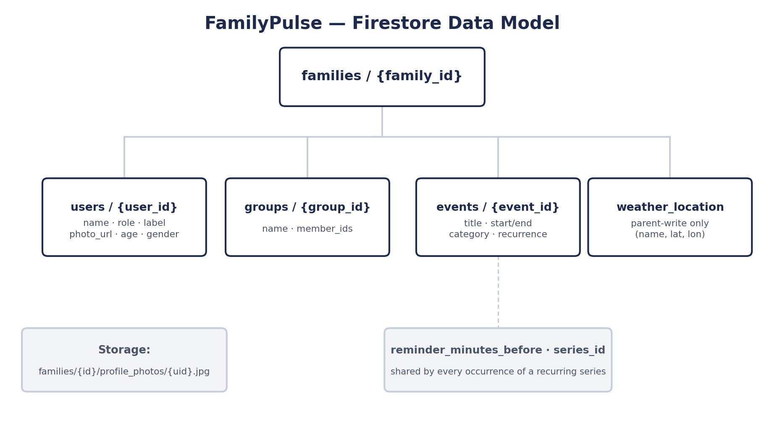
Figure 2. Firestore data model — one document per family, with sub-collections for members, groups, and events.

Figure 3 — Core Screens (goes in: Results)
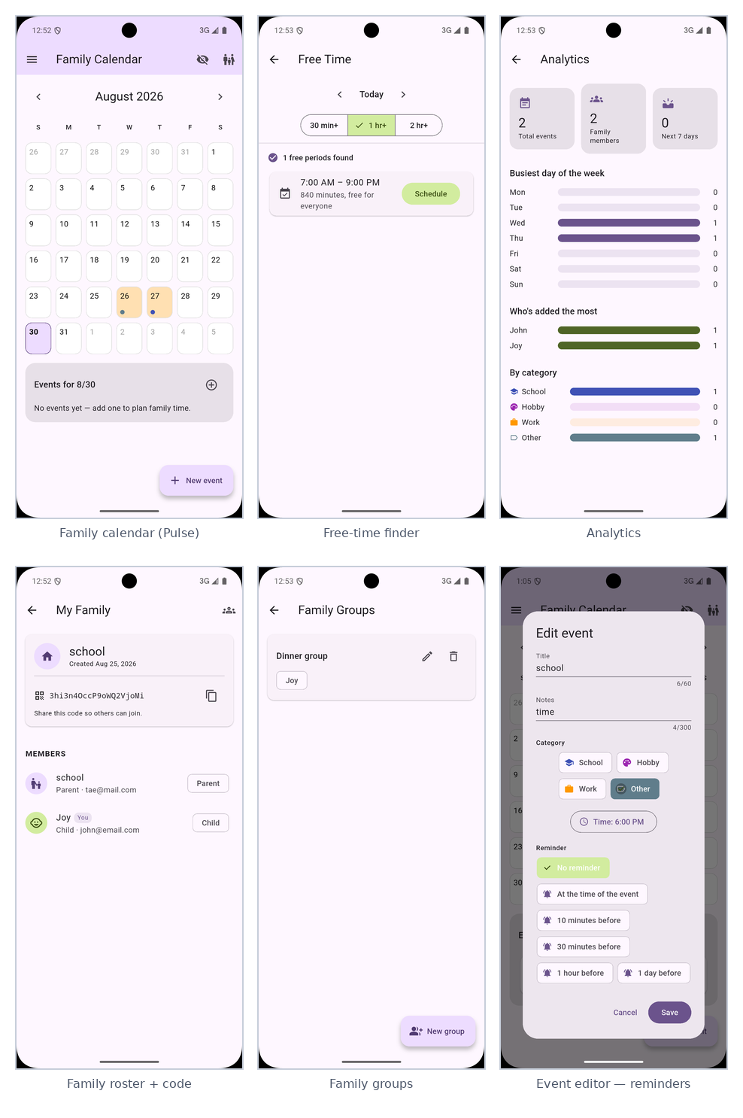
Figure 3. Core screens — family calendar, free-time finder, analytics, family roster, groups, and the event editor.

Figure 4 — Personalization & Weather (goes in: Results)
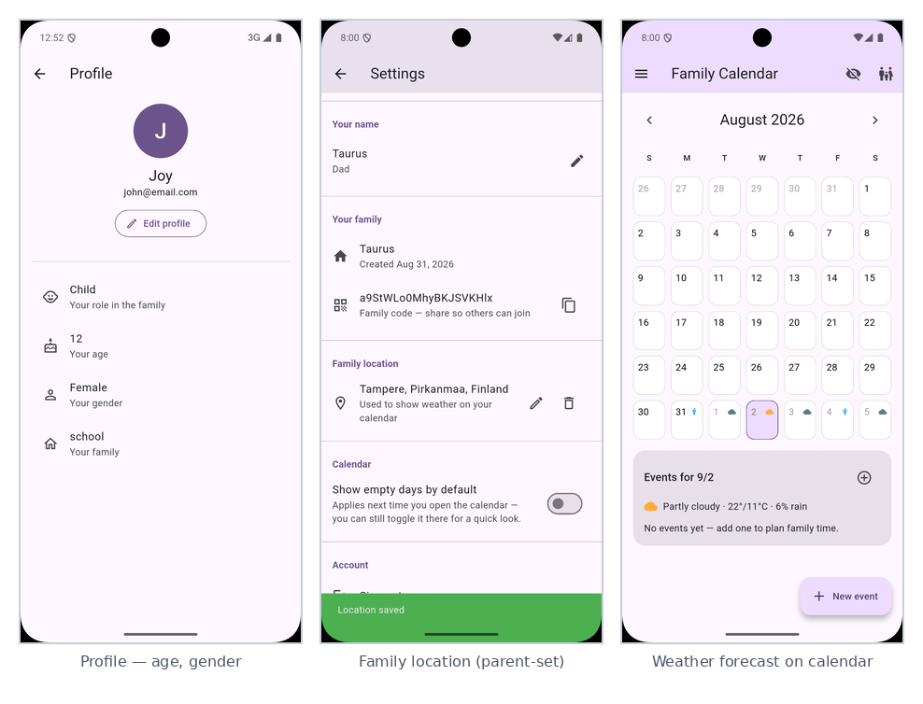
Figure 4. Personalization and the “wow feature” — member profile, parent-set family location, and the weather forecast on the calendar.

Table 2 — Feature Completion Snapshot (goes in: Results)
Metric | Result
Planned features (Appendix A backlog) | 25
Features delivered | 25 / 25 (100%)
Languages supported | English, Finnish, Swedish
Automated CI checks per push | 4 — analyze, format, test, build APK
Team size | 4
Submission deadline | September 9, 2026
Table 2. Feature completion snapshot.

