Rex Odomero Oghenerobo, Tatu Ekroth, Igor Smirnov, Jimmy Söderström

FAMILYPULSE

Managing the Family’s Time — A Shared Calendar App

Final project report
CENTRIA-AMMATTIKORKEAKOULU

Information and communication technology
September 2026

Content list
1 1. Project Information 4
2 Project Background and Objectives 5
3 Project Implementation 6
4 Results (Describe deliverables and outcomes) 7
5 Project Evaluation 8
6 Lessons Learned 9
7 Future Recommendations 10
8 Appendices 11

1. Project Information
- Project name: FamilyPulse
- Project ID: [add your course/module project ID here]
- Client / Organization: Centria University of Applied Sciences – ICT programme (course capstone project, no external client)
- Project Manager: Rex Odomero Oghenerobo
- Project Team: Rex Odomero Oghenerobo, Tatu Ekroth, Igor Smirnov, Jimmy Söderström
- Timeline: June 2026 – September 9, 2026 (submission deadline)
- Executive Summary:
FamilyPulse is a Flutter and Firebase mobile app that solves a small but constant problem in busy households: knowing who is free, what is planned, and who is doing it. Instead of scattered group-chat messages, FamilyPulse gives a family one shared, real-time calendar — backed by Cloud Firestore so every member’s phone stays in sync the moment an event is added, edited, or removed. The finished app supports account creation and login with full input validation; creating or joining a family via a shareable referral code; a live shared calendar with real event categories, recurring events, and on-device reminders; a home “Pulse” dashboard; an Analytics view of family activity; a Free Time finder that surfaces shared open windows; sub-groups within a family; expanded family roles with parent-managed member names; editable member profiles (photo, age, gender); a 7-day weather forecast woven directly into the calendar; and a navigation drawer with a personal Profile screen and a Settings screen covering theme, calendar defaults, and family info. Every feature originally planned for the project (Appendix A) is built, tested, and merged to main ahead of the September 9, 2026 deadline, and the codebase is protected end-to-end by a GitHub Actions CI/CD pipeline that runs static analysis, formatting checks, and the automated test suite on every pull request.

Project Background and Objectives
Family coordination today mostly happens through group chats, which are good at conversation but bad at answering simple planning questions — “who’s free Saturday afternoon?” gets buried within minutes of being asked. FamilyPulse’s objective is to replace that scattered coordination with a single, always-current shared calendar built specifically for families, rather than adapted from a generic productivity tool.
Against that background, FamilyPulse was built around four core objectives: to give every family member a live, shared view of the family’s schedule, updated in real time on every device; to make joining a family as simple as sharing one short code, including for children; to provide clear, human-readable feedback — validation, success, and error states — instead of silent failures or raw error text; and to lay a foundation of theme, settings, and roles that could grow into deeper family-time features such as shared free-time discovery, weather-aware planning, and activity analytics.

Project Implementation
FamilyPulse is built with Flutter and Dart, using Firebase Authentication for accounts and Cloud Firestore as the live, multi-device data store. State management is handled with Riverpod — StreamProviders keep the UI in sync with Firestore in real time — and navigation with go_router, which also drives access control: a router-level redirect gates every screen behind sign-up/login and family membership, rather than each screen checking authentication state independently. Figure 1 summarises how the pieces fit together.
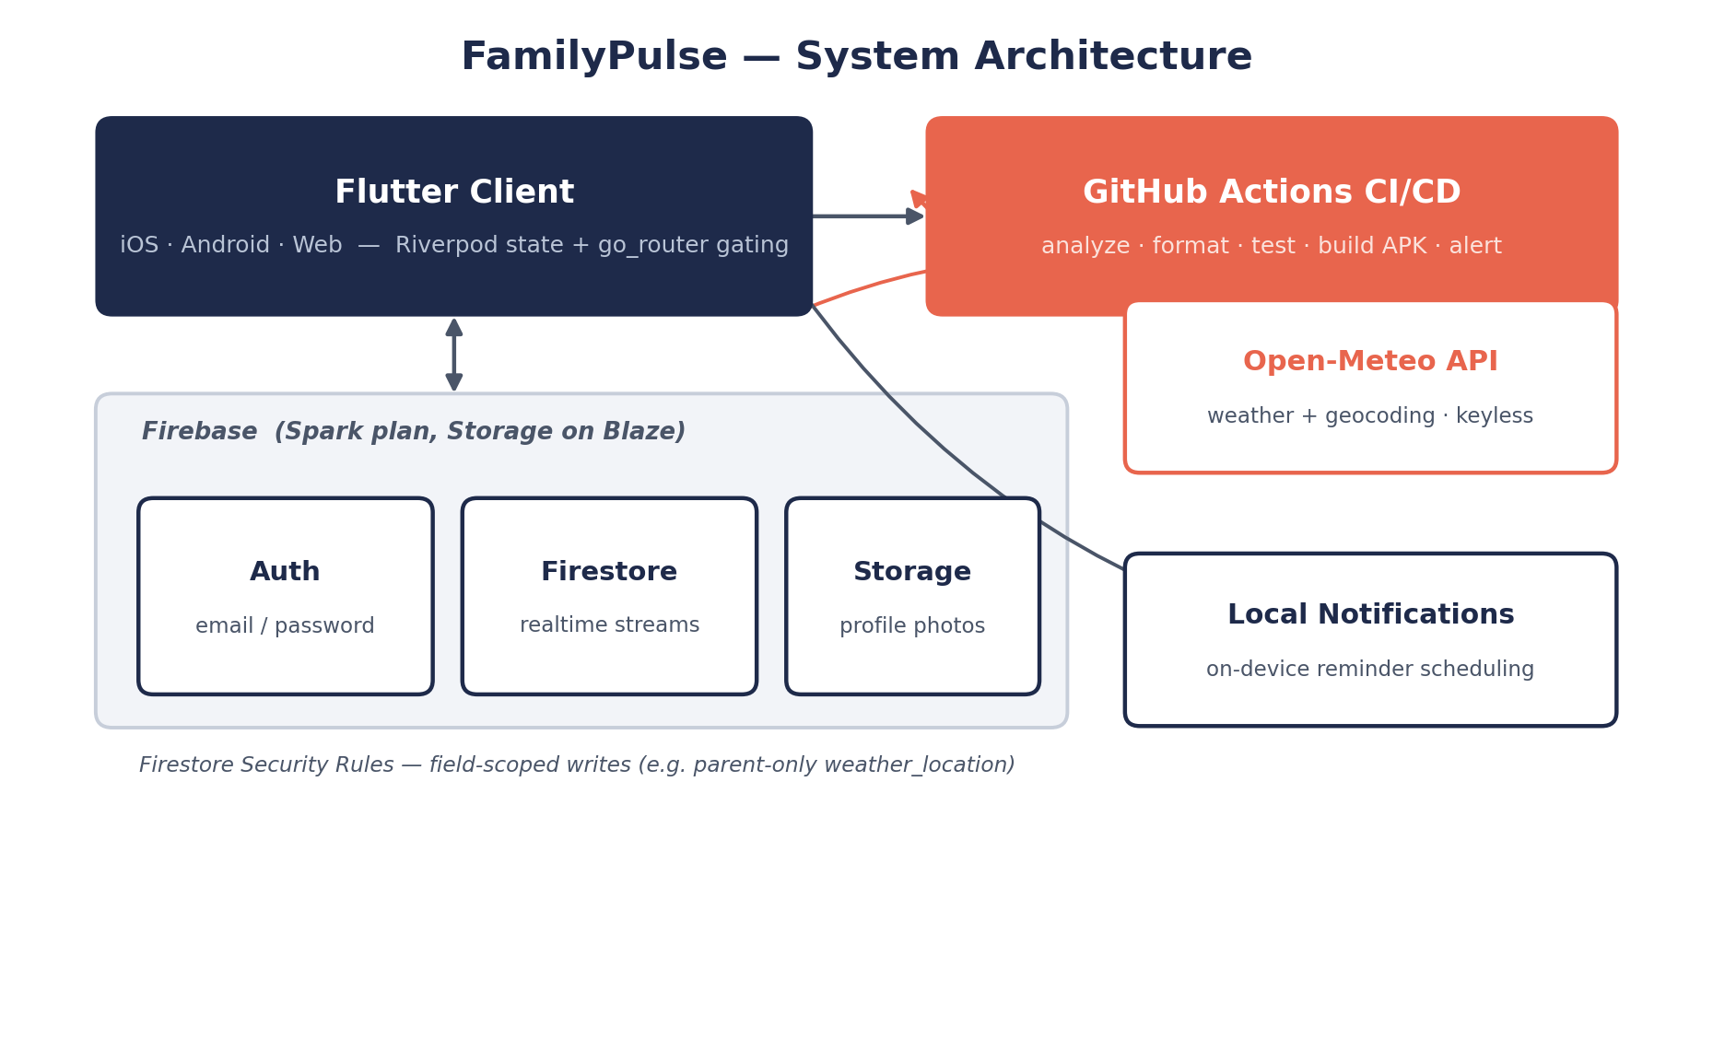
Figure 1. FamilyPulse system architecture — Flutter client, Firebase backend, CI/CD, and the keyless Open-Meteo weather integration.
Authentication supports email/password sign-up and login, both with inline field validation, a confirm-email and confirm-password step on sign-up, and a password show/hide toggle. Family management lets a user create a family — which generates a shareable referral code — or join one with that code; the family name, creation date, and code are all readable from Settings.
The calendar itself is a live, Firestore-backed month view: creating, editing, and deleting events all sync instantly to every family member’s device. Recurring events build on this with daily, weekly, monthly, or yearly presets and an optional end date, paired with on-device reminders ahead of an event (10 minutes, 30 minutes, 1 hour, 1 day, or at the time) that are rescheduled automatically each time the app opens. The weather forecast — the project’s stand-out feature — lets a parent set the family’s home location once in Settings; the calendar then shows a 7-day forecast icon per day, a full-day summary under the selected date, and a rain-risk badge on outdoor-leaning events, all powered by the free, keyless Open-Meteo API.
The home dashboard (“Pulse”) summarises today’s schedule, what’s coming up, and quick navigation to the rest of the app, while Settings covers appearance (light/dark/system theme, persisted across restarts), editable display name, family info, and the calendar display default. Underpinning all of this is a development process of feature branches, pull requests, and pre-commit checks (flutter analyze, dart format, flutter test) before merging to main, enforced automatically by the CI/CD pipeline shown in Figure 1.
Table 1. Technology stack.
Tool | Purpose
Flutter 3.44.4 | Mobile + web UI framework
Dart 3.12 | Programming language
Firebase Auth | User login and registration
Cloud Firestore | Database — families, users, events, groups
Firebase Storage | Profile photo uploads
flutter_local_notifications | On-device event reminders
Open-Meteo (via http) | Weather forecast + geocoding — free, no key
Flutter Riverpod | State management
go_router | Navigation and auth/family-gated routing
flutter_localizations | English / Finnish / Swedish
GitHub Actions | CI/CD — analyze, format, test, build, alert

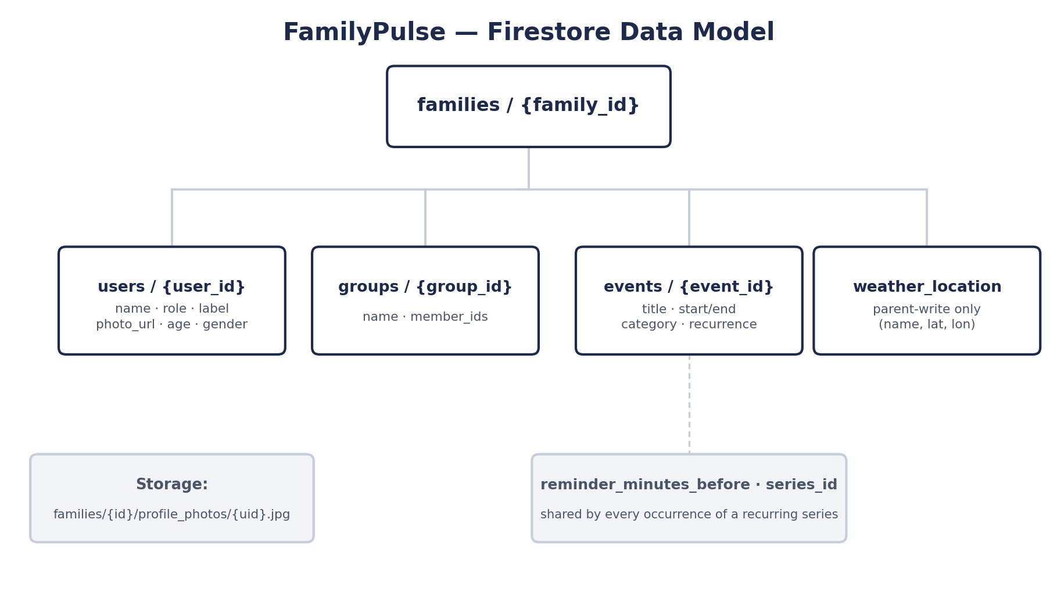
Figure 2. Firestore data model — one document per family, with sub-collections for members, groups, and events.
Figure 2 shows the Firestore data model: every family is one document holding sub-collections for its members, sub-groups, and events, plus a parent-writable weather_location field. Access is enforced in Firestore Security Rules rather than trusted to the client — for example, weather_location and member role/label changes use affectedKeys().hasOnly(...) checks combined with a get() lookup of the requesting user’s role, so only a parent account can move the family’s pin on the map or rename another member, and everyone else is limited to read access and to editing their own profile fields.

Results (Describe deliverables and outcomes)
As of this report, the following is built, tested, and working end to end.
Account creation and login now ship with full validation and clear error messaging, and creating or joining a family by referral code shows the code immediately, with copy-to-clipboard, right after a family is created. The live shared calendar reflects events created on one device on every other device in real time, with no manual refresh; recurring events and on-device reminders are rescheduled automatically each time the app opens; and editing or deleting an event carries its own confirmation step and success/error feedback.
The home dashboard summarises today’s and upcoming events, and Settings covers theme switching, profile name editing, family info display, and a persisted calendar display preference. An Analytics page computes total events, the busiest day of the week, who’s added the most, a category breakdown, and the load over the next seven days, all live from existing calendar data, while a Free Time finder overlays every member’s events to surface shared open windows with a tap-to-schedule shortcut. Family Groups add named sub-groups — “Kids”, “Chores squad” — with an editable member picker.
Expanded family roles (parent, child, guardian, other) plus an optional label such as “Mom” or “Dad” make co-parents distinguishable, and a parent can rename or relabel other members, enforced both in the UI and in Firestore Security Rules. Every member can edit their own profile — photo, age, and gender — and the calendar carries a 7-day weather forecast with a rain-risk badge on outdoor-leaning events, the project’s “wow feature”, built without needing an API key or billing setup. The app is fully localized in English, Finnish, and Swedish, and a navigation drawer reachable from every main screen sits alongside a personal Profile screen — editing your name now updates both Firebase Auth and your family-roster entry together, instead of only the former.
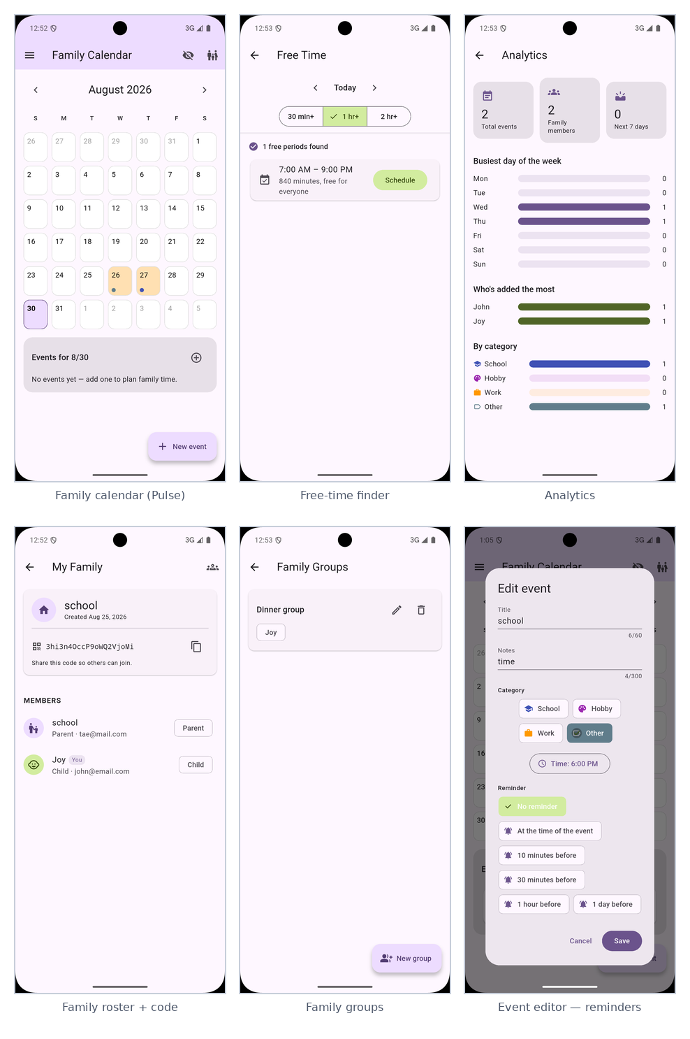
Figure 3. Core screens — family calendar, free-time finder, analytics, family roster, groups, and the event editor.
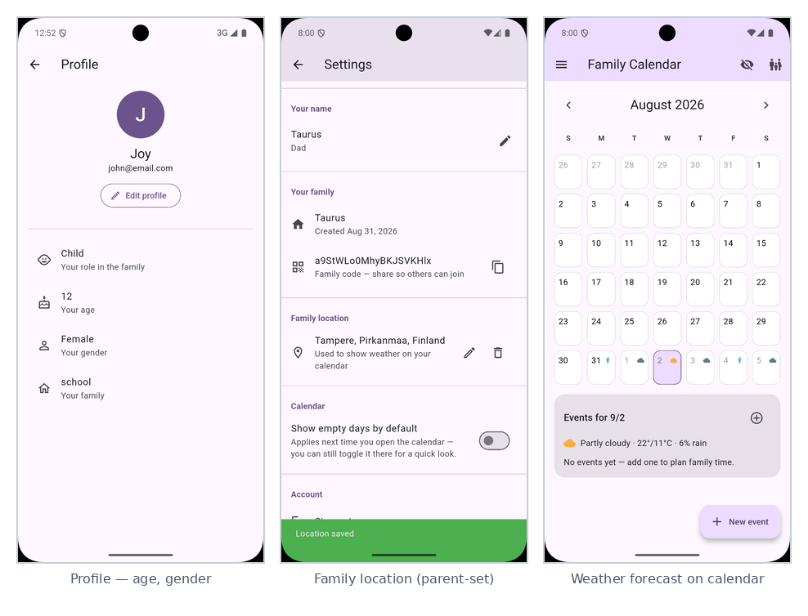
Figure 4. Personalization and the “wow feature” — member profile, parent-set family location, and the weather forecast on the calendar.
Table 2. Feature completion snapshot.
Metric | Result
Planned features (Appendix A backlog) | 25
Features delivered | 25 / 25 (100%)
Languages supported | English, Finnish, Swedish
Automated CI checks per push | 4 — analyze, format, test, build APK
Team size | 4
Submission deadline | September 9, 2026

Project Evaluation
The core real-time architecture has proven solid: once the Firestore stream wiring and router-level access gating were in place, every feature built on top of them (calendar, dashboard, settings, weather) worked without needing its own sync logic. Manual testing on an Android emulator and physical devices surfaced a small number of real bugs before they reached users — including a TextEditingController disposal race in the event editor dialog, a router-redirect race that hid the newly-created family’s referral code, and a visibility bug where the Family Location section of Settings rendered empty for non-parent accounts instead of a clear read-only state — all three were root-caused and fixed rather than patched over (see Lessons Learned).
Feature breadth, initially the main gap against the original ambition, closed substantially in the final stretch — analytics, the free-time finder, groups, expanded roles, real event categories, recurring events and reminders, and the weather forecast all landed before submission. Every item on the original backlog (Appendix A) is now built, tested, and merged to main.
[Team — add your own reflection here on what worked well and what you would do differently, including any feedback received during supervision.]

Lessons Learned

Technical
A dialog that creates its own TextEditingController should also dispose of it itself (via its own initState/dispose), rather than the caller creating and disposing the controller around an awaited showDialog() call — the latter can dispose the controller while the dialog is still animating closed, crashing the app. Similarly, a router redirect that reacts to a provider resolving can fire before a screen has finished showing the user something important (in this case, a newly-generated family code) — user-facing state changes that must be seen should happen before, not after, triggering a redirect. The same class of bug showed up a third time in the weather feature: the Family Location section of Settings was built assuming every viewer was a parent, so a child or guardian account saw a blank section instead of a clear “ask a parent to set this” message — a reminder that every role-gated UI needs an explicit, designed state for the roles that cannot edit it, not just the one that can.

Team process
Partway through development, it emerged that two team members had spent roughly three weeks building a parallel version of this app in FlutterFlow, sharing a single login between them rather than each working under their own account. This was not raised with the rest of the team until late, and it created two real problems: the two builds cannot be merged (FlutterFlow generates its own project structure and cannot be combined with a hand-written Flutter/Firebase codebase), so one of the two efforts is necessarily not carried forward; and a shared login leaves no individual record of who built what, which matters for a group project where contribution is assessed per person. The team’s decision was to consolidate on the Flutter/Firebase build described in this report, with all members contributing to it under their own accounts going forward. The lesson is straightforward: agree the tool and the workflow (including one account per person) as a team before dividing up work, not after.

Future Recommendations
The full, owner-and-status-tracked backlog is attached as Appendix A. Almost everything originally listed here as future work is now built; what remains is genuinely smaller in scope and is grouped below by priority.

High priority
Group-specific calendars for Family Groups are the one high-priority item remaining — right now a group is just a named subset of members, and giving each group its own event view is a natural next step now that the base feature exists.

Medium priority
At medium priority, the referral code could use kid-friendly polish, such as a QR code or a shorter code, so younger family members can join without typing a long string; a shared, family-wide weather view beyond the per-day calendar summary — for example a week-at-a-glance strip — would also help with trip and outing planning.

Low priority
At low priority, push notifications could extend beyond event reminders to cover moments like someone joining the family or a parent renaming a member, and role permissions could grow to let a parent change another member’s role rather than just their name or label — deliberately out of scope for now to keep the Firestore Security Rules change small and easy to audit.

Appendices
The following supporting documents are attached separately alongside this report:
- Appendix A — Feature Backlog & Team Contribution Log: FamilyPulse_Feature_Tracker.xlsx. Full prioritised feature list with status and owner columns, and a per-team-member contribution log.
- Appendix B — Timesheet: FamilyPulse_Timesheet_Rex.xlsx. Hour-by-hour log of Rex Odomero Oghenerobo’s work across planning, research, implementation, documentation, and meetings.
- Appendix C — Peer Reviews: FamilyPulse_Peer_Reviews.docx. Contribution reviews for Tatu Ekroth, Igor Smirnov, and Jimmy Söderström.

