山东大学 计算机科学与技术 学院
新兴网络技术与实践 课程实验报告

学号：202200150202 | 姓名：王泓然 |  | 班级：22国贸班
实验题目：
实验学时：2 |  | 实验日期：
实验目的：
- What is the IP address of the client?
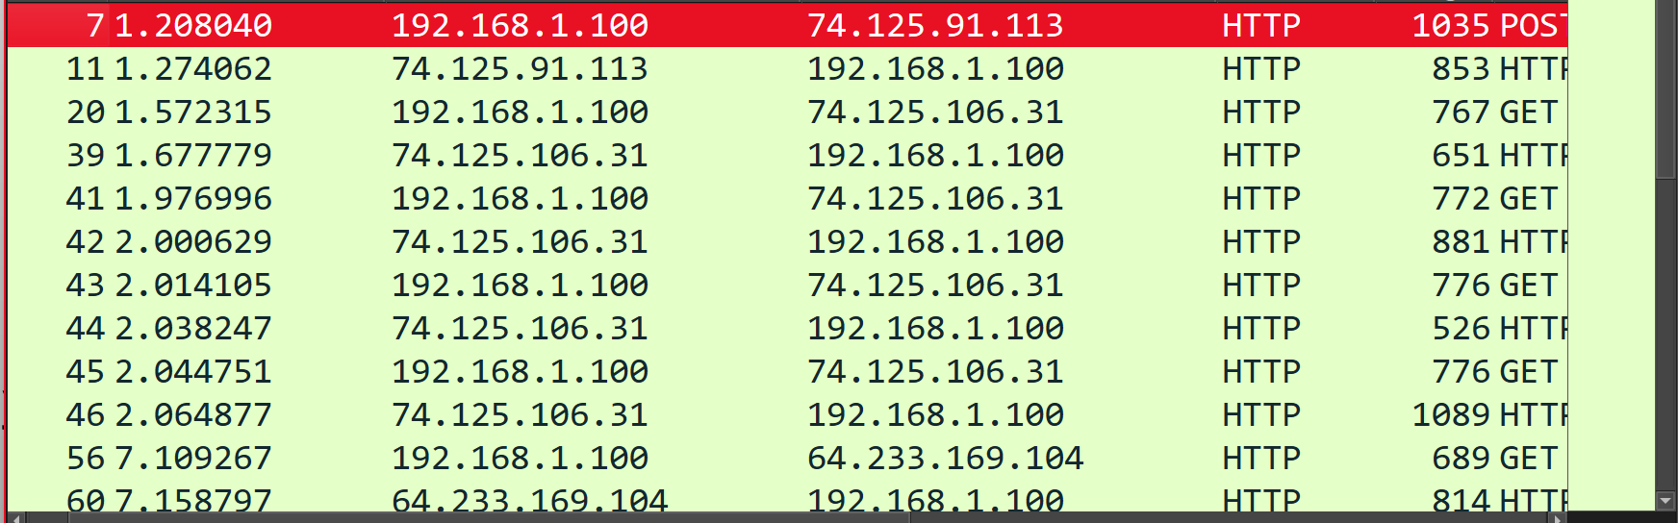
192.168.1.100

2. The client actually communicates with several different Google servers in order to
implement “safe browsing.” (See extra credit section at the end of this lab). The
main Google server that will serve up the main Google web page has IP address
64.233.169.104. In order to display only those frames containing HTTP messages
that are sent to/from this Google, server, enter the expression “http && ip.addr ==
64.233.169.104” (without quotes) into the Filter: field in Wireshark .
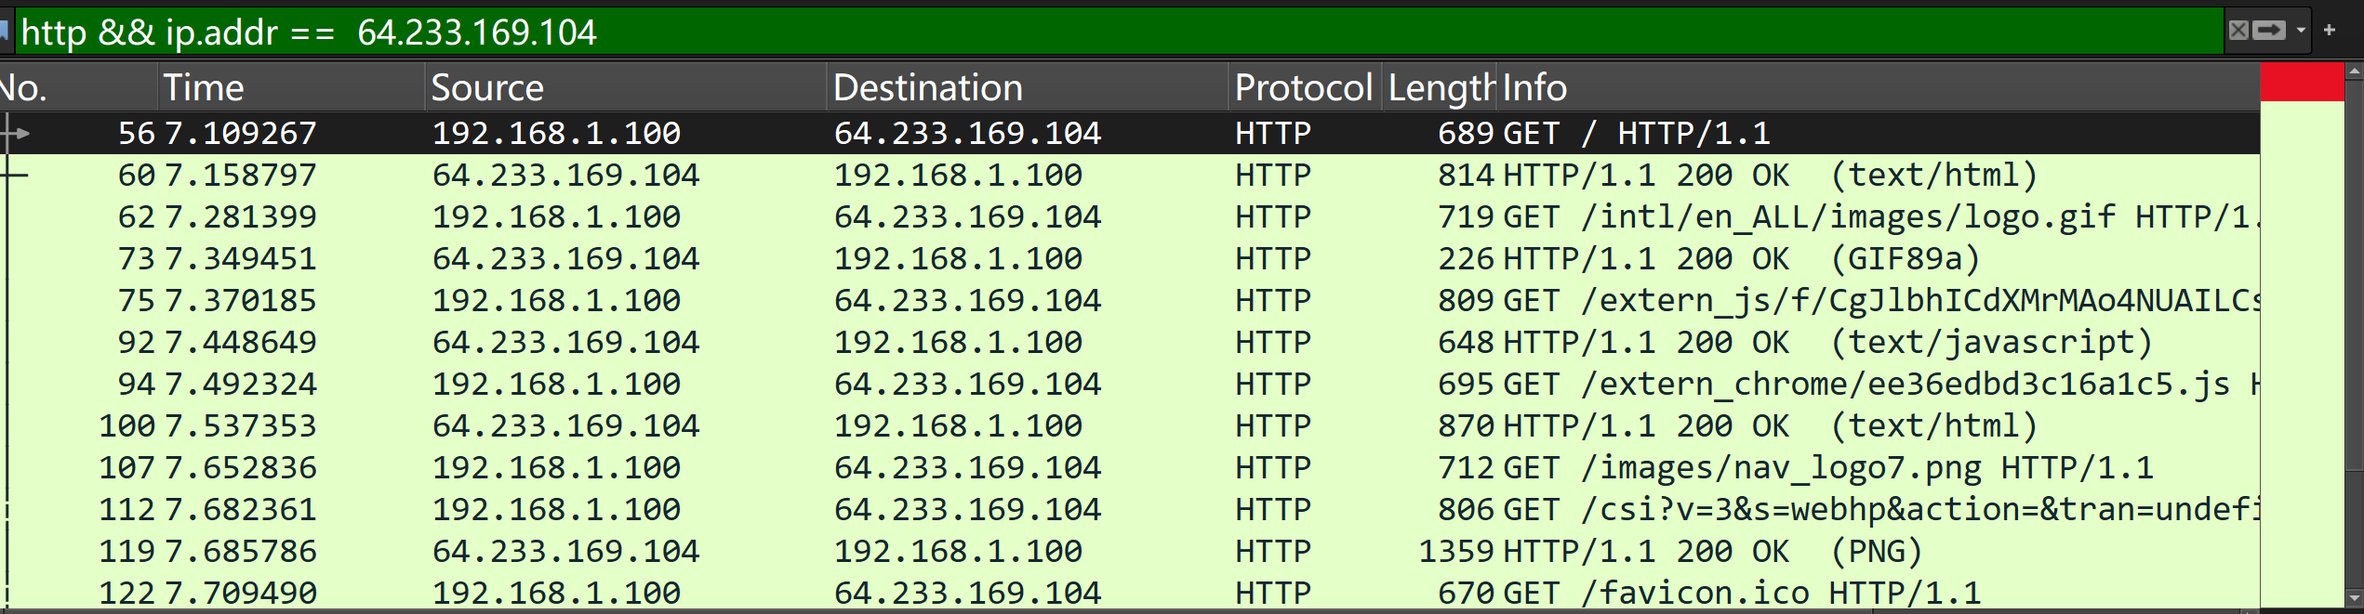

3. Consider now the HTTP GET sent from the client to the Google server (whose IP
address is IP address 64.233.169.104) at time 7.109267. What are the source and
destination IP addresses and TCP source and destination ports on the IP datagram
carrying this HTTP GET?

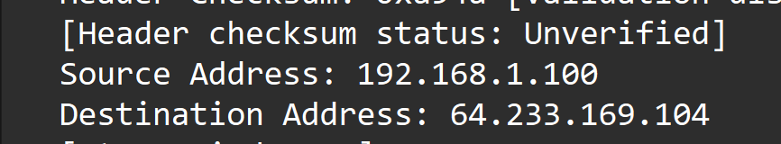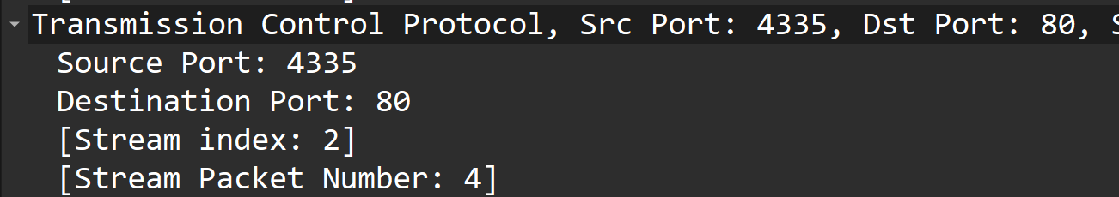

4. At what time4 is the corresponding 200 OK HTTP message received from the
Google server? What are the source and destination IP addresses and TCP source
and destination ports on the IP datagram carrying this HTTP 200 OK message?
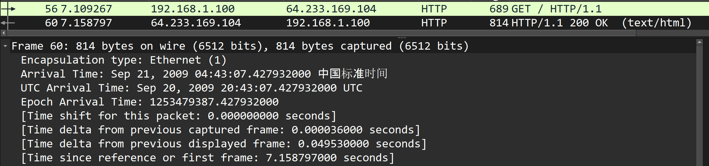
7.158797
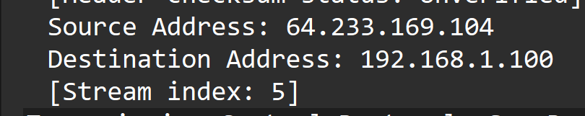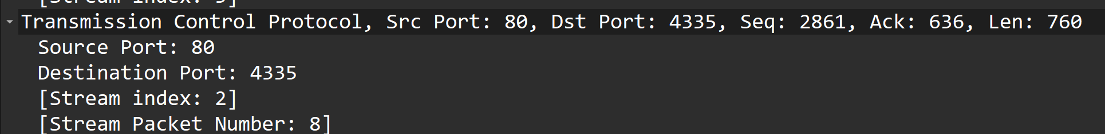

5. Recall that before a GET command can be sent to an HTTP server, TCP must first
set up a connection using the three-way SYN/ACK handshake. At what time is
the client-to-server TCP SYN segment sent that sets up the connection used by
the GET sent at time 7.109267? What are the source and destination IP addresses
and source and destination ports for the TCP SYN segment? What are the source
and destination IP addresses and source and destination ports of the ACK sent in
response to the SYN. At what time is this ACK received at the client? (Note: to
find these segments you will need to clear the Filter expression you entered above
in step 2. If you enter the filter “tcp”, only TCP segments will be displayed by
Wireshark).
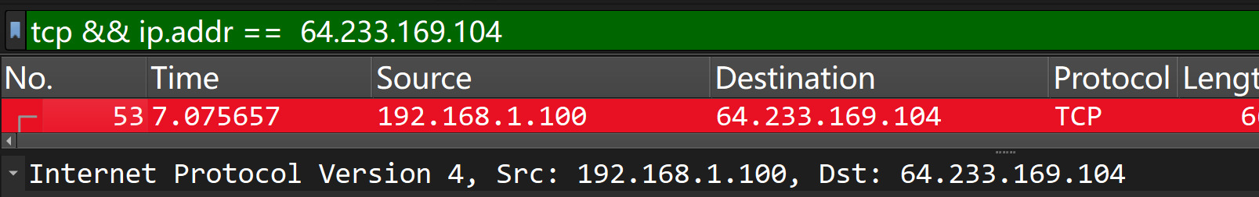
时间：7.075657 s；源IP：192.168.1.100，端口：4335；目的IP：64.233.169.104，端口：80。SYN ACK 报文——时间：7.108986 s；源IP：64.233.169.104，端口：80，目的IP：192.168.1.100，端口：4335。

6. In the NAT_ISP_side trace file, find the HTTP GET message was sent from the
client to the Google server at time 7.109267 (where t=7.109267 is time at which
this was sent as recorded in the NAT_home_side trace file). At what time does
this message appear in the NAT_ISP_side trace file? What are the source and
destination IP addresses and TCP source and destination ports on the IP datagram
carrying this HTTP GET (as recording in the NAT_ISP_side trace file)? Which
of these fields are the same, and which are different, than in your answer to
question 3 above?
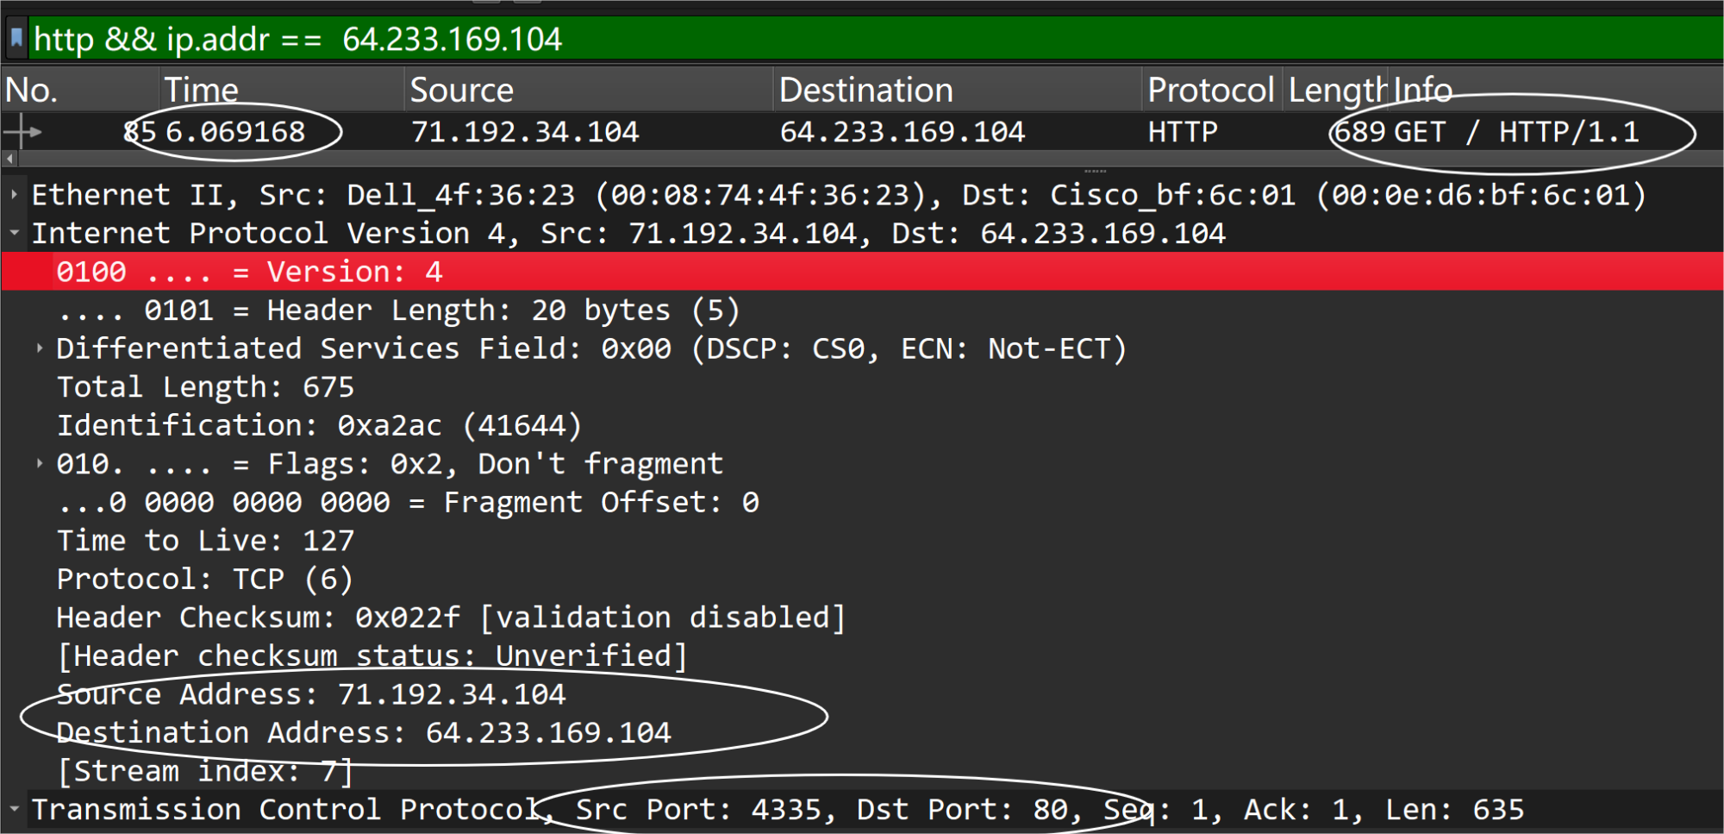

7. Are any fields in the HTTP GET message changed? Which of the following fields
in the IP datagram carrying the HTTP GET are changed: Version, Header Length,
Flags, Checksum. If any of these fields have changed, give a reason (in one
sentence) stating why this field needed to change.
比对未发现HTTP GET 消息字段更改。
但是在IP 封包中生存时间，校验和，发送源IP 均已更改。因为NAT 路由会接收该网域的客户端PC流量，解包处理IP 封包，并且进行TTL-1（经过每个路由器生存时间-1，当为0 时被舍弃），且重新计算校验和并且以自己源头重新封包进行转发。

8. In the NAT_ISP_side trace file, at what time is the first 200 OK HTTP message
received from the Google server? What are the source and destination IP
addresses and TCP source and destination ports on the IP datagram carrying this
HTTP 200 OK message? Which of these fields are the same, and which are
different than your answer to question 4 above?
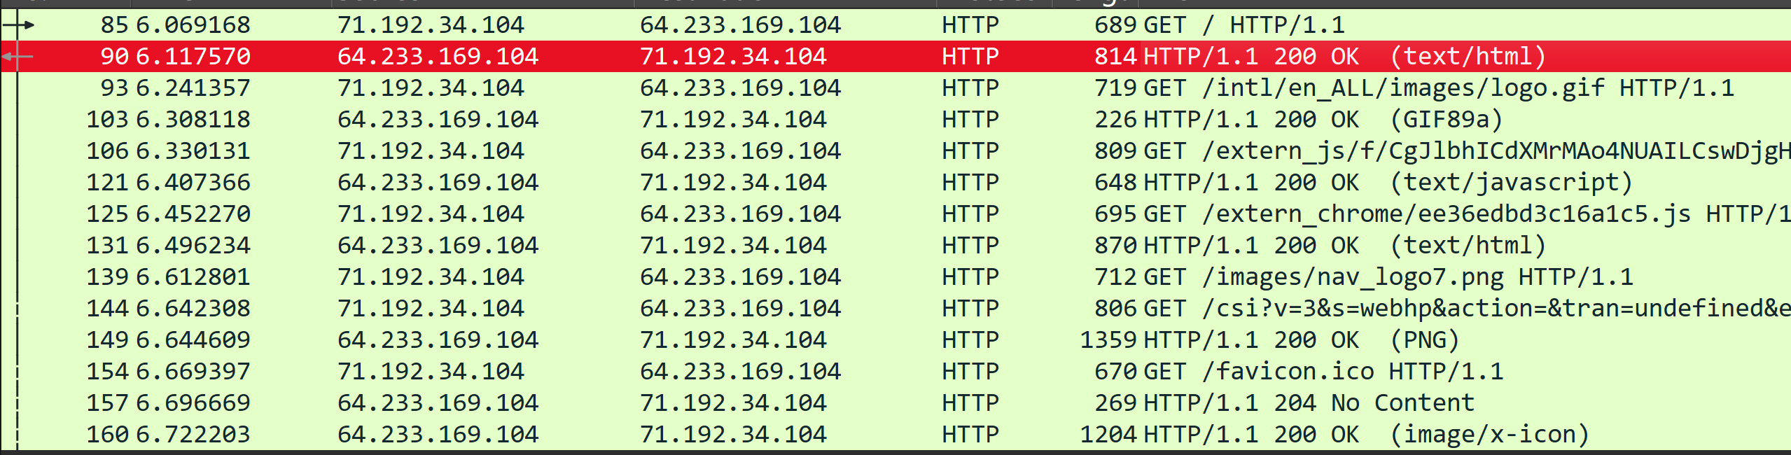
时间 6.117570s，源IP：64.233.169.104，端口：80，目的IP：71.192.34.104，端口：4335。比对除TCP 校验码以外未见承载的TCP 报文有何不同，除此以外IP 封包不同

9. In the NAT_ISP_side trace file, at what time were the client-to-server TCP SYN
segment and the server-to-client TCP ACK segment corresponding to the
segments in question 5 above captured? What are the source and destination IP
addresses and source and destination ports for these two segments? Which of
these fields are the same, and which are different than your answer to question 5
above?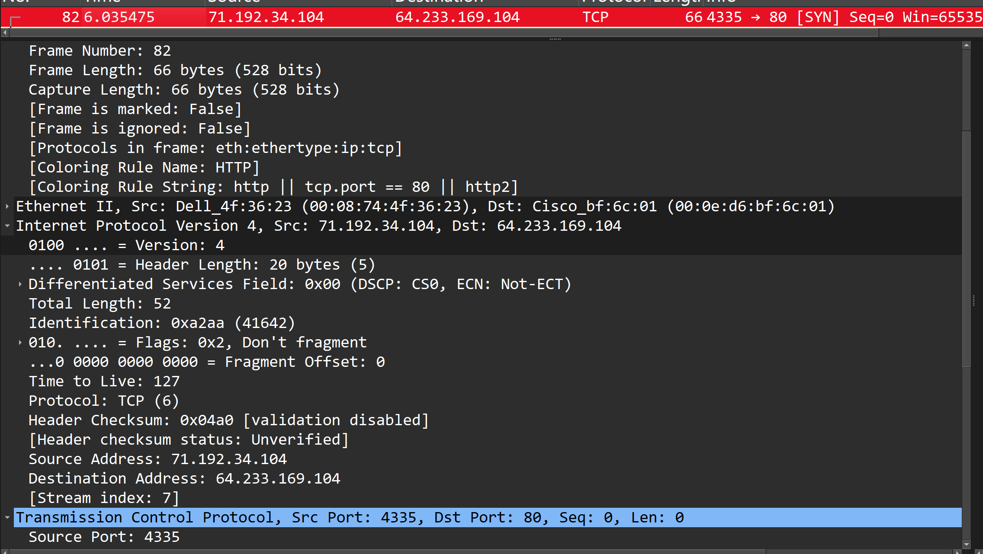
SYN 报文——时间：6.035475s，源IP：71.192.34.104，端口：4335，目的IP：64.233.169.104，端口：80。SYN ACK 报文——时间：6.06775s，源IP：64.233.169.104，端口：80，目的IP：71.192.34.104，端口：4335。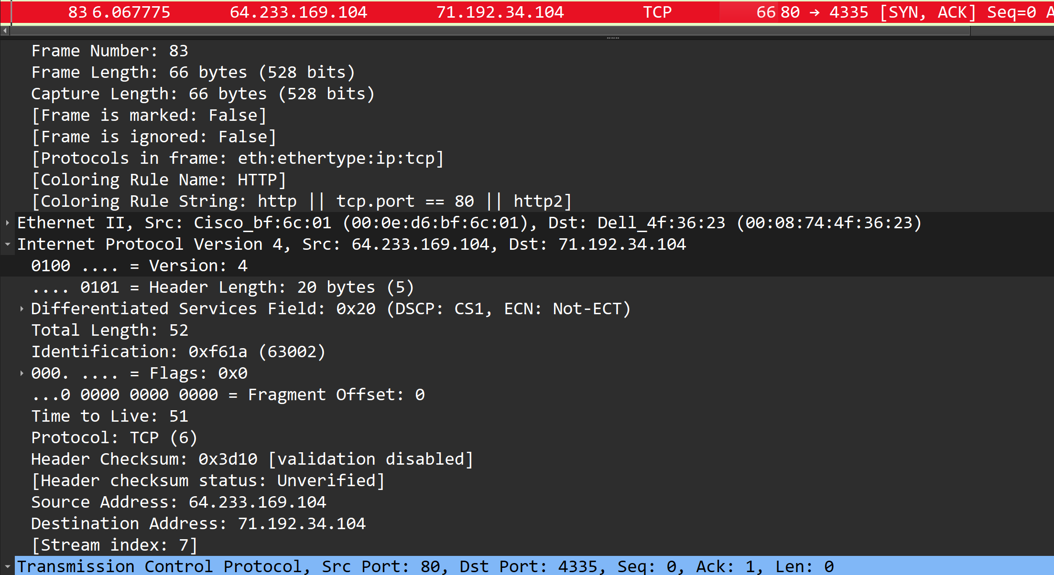
比对除TCP 校验码以外未见承载的TCP 报文有何不同，除此以外IP 封包不同

10. Using your answers to 1-8 above, fill in the NAT translation table entries for
HTTP connection considered in questions 1-8 above.
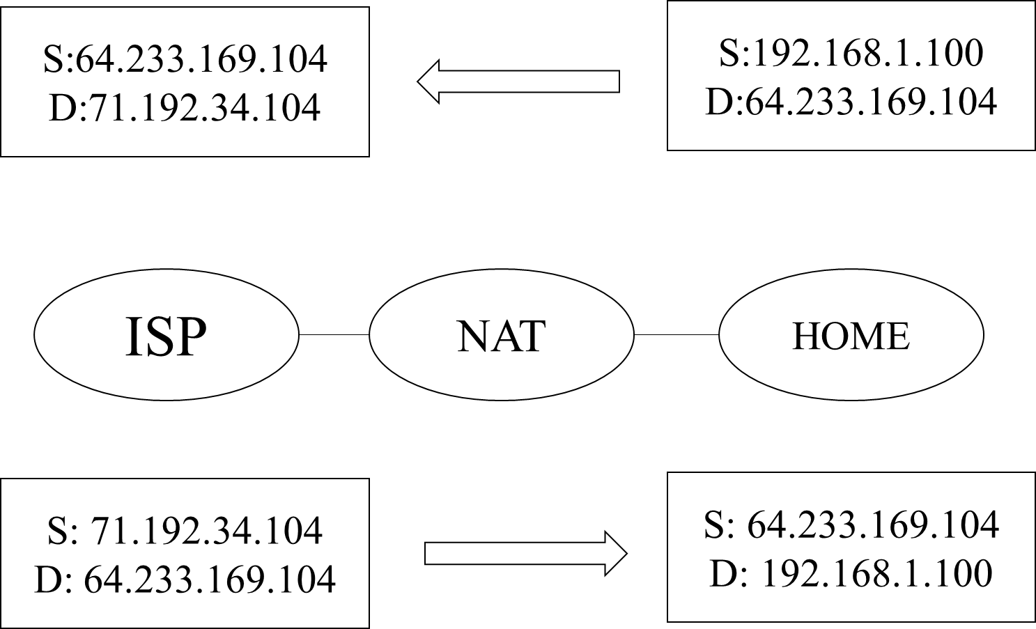

问题及收获：

