山东大学 计算机科学与技术 学院
新兴网络技术与实践 课程实验报告

学号：202200150202 | 姓名：王泓然 |  | 班级：22国贸班
实验题目：ICMP协议学习
实验学时：2 |  | 实验日期：6.13
实验目的：
1. What is the IP address of your host? What is the IP address of the destination
host?
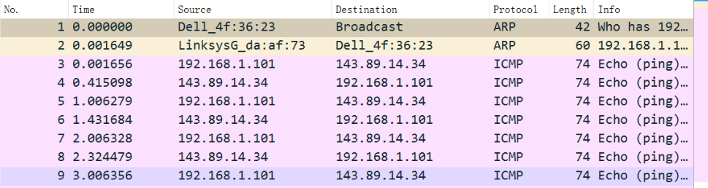
主机的IP地址：192.168.1.101 目的主机的IP地址：143.89.14.34

2. Why is it that an ICMP packet does not have source and destination port
numbers?
因为ICMP是网络层的协议，它不需要传输层TCP或者UDP的承载，直接使用IP数据报承载，因此不需要源端口号和目的端口号，只要源地址和目的地址即可。

3. Examine one of the ping request packets sent by your host. What are the ICMP
type and code numbers? What other fields does this ICMP packet have? How
many bytes are the checksum, sequence number and identifier fields?
ICMP类型：8(代表ICMP请求)
代码：0
还有Checksum、Checksum Status、Indetifier(BE)，Indentifier (LE)、Sequence number(BE)，Sequence number(LE)
校验和(Checksum)：2个字节
序列号(Sequence)：2个字节
标识符(Identifier)：2个字节
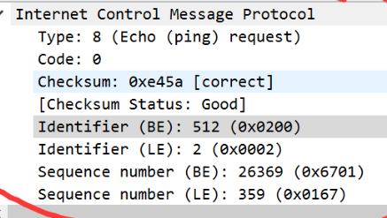

4. Examine the corresponding ping reply packet. What are the ICMP type and code
numbers? What other fields does this ICMP packet have? How many bytes are the
checksum, sequence number and identifier fields?
ICMP类型：0(0代表ICMP响应)
代码：0
还有Checksum、Checksum Status、Indetifier(BE)，Indentifier (LE)、Sequence number(BE)，Sequence number(LE)
校验和(Checksum)：2个字节
序列号(Sequence)：2个字节
标识符(Identifier)：2个字节

5. What is the IP address of your host? What is the IP address of the target
destination host?
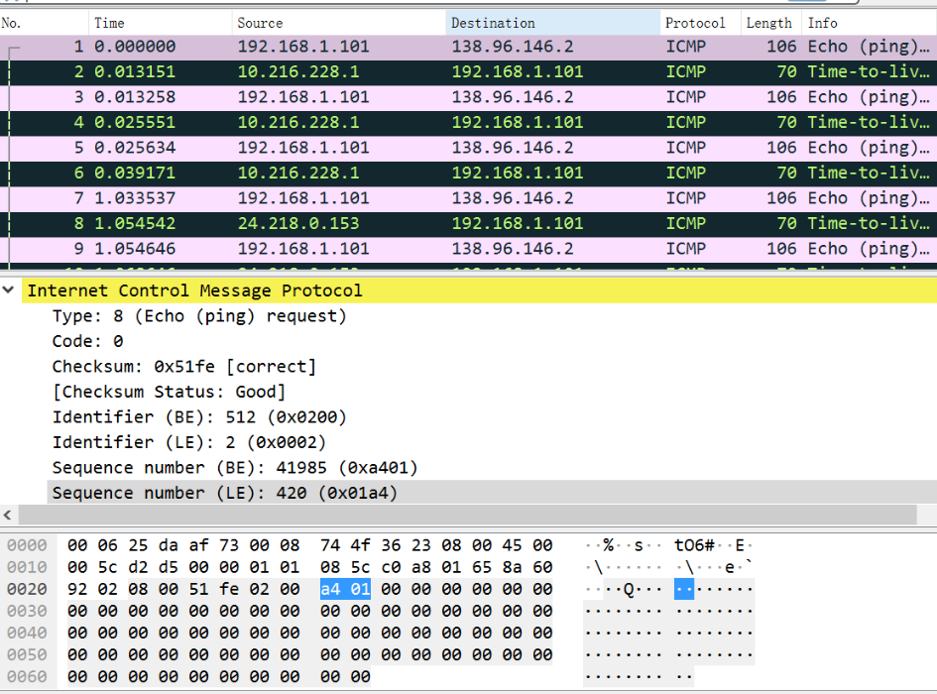
我的主机的IP地址：192.168.1.101 目的主机IP地址：138.96.146.2

6. If ICMP sent UDP packets instead (as in Unix/Linux), would the IP protocol
number still be 01 for the probe packets? If not, what would it be?
我是windows,没有UDP

7. Examine the ICMP echo packet in your screenshot. Is this different from the
ICMP ping query packets in the first half of this lab? If yes, how so?

8. Examine the ICMP error packet in your screenshot. It has more fields than the
ICMP echo packet. What is included in those fields?
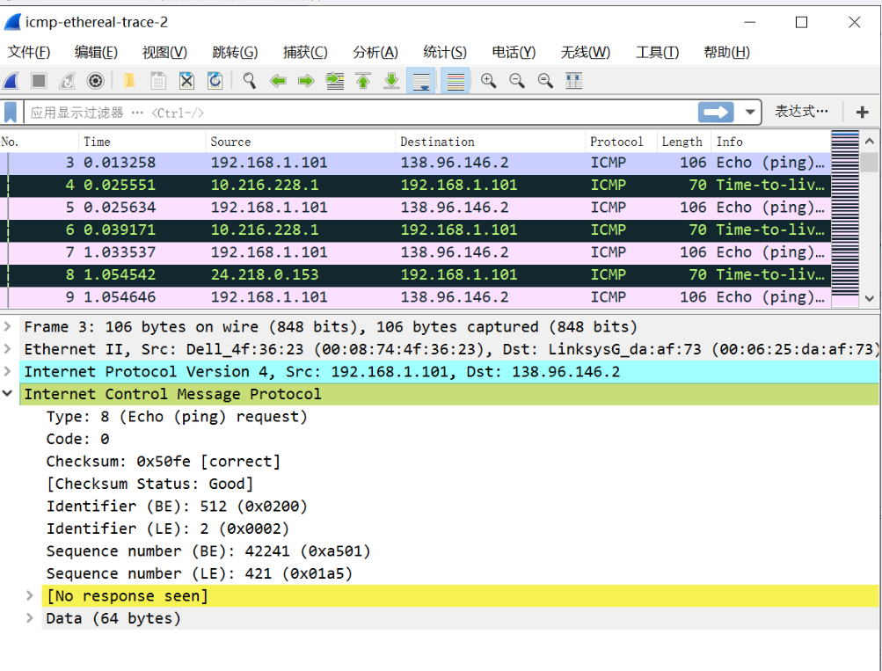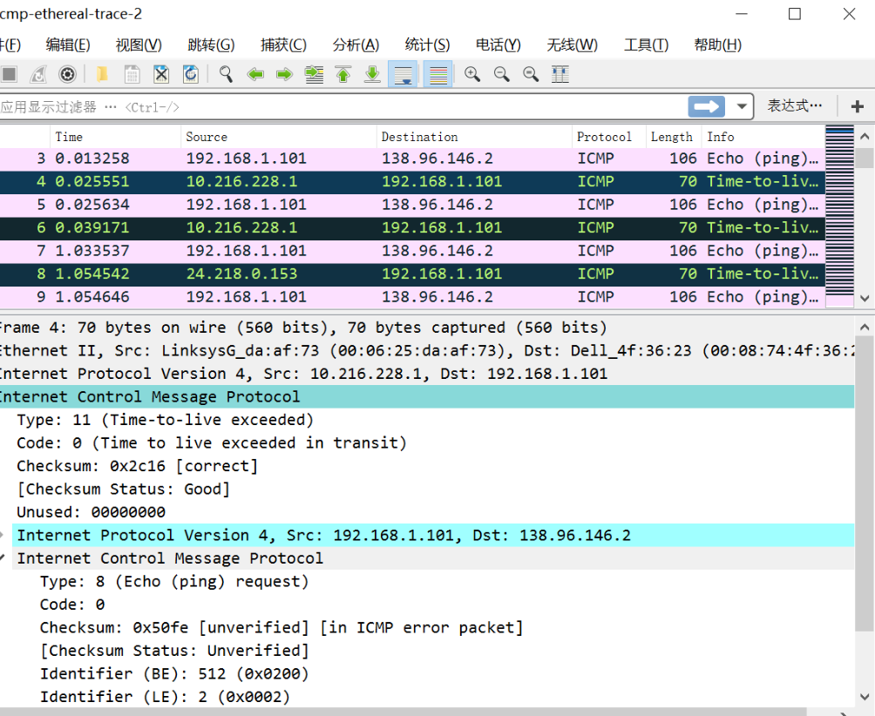

9. Examine the last three ICMP packets received by the source host. How are these
packets different from the ICMP error packets? Why are they different?
源主机收到的最后三个ICMP数据包是目的主机发送给我的ICMP回应数据包，因为路由查询是使用逐渐递增TTL的查询数据包，最后的ICMP查询数据包的TTL已经大于到达目的主机中间路由跃点数，因此不会被目标主机丢弃来发送ICMP超时的数据包，所以只会收到ICMP响应数据包。

10. Within the tracert measurements, is there a link whose delay is significantly
longer than others? Refer to the screenshot in Figure 4, is there a link whose
delay is significantly longer than others? On the basis of the router names, can
you guess the location of the two routers on the end of this link?
第10个请求明显多了。
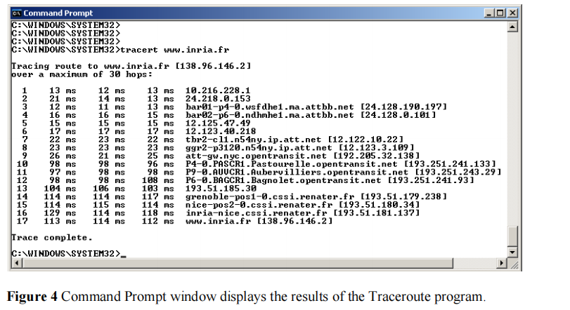

问题及收获：

