山东大学 计算机科学与技术 学院
新兴网络技术与实践 课程实验报告

学号：202200150202 | 姓名：王泓然 |  | 班级：22国贸班
实验题目：DNS
实验学时：2 |  | 实验日期：2025.3.27
实验目的：
- Run nslookup to obtain the IP address of a Web server in Asia. What is the IP address of that server?（搜索日本软银的IP地址）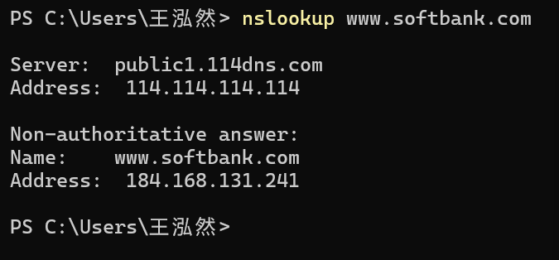
IP address: 184.168.131.241
2.Run nslookup to determine the authoritative DNS servers for a university in Europe.（查询德国慕尼黑大学的权威IP地址）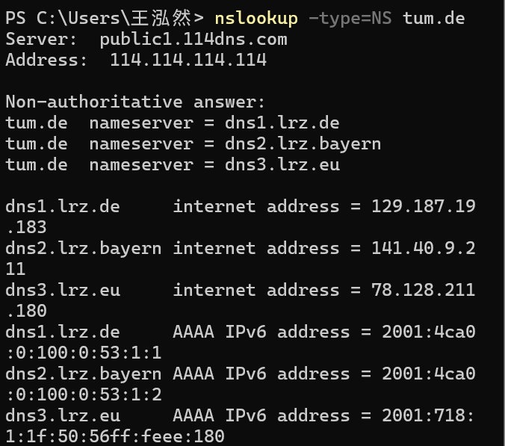
3.Run nslookup so that one of the DNS servers obtained in Question 2 is queried for the mail servers for Yahoo! mail. What is its IP address?（仍然使用德国慕尼黑大学服务器查询雅虎IP地址）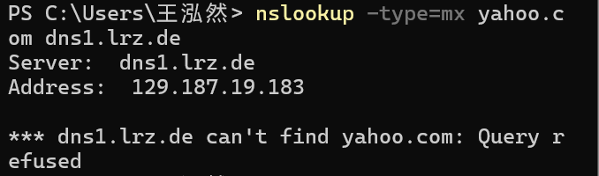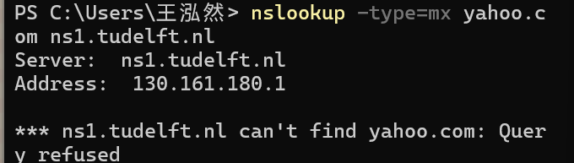
欧洲大学用户无法查找，使用公共DNS（dns.google）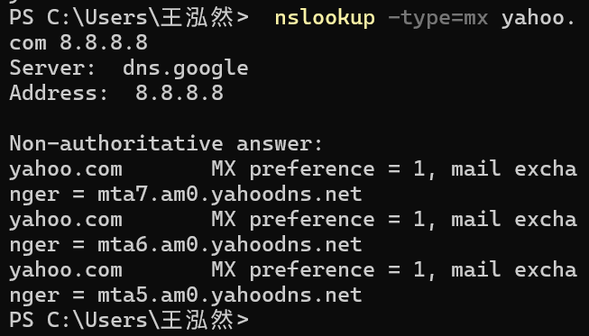
使用公共域名查询成功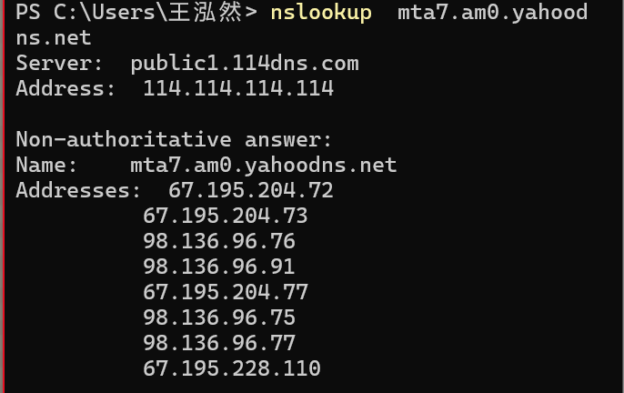
ADDRESS即为IP地址
4.Locate the DNS query and response messages. Are then sent over UDP or TCP?
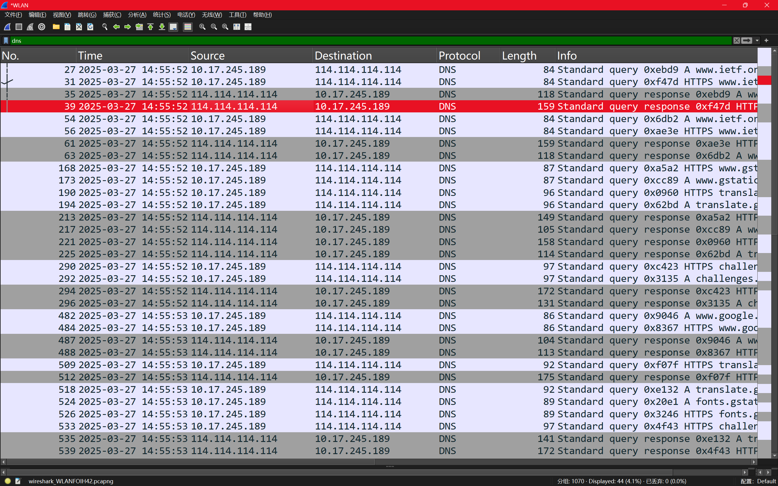
使用TCP传输
5.What is the destination port for the DNS query message? What is the source port of DNS response message? 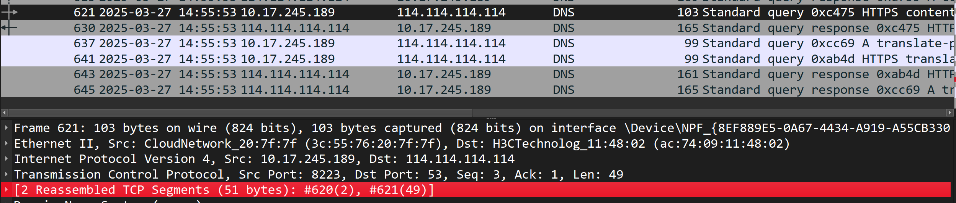
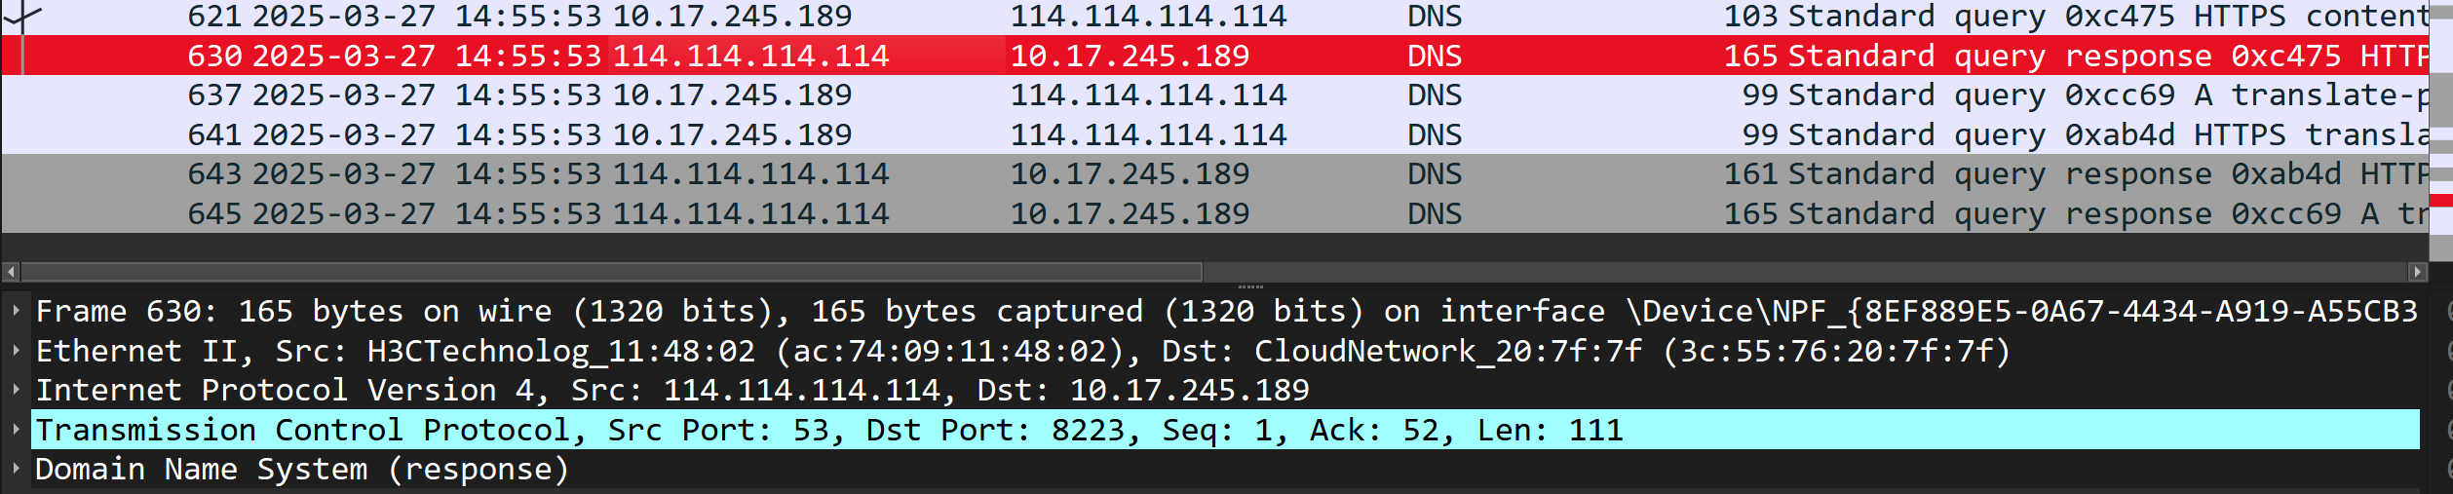
均为53端口。
6.To what IP address is the DNS query message sent? Use ipconfig to determine the IP address of your local DNS server. Are these two IP addresses the same?
相同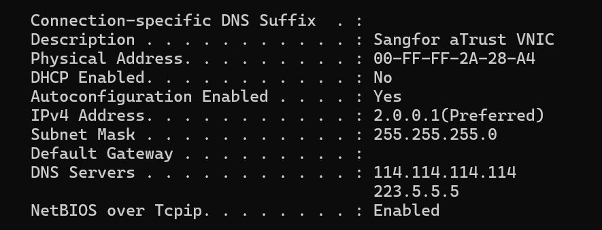
7.Examine the DNS query message. What “Type” of DNS query is it? Does the query message contain any “answers”?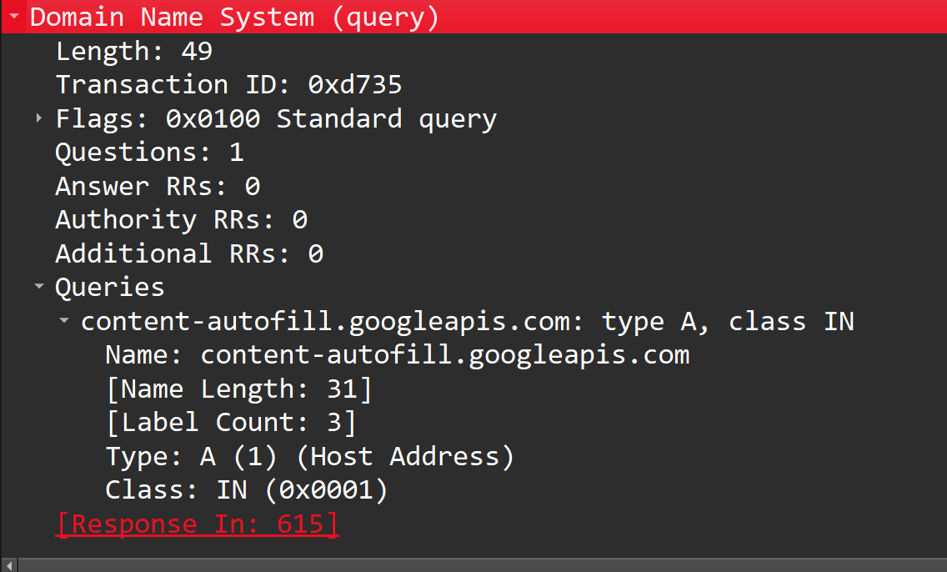
TYPE为A，没有任何答案
- Examine the DNS response message. How many “answers” are provided? What do each of these answers contain?
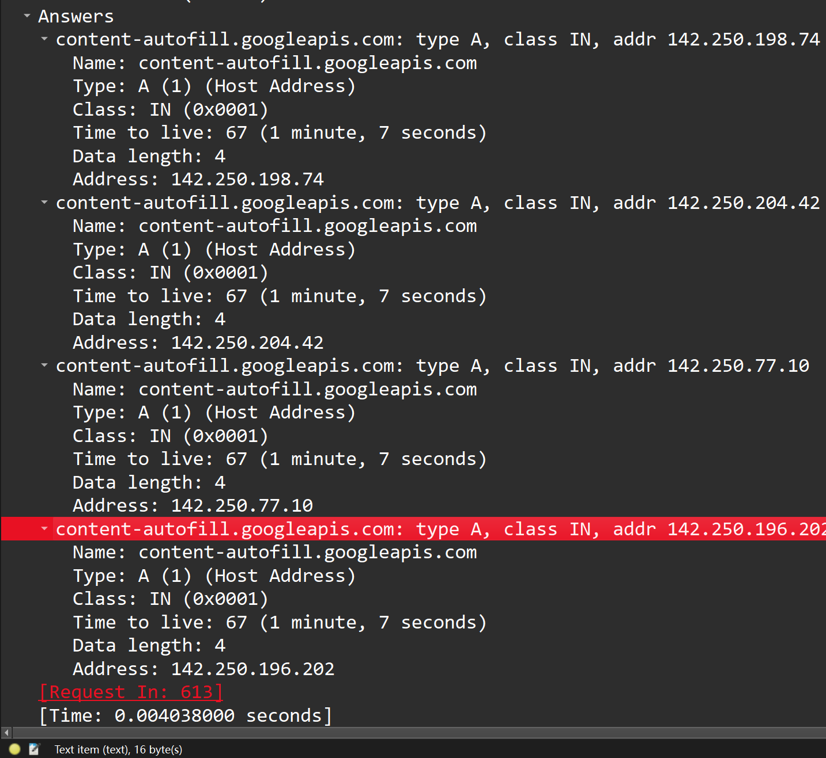
答案是4个地址
- Consider the subsequent TCP SYN packet sent by your host. Does the destination IP address of the SYN packet correspond to any of the IP addresses provided in the DNS response message?
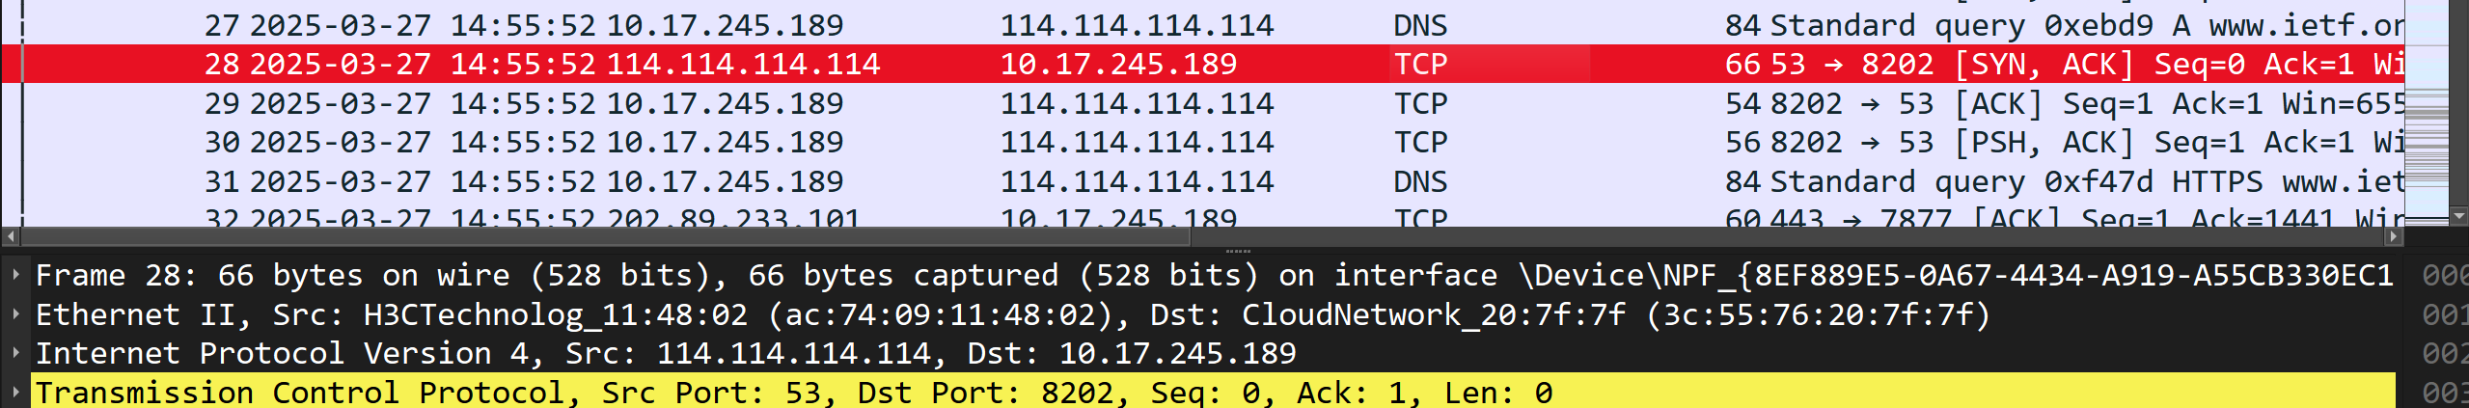
相等
10.This web page contains images. Before retrieving each image, does your host issue new DNS queries?
没有，因为本机 DNS 已经被缓存了，因此不需要发起新的 DNS 查询。
11.What is the destination port for the DNS query message? What is the source port of DNS response message?（只关注最后一次DNS）
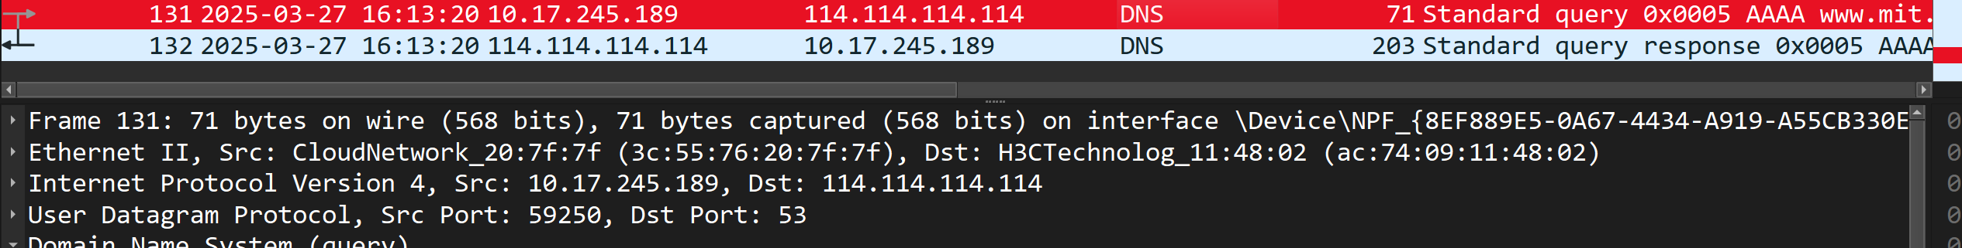
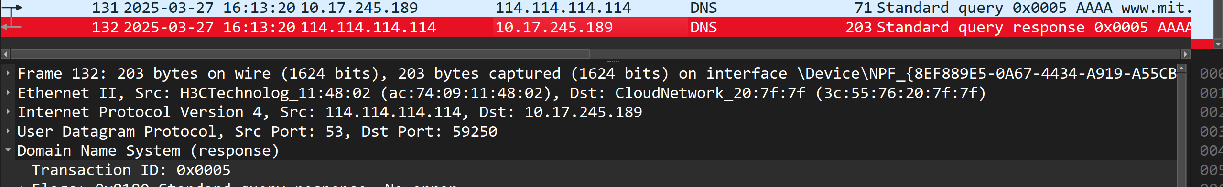
均为53
- To what IP address is the DNS query message sent? Is this the IP address of your default local DNS server?
是的
13.Examine the DNS query message. What “Type” of DNS query is it? Does the query message contain any“answers”?
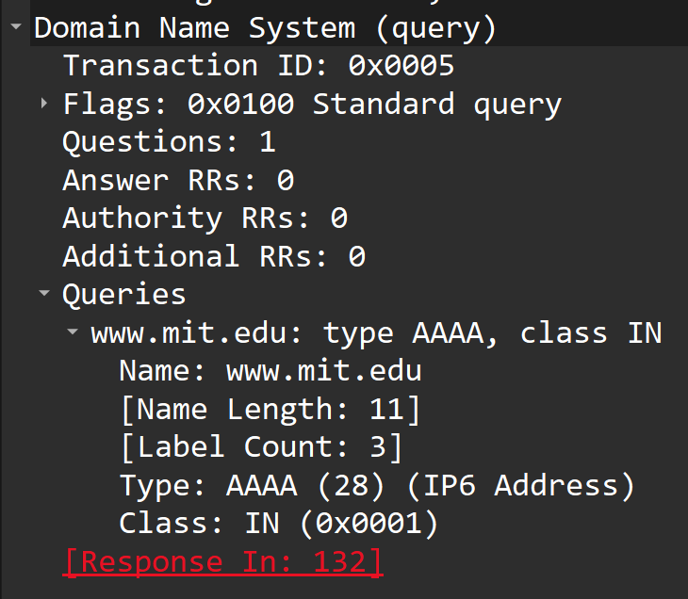
TYPE是AAAA，不含任何答案
14.Examine the DNS response message. How many “answers” are provided? What do each of these answers contain?
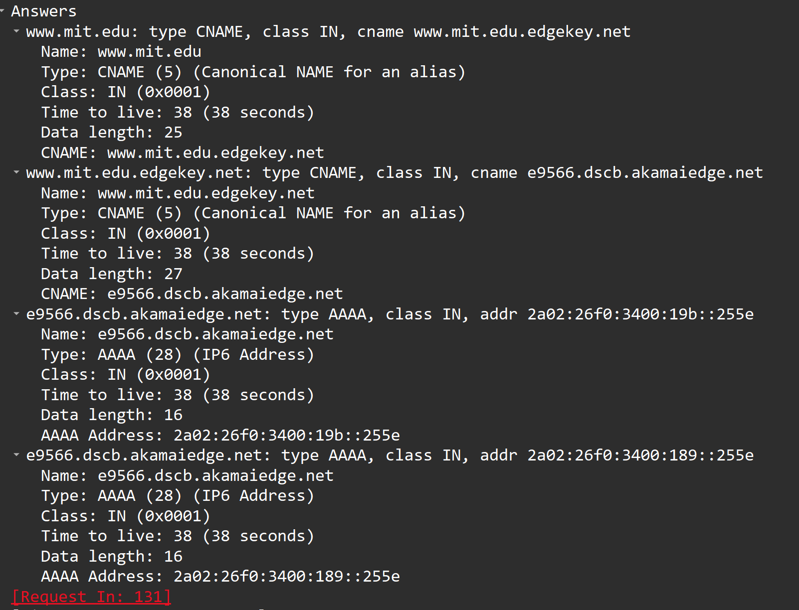
4个答案，两个IPV6地址和两个别名
16. To what IP address is the DNS query message sent? Is this the IP address of your default local DNS server?
是我的默认本地DNS IP
17. Examine the DNS query message. What “Type” of DNS query is it? Does the query message contain any “answers”?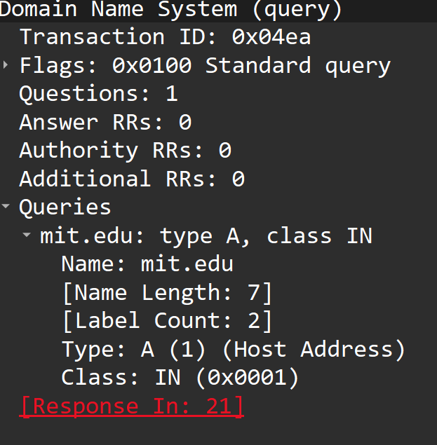
A 0个答案
18. Examine the DNS response message. What MIT nameservers does the response message provide? Does this response message also provide the IP addresses of the
MIT namesers?
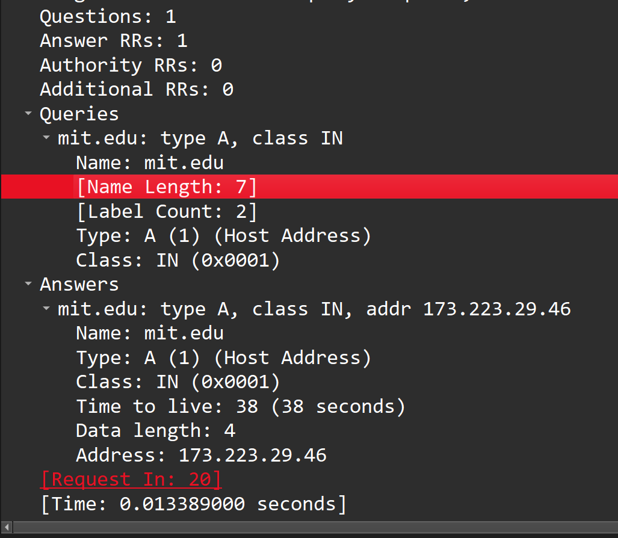
提供了一个IP地址，是的。
【响应超时，选择导入文件查看】
- To what IP address is the DNS query message sent? Is this the IP address of your default local DNS server? If not, what does the IP address correspond to?
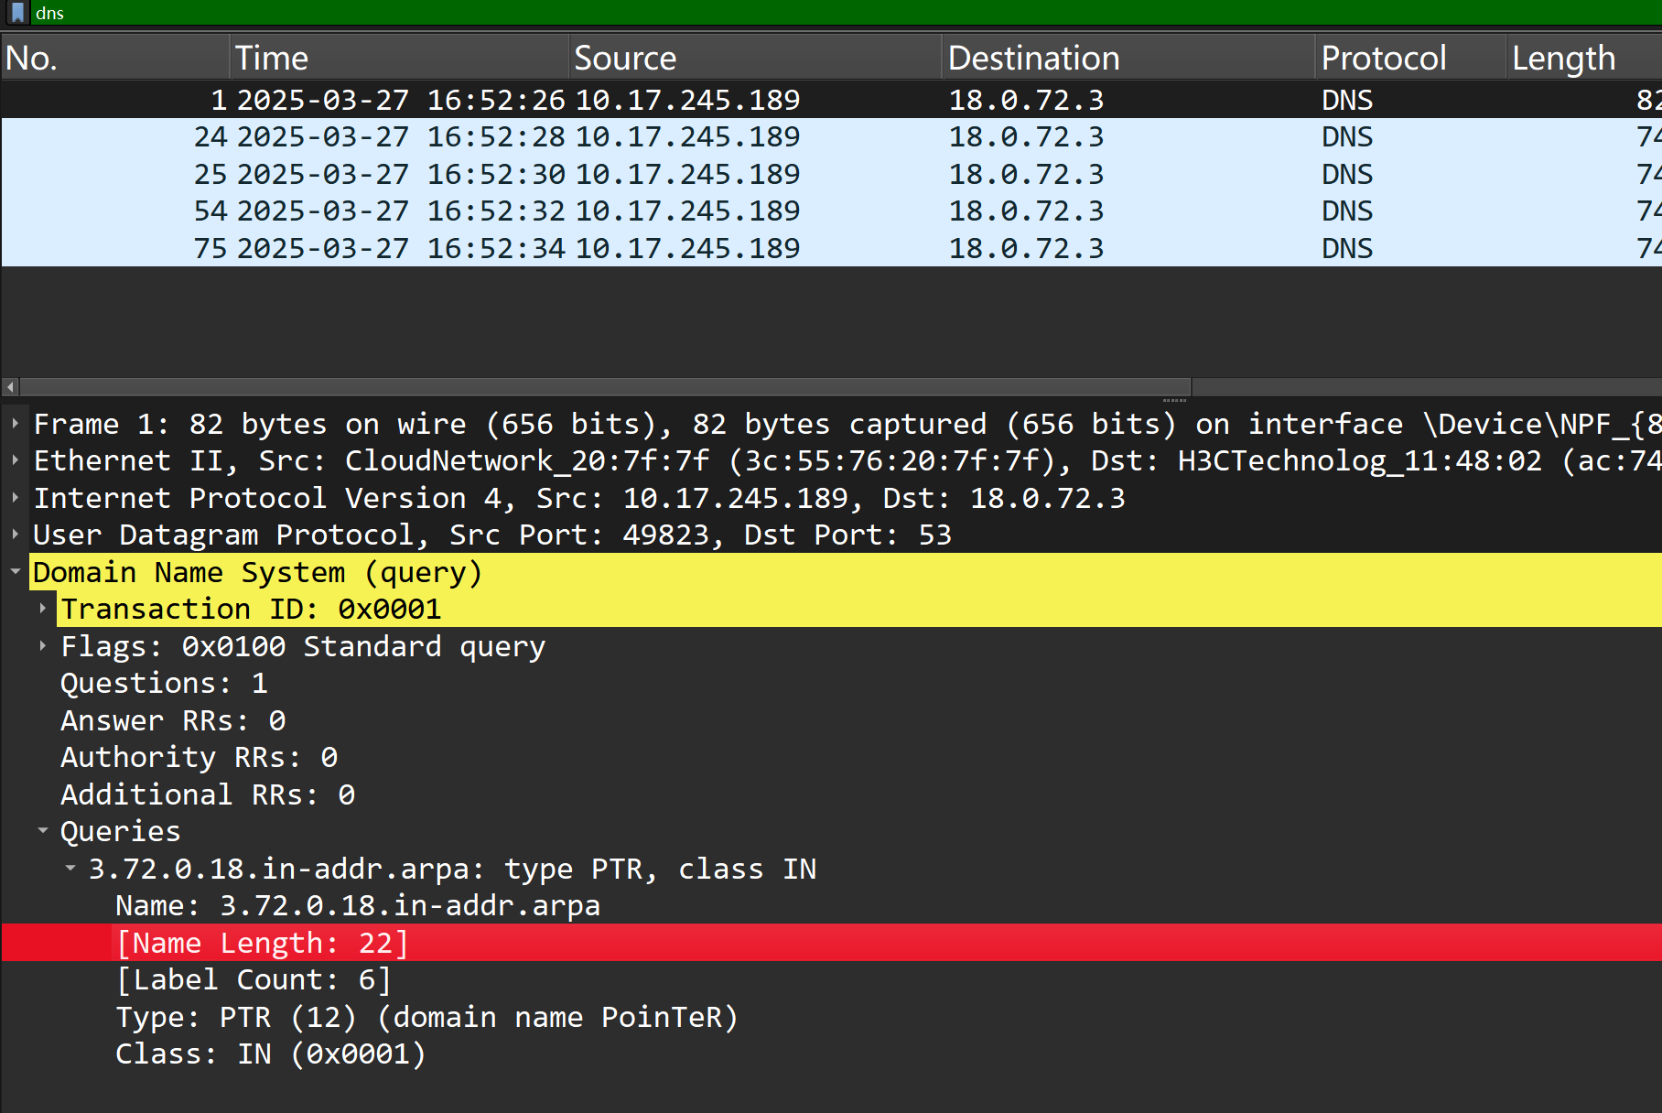
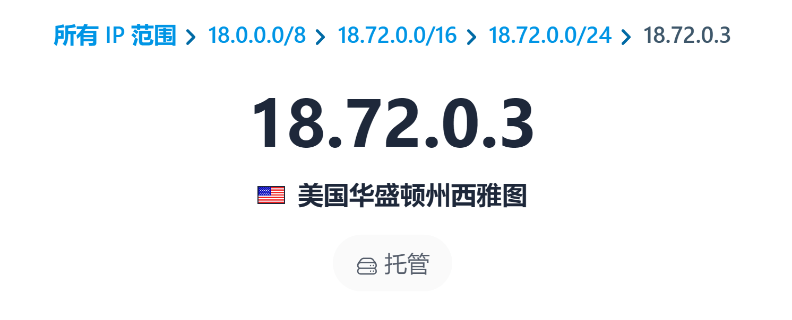
显示在华盛顿州西雅图，并不是我本地默认DNS
- Examine the DNS query message. What “Type” of DNS query is it? Does the query message contain any “answers”?
并不包含任何答案，TYPE是PTR
- Examine the DNS response message. How many
“answers” are provided? What does each of these answers contain?
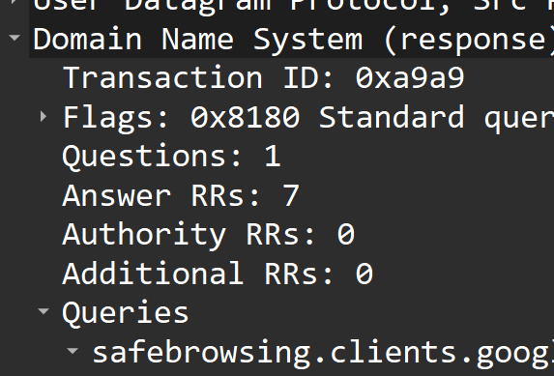
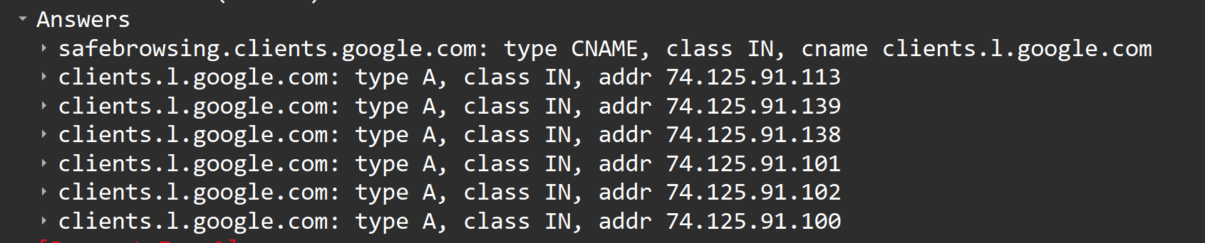
包含7个答案，包含6个IP地址。

问题及收获：

