山东大学 计算机科学与技术 学院
新兴网络技术与实践 课程实验报告

学号：202200150202 | 姓名：王泓然 |  | 班级：22国贸班
实验题目：DHCP协议学习
实验学时：2 |  | 实验日期：2025/5/16
实验目的：学习DHCP协议
- Are DHCP messages sent over UDP or TCP?
UDP
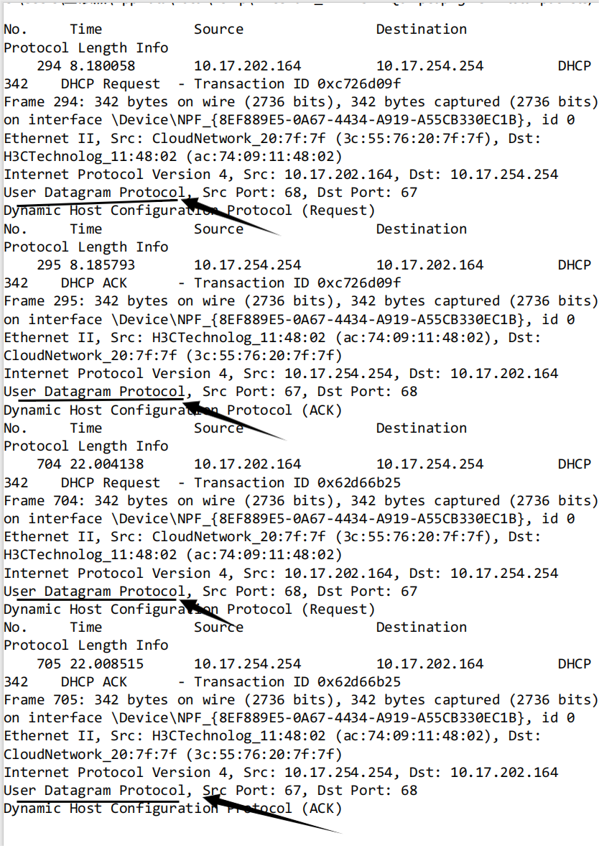
2. Draw a timing datagram illustrating the sequence of the first four-packet
Discover/Offer/Request/ACK DHCP exchange between the client and server. For
each packet, indicated the source and destination port numbers. Are the port
numbers the same as in the example given in this lab assignment?
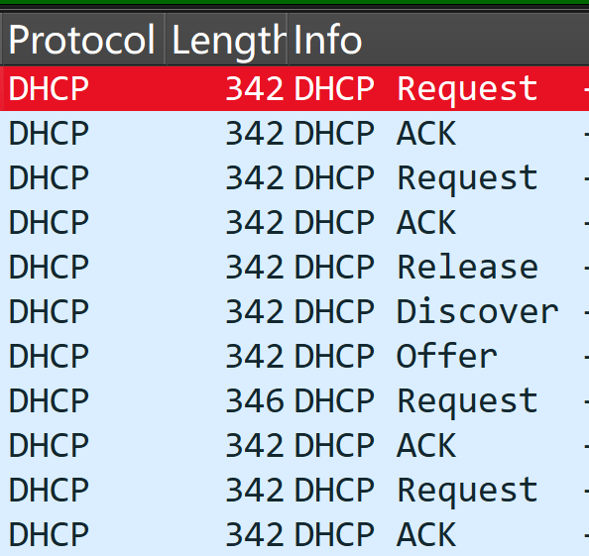
顺序向下
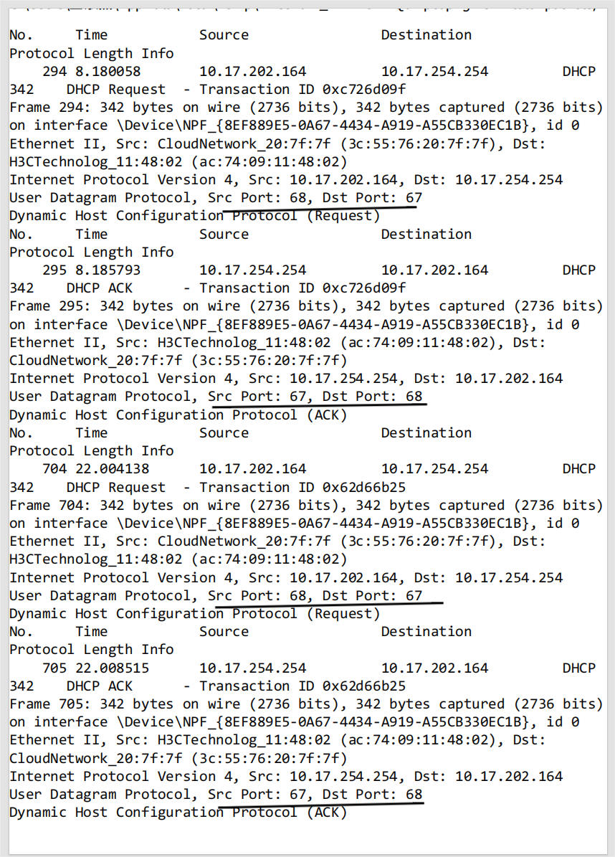
3. What is the link-layer (e.g., Ethernet) address of your host?
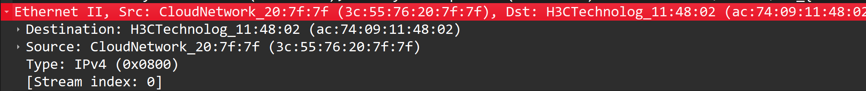

4. What values in the DHCP discover message differentiate this message from the DHCP request message?
DHCP Discover:
Does not include the server-identifier option, as the client has not yet selected a server .
DHCP Request:
Includes the server-identifier (the IP address of the chosen DHCP server) to specify which server’s offer the client is accepting .
This ensures the client’s request is directed to the correct server, even in multi-server environments.
DHCP Discover:
Typically does not include the requested-ip-address option, as the client has not received any IP offers yet .
DHCP Request:
Includes the requested-ip-address option to explicitly ask for the IP address offered by the selected server .
This option ensures the server allocates the exact IP address the client expects.

- What is the value of the Transaction-ID in each of the first four (Discover/Offer/Request/ACK) DHCP messages? What are the values of the Transaction-ID in the second set (Request/ACK) set of DHCP messages? What is the purpose of the Transaction-ID field?
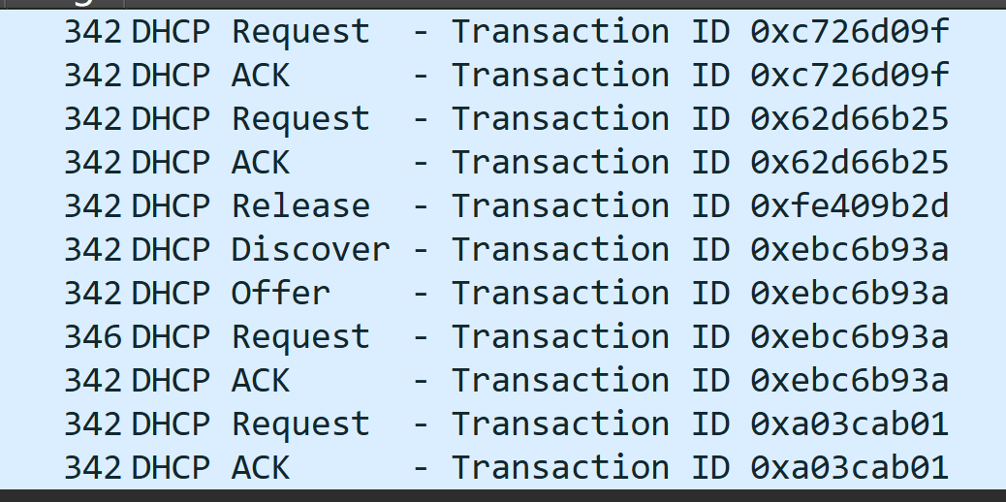
The Transaction-ID (Transaction Identifier) field in DHCP messages is a 32-bit random number generated by the DHCP client. Its core purpose is to uniquely identify a single DHCP session (i.e., the sequence of messages between a client and server during an IP address lease or renewal process). This ensures that all messages related to the same lease request/renewal are properly correlated, even in networks with multiple clients or delayed messages.

- A host uses DHCP to obtain an IP address, among other things. But a host’s IP address is not confirmed until the end of the four-message exchange! If the IP address is not set until the end of the four-message exchange, then what values are used in the IP datagrams in the four-message exchange? For each of the four DHCP messages (Discover/Offer/Request/ACK DHCP), indicate the source and destination IP addresses that are carried in the encapsulating IP datagram.
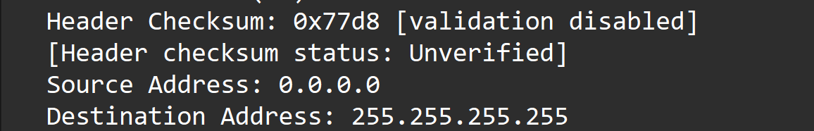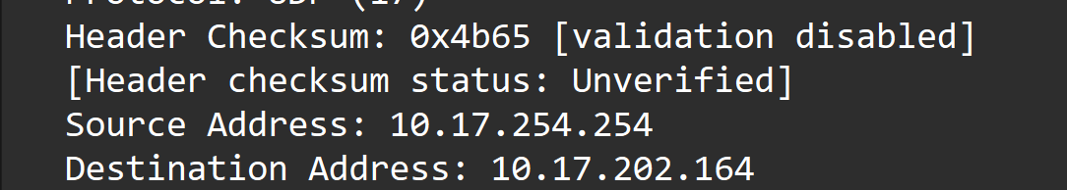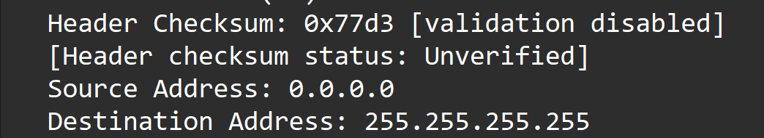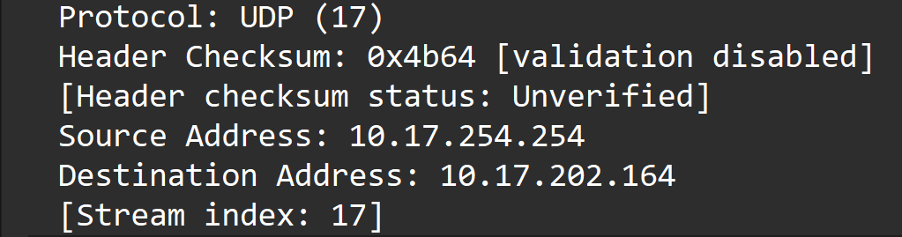

7. What is the IP address of your DHCP server?
255.255.255.255

8. What IP address is the DHCP server offering to your host in the DHCP Offer
message? Indicate which DHCP message contains the offered DHCP address.
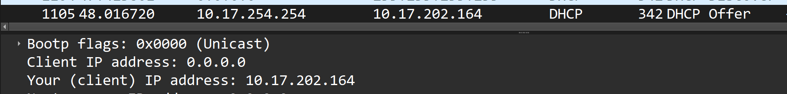
DHCP OFFER

9. In the example screenshot in this assignment, there is no relay agent between the
host and the DHCP server. What values in the trace indicate the absence of a relay
agent? Is there a relay agent in your experiment? If so what is the IP address of
the agent?
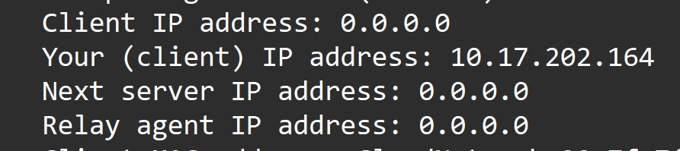
无中继代理

10. Explain the purpose of the router and subnet mask lines in the DHCP offer
message.
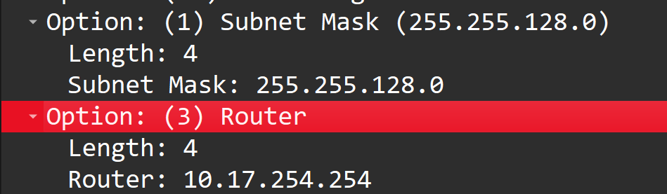
The subnet mask defines how the client’s IP address is divided into network and host portions. It tells the client:
Which part of its IP address represents the network/subnet it belongs to.
Which part represents the unique host identifier within that subnet.
The router (or default gateway) is the IP address of the device (e.g., a router or firewall) that allows the client to communicate with devices on other subnets or the internet. It serves as the first hop for all traffic destined outside the client’s local subnet.

11. In the DHCP trace file noted in footnote 2, the DHCP server offers a specific IP
address to the client (see also question 8. above). In the client’s response to the first server OFFER message, does the client accept this IP address? Where in the
client’s RESPONSE is the client’s requested address?
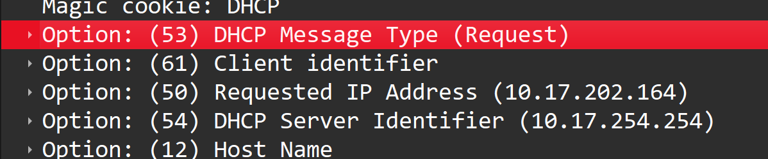
接受

12. Explain the purpose of the lease time. How long is the lease time in your
experiment? 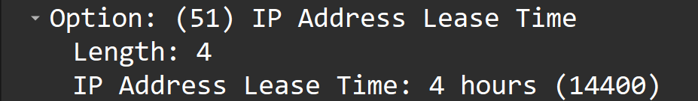
4h,
Efficient IP Address Management
IP addresses are finite resources. The lease time allows the DHCP server to reclaim an IP address after a specified duration. If a client no longer needs the IP (e.g., it disconnects from the network), the address can be reallocated to other devices, preventing waste and ensuring optimal use of the address pool.
Support for Dynamic Environments
In networks with mobile or transient devices (e.g., public Wi-Fi, offices with many portable devices), lease time accommodates devices that join and leave frequently. It ensures that addresses are not permanently reserved for inactive devices, adapting to the dynamic nature of such environments.
Facilitates Reconfiguration
If network settings (e.g., subnet mask, default gateway, DNS servers) change, the lease time enables the DHCP server to push updates. When a client renews its lease, it receives the latest configuration parameters, ensuring consistency and compatibility with network changes.
Lease Renewal Mechanism
Clients can renew their lease before it expires (typically via a DHCP Request message). This allows devices to retain their IP addresses if they remain active on the network, balancing temporary allocation with stability for ongoing connections.

13. What is the purpose of the DHCP release message? Does the DHCP server issue
an acknowledgment of receipt of the client’s DHCP request? What would happen
if the client’s DHCP release message is lost?
Purpose of the DHCP Release Message
The DHCP release message is sent by a client to explicitly return its leased IP address to the DHCP server. This allows the server to reclaim the IP address and make it available for assignment to other clients, optimizing IP address usage in the network. For example, when a device shuts down or moves to a different network, it sends a release message to free up the address.
Does the DHCP Server Acknowledge the Client’s DHCP Release Request?
No, the DHCP server does not issue an acknowledgment for the client’s DHCP release message. The server simply retains the IP address until the lease time expires. Even if the client releases the address early, the server waits for the lease duration to conclude before reassigning it, ensuring stability and avoiding premature reuse of the address.
If the Client’s DHCP Release Message Is Lost
If the release message is lost, the server remains unaware of the client’s intent to release the IP address. However, the server will still wait until the lease time expires before reassigning the address. The client’s network connectivity is not immediately affected, as the server honors the lease until its end. Once the lease expires, the server can then reallocate the IP address to another client, even if the release message was lost. This lease - based mechanism acts as a safeguard against address conflicts or premature reassignments.
14. Clear the bootp filter from your Wireshark window. Were any ARP packets sent
or received during the DHCP packet-exchange period? If so, explain the purpose
of those ARP packets.
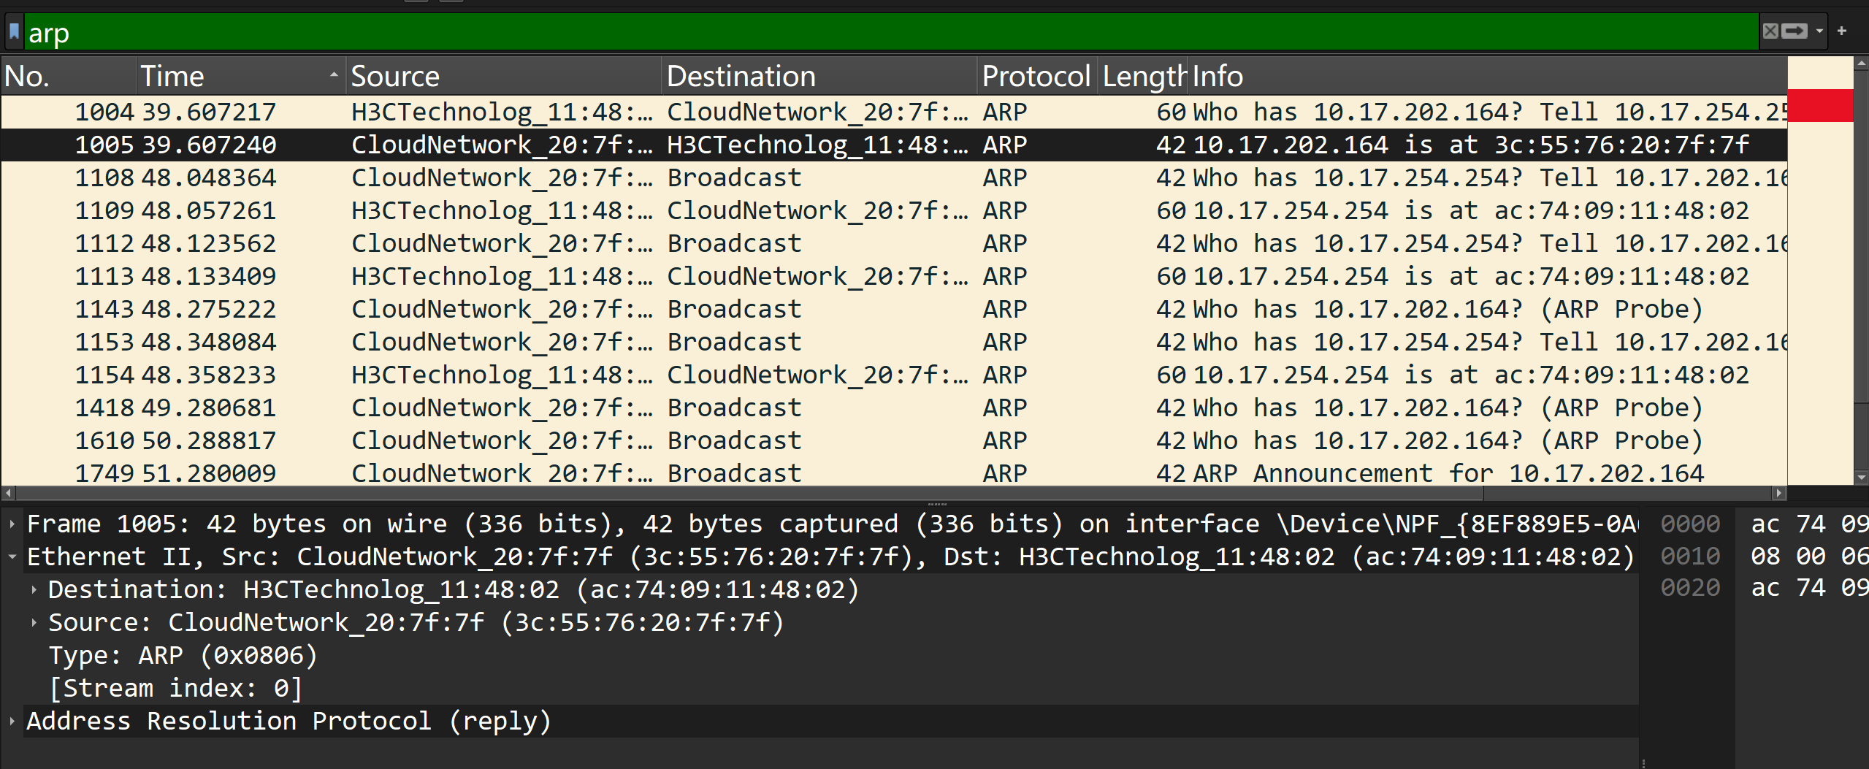
When a DHCP server intends to offer an IP address to a client, it often sends an ARP request for that specific IP address. The goal is to check if the IP address is already in use on the local network. If no device responds to the ARP request, the server confirms that the IP address is available and can safely offer it to the client. This prevents the server from assigning an IP address that is already leased to another device, avoiding IP - address conflicts. By verifying availability via ARP, the DHCP server ensures the integrity and proper functioning of the network’s IP - addressing scheme during the DHCP process.

问题及收获：

