山东大学 计算机科学与技术 学院
新兴网络技术与实践 课程实验报告

学号：202200150202 | 姓名：王泓然 |  | 班级：22国贸班
实验题目：UDP协议
实验学时：2 |  | 实验日期：2025.4.15
实验目的：UDP协议学习并捕获
1. Select one UDP packet from your trace. From this packet, determine how many
fields there are in the UDP header. (You shouldn’t look in the textbook! Answer
these questions directly from what you observe in the packet trace.) Name these
fields.
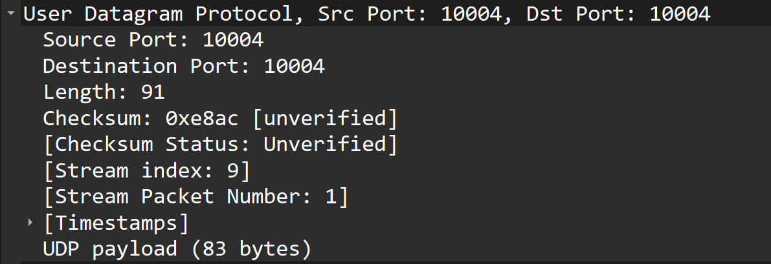
长度为91
2. By consulting the displayed information in Wireshark’s packet content field for
this packet, determine the length (in bytes) of each of the UDP header fields
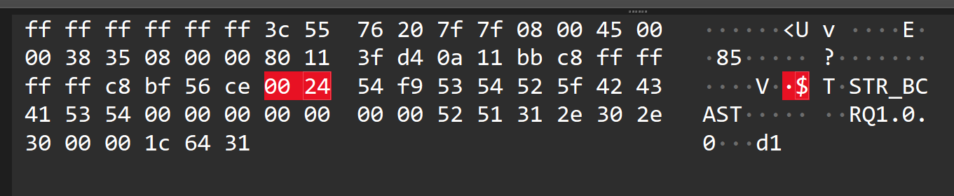
每个字段两个字节(每个字段两个字节是UDP规定)。
3. The value in the Length field is the length of what? (You can consult the text for
this answer). Verify your claim with your captured UDP packet.
UDP报文段长度：UDP头(8 Bytes) + 数据长度(对应不同的应用服务)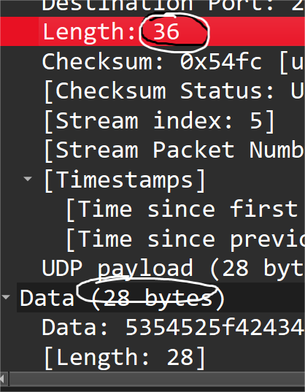
4. What is the maximum number of bytes that can be included in a UDP payload?
(Hint: the answer to this question can be determined by your answer to 2. above)
UDP报头就4个字段，每个字段2个字节，所以：
最大字节数： 4 * 2 = 8 字节
5. What is the largest possible source port number? (Hint: see the hint in 4.)
The largest possible source port number in a UDP packet is 65,535. This is because the source port field in the UDP header is a 16-bit field, which means it can represent values from 0 to 65,535.
6. What is the protocol number for UDP? Give your answer in both hexadecimal and
decimal notation. To answer this question, you’ll need to look into the Protocol
field of the IP datagram containing this UDP segment (see Figure 4.13 in the text,
and the discussion of IP header fields).
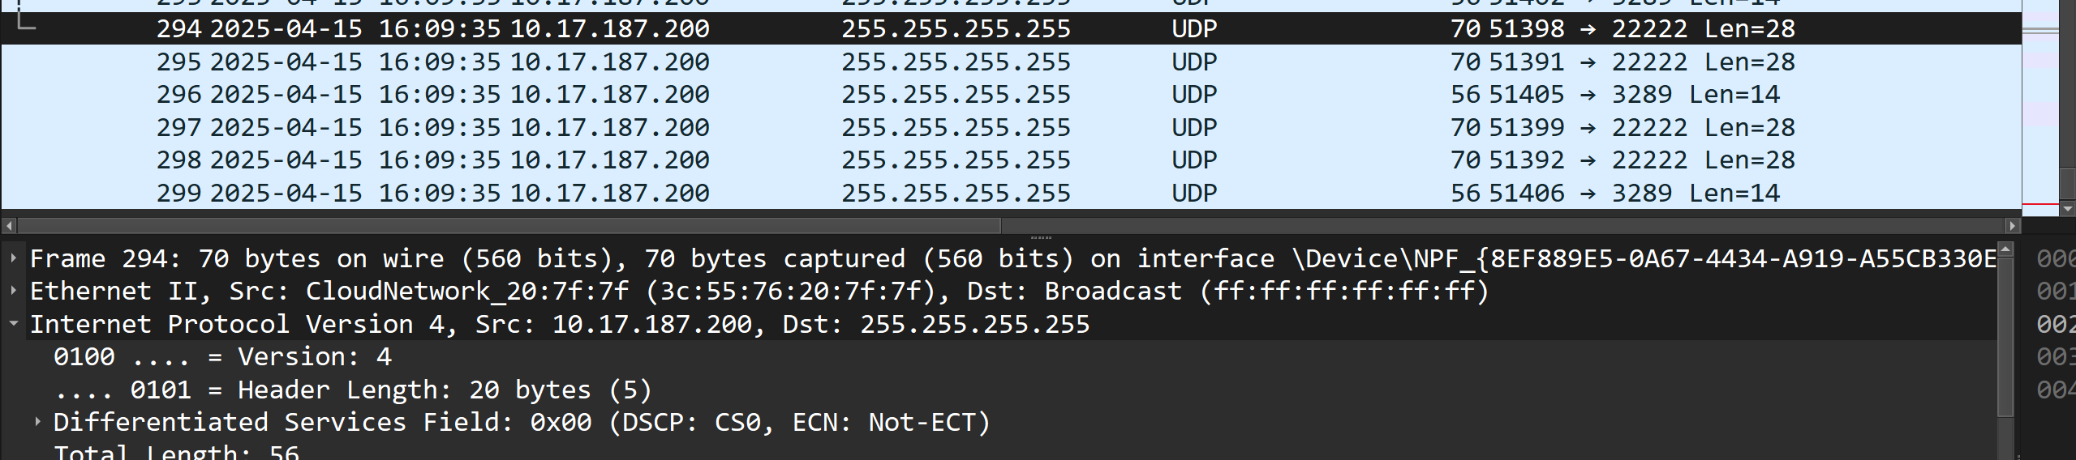
Protocol: UDP (17)
十六进制：0x11
十进制：17
7. Examine a pair of UDP packets in which your host sends the first UDP packet and
the second UDP packet is a reply to this first UDP packet. (Hint: for a second
packet to be sent in response to a first packet, the sender of the first packet should
be the destination of the second packet). Describe the relationship between the
port numbers in the two packets.
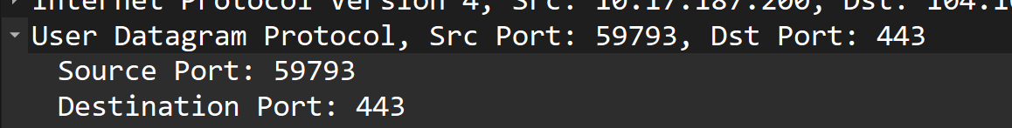相反关系
问题及收获：

