**Class:** Third Year (Computer Science and Engineering)

**Year:** 2020-21 **Semester:** 2

**Course:** Advanced Web and Mobile Application Development Lab (4CS381)

**Practical No. 6**

**Details**

1. 2018BTECS00033 – Mahendra Bhimrao Gharge
2. GitHub URL: https://github.com/g-mahendra/awamad

**Problem Statement 1:**

* Create an Express app for different route paths

1. Root path
2. b. /<class>/
3. c. /<class>/<batch>/
4. d. Use a string pattern for route path (e.g., /*fly/, etc.)
5. e. Use req.params to store and access the values of various parameters

**Screenshot 1:**

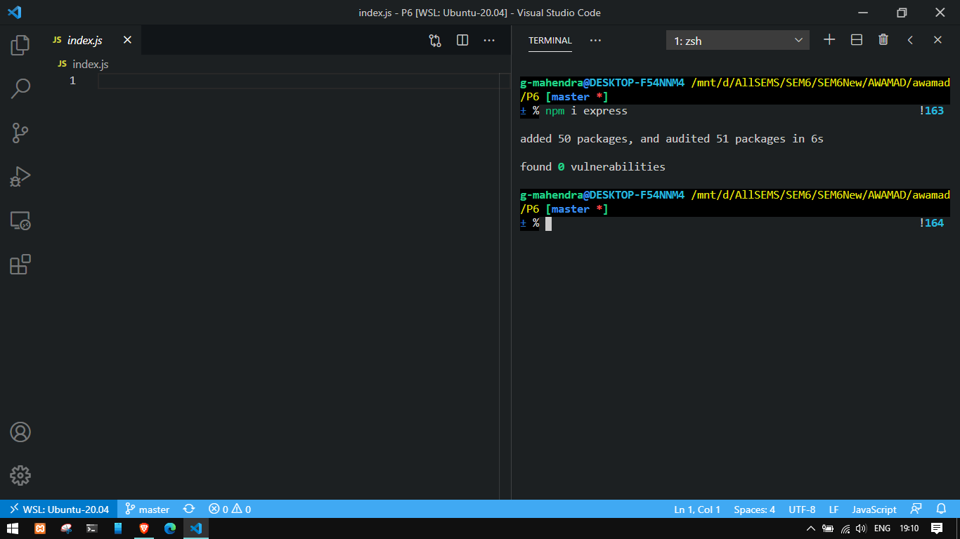

**Information 1:** Installed “express” using npm

**Screenshot 2:**

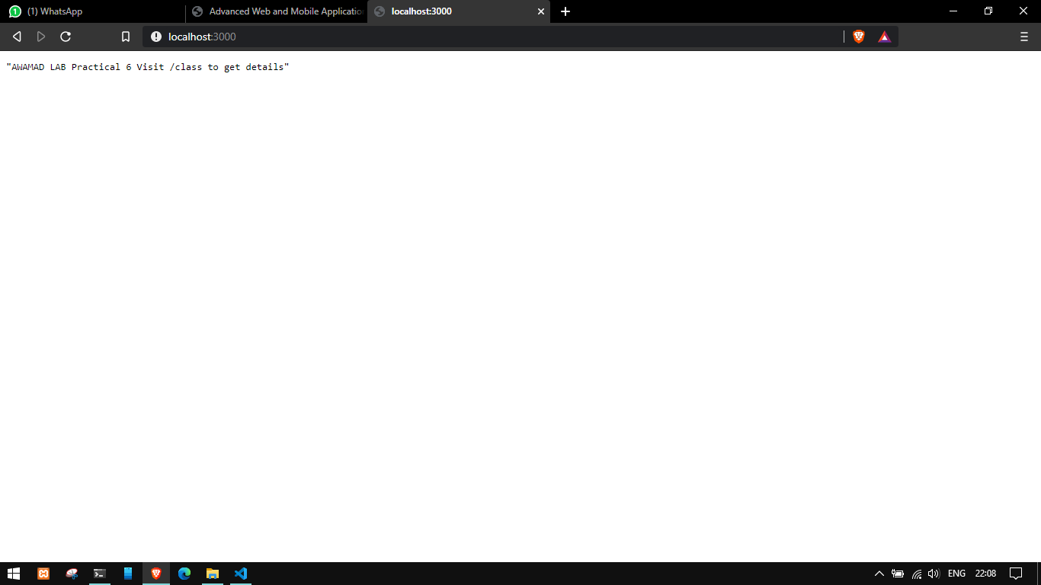

**Information 2:** Accessing root route

**Screenshot 3:**

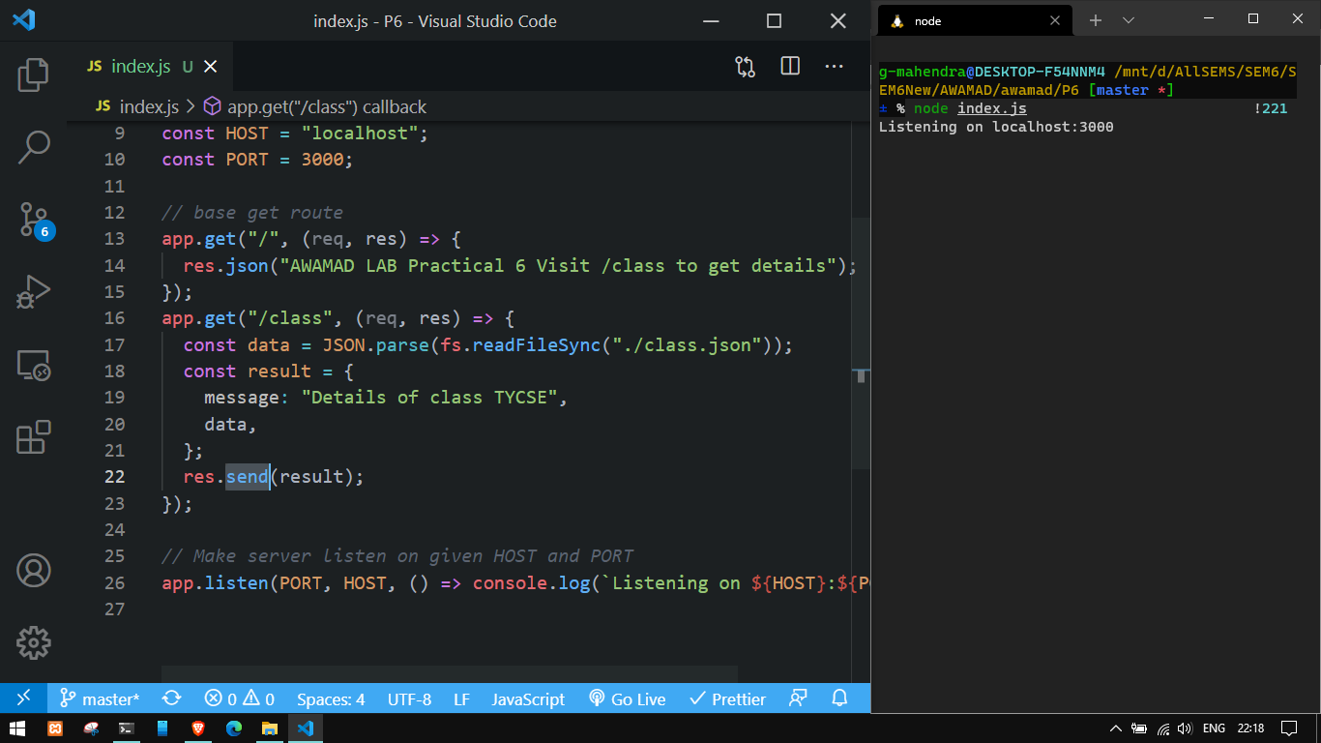

**Information 3:**  Accessing class route

**Screenshot 4:**

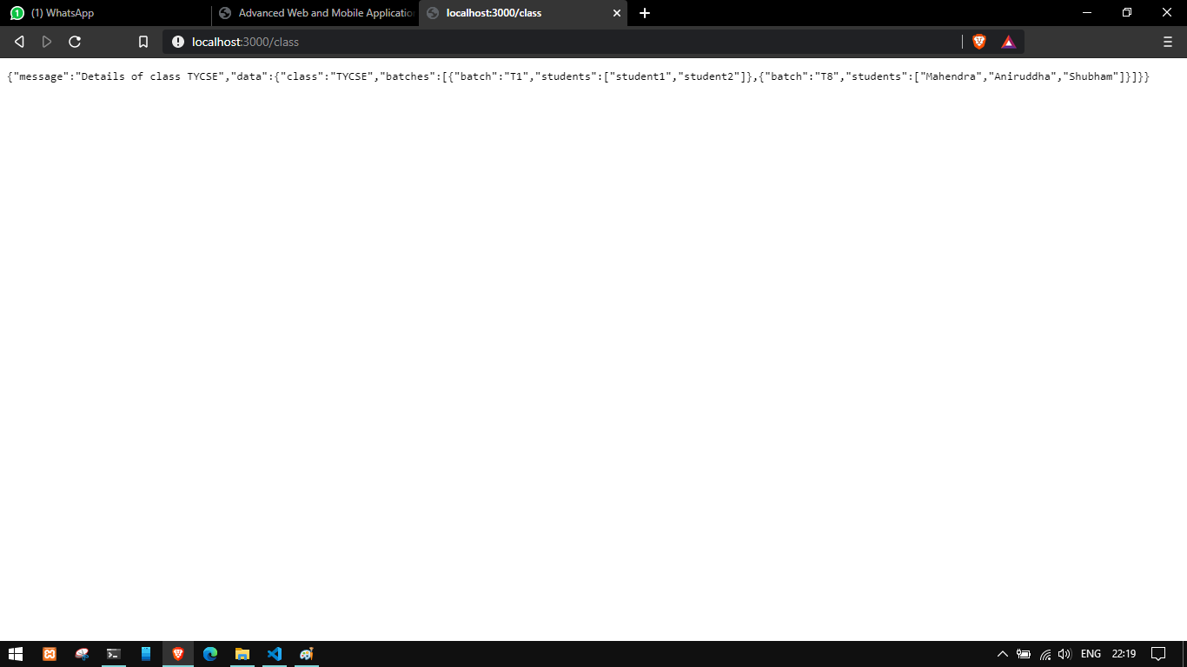

**Information 4:** JSON data from file sent as output for class route

**Screenshot 5:**

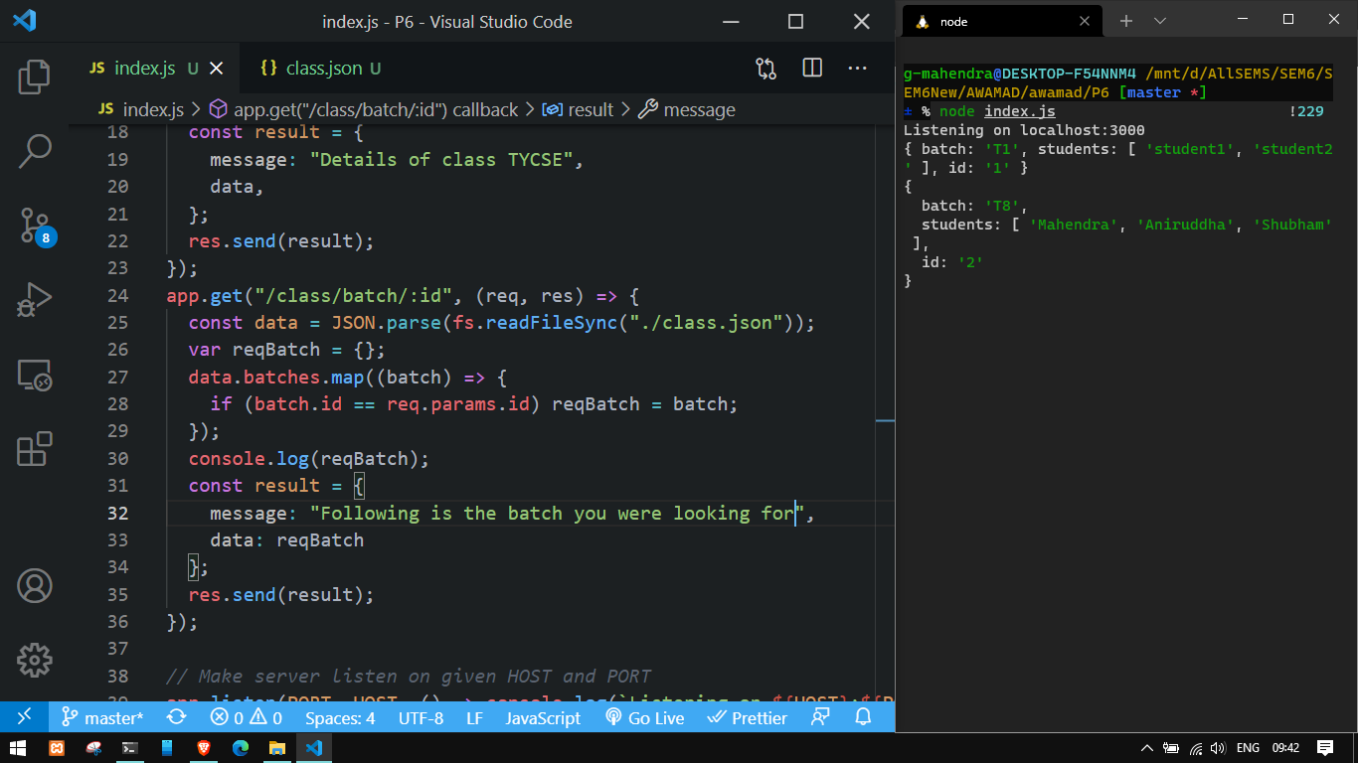

**Information 5:**  accessing batch route

**Screenshot 6:**

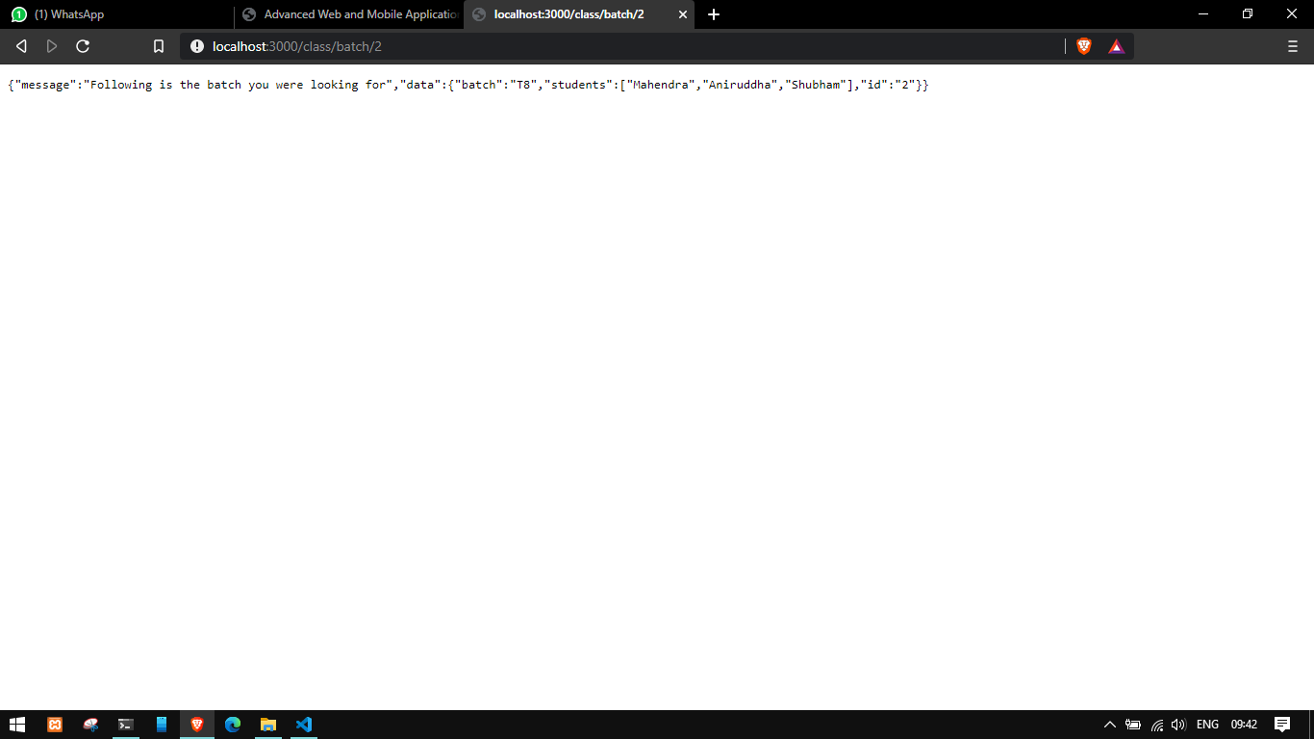

**Information 6:**  JSON data as output from file sent to batch route as output

**Screenshot 7:**

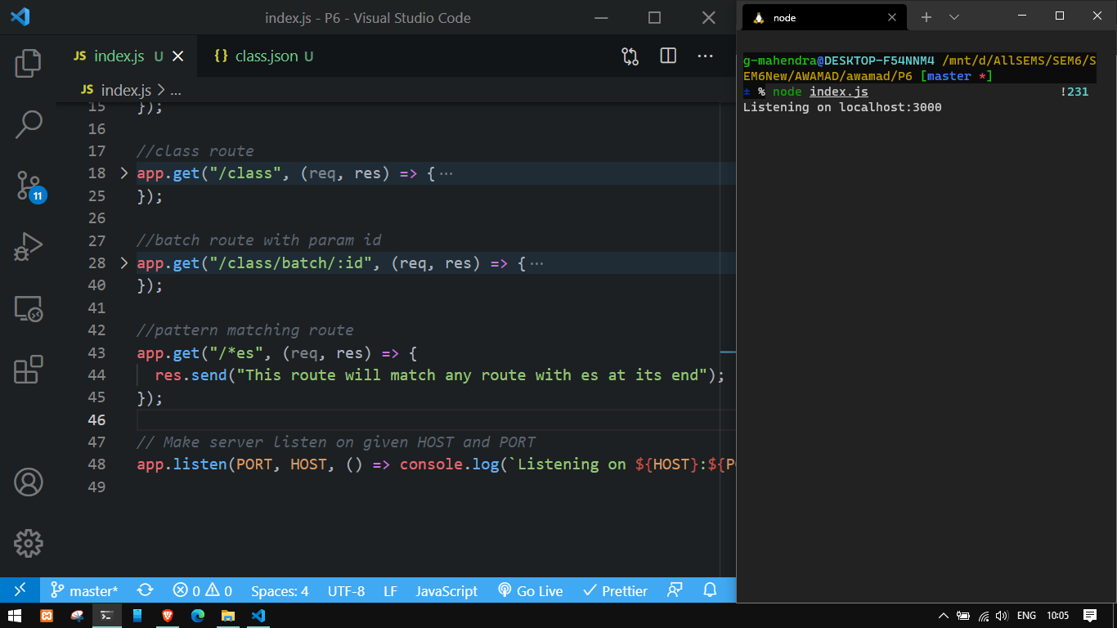

**Information 7:**  creating /*es route for matching all routes that match /es

**Screenshot 8:**



**Information 8:** Accepting id as route param to retrieve specific batch

**Screenshot 9:**



**Information 9:** Fetching specific batch by passing route param