**Class:** Third Year (Computer Science and Engineering)

**Year:** 2020-21 **Semester:** 2

**Course:** Advanced Web and Mobile Application Development Lab (4CS381)

**Practical No. 7**

**Exam Seat No:**

1. 2018BTECS00033- Mahendra Bhimrao Gharge
2. GitHub URL: https://github.com/g-mahendra/awamad

**Problem Statement 1:**

1. Write an Express app that uses the multiple call-back functions to handle a request.
2. Use different routes to show the use of call-back functions.
3. Use at least two call-back functions.
4. Use array of functions as an argument.

**Screenshot 1:**

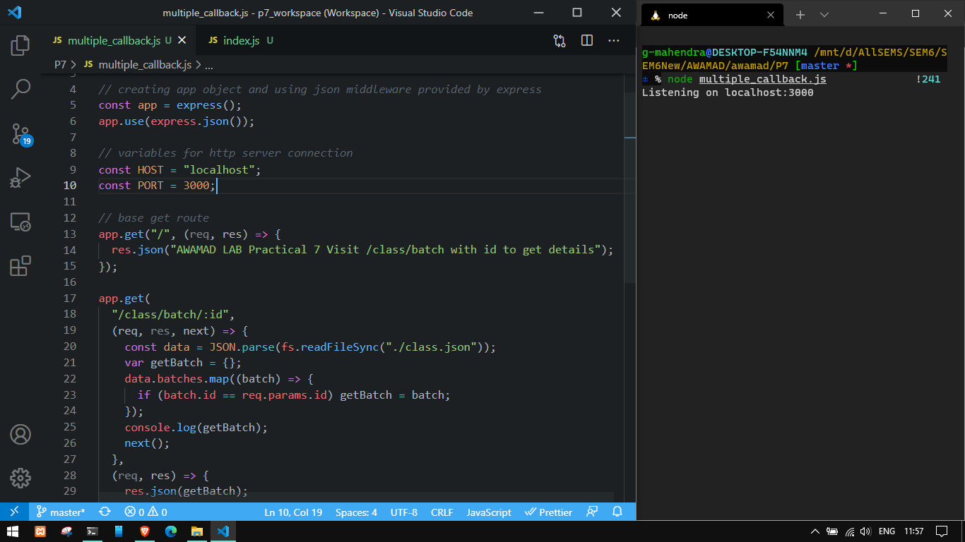

**Information 1:** Installed express with **npm i express**

**Screenshot 2:**

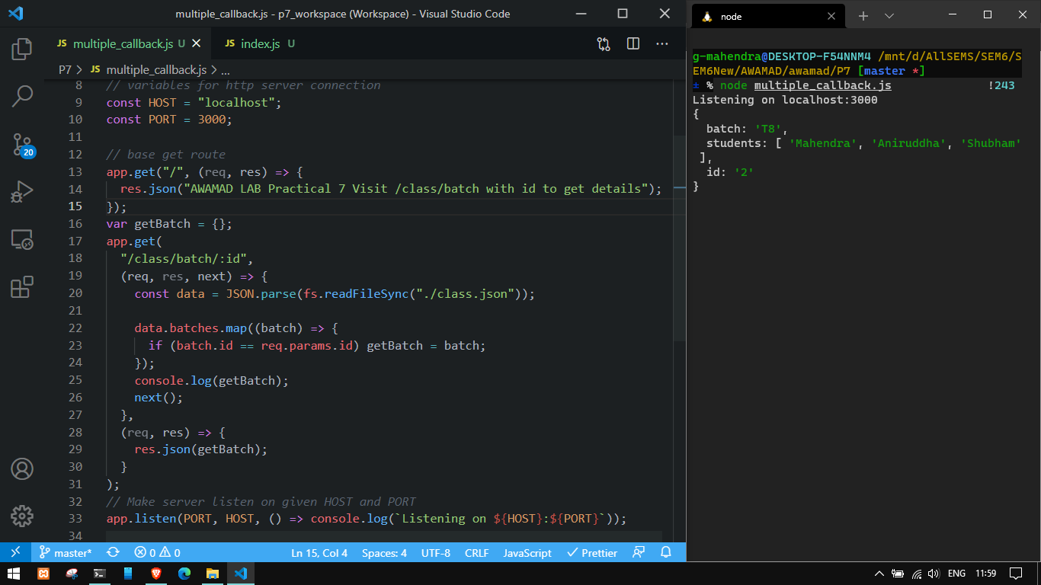

**Information 2:**  Using multiple callbacks for retrieving and sending JSON data.

**Screenshot 3:**

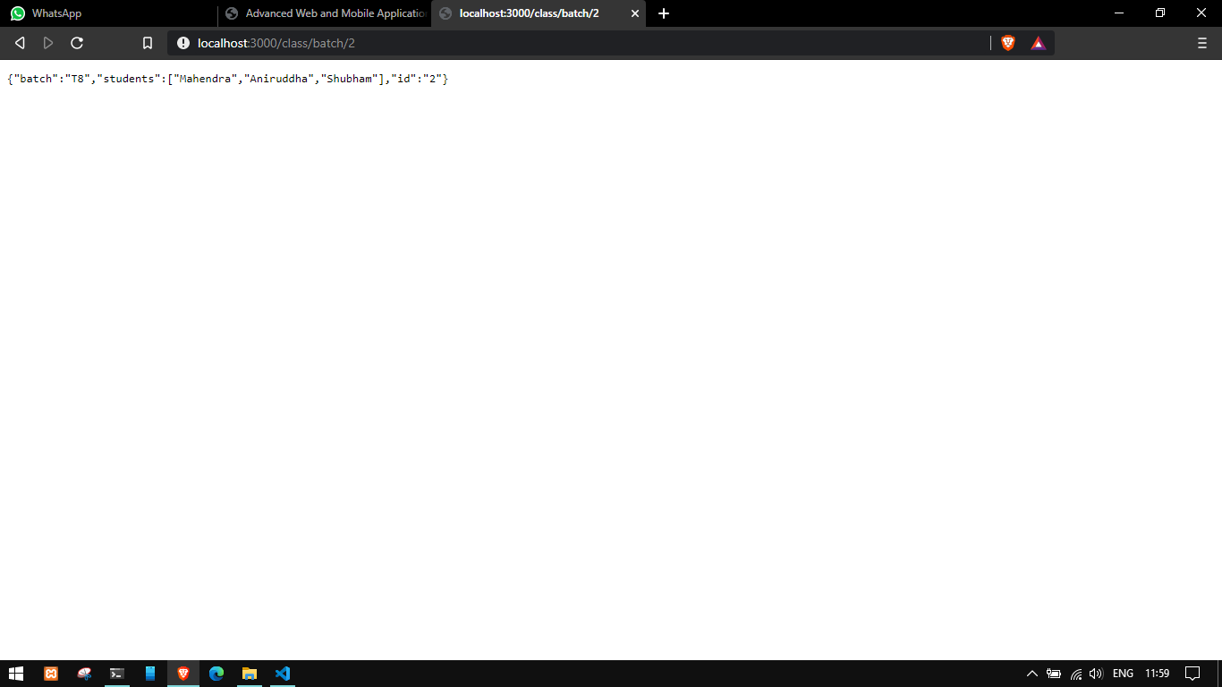

**Information 3:**  Output of data sent using multiple callbacks

**Screenshot 4:**

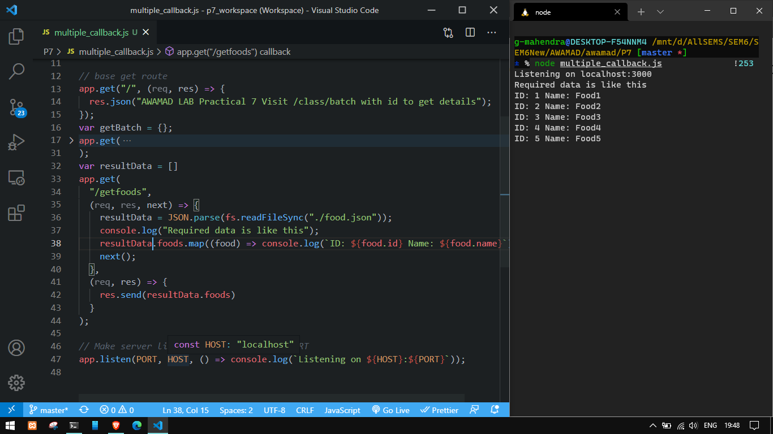

**Information 4:** Using route /getfoods to send data of foods using two call back functions

**Screenshot 5:**

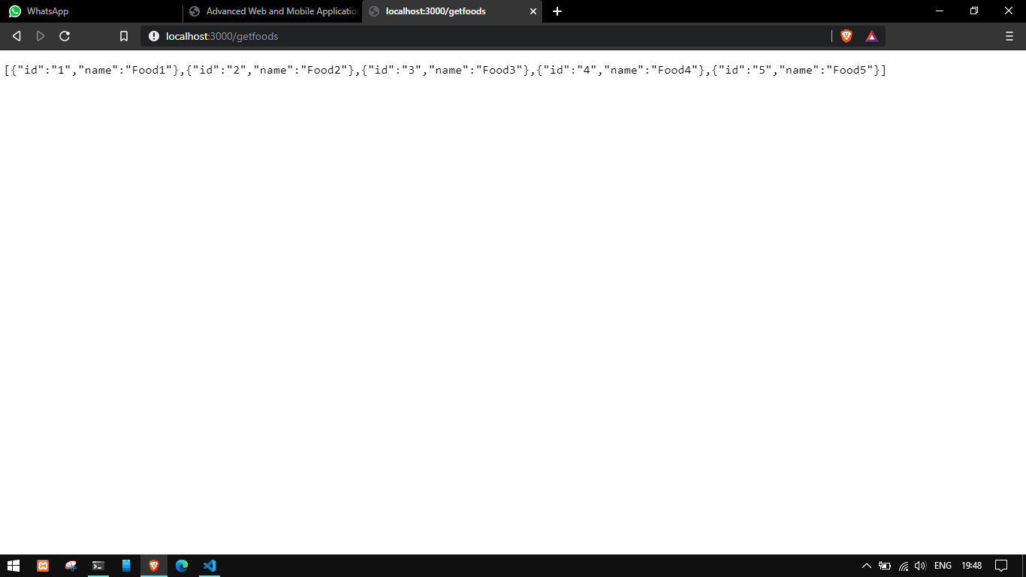

**Information 5:** Output of getFoods route

**Screenshot 6:**

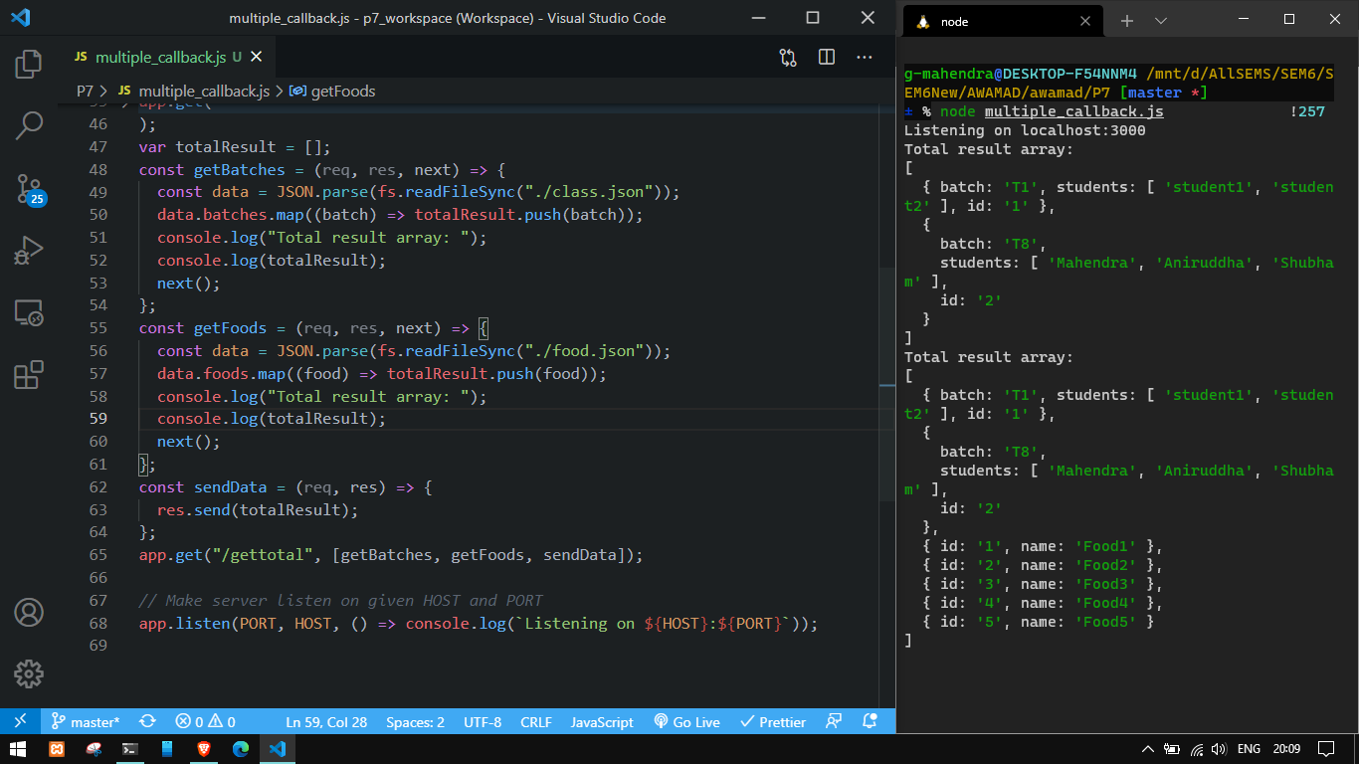

**Information 6:** Using three callbacks with array of callbacks

**Screenshot 7:**

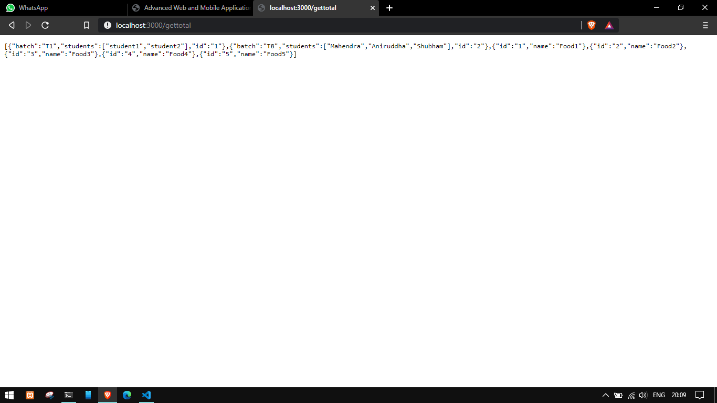

**Information 7: output of** using three callbacks with array of callbacks