**Class:** Third Year (Computer Science and Engineering)

**Year:** 2020-21 **Semester:** 2

**Course:** Advanced Web and Mobile Application Development Lab (4CS381)

**Practical No. 8**

**Exam Seat No:**

1. 2018BTECS00033 – Mahendra Bhimrao Gharge
2. GitHub URL: https://github.com/g-mahendra/awamad

**Problem Statement 1:**

1. Write an Express application that serves following types of files:
   1. Image Files (.jpeg)
   2. Audio Files (.mp3)
   3. Document Files (.pdf)
2. Create separate webpages for each of the file types.
3. Use different routes for different pages.

**Screenshot 1:**

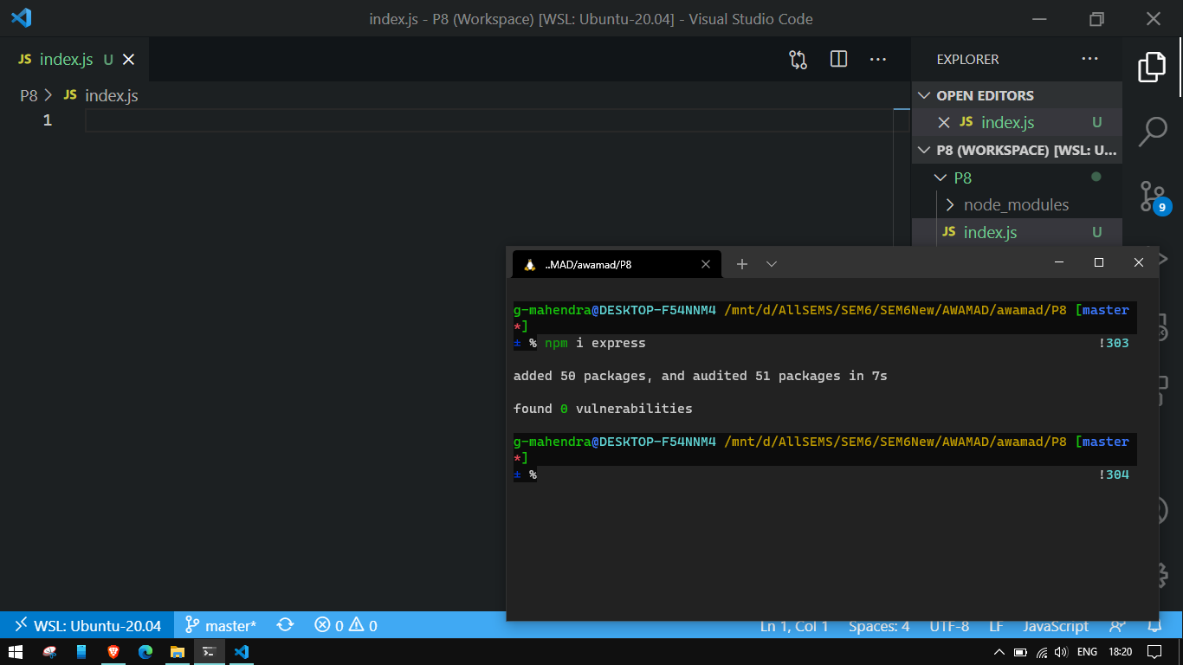

**Information 1:**  Installing express with **npm install express.**

**Screenshot 2:**

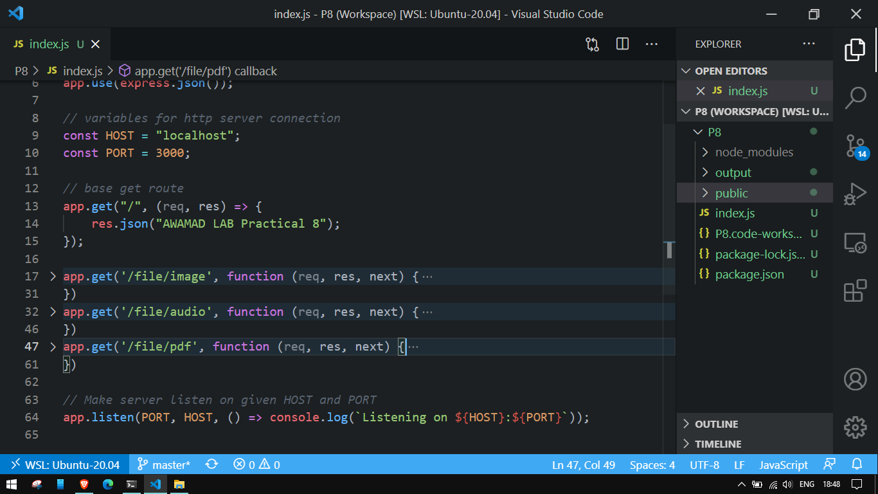

**Information 2:** Base route “/”.

**Screenshot 3:**

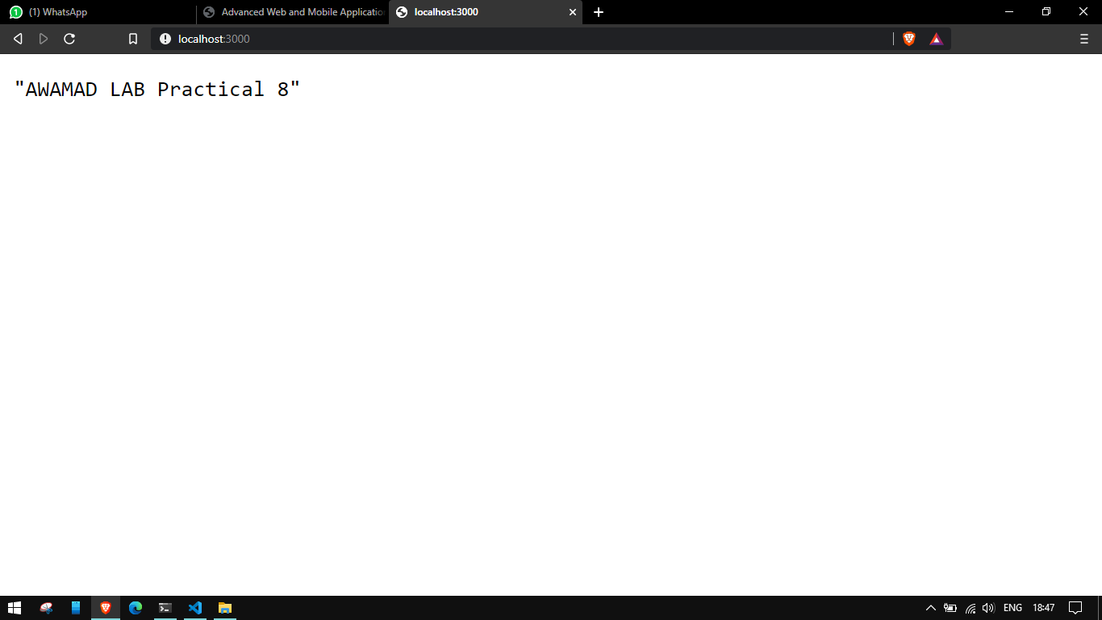

**Information 3:** Output of base route

**Screenshot 4:**

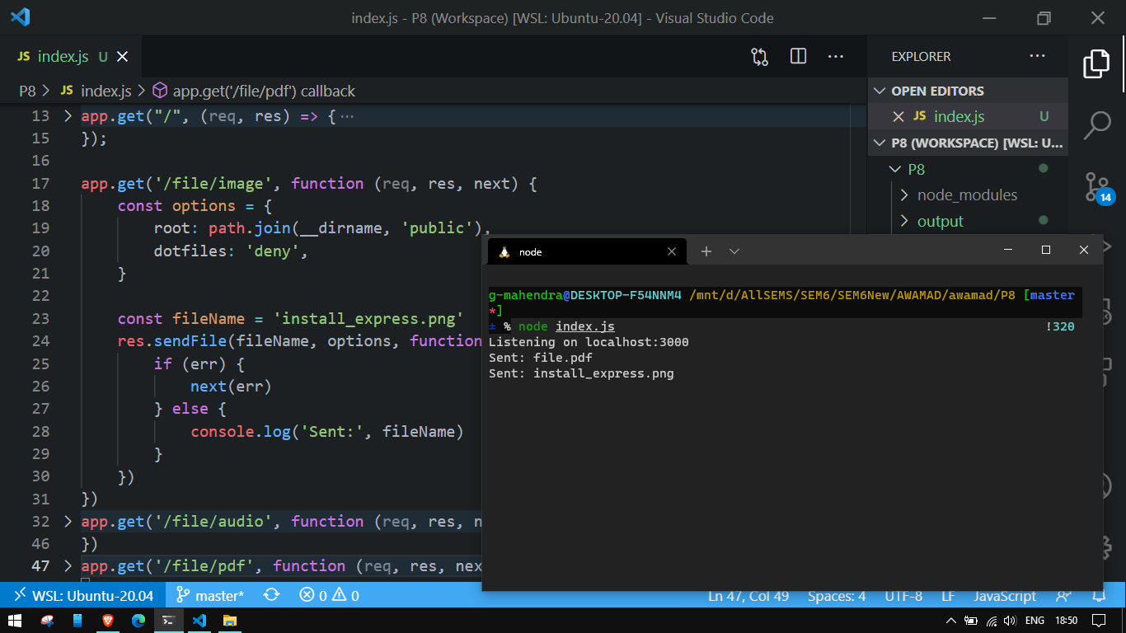

**Information 4:** Code to serve image

**Screenshot 5:**

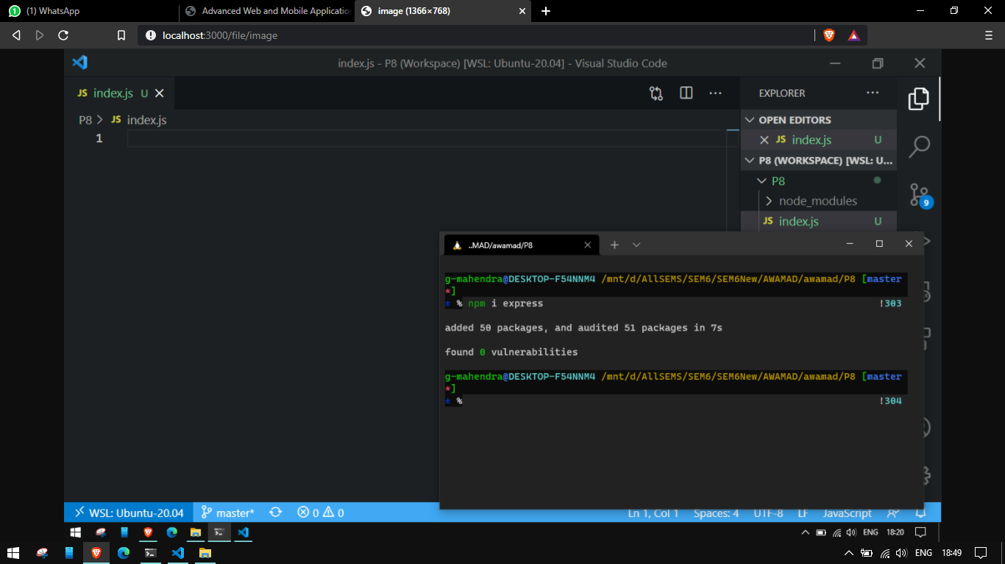

**Information 5:** Output of serving image on route “ /file/image”

**Screenshot 6:**

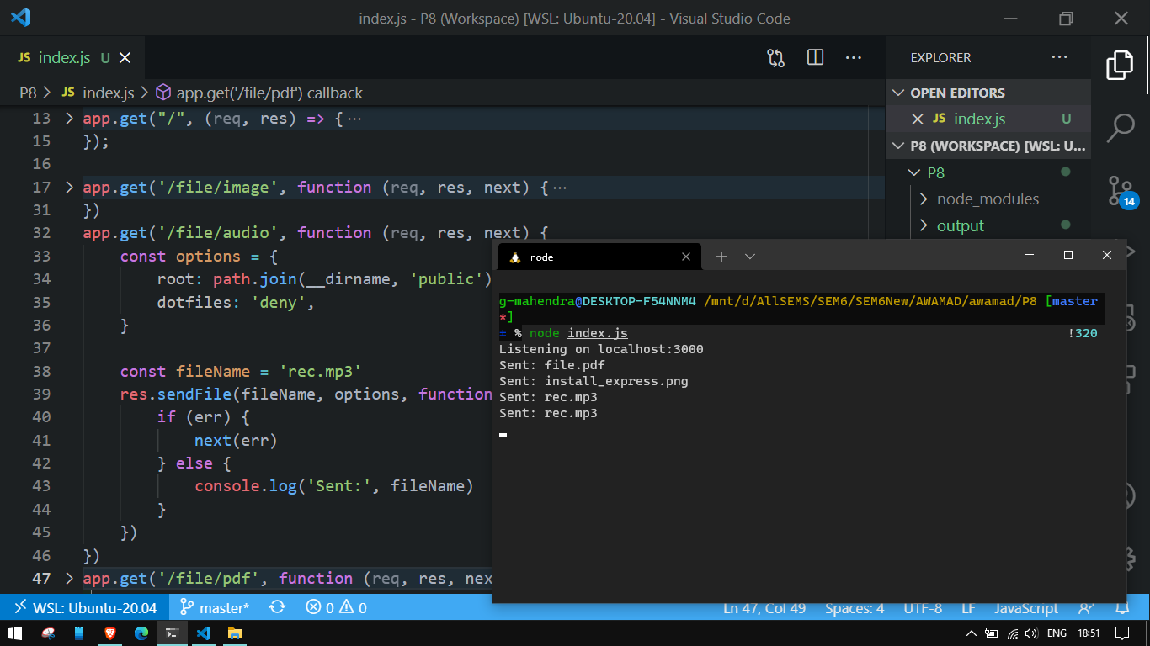

**Information 6:**  Send Audio code

**Screenshot 7:**

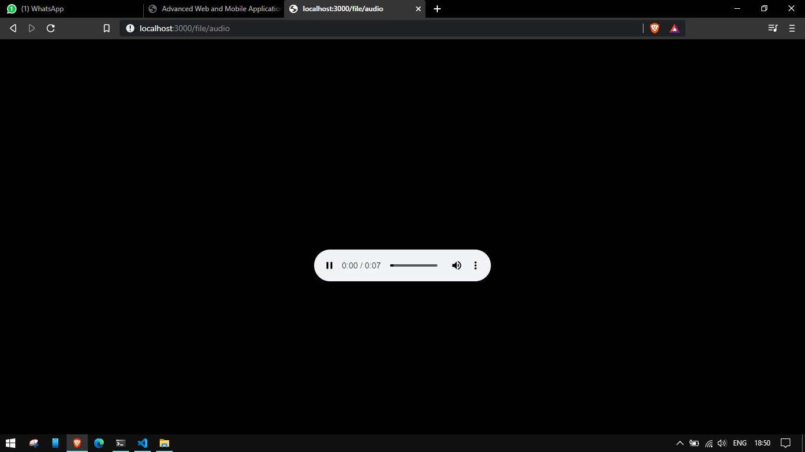

**Information 7:** Send audio output on route “/file/audio”

**Screenshot 8:**

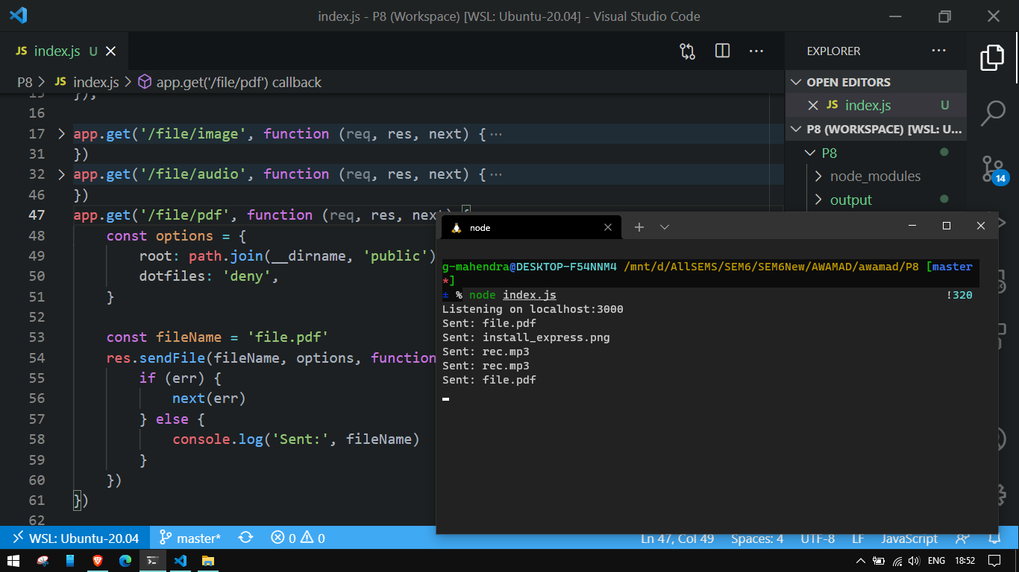

**Information 8:** Code to send pdf

**Screenshot 9:**

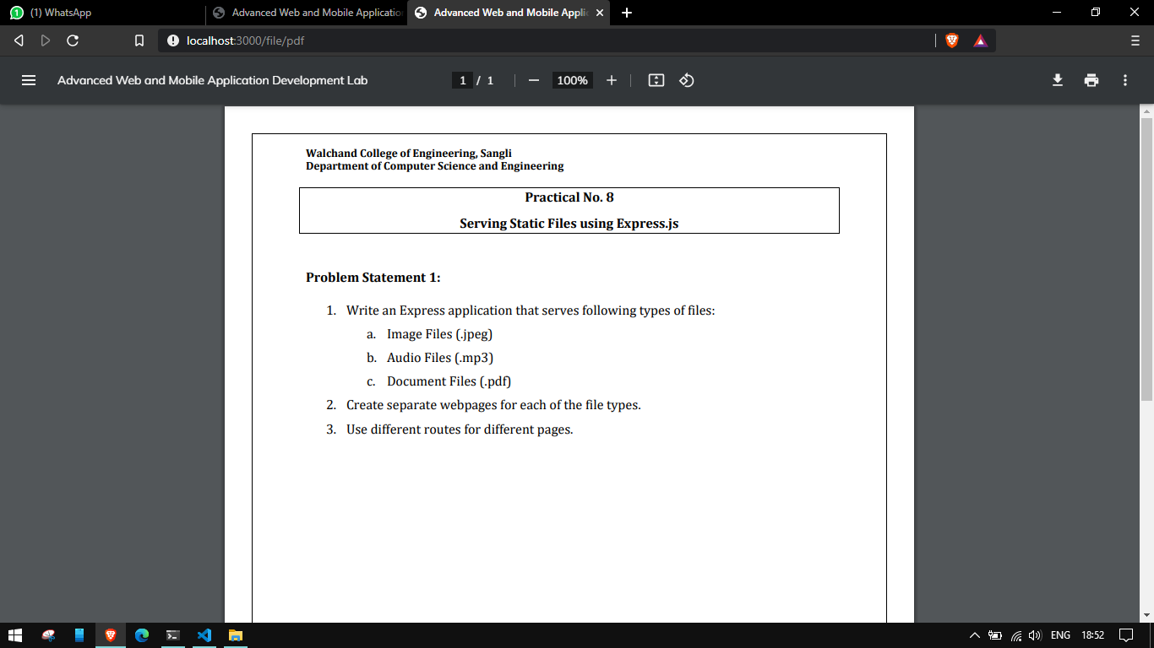

**Information 9:** Send pdf output on route “/file/pdf”