**First unique**

**Description**

The application accepts an arbitrary text as input and finds in each word of this text the very first symbol that is NOT repeated in the analyzed word. After that, from the collected characters set, the program must take the very first unique one (the one that is no longer encountered in the set) and return it.

### How to Install and Run the Project

Before running the application, you should be sure you have Python installed on your computer, by running **"python --version"** in your command prompt.

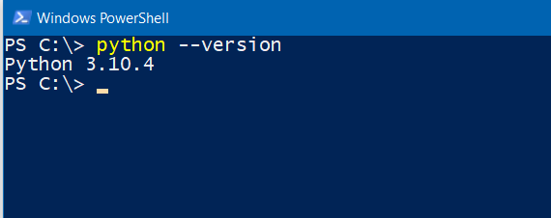

If not, you should to dowload and run Python installation by the link - <https://www.python.org/ftp/python/3.10.9/python-3.10.9-amd64.exe> (or use another way that is appropriate to your current operating system).

The only you should do while installing is to check both checkers on the form(look at the picture below).

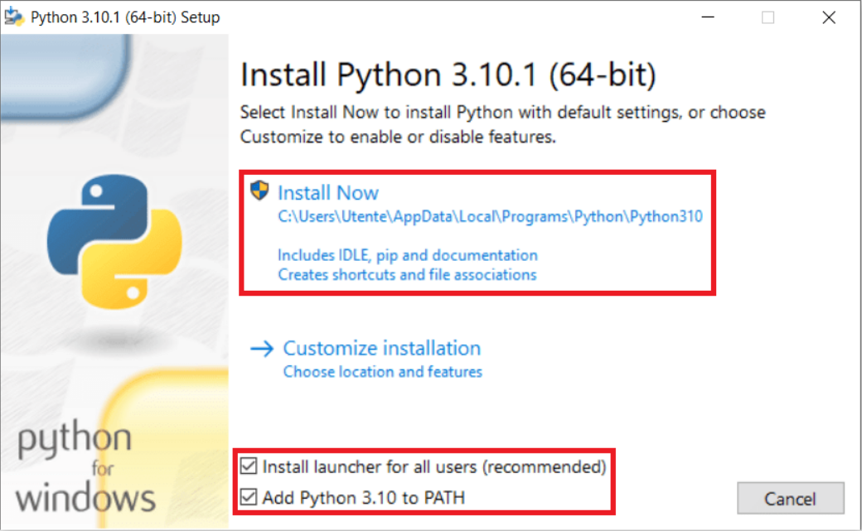

Further steps should be by default.

After installation is finished, run again - **"python --version"** and make sure you see the string with the Python version.



In your terminal go to the directory where “First unique.py” and “test.txt” are located and type the command – **“python 'First unique.py' test.txt”.**

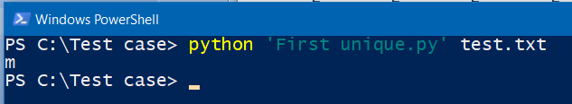

Make sure you have got the same result. In that case, your installation and settings are successful and you can use this application for your purposes.

### How to Use the Application

For using this application to operate another file you should put the file into the application folder and change "test.txt" into your file name with .txt extension, before the application runs.

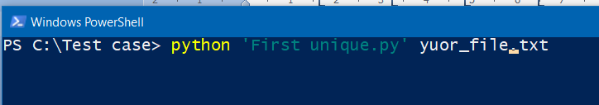

Another way is to open the test.txt file in your file redactor and replace the current text with yours and clothe the file with saving after.

**Thank you for your choice!**