CSC165H1 S - Exercise 3
Yizhou Sheng, Student# 999362602
Rui Qiu, Student# 999292509
Feb 2nd, 2012

Question 1:
Solution:

P | Q | R | PQ | QR | PR | PQ | QR | (a)  P(QR) | (b)  Q(PR) | (c)  (PQ)  (PR) | (d)  (PQ)R | (e)  P(QR)
T | T | T | T | T | T | T | T | T | T | T | T | T
T | T | F | T | F | F | T | F | F | F | F | F | F
T | F | T | F | T | T | F | F | T | T | F | T | F
T | F | F | F | T | F | F | F | T | T | F | T | F
F | T | T | T | T | T | F | T | T | T | T | T | T
F | T | F | T | F | T | F | F | T | T | T | T | T
F | F | T | T | T | T | F | F | T | T | T | T | T
F | F | F | T | T | T | F | F | T | T | T | T | T

According to the truth tables, (a)(b)and(d) are equivalent; (c)and(e) are equivalent.

Question 2:

Proof:
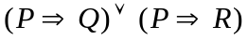
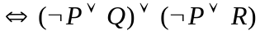......(Implication)
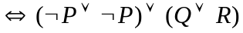......(Associativity)
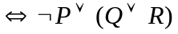......(Idempotency)
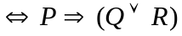......(Implication)
█

Question 3:

Proof:
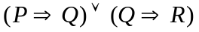
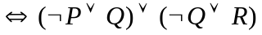......(Implication)
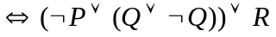......(Associativity)
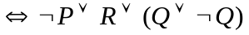......(Commutativity)
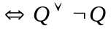......(Absorption)
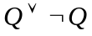 is always true no matter what the domain is.
is a tautology.
█

Question 4:

Proof:
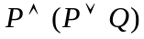
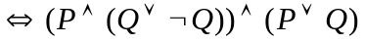......(Identity)
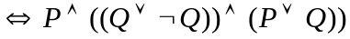......(Associativity)
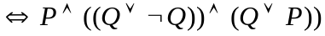......(Commutativity)
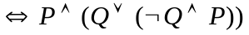......(Distributivity)
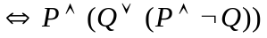......(Commutativity)
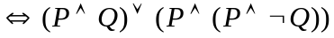......(Distributivity)
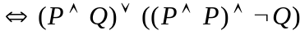......(Associativity)
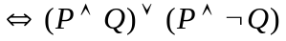......(Idempotency)
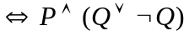......(Distributivity)
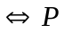......(Identity)
█

Question 5:

Solution:

Since  represents the statement that "William cheated",  represents the statement that "Xavier cheated", represents the statement that "Youssef cheated",  represents the statement "Zachary cheated".
Translate their words to logical expressions:
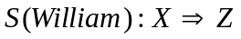
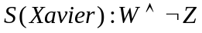
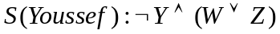
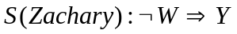

- If each student is telling the truth:
From S(Xavier) we know that William cheated but Zachary did not.
From S(William), we know that 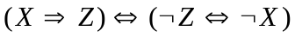, so Xavier did not cheat.
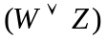 is true; to make S(Youssef) true, 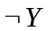 must be true, which means Youssef did not cheat.

In conclusion, if each student is telling the truth, then William cheated.

(b) ①Assume is false, which means Xavier is telling the truth:
Then William cheated but Zachary did not.
Since Zachary did not cheat, 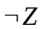 is true. 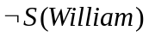 is true, so is true,, which contradicts the assumption.
②Assume is true, which means Xavier cheated and he is lying.
Then William did not cheat or Zachary cheated. ( is false or true)
Assume is true:
is true.
So 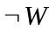 is true and is true, which means William did not cheat and Youssef did not cheat either.
false means 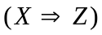, does not contradict the assumption.
false means 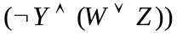, at least one of William and Zachary cheated, actually it is Zachary, also does not contradict the assumption:

Thus we have: false, true, false, true.

In conclusion, Xavier and Zachary cheated.

