What is Escalation? Measuring Crisis Dynamics in International Relations with Human and LLM Generated Event Data

Rex W. Douglass1, Erik Gartzke1, Jon R. Lindsay2, J. Andrés Gannon3, and Thomas Leo Scherer1

2024-01-17

Abstract

When a dangerous international crisis begins, leaders need to know whether their next move is going to resolve the dispute or amplify it out of control. Theories of conflict have mainly served to deepen the confusion, revealing fighting, bargaining, and signaling to be high-dimensional and subtle equilibrium behaviors with deeply contextual consequences. Should a leader communicate resolve through aggressive acts, avoid spirals through accommodation, or focus on ensuring the possibility of a bargain? We offer a data-driven empirical solution to this logjam in the form of a new large-scale analysis of actions taken within 475 crises. We combine two complimentary measurement projects, the human-coded International Crisis Behavior Events (ICBe) dataset and the new machine-coded ICBeLLM. We model directly whether an action tends to shorten or extend the length of a crisis. The result is a directly interpretable measure of the latent escalatory/de-escalatory nature of each action leaders have chosen over the last century.

1 University of California, San Diego  
2 Georgia Institute of Technology  
3 Vanderbilt University

# Introduction

What does it mean that an international crisis is escalating, and what actions within a crisis are escalatory? This question haunts recent and ongoing crises such as missile tests on the Korean Peninsula, Russian incursions in Ukraine, partial state death in Syria, and Chinese claims of sovereignty in the South and East China Seas. In these situations, leaders face a shared fundamental question about how to navigate a dangerous situation without accidentally sliding over the line into a larger-than-desired conflict (Snyder and Diesing 1977; Slantchev 2005). Often leaders must make decisions with limited time and inadequate information (Jervis 1976, p. 95). What guidance can we offer to help maintain peace and stability? Can we predict how states will react to specific events during crises? Can we recommend policies or actions that are most likely to lead to success without being destabilizing? In short, what empirical evidence can we bring to bear on the practical questions of crisis management?[1]

The international relations field offers two foundational perspectives on crisis dynamics, classically described by Robert Jervis (1976) as the deterrence model and the spiral model. The former blames escalation on the failure to credibly communicate threats (Rovner 2020) or misperceptions about capability or resolve (Morrow 2019). The latter views escalation as a retaliation to provocation where a tit-for-tat response fails to end the crisis (O’Neill 1991). These models offer contradictory policy prescriptions: on one hand, policymakers should use bold words and actions to discourage aggression; on the other, they should mitigate security dilemmas through compromise and accommodation. Historical studies typically provide more nuance, but the additional context needed to make sense of specific crises just highlights the fact that both models are underspecified. Neither model, moreover, is well integrated with more recent thinking about the underlying bargaining dynamics of military contests (Fearon 1995). Previous empirical research designed to validate or reject competing theoretical explanations for escalation has faced daunting challenges given that the basis for comparison and/or the logical discrepancies between alternative theories have not been resolved (Glaser 1992; Kydd 1997; Zagare and Kilgour 1998) and the ability to empirically assess such efforts is complicated by the structural indeterminacy of uncertainty (Gartzke 1999; Chen, et al. 2022). These efforts have yet to establish a consensus pecking order between canonical alternatives (c.f., Wright 1965; Carlson 1995; Kinsella and Russett 2002).

Recognizing the enormous efforts of previous theoretical and empirical scholarship, we adopt an abductive approach designed to explore the correlates of escalation/de-escalation in a novel data source constructed by the authors and others (Douglass, et al. 2022; Douglass, et al. forthcoming). Our approach capitalizes on a new dataset, the International Crisis Behavior Events (ICBe) dataset, augmented by machine-coded data ICBeLLM. To our knowledge, these are the first international conflict data to code the full sequence of statements and actions by actors necessary to capture escalation as a process. These data allow us to track the actions and reactions of every relevant actor in the 475 interstate crises available from the canonical ICB dataset; who did what to whom, when, where, and how. Doing so allows us to identify various factors most likely to lead to escalation or de-escalation in crises. Using these triggers, we can develop a model that estimates (predicts) both the path and duration of international crises and that indicates likely precursors and their effects. We find support for neither the deterrence nor spiral model, in their classic forms, suggesting the need for a more nuanced theory that can accommodate the historical contingency and complexity of crisis processes.

This analysis is organized as follows. Section 2 briefly formalizes the concept of an international crisis and the concept of escalation within a crisis. It then draws prior beliefs from existing theories of escalation, particularly deterrence and spiral models of conflict. Section 3 introduces the data, turn-by-turn event data collected for 475 individual crises (Douglass, et al. 2023). This section also presents our estimand—the unobserved latent quality of an action being escalatory or de-escalatory at a specific point in a crisis—and our measurement strategy, which involves observing the empirical increase or decrease in the remaining duration of a crisis as a function of the observed actions. Section 4 describes our modeling strategy and presents empirical results. Section 5 provides a qualitative deep dive with a few choice case studies (Tavory and Timmermans 2014; Heckman and Singer 2017). Section 6 offers concluding remarks and implications of our findings.

# Crises, Escalation, and the State of the Art

The scientific state of the art on crisis escalation is too large and amorphous of a topic to fully summarize, and so we draw attention to the minimal necessary machinery for understanding the empirical argument made here. Those components are the domain of the activity in question, the definition of the outcome we seek to explain, theoretical priors about the connection between different possible actions and that outcome, and empirical attempts to measure the above.

## Crisis and Stability

The status quo in international relations is almost always one of stability, slow-changing bargains, and relative cooperation. War and conflict are the exceptions (Vasquez and Valeriano 2010). Formally, consider a set of autonomous political actors or players, $p∈P$, consisting of states, international organizations, and subnational organizations. At each moment in time, $t$, they engage in behaviors, $b∈B$, individually and towards each other which they each then hold preferences over. Any player can transition to a period of crisis when those behaviors swing toward “disruptive interaction with a heightened probability of military hostilities that destabilizes states’ relationships or challenges the structure of the international system” (Brecher and Wilkenfeld 1982). The International Crisis Behavior project has documented 496 such periods since 1918 (Brecher and Wilkenfeld 1997). Formally, we can think of this as a simple Markov model with two discrete latent states, stability $S$ and crisis $C$, $Θ_{p,t}∈\left[S,C\right]$. This latent state is in turn partially observed in the current and historical behavior of the players.

The measurement strategy for the unobserved latent state is to use observables like behaviors as proxies, $b_{p^{−}1,t}=F\left(Θ_{p,t}\right)$. When other players are behaving badly, we think a player is strictly more likely to be in a state of crisis. However, the policy-relevant question we want to answer concerns the causal impact of a behavior on the continuation or resolution of a crisis, $Ω_{p,t}=F\left(b_{p^{−}1,t−1},b_{p,t−1}\right)$. This reveals an immediate conceptual difficulty. Behaviors appear on both sides of the regression equation, first on the left hand side as a proxy measurement for the dependent variable of state of crisis in time $t$ and then individually on the right hand side as potential causes of crisis if observed in time $t−1$. This means the definition and measurement of a discrete-time step within a crisis is doing the majority of our conceptual work. This fact has created unending confusion between measurement, explanation, prediction, and prescription in the study of crises, and we tackle it directly below.

## Defining Crisis

For now, imagine a stylized crisis with two discrete and clearly distinguishable time steps, $t$ and $t−1$. In $t$, we want to know whether a player is in a state of stability or crisis. We observe the behaviors of other actors in time $t$, $b_{p^{−}1,t}$. International relations theory holds strong beliefs about which behaviors are more crisis-like. For each behavior, $b$, assign a weight $w=\left[w_{1},w_{2},...,w_{n}\right]$, representing the strength of the signal it provides that a player is currently in a crisis state and the discrete state is some function of the sum of each of these weighted observed behaviors $Θ_{p,t}=F\left(\sum_{i=1}^{n}{w_{i}}*b_{i}\right)$.

We draw prior beliefs from international relations literature about the sign and rank ordering of these weights across behaviors. Much of 20th-century security studies was preoccupied with conventional warfare as the most extreme behavior, e.g. the Correlates of War (COW) project. In the shadow of possible nuclear war, scholars turned to measuring events that might be a precursor to actual fighting, e.g. the threat, display, or use of military force short of war recorded by the Militarized Interstate Disputes (MIDs) dataset (Maoz, et al. 2019). Others recorded entire streams of events from news headlines (McClelland 1978; Goldstein 1992; Azar 1993; Sherman 1994) and defined their level of departure from stability by hand, e.g. Goldstein scores (Goldstein 1992), or through unsupervised dimensionality reduction, e.g. Item Response Scores (Schrodt 2007). The ICB project took an even wider view, recording a “trigger” for each crisis which could take one of 9 different forms (verbal act, political act, economic act, external change, other non-violent act, internal verbal or physical challenge to regime or elite, non-violent military act, indirect violent act, or violent act).

The ICBe ontology divided crisis events into two conceptual categories across armed actors vs unarmed actors and, given that, escalatory/uncooperative vs de-escalatory/cooperative behavior, shown in Table 1 below. It further recorded details related to scale and severity, like the number of troops involved in an act, number of casualties, amount of territory exchanged, etc. The labels of escalatory/de-escalatory were perhaps premature, and instead for our purposes here we argue these are better thought of as indicators for and against a state of crisis/stability within a single discrete time step.

<-Insert Table 1 Here->

## Defining Escalation/De-escalation

We take exactly one time step back in our stylized crisis to $t−1$ and define the relationship between a given behavior and crisis stability. For simplicity, we assume the player is already in a state of crisis at $t−1$, and so the only transition probabilities we are interested in are from crisis to crisis, $P\left(C→C\right)$, and from crisis to stability $P\left(C→S\right)$. Because the two outcomes are mutually exclusive, we can further consider just a single transition, and so we choose $P\left(C→C\right)$, the probability of crisis being followed by more crisis. As before, we can think of all of the same behaviors, $b_{p^{−}1,t}$, simply observed one time step earlier, and we can assign another weight vector $β=1,2,..,n$, and specify some function that maps the last period’s behaviors to the next period’s probability of being in a state of crisis $Θ_{p,t}=F\left(\sum_{i=1}^{n}{β_{i}}*b_{t−1,i}\right)$.

Unlike before, the theoretical literature on crisis stability is far more divided on what those weights should be (Brams and Kilgour 1987; Powell 1989). As a gross simplification, one major vein of literature views the weights of escalation to be highly correlated with the weights indicating a crisis (Colaresi and Thompson 2002), while another views at least some of the weights as flipped (Spaniel and Idrisoğlu 2023).

## Perspectives on Escalation

One might assume that doing more aggressive and destructive things would be followed by even more aggression and destruction. Yet those same aggressive actions might intimidate others into backing down. In one case, aggression begets aggression, and in the other, aggression encourages submission. Security dilemma models following from pessimistic assumptions tend to focus on the first case, and relatively more optimistic deterrence models on the second. Scholars have explored subtle situations in which even two well-meaning players might find themselves caught in a conflict that neither of them intended. The so-called spiral model considers tough talk and a forward military posture to be inflammatory, exacerbating security dilemmas and heightening the risk of war (Herz 1950; Smoke 1977; Jervis 1978; Glaser 1997). Threats alert an adversary, weakening defense and triggering anticipatory reactions. A nation targeted by an adversary with threats of retaliation should be less likely to back down if there are reputational costs (domestic, international) or psychological burdens for failing to fight (Jervis, Lebow, and Stein 1989; Lebow and Stein 1989). Indeed, such threats may trigger action where none exists. In the model above, the weights of escalation and crisis indicators are highly correlated.

Another vein of literature argues that at least some of the weights should be flipped. If weakness or uncertainty invites conflict, then some of the most crisis-like behaviors may in fact be needed to transition back to stability. Deterrence theory fundamentally sees conflict onset, and by extension escalation, as a cost-benefit analysis (Freeman 2004). Nations that find war prohibitive, or that are unwilling to endure the risks of escalation, are unlikely to fight (Morgan 1977). Deterrence is most effective when threats are clear, plausible, and consequential—when words credibly signal contingent actions (Powell 1990). Deterrence theory thus advocates the use of threats to impose costs or risks on a potential adversary in the hopes that the prospect of risk or harm will derail aggression and discourage escalation (Brodie 1959; Wohlsletter 1959; Snyder 1961; Schelling 1966; Waltz 1990; Danilovic 2002). The empirical challenge in identifying deterrence success given strategic self-selection into disputes (Fearon 2002) has motivated others to disaggregate this idea further, introducing distinctions between, for instance, immediate deterrence, where a state or other actor is seeking to prevent an actual attack from an adversary, and general deterrence, where the effort to discourage an adversary from even considering force as an option (Huth 1988). Many other such nuances have been employed, highlighting the underappreciated role of historical context in determining the escalatory dynamics of any given crisis (Kreps and Schneider 2019; Cunningham 2020; Lin-Greenberg 2023).

Despite the better part of a century of speculation and debate, experts have been unable to establish a consensus theoretical understanding of escalation, its causes, or likely triggers (Kahn 1965; Kydd 1997; Smith 1999; Sechser and Fuhrmann 2013). Fundamental disagreement persists about what words or actions are escalatory and which are more likely to reduce tensions between actors. Other research questions whether crisis actions such as threats and mobilizations are even a primary driver of crisis dynamics or if circumstantial factors, such as power and distance, are sufficient to account for actions and outcomes (see Stam 1996, Schultz 1998, Smith 1998, Gelpi and Griesdorf 2001, Kinsella & Russett 2002, and Gartzke & Hewitt 2010 on interests, Huth 1988 and Mearsheimer 1983 on capabilities, Banks 1990, Slantchev 2010, and Fey & Ramsay 2011 on information, Gartzke 1999 and Chen et al. 2022 on uncertainty, and Huth, Gelpi, & Bennett 1993 on nuclear weapons). Scholars have begun to make sense of various conflict processes, creating the opportunity to develop tools capable of predicting and assisting in the evaluation of policy options (e.g., Hegre et al. 2017). However, contemporary theories fall short of providing clear, consensus perspectives on escalation management (Altfeld 1983, Diehl 1985, Nalebuff 1986, Moul 1988, Fearon 1994, Carlson 1995, Bueno de Mesquita, et al. 1997, Reed 2000, Huth and Allee 2002). Ambiguity is rooted in the conflicting spiral and deterrence frameworks that have developed to explain crisis dynamics.

Both the classical spiral and deterrence frameworks are rooted in earlier intuitions about the nature of war. More recently scholars have come to appreciate the centrality of bargaining in conflict processes (Fearon 1995). In this view, actors are strictly better off coming to a mutually advantageous deal rather than engaging in costly conflict, which destroys the bargaining surplus, but they also have incentives to misrepresent their capabilities or intentions to get a better deal without fighting. Yet, this means that there is an important endogenous role for bargaining moves in a crisis that can either resolve or exacerbate information problems (Gartzke 1999; Coletta and Gartzke 2003).

Process matters, as historians have long understood, but the spiral and deterrence models do not explicitly incorporate contingency. Process seems to be more relevant in the spiral model, which implies a long history of tit-for-tat interactions building up to an explosive crisis, yet even here, each event is assumed to be positively correlated with a greater likelihood of war in the future, so the temporal sequence is less relevant than it first appears. The deterrence model, likewise, cannot explain why the same type of move, say the mobilization of troops on a border or deployment of warships to a coast, is followed by stability in one crisis yet instability in subsequent crises. The string of crises leading up to World War I is only the most obvious example. To use the terms of the illustrative model above, there is some other vector of $X$ contextual conditions that determines whether escalatory weights are correlated one way or the other. Classical theories are underdetermined because they’ve just taken a coarse average over all of those conditions.

## The Measurement Problem in Escalation Research

At least part of the difficulty with making sense of escalation empirically lies in the limitations imposed by existing data. Conventional datasets in international security either code outcomes or events, which means that the conflict processes modeled above are aggregated into discrete data points. However, escalation is a process, a series of relationships that both tie events together across time and that are sequentially meaningful or significant. Immediate deterrence implies a general deterrence failure (perhaps). A spiral requires triggers and effects, each related to the other. If researchers lack information about what might be called the “begats” of international relations—what factors preceded and precipitated outcomes of interest—then it will be difficult to decide whether deterrence or a spiral even occurred, let alone how they work and why.

There are generally two types of datasets that code conflict behaviors in international relations, conflict and events data. Conflict data provides information about outcomes. Events of interest such as wars, disputes, or other behaviors are recorded, with dates and other relevant and useful information (actors, initiator/target, intensity, location, etc.) included to aid researchers in conducting analysis. A prominent example of conflict data is the Correlates of War dataset, especially the Militarized Interstate Disputes (MIDs) dataset (Maoz, et al. 2019). While far from perfect, these data have been utilized in hundreds of studies over decades. They are considered fairly reliable. However, they do not specifically delineate why outcomes of interest occurred. Indeed, this is generally the subject of conjecture (hypothesizing) and testing using these data. It is especially difficult to discern whether given outcomes are the product of other acts or behaviors, such as is assumed to occur with escalation and other conflict processes. A standard practice is actually to use statistical techniques intended to eliminate any correlation between events in these data, due to concerns about common priors (dependence) (Beck, et al. 1998; Carter and Signorino 2010). Because of the structure and coding of conflict data, it is thus extremely difficult to effectively assess claims about processes, such as escalation, where values of given variables in the dataset are assessed to discern whether they lead to other values.

A second, less common though important, and innovative form of conflict data collection involves events datasets. Events data have a long history in international relations (McClelland 1978; Goldstein 1992; Azar 1993; Sherman 1994), which has ebbed and flowed over time as new techniques have been introduced and as theoretical and substantive interests evolved. In essence, the promise of events data is the ability to capture precisely what conflict data is missing, the “begets” in world affairs (Merritt, et al. 1993). By collecting a large and, increasingly with the rise in computing power, vast amounts of events the expectation was that the bonds between events would become apparent also. Projects such as CAMEO (Schrodt 2012), ACLED (Raleigh 2010), and others have managed to hoover up enormous quantities of data. The problem has been what to do with it, and how to make it make sense of the world.

As it turns out, there may not be a direct connection between the amount of information (number of events) collected and the ability to capture the “begats” that are intrinsic to making sense of processes. We just do not know in a large corpus of conflict events what prior events do to make subsequent events more or less likely. Lacking clear theory or correlates, the tendency has been to “bin” events, creating counts by type or intensity by time period that begin to look much more like conflict data than was originally the intent of events researchers. We propose a different, hybrid approach seeking to sort out cause and effect in studying escalation, at least as an interim measure.

# Data and Measurement Strategy

We employ narratives of 475 crises recorded by the ICB project version 12. To measure the actions that take place within those crises we employ the International Crisis Behavior Events dataset (ICBe) (Douglass et al. 2022). Human codings are provided by ICBe v1.1, which we subset to just expert-trained coders (discarding additional novice student coders). Machine codings are provided by ICBeLLM (Douglass et al. 2023), which uses a large language model with engineered prompts to approximate the human application of the ICBe ontology to crisis texts. To maximize precision, we keep only details that were reported by at least two experts or by one expert and the LLM. The raw unit of analysis is the crisis-sentence-actor set (n=15,487). An actor-set is a unique combination of values for {think_actor_a, say_actor_a, say_actor_b, do_actor_a, do_actor_b}. Each sentence can then be mapped to multiple events as long as those events involve the same actors (e.g. an action by actor A against actor B can be coded alongside a different action by actor B against actor A, and a speech act can be coded in addition to a separate action, etc.). The inclusion of ICBeLLM increases the number of observations from 9,358 expert human coder-only events to 15,487 events total, a 65% increase in the sample size without compromising quality and without hiring and training additional human coders.

## Unit of Analysis

Our unit of analysis is the crisis-time step. We have 475 crises. Our stylized example crisis had only two time steps, whereas we estimate between 2 and 68 time-steps (median 13) for our corpus of narratives. There are 7,126 crisis-time steps in total. A time-step is defined as a sentence in a narrative that generated any ICBe/ICBeLLM events. We aggregate all behaviors observed across events within that time-step, e.g. a sentence describing a threat by one actor and an attack by another are all assigned to that single time step.

## Measuring Crisis – ICB Universe of Crises

We rely on the human judgments of the ICB project to define the start and stop of a crisis. We imagine the qualitative coding process as dragging a convolutional filter across a sequence of behaviors and then firing once the perceived departure from the norm reaches sufficient strength. When the ICB narrative stopped describing events for that crisis we consider that a transition from crisis to stability.

## Measuring Escalation/De-escalation – Time Until Crisis End

Our outcome of interest is the number of time steps remaining until a given crisis ends, $Y_{c,t}∈\left[0,...,max\left(t_{c}\right)\right]$. Our stylized example crisis consisted of only two time steps and a single transition. Our full crises consist of multiple steps, any one of which could have transitioned to stability. The number of steps remaining provides more information than a single yes/no transition, and it has a nice intuitive interpretation. ‘Time until crises end’ is a directly interpretable proxy measure of escalation/de-escalation. A behavior that greatly increases the expected length of the crisis is escalatory and one that shortens the length is de-escalatory. This definition does not rely on pre-decided judgments of behaviors, and it allows for theories that argue even more aggressive/violent behaviors might actually shorten or deter a crisis altogether.

# Modeling Strategy

Our ultimate goal is to be able to give policy decision-makers evidence-based recommendations about what kinds of actions they can take to de-escalate a crisis and restore a stable international environment. Unfortunately, we lack the leverage to establish the necessary counterfactuals to make such strong causal claims. However, with a large and increasingly detailed historical repository of international events, we can achieve a related goal of giving policymakers the analytical ability to see how an unfolding crisis compares with other crises, especially those that are objectively “most similar” within a given period of history. For any currently unfolding crisis, we should be able to say that given events up until a certain point in time $t$ are the most valid historical analogies with similar histories. Although history never repeats itself exactly, knowing the distribution of outcomes among an event’s nearest rhymes or whether an ongoing crisis has no near historical analogs is itself useful for policymakers.

## When Behaviors Appear in Crises

To illustrate the idea, we begin first with a simple descriptive exercise arranging the types of behaviors we observe empirically in crises by when (i.e. the time point) that they tend to occur within a crisis. Our unit of analysis is the crisis-sentence-behavior. We calculate each behavior’s relative position within a crisis by counting the number of behaviors occurring before it and dividing this number by the total number of events, $Y∈\left[0,1\right]$. The mean location within narratives across the entire corpus is shown in Figure 1 below.

< FIGURE 1 about here >

We find that behaviors align in time in a way that largely mirrors our prior beliefs about what constitutes escalatory/non-cooperative versus de-escalatory/cooperative behaviors. The ICBe ontology explicitly binned actions into escalator/non-cooperative (red)—which we find here appear earlier in crises—and de-escalatory/cooperative (green)—which we find appear later in crises. The two groups are so strongly correlated with time within crises that they are nearly linearly separable. Thought behaviors were not pre-divided into types, but they similarly align over time with motivations for conflict appearing early (start of crisis, territory aims, regime change aims, preemptive aims, discovering or becoming convinced of a fact, etc.) and thoughts ending late (perceptions of defeat, perception of end of a crisis). Likewise, speech acts that appear early on in crises include accusations, demands, ultimatums, and threats, while speech acts that tend to be associated with the ending of crises include promises, offers, and acceptances. The details of actions tend to appear earlier in crises, e.g. how many troops, while the consequences, e.g. changes in territory, tend to come toward the end.

## Predicting Time Until Crisis Resolution

We can now move to analyzing variation within crises. Our unit of analysis shifts to the crisis-time step, where each sentence of the crisis narrative with coded ICBe events represents a single step. This measure (number of time steps remaining until the termination of a given crisis) roughly represents our earlier discussion of crisis resolution versus extension. When a crisis begins at $t=0$, participants do not know whether it is going to last a long time or end quickly. Once we’ve seen a few behaviors, we want to update our beliefs and ask whether it is more likely that participants are getting closer to, or conversely further away from a resolution of the crisis. Importantly, we want to understand which behaviors signal the likely impending termination of a crisis.

We want to predict the time it will take to resolve a crisis as a function of the history of behaviors until time $t$, $Y_{c,t}=F\left(X_{t}\right)$. We encode the history of crisis behaviors as features of the crisis in the following way. For each of the 140 possible behaviors/details, we calculate the number of time steps since it was last observed (0 in cases where it appeared in the current time step, 1 for one time step ago, etc.). For behaviors/details not observed at all, we set them at an extreme value of 100, allowing our tree-based estimator to intelligently bin events that never appeared with those that appeared a very long time ago, or alternatively to split them off entirely as a different category of behaviors altogether. We further add a single control variable of the crisis number coarsened into five blocks of ~100, to account for the ICB crisis project trending toward writing longer narratives for more recent years.

Our cross-validation strategy takes into account the nested-panel structure of our data. We divide the $C=475$ crises into 10 test folds. For each test fold ($c=48$), we fit a model dividing the remaining crises, $c=427$, into a training set of crises, $c=405$, and a validation data set, $c=23$. The same crisis will therefore never appear in both training and test, or training and validation, etc. Because we fit 10 different models predicting out-of-sample for each of the 10 test folds, we are able to present results below that cover the entire dataset and are based only on out of sample predictions.

We employ a gradient-boosted trees estimator, specifically LightGBM (Ke, et al. 2017). We choose this estimator because of its speed, flexibility, and predictive performance. It is nonparametric, allowing us to easily distinguish differential effects of a behavior happening recently from long ago, and to automatically search for interactions among behavior types. We optimize an L1 regression loss, mean absolute error, rather than mean squared error, which is less sensitive to outlier very long crisis narratives, and empirically had better out-of-sample performance.

Our estimand is the degree to which previous behaviors lengthen or shorten a crisis, the degree to which a behavior is escalatory, the weights $β$ introduced earlier. We approximate that estimand using the out of sample feature contributions of each behavior - time since observed. Our measure of feature contributions is SHAP values which is a local approximate decomposition of each feature’s contribution to the final prediction produced by the full black box model.

The results are shown in Figure 2 below. The outcome is predicted time until the end of the crisis (defined as no more events coded from the narrative). Along the Y-axis each row lists the behaviors with the greatest contribution to the model’s predictions. Along the X-axis, each column lists the number of time steps in the past that behavior was last observed, with 0 being concurrently to a given time $t$. The cells are shaded with the observed SHAP value for that behavior last observed that many time steps ago, with bright red reflecting a strong increase in the expected number of steps until the end of the crisis and deep blue representing a strong expected decrease in the number of steps until the end of a crisis. Behaviors are arranged in descending order, from the largest expected increase in time until crisis end to the largest expected decrease (sum each row’s total SHAP contribution, dividing each cell’s value by the time since it was observed to place greater weight on more recent acts).

< FIGURE 2 about here >

We start by describing the easiest-to-understand behavior, “end of crisis,” which is something that was explicitly mentioned in each crisis narrative and coded by ICBe as a thought behavior. Once the narrative mentions that one of the actors has decided that the crisis has ended, the model expects the whole narrative to wrap up shortly and stop producing coded events. The effect also grows stronger in time; the longer in the past that an end to the crisis is mentioned, the more likely it is that the narrative really will be wrapping up soon, until at some point the sign flips and it becomes more likely that the crisis ended for only a subset of actors and the rest continued on their own path. On the opposite end of the spectrum, forming a military alliance is most indicative that the crisis is going to extend longer and as before the strength is greatest the more recent the behavior was observed.

Zooming out, several general trends are immediately apparent. First, there was a strong signal for only some behaviors with many having little or no contribution to the model’s predictions (we show 123 of 140 here). This is a function of the actual data-generating process (some behaviors are orthogonal or redundant to crisis duration), to measurement (some behaviors are measured or reported more noisily than others), and to the sample size (a larger corpus would likely tease out the role of more behaviors). Second, the effect of a behavior generally decays in time, with more recent events being more informative than those that are more distant in time. Third, there is variation in the degree of decay across behaviors. Figure 2 depicts a triangle-shaped surface, with behaviors toward the middle still being informative but only if they have occurred relatively recently (the shape is an intentional artifact of the ordering).

Moving to a substantive interpretation, the types of behaviors that extend versus those that reduce the length of a crisis lend support to some theories of international relations more than others. We find the biggest winners to be bargaining models of war (Fearon 1995; Wagner 2000, 2007) that see large violent shocks as stability-inducing because they provide information to both sides about who is likely to win should the contest continue (Shirkey 2016, Weisinger 2013). Behaviors that indicate a crisis is coming to an end include a perception of victory or defeat, a surrender or withdrawal from an area or a retreat, a large gain in territory, and to a lesser degree even battles/clashes and attacks. Meanwhile behaviors that indicate a lengthening of the crisis are large changes in the international system that might increase uncertainty, like the formation of a new military alliance (Benson 2012; Benson and Smith 2022), a political succession, a declaration of war, a third party entering a way (Shirkey 2012), or a change in institutions change.

In terms of diplomacy, aggressive speech that might signal resolve like making an ultimatum or breaking off negotiations, are more likely followed longer crisis periods. Meanwhile engaging in mediation, making an offer without conditions, even expressing disapproval, rejection, or acceptance, all indicate the crisis is shifting to speech and away from actions and likely to end sooner.[2] Mentions of grievances and specific topics are also indicators of more time until resolution, such as threats or accusations, fears or desires, territorial or policy aims, becoming convinced of a policy fact, human rights violations, etc.

We stress that this is a purely observational research design that cannot distinguish causes of crisis resolution from coincident indicators of a crisis winding down. For example, mediation may not actually cause a crisis to end. Rather, mediation may be associated with the end of a conflict process that’s already begun to terminate for other reasons. That said, we do find unexpected correlates in behaviors we considered escalatory/un-cooperative being associated with a crisis ending sooner and others that we have considered de-escalatory/cooperative being associated with a crisis persisting for longer periods of time. In particular, the ones that flipped appear to be consistent with a bargaining model view of international conflict, with cooperative acts that signal major realignments—and thus create additional uncertainty—extending crises, while escalator/uncooperative acts that kill and destroy but provide information being more often associated with bringing a crisis to a close.

From the perspective of the debate between deterrence and the spiral model, these results are much less supportive. Preparing to fight a war and actually declaring it are closely related, and so mobilizing forces, events involving tens of thousands of troops, conducting a weapons test, and other similar events that potentially transmit information about resolve (signaling) all tend to indicate that the crisis is just warming up. Likewise, intensive fighting and to a lesser degree just fighting in general tend to indicate a crisis is coming to an end. As a mental model, this corpus of crises can be thought of as long lead-ups in grievances and disputes ending either in diplomacy or exploding in the use of decisive violence. To the degree that decisive violence is self-perpetuating, it is more likely to be evidenced in the creation of new crises between the same actors over years as they regroup and find a new approach/vector to attack one another.

# Case Examples

In this section, we detail three case study examples that help to illustrate how behaviors impact expectations over the course of a crisis. Additional details of each case are depicted in Figure 3. The Y-axis in Figure 3 reports the predicted number of steps estimated to remain in the crisis. The X-axis details the step T in the crisis (note that the length of each crisis differs). We annotate each point with the behavior that most strongly contributed to a given prediction (colored by the strength and direction of that particular contribution).

< FIGURE 3 about here >

For example, at the first time-step of the Cuban Missile Crisis, the model estimates that there are likely to be 10 more steps, which is driven primarily by the global average and partly by the only information seen so far in the behaviors of just that first step. The behavior in that first step that most contributed to the prediction was that the United States discovered a fact, leading the model to increase the expected length of the crisis. The next step contained little information keeping the number of expected steps at 10 despite advancing 1. In the third step, the model lowers its expected length because of a rejection combined with the mobilization last observed only 2 steps prior. In this way, the model proceeds downward and to the right, updating its expectation given the full history observed thus far. A series of back-to-back promising signs, colored in blue, reduce the predicted length of the crisis (e.g. withdraw from an area, mediation, mediation, withdraw), until the shootdown of the U-2 spy plane which sparks an increase in the expected length of the conflict. It does not begin to decline again until the signing a formal agreement, a withdrawl from an area, and then an explicit end of crisis craters the expectation to only 4 steps remaining. At some steps, the behaviors of the top feature provide no clear signal, with small SHAP values (gray color).

The three example cases vary in their overall temporal signature. The Cuban Missile Crisis is U-shaped with a high level of intensity early on with a reversion right toward the end. The Gulf War has three distinct phases, starting first with the invasion of Kuwait, which is followed by furious negotiating and brinkmanship, which the model predicts will end the crisis. In the second phase, the coalition makes an ultimatum to invade and there is another round of negotiation. A final third phase signals the start of the war. Finally, the Crimea-Donbas crisis began with intensity but then stair stepped down once mediation between the two sides began.

To see how representative these temporal trends are we next cluster the predicted number of remaining steps at each time point for every crises, shown in Figure 4 below. We find several general patterns similar to the case studies above, across 6 clusters: crises that resolve almost immediately, crises that begin to resolve but then revert to a high unsatisfying level of hostility, crises that stair step down in escalation, and finally crises that stair step upward over time. We interpret this as evidence of intermittent rounds of fighting and bargaining within crises. This demonstrates the importance of scale in measurement. Some of these crises have episodes and breaks within them. Earlier we noted that beyond a certain scale of conflict, events are likely broken down across separate crises over years. How we interpret the consequences of a particular behavior turns on our beliefs about the importance of the short-, medium-, and long-term consequences of a statement, action, or outcome. Future work will need to pay close attention to the endogenous nature of how combatants define the start and end of a crisis, and how social scientists in turn choose to group events and periods into large constructs when conducting their analyses.

< FIGURE 4 about here >

# Discussion

The research design here is purely observational and will require additional strong priors to make causal determinations from otherwise correlational findings. That said, we provide two different views on empirical regularities in crisis events that allow us to begin the process of a more intensive, and detailed, disentangling of causal claims. The first view lays out a large number of behaviors (140) on an intensity scale from most to least escalatory as represented by whether they tend to appear early in a blooming crisis (more escalatory) or later when a crisis is winding down to its conclusion (less escalatory). That proxy view very closely approximated our prior beliefs used in building the original ICBe ontology and distinguishing escalatory/uncooperative events from de-escalatory/cooperative events. The second view we provide complicates the picture more and asks what kinds of events are most indicative that a crisis is likely to end soon. We find suggestive evidence that there may be certain types of events that can shock a crisis into a quick conclusion - such as military contests that result in territorial shifts, surrenders, or major realignments through coups or a third-party joining in a war. Likewise, we found suggestive evidence that certain kinds of behaviors are associated with causing or extending a crisis, like changes in international millitary alignment or shifts in internal institutions.

Much remains to be done to untangle relationships and to clarify cause and effect. The relationships we identify are correlations, not causations. But this may be sufficient if the goal is simply to delineate factors that are associated with de-escalation, rather than making specific causal claims. Much of our findings suggest that the classical dialectic between deterrence and the spiral model is at best broadly descriptive and has little predictive value. Deterrence may be influencing behavior earlier on before a crisis manifests (i.e., general deterrence). Consistent with other findings (Beardsley, et al. 2024), we find little evidence in our analysis to support claims that immediate deterrence works as predicted in theory; actors are not de-escalating because an adversary escalated. At least, it is far from clear that this dynamic is in any way modal. Instead, it appears more usual for states to mirror image one another, escalating when the other does so, and vice versa.

# References

Altfeld, Michael F. 1983. “Arms Races – and Escalation?: A Comment on Wallace.” *International Studies Quarterly* 27(2), 225-231.

Azar, Edward E. “Conflict and Peace Data Bank (COPDAB), 1948—1978.” *Inter-university Consortium for Political and Social Research (ICPSR)* Codebook #7767. University of Michigan.

Banks, Jeffrey S. 1990. “Equilibrium Behavior in Crisis Bargaining Games.” *American Journal of Political Science*, 599-614.

Beardsley, Kyle, Jonathan Wilkenfeld, Phuong Pham, Corinne DeFrancisci, Diana Partridge, and Megan Rutter. forthcoming. “Deterrence in the Early Stages of Crisis” In Kyle Beardsley, Patrick James, and Jonathan Wilkenfeld (eds.), *A Century of International Crises, 1918-2019*. Ann Arbor: University of Michigan Press.

Beck, Neal, Jonathan Katz and Richard Tucker. 1998. “Taking Time Seriously:  Time-Series—Cross-Section Analysis with a Binary Dependent Variable.” *American Journal of Political Science*. 42(4): 1260—1288.

Benson, Brett and Bradley C. Smith. 2022.  “Commitment Problems in Alliance Formation.” *American Journal of Political Science* 67(4): 1012—1025.

Benson, Brett. 2012. *Constructing International Security: Alliances, Deterrence and the Moral Hazard*. Cambridge, UK: Cambridge University Press.

Bismarck, Otto von. 2013[1899]. *Bismarck: The Man and the Statesman*, vols 1&2. New York: Cosimo Classics.

Bosch, Richard. 2017.  “Conflict Escalation.” *The Oxford Encyclopedia of International Studies*. pp. 1-26. Oxford, UK: Oxford University Press.

Brams, Steven J., and Kilgour, D. Marc. 1987. “Threat Escalation and Crisis Stability: A Game-theoretic Analysis.” *American Political Science Review* 81:833–50.

Brecher, Michael, and Jonathan Wilkenfeld. 1997. *A Study in Crisis*. Ann Arbor, MI: University of Michigan.

Brecher, Michael, and Jonathan Wilkenfeld. 1982. “Crises in World Politics.” *World Politics* 34(3):380–417.

Brodie, Bernard. 1959. “The Anatomy of Deterrence.” *World Politics* 11(2): 173—191.

Bueno de Mesquita, Bruce, Morrow, James D., Zorick, Ethan. 1997. “Capabilities, Perception and Escalation.” *American Political Science Review* 91(1), 15-27.

Carlson, Lisa J. 1995. “A Theory of Escalation and International Conflict.” *Journal of Conflict Resolution* 39(3), 511-534.

Carter, David B. and Curtis S. Signorino. 2010. “Back to the Future: Modeling Time Dependence in Binary Data.” *Political Analysis* 18(3): 271—292.

Chen, Chong, Jordan Roberts, Shikshya Adhikari, Victor Asal, Kyle Beardsley, Edward Gonzalez, Nakissa Jahanbani, Patrick James, Steven E Lobell, Norrin M Ripsman, Scott Silverstone, and Anne van Wijk. 2022. “Tipping Points: Challenges in Analyzing International Crisis Escalation.” *International Studies Review* 24(3).

Colaresi, Michael P., and William R. Thompson. 2002. “Hot Spots or Hot Hands? Serial Crisis Behavior, Escalating Risks, and Rivalry.” *The Journal of Politics* 64(4): 1175–98.

Coletta, Damon, and Erik Gartzke. 2003. “Testing War In the Error Term.” *International Organization* 57(2): 445–48. doi: 10.1017/S0020818303572083.

Cunningham, Fiona S. 2020. “The Maritime Rung on the Escalation Ladder: Naval Blockades in a US-China Conflict.” *Security Studies* 29(4): 730–68.

Danilovic, Vesna. 2002. *When the Stakes are High: Deterrence and Conflict among Major Powers*. Ann Arbor, MI: University of Michigan Press.

Diehl, Paul. 1985. “Contiguity and Military Escalation in Major Power Rivalries, 1816-1980.” *Journal of Politics* 47(4), 1203-1211.

Douglass, Rex W., Thomas Leo Scherer, J. Andres Gannon, Erik Gartzke. forthcoming. “ICBeLLM: High Quality International Events Data with Open Source Large Language Models on Consumer Hardware.” In Kyle Beardsley, Patrick James, and Jonathan Wilkenfeld (eds.), *A Century of International Crises, 1918-2019*. Ann Arbor: University of Michigan Press.

Douglass, Rex W., Thomas Leo Scherer, J. Andrés Gannon, Erik Gartzke, Jon Lindsay, Shannon Carcelli, Jonathan Wilkenfeld, et al. 2022. “Introducing the ICBe Dataset: Very High Recall and Precision Event Extraction from Narratives about International Crises.” arXiv:2202.07081 [Cs, Stat], February. [https://arxiv.org/abs/2202.07081](https://urldefense.com/v3/__https:/arxiv.org/abs/2202.07081__;!!Mih3wA!CLsJAkIaG18LhmH8jhnNw4GVB0of31s_n91IbLKW_lSvbtP4jy3sO8Kgd4zgE_R38RC2ALcN0AsDgo9rF1LIew$).

Fearon, James D. 1995. “Rationalist Explanations for War.” *International Organization* 49(3): 379—414.

Fearon, James D. 1994. “Signaling Versus the Balance of Power and Interests: An Empirical Test of the Crisis Bargaining Model.” *Journal of Conflict Resolution* 38(2): 236—269.

Fearon, James. 2002. “Selection effects and deterrence.” *International Interactions* 28(1): 5-29.

Fey, Mark, and Kristopher W. Ramsay. 2011. “Uncertainty and Incentives in Crisis Bargaining: Game‐Free Analysis of International Conflict.” *American Journal of Political Science*, 55(1), 149-169.

Freedman, Lawrence. 2004. *Deterrence*. Washington DC: Polity Press.

Freedman, Lawrence. 1981. *The Evolution of Nuclear Strategy*. London: Palgrave Macmillan.

Glaser, Charles L. 1992. “Political Consequences and Military Strategy: Expanding and Refining the Spiral and Deterrence Models.” *World Politics* 44(4):497—538.

Gannon, J Andrés. 2022. “One If by Land, and Two If by Sea: Cross-Domain Contests and the Escalation of International Crises.” *International Studies Quarterly* 66(4).

Gartzke, Erik. 1999. “War Is in the Error Term.” *International Organization* 53(3): 567–87.

Gartzke, Erik, and Joseph J. Hewitt. 2010. “International Crises and the Capitalist Peace.” *International Interactions*, 36(2), 115-145.

Gelpi, Christopher, and Michael Griesdorf. 2001. “Winners or Losers? Democracies in International Crises.” *American Political Science Review*, 95(3), 633-47.

Goldstein, Joshua S. 1992. “A Conflict—Cooperation Scale for WEIS Events Data.” *Journal of Conflict Resolution* 36(2): 369—385.

Guolin Ke, Qi Meng, Thomas Finley, Taifeng Wang, Wei Chen, Weidong Ma, Qiwei Ye, Tie-Yan Liu. 2017. “LightGBM: A Highly Efficient Gradient Boosting Decision Tree”. *Advances in Neural Information Processing Systems* 30:3149-3157.

Heckman, James J., and Burton Singer. 2017. “Abducting Economics.” *American Economic Review*, 107 (5): 298-302.

Hegre, Haavard, Nils W. Metternich and Julian Wucherpfennig. 2017. “Introduction: Forecasting in Peace Research.” *Journal of Peace Research*, 54(2), 113-124.

Herz, John. 1950. “Idealist Internationalism and the Security Dilemma.” *World Politics* 2(2):  
157-180.

Hobbes, T. (1651). *Leviathan or the Matter, Forme, and Power of a Common-Wealth Ecclesiastical and Civill*. Project Gutenberg Ebook:  https://www.gutenberg.org/files/3207/3207-h/3207-h.htm.

Huth, Paul K. 1999. “Deterrence and International Conflict: Empirical Findings and Theoretical Debates.” *Annual Review of Political Science* 2: 25—48.

Huth, Paul K. 1988. *Extended Deterrence and the Prevention of War*. Yale University Press.

Huth, Paul and Todd L. Allee. 2002. “Domestic Political Accountability and the Escalation and Settlement of International Disputes.” *Journal of Conflict Resolution* 46(6): 754-790.

Huth, Paul K, Christopher Gelpi, and D. Scott Bennett. 1993. “The Escalation of Great Power Militarized Disputes: Testing Rational Deterrence Theory and Structural Realism.” *American Political Science Review*, 87(3), 609-623.

Huth, Paul K., and Bruce Russett. 1988. “Deterrence Failure and Crisis Escalation.” *International Studies Quarterly* 32(1): 29—45.

Huth, Paul K., and Bruce Russett. 1984. “What Makes Deterrence Work?: Cases from 1900 to 1980.” *World Politics* 36(4): 496—526.

Kinsella, David, and Bruce Russett. 2002. “Conflict Emergence and Escalation in Interactive International Dyads.” *The Journal of Politics*, 64(4), 1045-1068.

Jervis, Robert, Richard Ned Lebow and Janice Gross Stein. 1989. *Psychology and Deterrence*. Baltimore, MD: Johns Hopkins University Press.

Jervis, Robert. 1976. *Perception and Misperception in International Politics*. Princeton, NJ:  Princeton University Press.

Kahn, Herman. 1965. *On Escalation: Metaphors and Scenarios*. New York: Praeger.

Kahn, Herman. 1960. *On Thermonuclear War*. Princeton, NJ: Princeton University Press.

Kissinger, Henry. 1957. *Nuclear Weapons and Foreign Policy*. New York: Harper.

Kreps, Sarah, and Jacquelyn Schneider. 2019. “Escalation Firebreaks in the Cyber, Conventional, and Nuclear Domains: Moving beyond Effects-Based Logics.” *Journal of Cybersecurity* 5(1): 1–11.

Kydd, Andrew. 1997. “Game Theory and the Spiral Model.” *World Politics* 49(3):371—383.

Lebow, Richard Ned and Janice Gross Stein. 1989. “Rational Deterrence Theory: I Think, Therefore I Deter.” *World Politics* 41(2): 208—224.

Lin-Greenberg, Erik. 2023. “Evaluating Escalation: Conceptualizing Escalation in an Era of Emerging Military Technologies.” *The Journal of Politics*. 85(3):1151-1155.

Maoz, Zeev, Paul L. Johnson, Jasper Kaplan, Fiona Ogunkoya and Aaron P. Shreve. 2019. “The Dyadic Militarized Interstate Disputes (MIDs) Dataset, Version 3: Logic, Characteristics and Comparisons to Alternative Datasets.” *Journal of Conflict Resolution* 63(3): 811—835.

McClelland, Charles. 1978. “World Event Interaction Survey.” *Inter-university Consortium for Political and Social Research (ICPSR)* Codebook #5211. University of Michigan.

Mearsheimer, John J. 1983. *Conventional Deterrence*. Cornell University Press.

Merrett, Richard L., Robert G. Muncaster and Dina A. Zinnes. 1993. *International Event-Data Developments: DDIR Phase II*. Ann Arbor, MI: University of Michigan Press.

Morgan, Patrick M. 1977. *Deterrence: A Conceptual Analysis*. Los Angeles, CA: Sage.

Morgenthau, Hans J. 1964. “The Four Paradoxes of Nuclear Strategy.” *American Political Science Review* 58(1): 23—35.

Morrow, James D. 2019. “International Law and the Common Knowledge Requirements of Cross-Domain Deterrence.” In *Cross-Domain Deterrence: Strategy in an Era of Complexity*, edited by Jon R. Lindsay and Erik A. Gartzke, 1st edition., 187–204. New York, NY: Oxford University Press.

Moul, William 1988. “Balance of Power and the Escalation to War of Serious Disputes among the European Great Powers, 1815-1939: Some Evidence.” *American Journal of Political Science* 32(2), 241-275.

Nalebuff, Barry. 1986. “Brinkmanship and Nuclear Deterrence: The Neutrality of Escalation.” *Conflict Management and Peace Science* 9(1), 19-30.

O’Neill, Barry. 1991. “Conflictual Moves in Bargaining: Warnings, Threats, Escalations, and Ultimatums.” In *Negotiation Analysis*, edited by H. Peyton Young, 87–108. University of Michigan Press.

Powell, Robert. 1989. “Crisis Stability in the Nuclear Age.” *American Political Science Review* 83(1): 61–76.

Powell, Robert. 1990. *Nuclear Deterrence Theory: The Search for Credibility*. Cambridge, UK:  Cambridge University Press.

Quackenbush, Stephen 2011. *Understanding General Deterrence: Theory and Application*. New York:  Palgrave Macmillan.

Quackenbush, Stephen 2010. “General Deterrence and International Conflict: Testing Perfect Deterrence Theory.” *International Interactions* 36(1): 60-85.

Raleigh, Clionadh, Andrew Linke, Haavard Hegre and Joakim Karlsen. 2010. “Introducing ACLED: An Armed Conflict Location and Events Dataset.” *Journal of Peace Research* 47(5): 652—660.

Reed, William. 2000. “A Unified Statistical Model of Conflict Onset and Escalation.” *American Journal of Political Science* 44(1), 84-93.

Rovner, Joshua. 2020. “Give Instability a Chance?” *War on the Rocks*, July 28. https://warontherocks.com/2020/07/give-instability-a-chance/.

Sagan, Scott D. 1993. *The Limits of Safety: Organizations, Accidents and Nuclear Weapons*. Princeton, NJ: Princeton University Press.

Sagan, Scott D. 1989. *Moving Targets: Nuclear Strategy and Nuclear Security*. Princeton, NJ: Princeton University Press.

Schelling, Thomas. 1966. *Arms and Influence*. New Haven, CT: Yale University Press.

Schrodt, Philip A. 2007. “Inductive event data scaling using item response theory.” In *Summer Meeting of the Society of Political Methodology*. Available at http://eventdata.psu.edu.

Schrodt, Phillip A. 2012. “CAMEO: Conflict and Mediation Event Observations Event and Actor Codebook.” Typescript. The Pennsylvania State University.

Schultz, Kenneth A. 1998. “Domestic Opposition and Signaling in International Crises.” *American Political Science Review*, 92(4), 829-844.

Sechser, Todd S., and Matthew Fuhrmann. 2013. “Crisis Bargaining and Nuclear Blackmail.” *International Organization* 67(1): 173—195.

Sherman, Frank. 1994.  “SHERFACS: A Cross-Paradigm, Hierarchical and Contextually Sensitive Management Dataset.” *International Interactions* 20(1): 79—100.

Shirkey, Zachary. 2016. “Uncertainty and War Duration.” *International Studies Review* 18(2): 244—267.

Shirkey, Zachary. 2012. “When and How Many: The Effects of Third Party Joining on Casualties and Duration in Interstate Wars.” *Journal of Peace Research* 49(2): 321-334.

Slantchev, Branislav L. 2005. “Military Coercion in Interstate Crises.” *American Political Science Review* 99(4): 533-547

Smith, Alastair. 1999. “Testing Theories of Strategic Choice: The Example of Crisis Escalation.” *American Journal of Political Science* 43(4): 1254—1283.

Smith, Alastair. 1998. “International Crises and Domestic Politics.” *American Political Science Review*, 92(3), 623-638.

Smith, Alastair. 1995. “Alliance Formation and War.” *International Studies Quarterly* 39(4): 405—425.

Snyder, Glenn H. 1961. *Deterrence and Defense*. Princeton, NJ: Princeton University Press.

Snyder, Glenn H., and Paul Diesing. 1977. *Conflict Among Nations: Bargaining, Decision Making and System Structure in International Crises*. Princeton, NJ: Princeton University Press.

Sorokin, Gerald L. 1994. “Alliance Formation and General Deterrence: A Game-Theoretic Analysis.” *Journal of Conflict Resolution* 38(2): 298—325.

Spaniel, William, and Işıl İdrisoğlu. 2023. “Endogenous Military Strategy and Crisis Bargaining.” *Conflict Management and Peace Science*, 0(0).

Stam, Allan. 1996. *Win, Lose or Draw: Domestic Politics and the Crucible of War*. University of Michigan Press.

Tavory, Iddo, and Timmermans, Stefan. 2014. *Abductive Analysis: Theorizing Qualitative Research*. United Kingdom, University of Chicago Press.

Wagner, R. Harrison. 2007. *War and the State*. Ann Arbor, MI: University of Michigan Press.

Wagner, R. Harrison. 2000. “Bargaining and War.” *American Journal of Political Science* 44(3):469—484.

Waltz, Kenneth 1990. “Nuclear Myths and Political Realities.” *American Political Science Review* 84(3): 731—745.

Weisiger, Alex. 2013. *Logics of War*. Ithaca, NY: Cornell University Press.

Wohlsletter, Albert. 1959. “The Delicate Balance of Terror.” *Foreign Affairs* 37: 209—234.

Zagare, Frank C. and D. Marc Kilgour. 2000. *Perfect Deterrence*. Cambridge, UK:  Cambridge University Press.

Zagare, Frank C. and D. Marc Kilgour. 1998. “Deterrence Theory and the Spiral Model Revisited.” *Journal of Theoretical Politics* 10(1):59—87.

Table 1 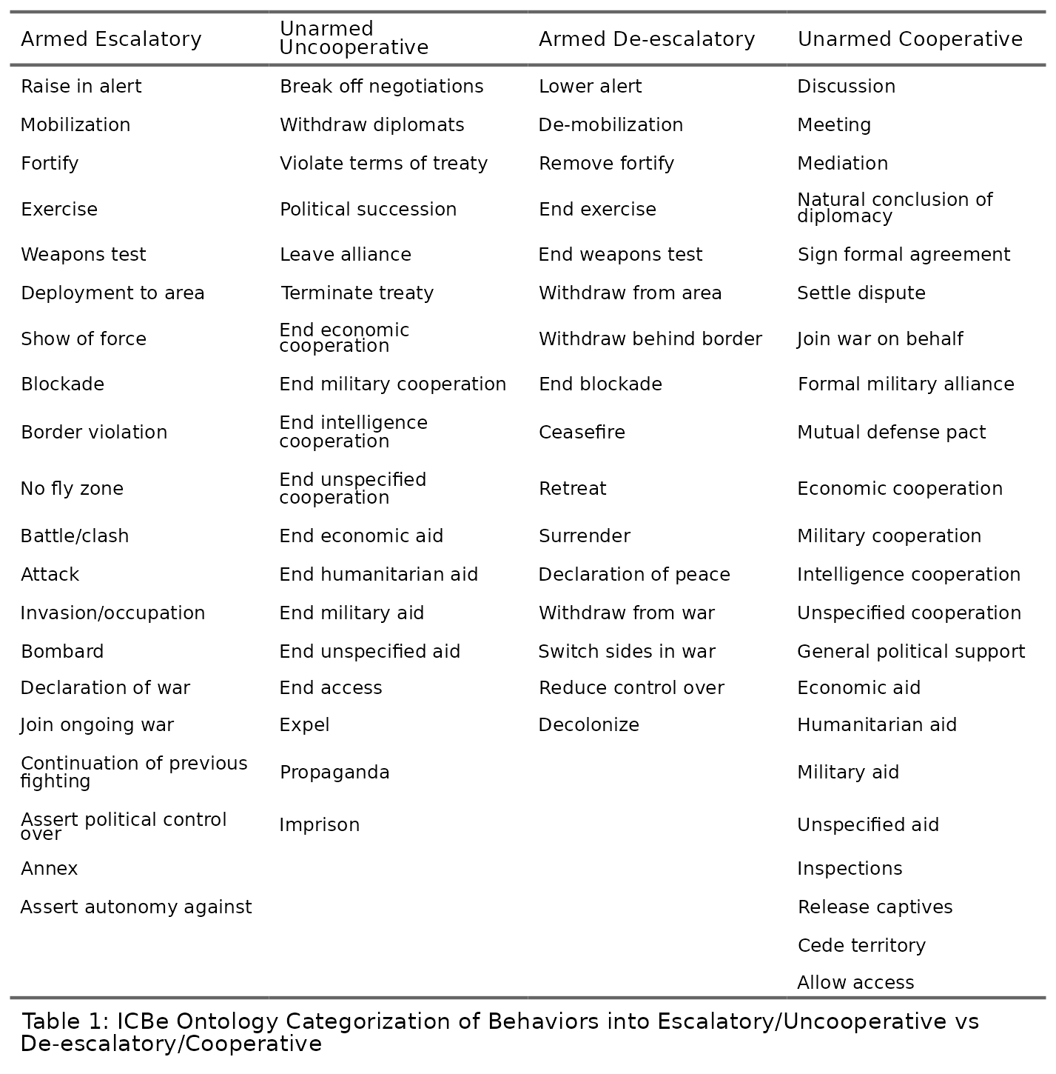

Figure 1

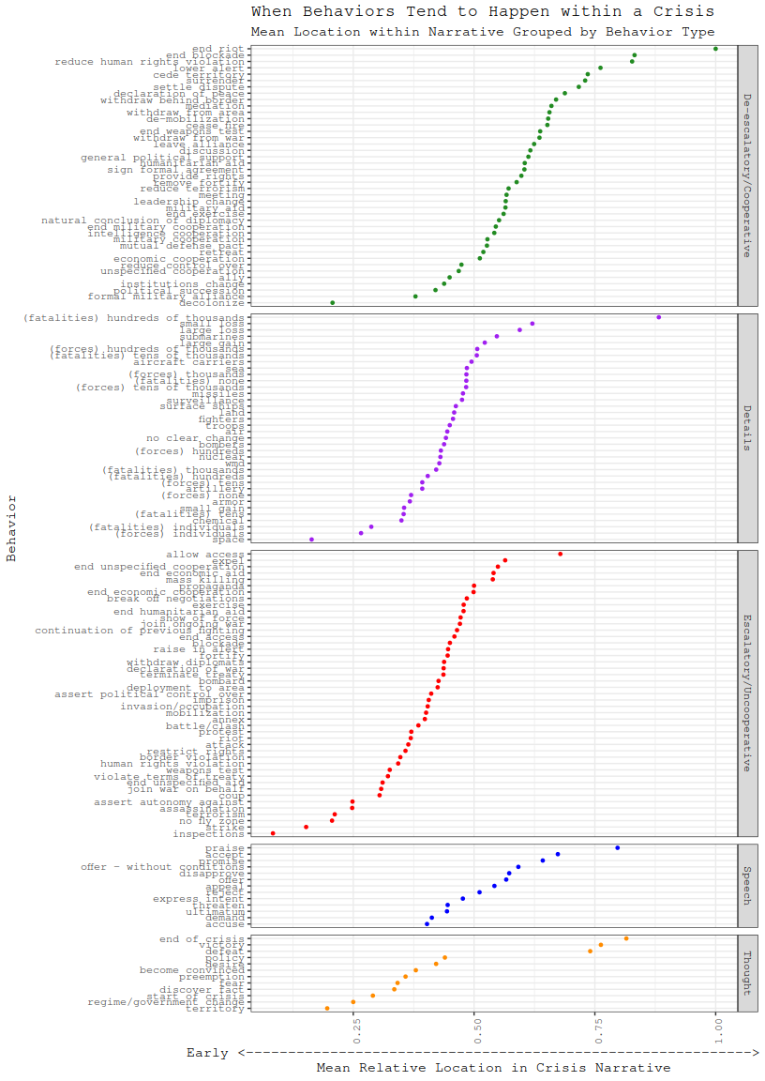

Figure 2

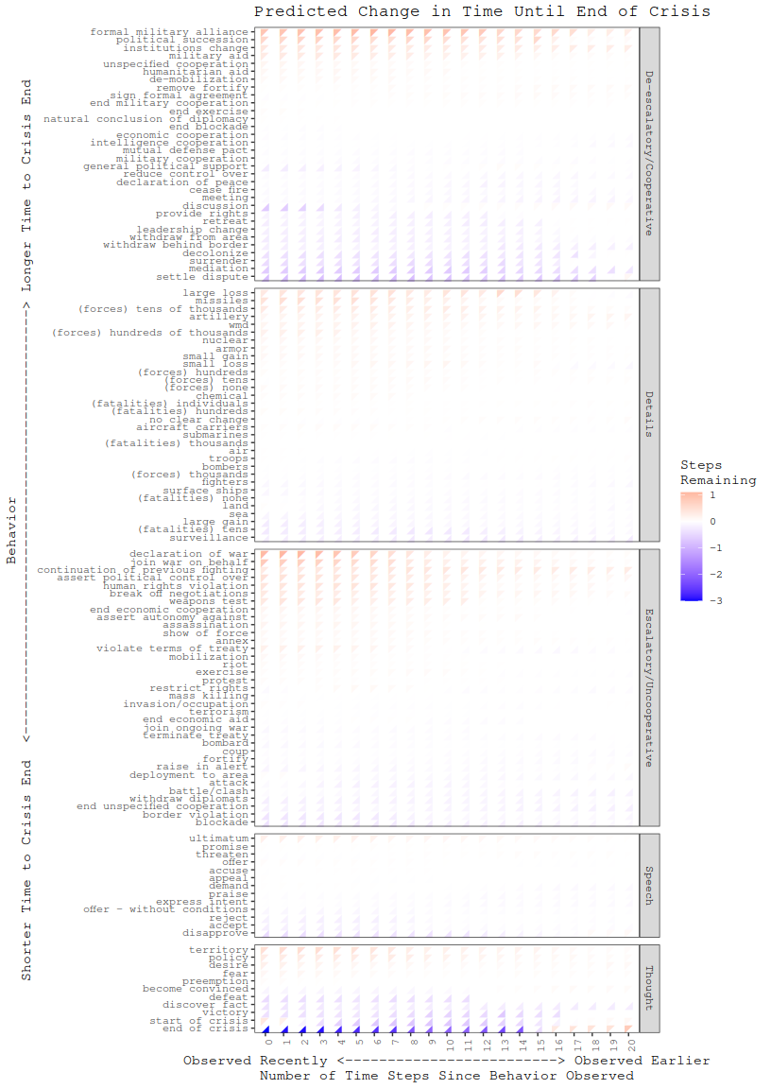

Figure 3

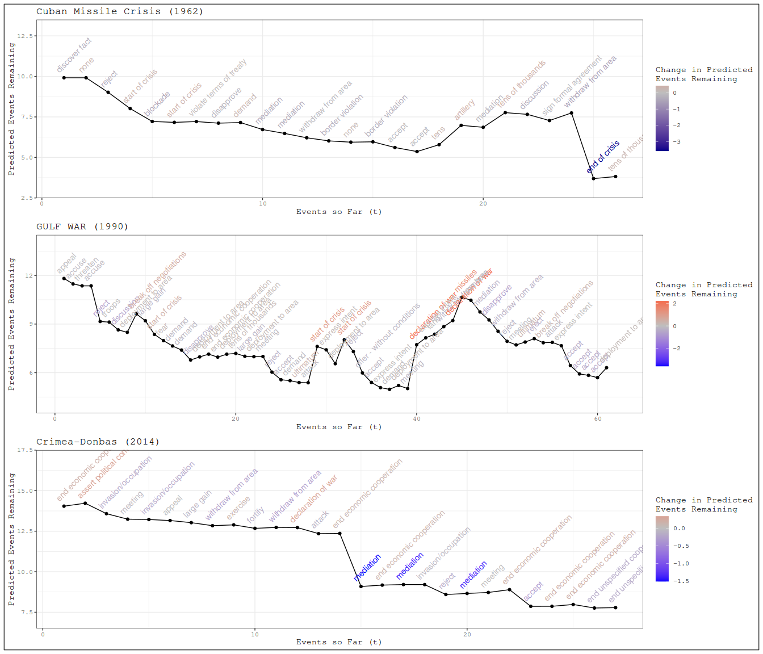

Figure 4

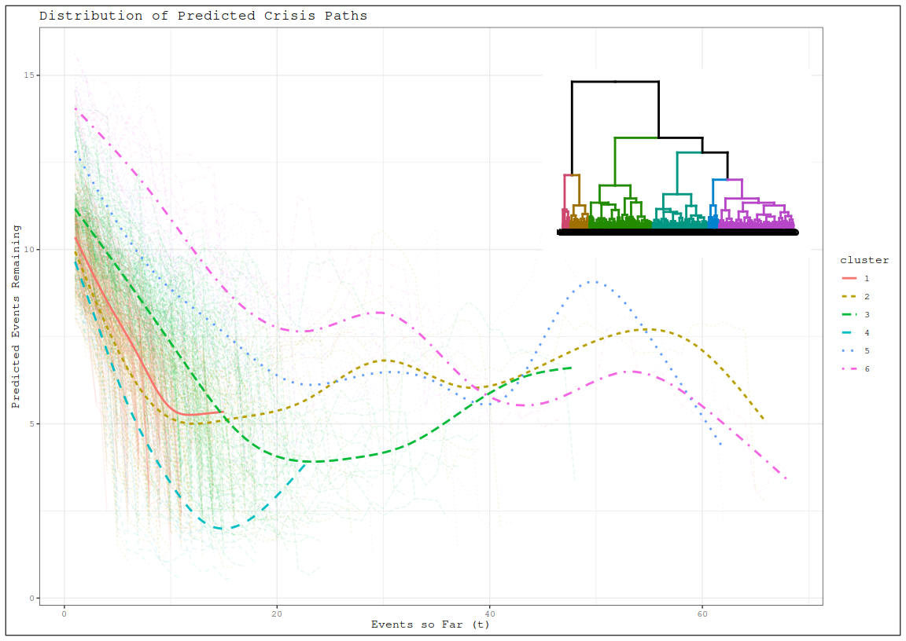

1. See Gannon (2022) for a recent review in the context of cross-domain deterrence and escalation.
2. These could be associated with the end of a crisis because the structure of the narratives describes mediation efforts at the conclusion of the crisis summary. Later analyses could identify the time period when mediation efforts occurred relative to the observed end of the crisis to see if different patterns emerge.