

**Ateneo de Zamboanga University**

**Machine for Recycling Bottles with Incentive Noting  
(MR BIN)**

By

Rex Christian R. Endozo

John Ray F. Navarro

BS ECE 5

March 2019

TABLE OF CONTENTS

LIST OF FIGURES 4

LIST OF TABLES 5

LIST OF LISTINGS 6

CHAPTER 1 INTRODUCTION 7

1.1 Background of the Study 7

1.2 Problem Statement 9

1.2.1 Improper segregation 9

1.2.2 Lack of enforcement in waste segregation 10

1.2.3 Lack of incentives for segregating properly 10

1.3 Conceptual Diagram 11

1.4 Objectives 14

1.4.1 General Objectives 14

1.4.2 Specific Objectives 14

1.5 Significance of the Study 14

1.6 Scope and Limitations 15

CHAPTER 2 REVIEW OF RELATED LITERATURE 17

2.1 Plastics recycling: Challenges and Opportunities 17

2.2 Color Coded Trash Bins 20

2.3 ATM Pet Bottle Machine (Pfand) 21

2.4 Why Should I Segregate My Waste Properly 23

2.5 What’s the Problem with Plastic Bottles? 24

CHAPTER 3 METHODOLOGY 25

3.1 Hardware Development 25

3.1.1 Hardware Specifications 26

3.1.2 User Identification Module 26

3.1.2.1 RFID Enabled User ID 28

3.1.2.2 RFID Reader 28

3.1.2.3 Power Module 29

3.1.2.4 LCD Monitor 31

3.1.3 PET Bottle Processor Module 32

3.1.3.1 Microcontroller Unit 33

3.1.3.2 Camera Module 34

3.1.3.3 Ultrasonic Distance Sensor 35

3.1.4 PET Bottle Storage Module 35

3.1.4.1 Ultrasonic Sensor 36

3.1.4.2 Servo Motor 37

3.1.4.3 Solenoid Latch 38

3.2 Software Development 39

3.2.1 RFID Scanning Module 40

3.2.2 PET Bottle Processor Module 42

3.2.2.1 Image Processing 44

3.2.2.2 Camera Calibration Module 45

3.2.2.3 Object Classification Module 46

3.2.2.4 Object Measurement Module 47

3.2.2.5 Data Normalization 48

3.2.3 Storing Module 49

3.3 Hardware and Software Integration 50

3.4 Test Plan 50

3.4.1 Microcontrollers Test 52

3.4.2 RFID Scanning Test 53

3.4.3 Camera Calibration Test 53

3.4.4 PET Bottle Detection Test 54

3.4.5 PET Bottle Height Measurement Test 55

3.4.6 PET Bottle Diameter Measurement Test 55

3.4.7 PET Bottle Volume Calculation Test 56

3.4.8 PET Bottle Storage Test 57

3.4.9 Bin Storage Monitor Test 57

3.4.10 Incentive Calculation Test 58

3.4.11 Database Storing Test 58

REFERENCES 59

LIST OF FIGURES

Figure 1‑1: Systems Design 11

Figure 3‑1: User Identification Module 25

Figure 3‑2: RFID Card 27

Figure 3‑3: RFID Reader 28

Figure 3‑4: Relay Module 29

Figure 3‑5: Battery Pack 29

Figure 3‑6: LCD Monitor 31

Figure 3‑7: PET Bottle Processor Module 31

Figure 3‑8: Raspberry Pi 3 Model B+ 32

Figure 3‑9: Pi Camera 33

Figure 3‑10: Application of Distance Sensor 34

Figure 3‑11: Ultrasonic Distance Sensor 34

Figure 3‑12: PET Bottle Storage Module 35

Figure 3‑13: Ultrasonic Sensor Inside the Bin 36

Figure 3‑14: Servo Motor 37

Figure 3‑15: Solenoid Latch 37

Figure 3‑16: Operation of MR BIN 38

Figure 3‑17: PET Bottle Processor Module Software Diagram 41

LIST OF TABLES

Table 1‑1: System Modules 11

Table 2‑1: Design Criteria 16

Table 3‑1: Summary Table of Test Plan 50

LIST OF LISTINGS

Listing 1: RFID Scanning Module Pseudocode 41

Listing 2: PET Bottle Processor Module Pseudocode 44

Listing 3: PET Bottle Storage Module Pseudocode 49

# CHAPTER 1 INTRODUCTION

## Background of the Study

Polyethylene terephthalate (PET) has become the most promising packaging in the world for food and especially beverages. The reason for this is because of its characteristics: it is light weight, portable and durable (Welle, 2011). However, consequences arise in the production of PET. Plastic production has drastically increased over the last 60 years. Around 4% of the world’s oil and gas is being consumed for the said production and these are all coming from non-renewable resources. Also, 3 – 4% is utilized to provide energy for the manufacturing process. These plastics are produced for disposable containers for food and beverages and the time of use is short-lived, given the amount of energy and time to produce the said material. Also, when it is thrown, the amount of time for it to recycle itself is of great difference compared to its time of use and production; this leads to plastic bottles building up and accumulating most of the landfills and even natural habitats like the ocean (Hopewell, Dvorak, & Kosior, 2009).

Recycling is the most important and readily available solution to reduce the impact of the dangers brought by plastics, especially PET bottles, to the landfills, natural habitats and more importantly the environment. Recycling reduces the carbon dioxide emissions and the quantities of waste requiring disposal.

Waste management has been a part of the Barangay San Roque Community is striving to implement, practice and improve for the welfare of the barangay, for the people, and its surroundings Despite that, residents, non-residents and even solid-waste workers were not compliant to the program. It was evident by the presence of bin contamination and trash bags along the streets and the riverbanks (Delgado, 2019). These contaminations can be compromised with proper segregation that is why the presence of compliance reinforcement is needed upon these inadequate acts.

One of the factors of improper disposal could be the improper waste segregation in corresponding bins. For example, in PET-Bottle exclusive bins, other types of trashes are present inside. Without the knowledge of garbage collectors what’s inside, they dispose it causing trashes to be contaminated. Although it is difficult to monitor every trash thrown in each bin, this study may provide an alternative that can be useful to prevent improper disposal, especially PET bottles.

For the most part, it could be the unawareness of proper segregation as to where these types of wastes correspond to their respective trash-bin. The inconvenience of having to distinguish could be time consuming especially to members of the barangay. In most cases, residents senselessly throw other trashes to PET bottle exclusive bins because of where it is situated, and no individual can monitor each trash thrown inside.

With the help of a device that can monitor what is being thrown inside and at the same giving rewards to those who do so, it can help the residents and non-residents in the barangay community in terms of properly disposing PET bottles in its exclusive bin. Thus, the proponent sees that this study is not only a need but an opportunity in improving waste management at the barangay.

## Problem Statement

This study primarily concerns with PET bottles within the barangay which often get mixed up with other wastes inside the trash bins. The study aims to help reinforce the waste segregation currently implemented in the barangay.

### Improper segregation

The improper segregation of PET bottles symbolizes the incompliance of the barangay’s waste disposal program. Evidently enough, if we look inside all the PET bottle exclusive bins deployed in the barangay community, there will be other wastes mixed up inside this PET bottle ‘exclusive’ bins. It shows that the enforcement of the implementation of PET bottle exclusive bins is merely ineffective. Furthermore, this study concerns with the general cleanliness and order of the barangay community’s waste disposal. In light of this matter, the study looks to the possibility of significantly reducing the throughput of PET bottles on waste dumps. The unreliable system of the current PET bottle segregation resulted in the community being lax about segregation and contributed to the overall wastes being mixed up with PET bottles.

According to the Barangay Captain Mr. Delgado (2019), the trashes that are not segregated technically should not be collected, but they cannot leave them uncollected because those trashes will build up and just be present in the streets leaving them with no choice but to just collect it.

### Lack of enforcement in waste segregation

Past decisions in implementing enforcements with waste segregation have already been made by Barangay San Roque. Citation tickets are granted to violators and must be paid upon due. The implementation of this enforcement was weak; for every booklet of citation ticket, only three (3) to less than ten (10) violators complied properly (Delgado, 2019). The result of this problem correlates with the result of the previous problem; the trash collectors face the problem of not collecting the trashes because of improper segregation, thus this result to trashes being evident and building up on the streets and therefore, they have no choice but to take the trash whether it is segregated or not.

### Lack of incentives for segregating properly

The City Government recently imposed an ordinance that forces people to pay for a garbage fee in exchange for services of collecting the trashes by the garbage truck. The result of this ordinance brought more adamance for people not to segregate because according to the words of the Barangay Captain Mr. Delgado “Nag impose na naman yung city na kailangan may garbage fee, so, mas lalong titigas ang ulo ng mga tao kasi “Nagbabayad ako ng garbage fee? Dapat kunin mo yang basura kahit hindi segregated!”. Ganun mangyari! Kasi nag babayad man sila ng garbage fee.” (Delgado, 2019). Instead of incentivizing the act of segregation, they are doing the exact opposite which causes the people to be stubborn with regards to proper segregation.

One of the possible factors of why PET bottles get mixed up with other wastes is that, the barangay community don’t receive enough incentives to have them properly throw PET bottles in the right trash bin. With this, the community lack encouragement to throw their wastes properly. Despite the efforts of the barangay to enforce waste segregation, the amount of other types of wastes being mixed up with PET bottles are significant enough to say that waste segregation implemented in the barangay is not enough. Since there are no trash bins in the barangay community that can detect if the object deposited inside the bin is a PET bottle or not, the residents can just throw other wastes inside these PET bottle exclusive bins due to carelessness or lack of knowledge of the material.

### Inability of trash bins to distinguish PET bottle from other types of wastes

Trash bins in nature are only there to be a containment of trashes of people. It is the sole responsibility of the user whether to properly throw their trashes or not. According to the Barangay Captain “ “. The exclusive PET bottle bins they provided for the residents are not entirely effective. Trash bin enforcers should be present in these bins, but we know this is not entirely possible. It is vital to the recycling process for trashes to be properly segregated because different categories of wastes must not mix with the others because according to ___ “It will be much easier to recycle. Effective segregation of wastes means that less waste goes to landfill which makes it cheaper and better for the environment.” Also, different wastes go to different places; as for plastic bottles, they belong to the recyclables category and therefore go to the MRF or also can be made into other products.

## Conceptual Diagram

This device operates on a three-step function. The first step is for the user to scan his/her RFID-enabled ID to the RFID scanner module to identify the current user. The second step is for the user to deposit the PET bottle into the device and with the camera and image processing software, it will automatically detect the object and distinguish if it is a PET bottle or not. It will then measure the PET bottle’s physical dimensions and stores the data for later use. However, if the object deposited into the device is not a PET bottle, the device instructs the user to retrieve the object. The third and final step is the confirmation wherein the device prints out to the LCD the properties of the deposited PET bottle and its corresponding incentives to be given to the current user. The data is then stored in the database. After all these processes are successfully executed, the device will then automatically store the PET bottle into the device’s container unit isolated from all other wastes and contaminants.

There will be multitude of sensors, controlled by separate microcontrollers, to detect the object deposited and to quantify the properties of the PET bottle, if it is one. The quantification method revolves around specific algorithms and image processing techniques to measure the volume of the PET bottle. Measuring these properties require specific hardware components integrated with an image processing software suited for the purpose of this study. After the properties are quantified, it will be normalized to a specific range of values which will then be the variables for the incentive calculation. The incentive will be based from the received variable and the magnitude of the incentives generated will be ruled by the barangay. After the calculation of the incentive points, it will be given to the user and the display module will display the corresponding incentive given.

Figure 1-1 shows the systems design of the proposed device and its respective modules.

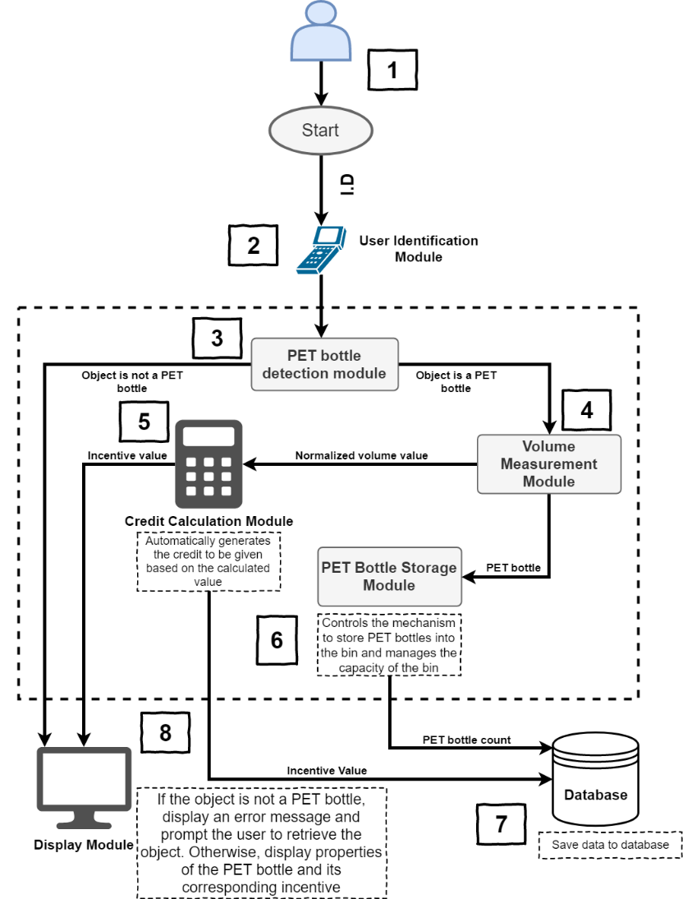

Figure 1‑1: Systems Design

|  |  |  |
| --- | --- | --- |
| Module Number | Module Name | Module Description |
| 1 | User | The user which will use this device |
| 2 | User identification | Identifies who is using the device |
| 3 | PET bottle detector | Detects the material of the object deposited, either PET bottle or not. |
| 4 | Volume Measurement | Measures the approximate volume of the PET bottle |
| 5 | Credit Calculator | Generates the corresponding credit based on the properties of the PET bottle to be given to the user |
| 6 | PET Bottle Storage | Controls the mechanism such as latches, motors and sensors that will store the PET bottle properly and checks the capacity of the bin |
| 7 | Database Server | Stores the data to the local database |
| 8 | LCD Display | Displays the properties of the PET bottle and the credits given to the user |

Table ‑: System Modules

## Objectives

### General Objectives

The objective of this study is to design, create, and develop a device capable of detecting and distinguishing PET bottles from other waste types and to measure its physical dimensions and generate the corresponding incentives to be given to the user of this device.

### Specific Objectives

**1.4.2.1** To create a device that can recognize PET bottles using machine learning.

**1.4.2.2** To devise a calculation method that can accurately correspond to the deposited PET bottle for the incentive generation.

**1.4.2.3** To design a module that can measure the height of the PET bottle using image processing.

**1.4.2.4** To design a module that can measure the diameter of the PET bottle using image processing.

**1.4.2.5** To create a module that can approximate the volume of the detected PET bottle.

**1.4.2.6** To design a bin that can detect if the container is full.

**1.4.2.7** To create a database capable of storing user data and their corresponding incentive values.

## Significance of the Study

In using this device, there will be several significant benefits for the Barangay San Roque community, as well as for the garbage collectors. First, it will raise awareness of the importance why PET bottles need to be in the proper and exclusive trash bin rather than getting mixed up in other trashes or the other way around. In connection to this, another benefit would be having PET bottles segregated in the proper place, so garbage collectors can easily accumulate the PET bottles knowing it’s the only thing inside the bin—no longer having to check and segregate it second-hand.

It will improve the proper segregation and waste disposal as long as the Barangay San Roque residents and non-residents will take part and strive to achieve it. There will be more PET bottles actually segregated and properly disposed rather than getting mixed up in the garbage. It still does require the active participation of the residents that is why incentives will be given for them to do so. There will be less time garbage collectors to segregate. Concepts and theories involved in this study may also be significant to other related subjects. Thus, this study can be used as tool or reference.

## Scope and Limitations

This device will be designed in a way that it can detect and measure the dimensions of a plastic bottle, so it will calculate the reward for the user. It will be studied and installed inside the building of the barangay hall. In this setting, it is required to have a wired connection for the device/bin to access the barangay’s database and server to get and update information regarding the progress of the user’s rewards.

The device/bin should be instated indoors to avoid weathering and malfunctioning of components contained inside. It is also highly encouraged for plastic bottles to avoid exposure to sunlight for instances, although very low chance, of plastic melting under heat causing toxins that are bad for the health and for the components inside.

Since there are various PET bottles ranging from 350ml to 7 liters, the device is only capable of detecting up to 2 liters since it is the only maximum measurement that can fit into bottle detection module. The device also cannot detect if the bottle is empty or not.

It does not measure the exact volume of a bottle but rather just an approximation. It is due to the translucency of the plastic bottles, image processing technique used and the camera’s quality. This is compensated by the normalization technique to categorize the approximation measurements and give out certain points with the different categories.

# CHAPTER 2 REVIEW OF RELATED LITERATURE

This chapter will investigate the already existing solutions that are related to the study/proposal. These solutions will have a similar strategy in tackling for a better waste management and segregation. The following features presented may also be integrated into the device to help signify the desired software and hardware design. The table below shows the design criteria of our study. For the criteria, a rating of 0 is used being the lowest and a rating of 5 is used being the highest.

|  |  |  |  |  |
| --- | --- | --- | --- | --- |
|  | Cost | Long term Reliability | PET bottle isolation from other wastes | Accessibility |
| Color-coded trash bins | 4 | 1 | 2 | 5 |
| Pfand ATM bottle recycler | 1 | 5 | 4 | 0 |
| Manual Collection of PET bottles | 5 | 0 | 5 | 3 |

Table 2‑1: Design Criteria



## Plastics recycling: Challenges and Opportunities

Generally, plastic means changeable. There are two kinds of plastics: thermoplastic and thermosets. A thermoplastic behaves like ice and water; it solidifies when it undergoes low temperature and it will melt into liquid when it undergoes high temperature. A thermoset behaves more like a fried egg. It is liquid until it is heated enough to solidify; but when heated long enough, it will burn. This is how recycling works.

A thermoplastic is a hydrocarbon polymer - a long chain of carbon atoms with hydrogen atoms on the side. Hopewell, Dvorak, & Kosior (2009) says that PET (polyethylene terephthalate) is a thermoplastic meaning the bottles are made from similar grades of PET suitable for both the bottle manufacturing process and reprocessing to polyester fiber. Basically, PET bottles can be melted and again be turned into another PET product.

There are four categories of recycling: primary (closed-loop recycling) is the process of mechanical reprocessing into a product with equivalent properties. Secondary (downgrading) is mechanical reprocessing into products requiring lower properties. Tertiary recycling is either described as chemical or feedstock recycling and applies when the polymer is de-polymerized to its chemical constituents (Fisher 2003). Quaternary recycling is energy recovery, energy from waste or valorization. Biodegradable plastics can also be composted, and this is a further example of tertiary recycling, and is also described as organic or biological recycling (Song et al. 2009).

Theoretically it is possible for closed-loop recycling, in which (PET is under this category) to recycle most thermoplastics; however, plastic packaging frequently uses a wide variety of different polymers and other materials such as metals, paper, pigments, inks and adhesives that increases the difficulty (Hopewell, Dvorak, & Kosior, 2009). Some plastic recovered that is not suitable for recycling into the form it has previously taken is used to make other PET products.

Hopewell, Dvorak, & Kosior (2009) says that plastic materials can be recycled in a variety of ways and the ease of recycling varies among polymer type, package design and product type. Thermoplastics, including PET, PE and PP all have high potential to be mechanically recycled.

Hopewell, Dvorak, & Kosior (2009) finds that in terms of the overall consumption typically only 30–40% of post-consumer plastic bottles are recovered, as a lot of this sort of packaging comes from food and beverage consumed away from home. For this reason, it is important to develop effective ‘on-the-go’ and ‘office recycling’ collection schemes if overall collection rates for plastic packaging are to increase.

Most local authorities or material recovery facilities do not actively collect post-consumer flexible packaging as there are current deficiencies in the equipment that can easily separate flexibles. Many plastic recycling facilities use trommels and density-based air-classification systems to remove small amounts of flexibles such as some films and labels. There are, however, developments in this area and new technologies such as ballistic separators, sophisticated hydrocyclones and air-classifiers that will increase the ability to recover post-consumer flexible packaging (Fisher 2003).

One of the key benefits of recycling plastics is to reduce the requirement for plastics production. It has been estimated that PET bottle recycling gives a net benefit in greenhouse gas emissions of 1.5 tonnes of CO2-e per tonne of recycled PET (Department of Environment and Conservation (NSW) 2005). As well as reduction in landfill and net energy consumption. An average net reduction of 1.45 tonnes of CO2-e per tonne of recycled plastic has been estimated as a useful guideline to policy (ACRR 2004).

## Color Coded Trash Bins

This scheme uses color-based codes to have better segregation of wastes. In segregating, it is not just about separating wet waste from dry waste as we normally do, but there are now three types of bins where different types wastes will go. Although it can reduce waste going into the wrong bins, it is not a reliable system to entirely separate PET bottles from other wastes. In this study however, the total isolation of PET bottles from other wastes is feasible.

Essentially, there will be three different colors corresponding to the type of waste that it holds. Green is for the wet waste, which typically consists of food, solutions, and other wastes that are not dry. Blue is for recyclable wastes, which consists of plastic bottles, cans, cardboard, etc. Red is for the reject wastes, which includes biowaste materials like diapers, bandages and such.

The three-way segregation of waste scheme is followed around the world. It generally follows the same concept, and only slightly differs from the colors used or the types of waste that should go into a specific color. This scheme aims to work similarly to a traffic light. Traffic light colors are encoded into most people’s mind, such as green means go, red means stop, yellow means wait. With this, people can also memorize which types of waste go to what kind of color. In some foreign cities for example, plastics and aluminum cans go into separate bins. Even though an individual take in the habit of knowing where to throw specific type of wastes, one can easily be careless and throw the wrong type of waste in the wrong bin. This study aims to remove that error by having one specific bin storing only one type of waste.

Ideally, the color-coding bins is suitable for everyone. Every household could adopt at least one set of three bins of these colors. Even children can easily pick up this scheme and can be trained as a habit. Every function rooms such as the cafeteria should have these color-coded trash bins. It is important that we take color coding publicly, in malls, airports, bus terminals and such. Before the color-coded bins, foods from tables and other wastes go into one bin.

Color-coded trash bins act as a reminder that everyone should segregate. It is a clear sign that everyone should do their part to help the environment. It is irrelevant that the waste collection system takes a bit of time to do its job and transport the different wastes separately to different processing hubs. It is imperative that we start segregating first (Vincent, 2012).

## ATM Pet Bottle Machine (Pfand)

Plastic products have been aiding us go by our daily lives. We use these for PET bottles for our beverages, bags for carrying loads, containers for foods and many other uses. Plastic products truly have been useful for us; however, it poses a danger to our environment and ecosystem. There have been countless attempts to steer the community to go “green”, wherein instead of using plastic products, we look for other alternatives. Recycling became a common practice and many companies strive to make innovations that will encourage people to recycle (Lei, 2017).

In Germany, when a person buys a canned or bottled beverage that has a Pfand symbol, they are charged with a few extra cents as a deposit to encourage consumers to return the bottle. Once the bottle is empty, it can then be deposited in a machine where different types of bottles have different corresponding amounts. However, the machine only accepts bottles with the Pfand symbol on it. The machine will then print out a receipt that tells the consumer how much the recycled bottle is amounted to. The consumer can then exchange the amount from the machine for cash or groceries.

The German Pfand system is basically a cycle. The drinks manufacturer fills his/her product, like water, soda or beer, into these bottles. The bottles are then sold to wholesaler or retailers that pays a deposit to the producer, which is then directly passed on to the end-consumers in a form of surcharge. Single-use bottles are regulated by law in Germany, and everyone who sells them must always accept the return of these empty bottles. With the ATM recycler machine, it will accept the returned empty bottles 99% of the time provided it is a bottle with a valid German Pfand label and barcode on it (James, 2017).

The machine presented is really similar to this study. Although used as a commercial product, the machine’s concept is applicable to the study. However, the device discussed uses barcode scanning to determine the type of material and checks whether there is a specific symbol printed on the bottle. If the symbol or the barcode had been removed, there will be no way for the device to read the object deposited inside it. This study, however, uses photoelectric sensors to detect the sensing object to determine if it is a PET bottle or not. If the barcode of the PET bottle for instance was removed, this study can still detect the PET bottle to decide whether it is accepted or not.

## Why Should I Segregate My Waste Properly

In many places like school or business properties and even residential areas there are different forms of waste segregation. There might be 3 different types of trash bins or simply a recyclable exclusive bin. But how important is it to put the right waste in the right bins?

The first reason is it is lawfully required. Under the Waste Regulations 2011, trashes must be segregated according to its material: paper, cardboard, plastic, metal and glass. Under the same regulations, you should implement the waste hierarchy; reduce, reuse, recycle, other recovery and disposal. By law, you should implement this hierarchy and segregation helps with recycling

Waste segregation is lawfully urged because in this way it is much easier to recycle. Effective segregation means less waste goes to landfill which makes it cheaper and better for people and the environment. Waste segregation is also very significant in concerning public health; particularly hazardous wastes can cause long term problems or can establish breeding grounds for pests and deadly mosquitoes.

There are a number of important reasons waste segregation is and should be heavily implemented: legal obligations, cost savings and protection of human health and the environment. So next time you’re presented with a choice to put your plastic bottle in a general waste bin or a plastic bin, reach over to the plastic one and pop it in there.

## What’s the Problem with Plastic Bottles?

Plastic bottles are made from a petroleum product known as polyethylene terephthalate (PET), and they require huge amounts of fossil fuels to both make and transport them. In the 1970s the U.S. was the world’s largest exporter of oil, but now it is the largest importer. If you fill a plastic bottle with liquid so that it is 25% full, that’s roughly how much oil it took to make the bottle. For a single-use disposable item, that’s a lot.

It’s harder to recycle plastic bottles than you think. Of the mass numbers of plastic bottles consumed throughout the world, most of them are not recycled because only certain types of plastic bottles can be recycled by certain municipalities. They either end up lying stagnant in landfills, leaching dangerous chemicals into the ground, or they infiltrate our streets as litter. They are found on sidewalks, in parks, front yards and rivers, and even if you chop them into tiny pieces, they still take more than a human lifetime to decompose.

It gets worse. In the case of bottled water, the plastic-making process requires over two gallons of water for the purification process of every gallon of water.

# CHAPTER 3 METHODOLOGY

The MR BIN is primarily divided into software and hardware corresponding modules. The hardware design of the device is achieved with the availability of materials that is suitable for application to our study. The software design will be dependent on the type of microcontroller used and its corresponding language.

This methodology aims to deliver the users the detailed explanation of the composition and specifications of the design. The specified components mentioned later are the best possible options that considers the effectivity and longevity. Price will also be a factor for choosing these parts because this device aims to have the most effective function with the lowest price; also, these parts will, although cheap, not compromise the quality of the overall device.



## Hardware Development

The MR BIN is comprised of three main modules: (1) User Identification module, (2) PET bottle processor module, and (3) PET bottle storage module. Each module will be composed of circuits and programs necessary to accomplish the function. The body of the device will be the same with current existing trash bins. It differs in structure with the attached modified lid that accommodates the sensors, microcontrollers, and a display panel.

### Hardware Specifications

This section will provide the details of the hardware specifications of the device from the trash bin to the lid and the display panel. This module is necessary for the accommodation of all the modules. The trash bin must be made up of solid robust plastic with dimensions of 34cm x 34cm x 90cm. A trash bin having this size is enough to fill up to 55L of plastic bottles.

The display panel will be a 3.5” Raspberry Pi TFT LCD. This display panel will be enough to show the valuable information and to display the process the device is undergoing. For the chassis, it will be a mix of wood and aluminum casing. Aluminum will be used as the material for moving parts as it is not only lightweight, but also sturdy.

### User Identification Module

This section explains the basic function of a module that will be responsible for the user identification and authentication. This ensures that the device can properly give the credits generated to the indiviual where it is due. It will also be responsible for the power delivery of the sensors and actuators for the next phase.

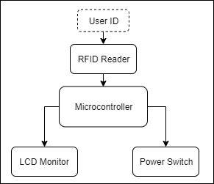Figure 3-1 provides the conceptual design for the user identification module.

Figure 3‑1: User Identification Module

Power will be provided by a portable battery which will suffice all the sensors and motors that will be used in the device. To save power, the sensors will be initially off. The user identification module not only functions as an authenticator, but also as a switch to deliver power to the device, in this way the sensors will be off until a user activates with the ID scanner, this will save power; the power switch will be accomplished by the microcontroller of the device. Once the user is authenticated, the servo motor will activate for the user to be able to deposit the PET bottle.

#### RFID Enabled User ID

For users to be able to access this device, the user must have an RFID enabled ID that operates on the 13.56MHz frequency. We opt to use RFID as an authentication method because every RFID chip has 4-byte of ID burned into the chip and cannot be changed. This is to ensure that the incentive to be given is due to the proper user of the device. Figure 3-2 shows an example of an RFID card.

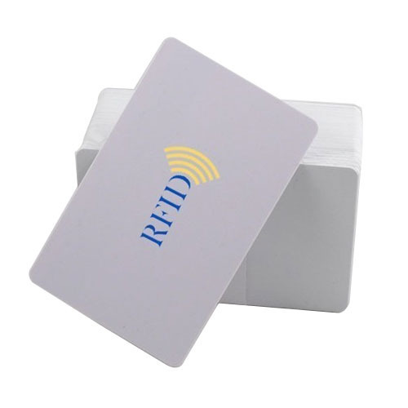

Figure 3‑2: RFID Card

#### RFID Reader

It is vital for the RFID reader to be functional and at the same time consumes less power. The reader should be powered at least 3V and the operating frequency to be at least 13MHz. The RFID be connected to an Arduino UNO microcontroller. It should be able to read approximately 3cm in contact with the RFID. The transfer rate must be at least 8 – 10Mbit/s. This will be enough for the reader to identify the user’s ID and be a corresponding input to our database. The Arduino UNO will be interfaced with the Raspberry Pi 3 Model B+ via USB for the RFID Reader to able to access the database. The RFID reader to be used is an RFID-RC522 with an operating frequency of 13.56MHz as shown in Figure 3-3.

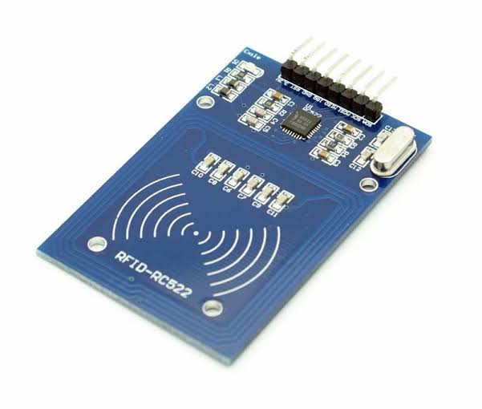

Figure 3‑3: RFID Reader

#### Power Module

For the purpose of energy saving when the device is unused, a relay will be utilized to control the power distribution of the device. A 9-Volt battery will power the Arduino and all the other sensors. When there are no users using the device, no power will be distributed to the sensors and motors. However, the Arduino Microcontroller and the RFID Scanner will always be turned on. A low voltage relay module will be suitable for our study since most of the components only use 3 to 12 volts and relatively low 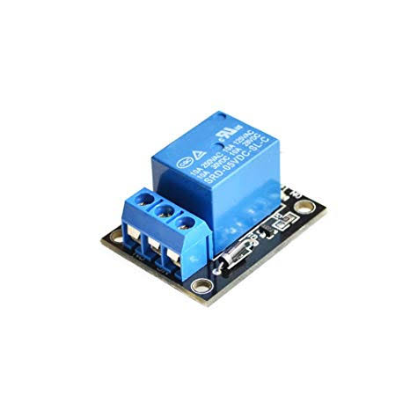current. The relay module that we will be using is shown in Figure 3-4.

Figure 3‑4: Relay Module

For the power of the Arduino and other sensors, motors and latches, a battery capacity of 9 volts is suitable. The battery pack that we will be using in this study can be seen in Figure 3-5.

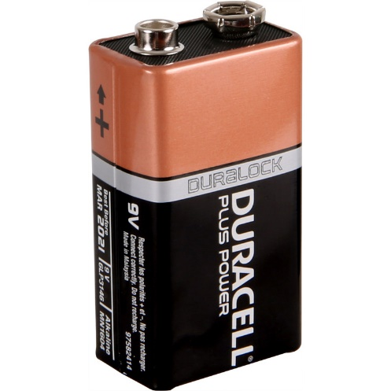

Figure 3‑5: Battery Pack

#### LCD Monitor

For displaying important information to the users, we will use a Liquid Crystal Display monitor. It is a 3.5” TFT touch screen display with a resolution of 480x320 specifically designed for Raspberry Pi Microcontroller. Thus, the Raspberry Pi microcontroller will control the LCD monitor as the unit is only compatible for Raspberry Pi microcontrollers. Conveniently, the LCD Monitor can be mounted on top of the Raspberry Pi microcontroller due to its compatible size. This setup will minimize wire buildup and can be presented neatly. The LCD monitor will be the medium of communication between the computer and the user. It will instruct users what to do and display errors, if any. The LCD Monitor will also print out the user’s name attained incentive points. After the user successfully transacts using the device, the LCD monitor will also print out the properties of the PET bottle and the incentive points to be given to the user.

Since the LCD monitor that we will be using is capable of touch input, users can specify their name after scanning their ID for the first time. This is to provide a more user-friendly experience. Figure 3-6 shows the LCD 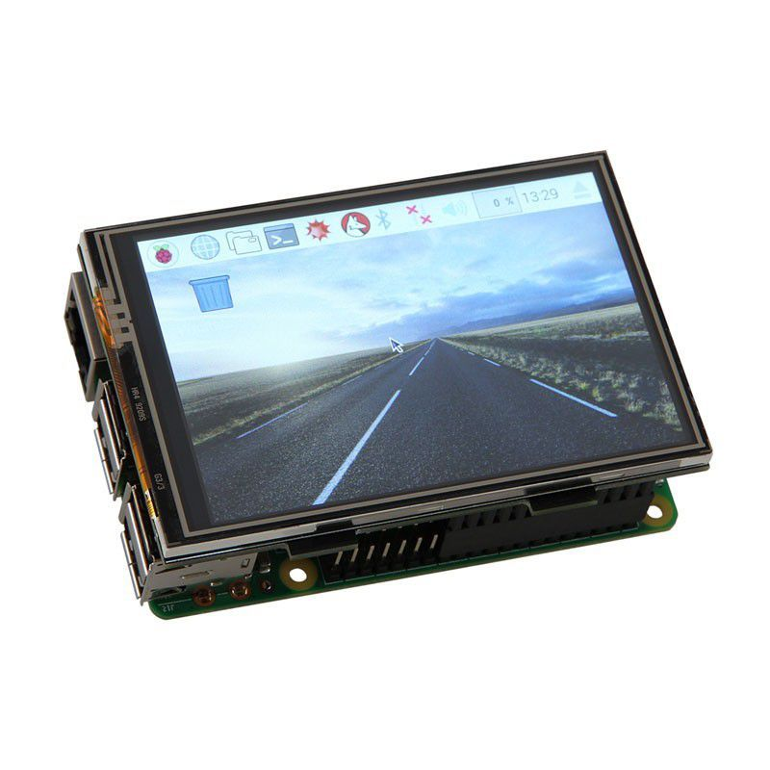Monitor to be used in this study.

Figure 3‑6: LCD Monitor

### PET Bottle Processor Module

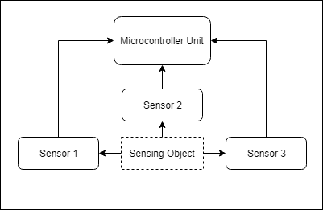This section explains the workings of the sensors responsible for detecting PET Bottles and its properties. The purpose of the PET bottle processor module is to detect PET bottles and the properties of the PET bottle, which includes its volume. The principle of the PET bottle detection sensors is shown in Figure 3-7

Figure 3‑7: PET Bottle Processor Module

#### Microcontroller Unit

The microcontroller unit will integrate an image processing software for the purpose of processing the image fed by the image sensor to calculate the volume of the PET bottle inside the enclosure. The microcontroller unit will also be used for the classification of objects inserted in the device. By taking in data from the image sensor and converting the data to a readable format for the computer, which is a series of matrices, we can use a software that is suitable to working with the data received from the image sensor. To be able to accomplish these tasks, a fast microcontroller capable of heavy processing is needed. We chose the Raspberry Pi 3 Model B+ to carry out the tasks. The Raspberry Pi should contain at least 1 Gigabytes of RAM to perform the machine algorithms and techniques needed for image processing. Figure 3-8 shows the microcontroller to be used in our study.

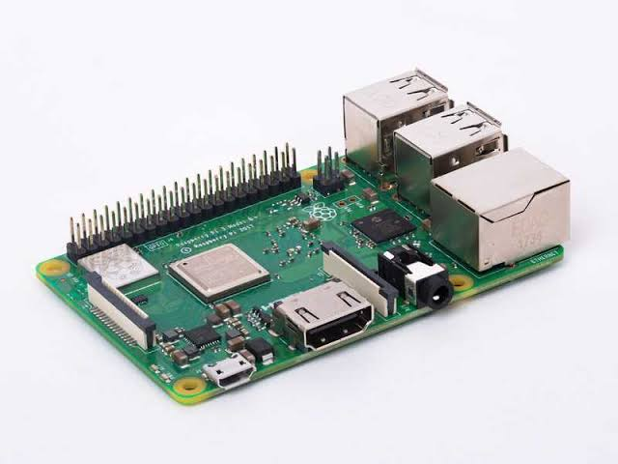

Figure 3‑8: Raspberry Pi 3 Model B+

#### Camera Module

The camera module will mainly be the one responsible for both the object classification for PET bottle distinction and the measurement of the volume of the PET bottle. With the camera module feeding live image to the microcontroller unit, we can integrate software needed to distinguish the object to be a PET bottle or not and alongside with the measurement of the physical dimensions of the PET bottle using the microcontroller as the main processing unit for calculations.

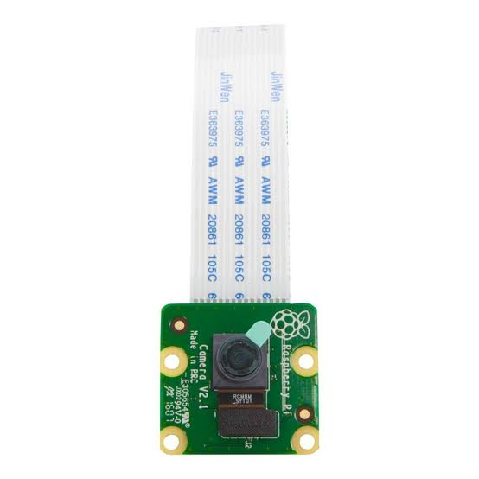For this study, we will be using a Raspberry Pi camera that is compatible to our Raspberry Pi 3 Model B+ unit. It will be directly connected to the microcontroller via a dedicated 15-pin MIPI Camera Serial Interface (CSI), which are specifically designed for interfacing to cameras. The camera must have a resolution of at least 5 megapixels for more accurate results. The camera module that we will be using is capable of 1080p @ 30fps recording and 720p @ 60fps recording. The camera module will be implemented overhead to get a top view of the object for proper measuring. Figure 3-9 shows what the Raspberry Pi camera module looks like.

Figure 3‑9: Pi Camera

#### Ultrasonic Distance Sensor

For the detection of objects inside the enclosure, an ultrasonic distance sensor will be used. The ultrasonic works in the principle of radar and echo location. When the ultrasonic sensor detects an obstruction to its field of view, it will send an analog signal to the microcontroller unit which decides if there is an object within proximity inside the device. We can use the ultrasonic sensor to check whether there is an object inside before initializing the other sensors as to save power. Figure 3-10 shows the Ultrasonic Distance Sensor and Figure 3-11 demonstrates how it is applied.

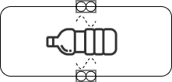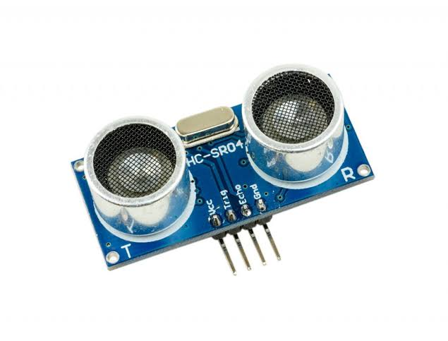

Figure 3‑11: Application of Ultrasonic Sensor

Figure 3‑10: Ultrasonic Distance Sensor

### PET Bottle Storage Module

This section will delve into the workings of the PET Bottle Storage Module. This module will be responsible for storing the PET Bottle into the bin and in charge of controlling the motors and latches for the locks. The module will also consist of sensors capable of monitoring the bin; checking if the bin is full or not. If the sensors detect that the bin is full, it will disable the further storing of PET bottles into the device and will display a message that the bin is full. There will be a microcontroller controlling the sensors within the module. An authorized user can then use their ID to manually open the trash bin and gather the deposited PET bottles for recycling or other purposes. Figure 3-12 will explain the process of this module.

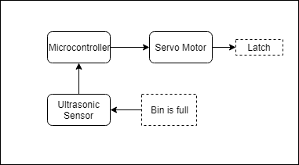

Figure 3‑12: PET Bottle Storage Module

#### Ultrasonic Sensor

The ultrasonic sensor will be used to detect if PET bottles are reaching the top of the bin. The ultrasonic sensor will be used to monitor the bin’s total capacity. The ultrasonic sensor should have a minimum ranging distance of 2-400 cm. When PET bottles are nearing the top of the bin or the threshold, the microcontroller will send out a signal locking the bin and preventing any further deposit of objects inside the bin. The setup of the ultrasonic distance sensor inside the trash bin is shown in Figure 3-13.

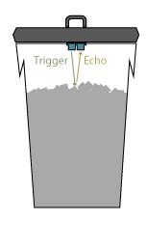

Figure 3‑13: Ultrasonic Sensor Inside the Bin

#### Servo Motor

The lid is made of aluminum to serve as an effective protection to the device and to also have the minimum weight as it will serve as a load to the servo motor. A servo motor with a stall torque of 8.65 to 9.35 kg-cm should be able to accomplish its function of securing the lid while having an object loaded within the motor, to prevent being compromised and to also open the lid. The minimum voltage to turn on the servo motor is 4.8V @ 8.65 kg-cm stall torque and 6V @ 9.35 kg-cm stall torque. The servo motor that we will be using is shown in Figure 3-14.

#### Image result for JX PDI-6209MG"Solenoid Latch

Figure 3‑14: Servo Motor

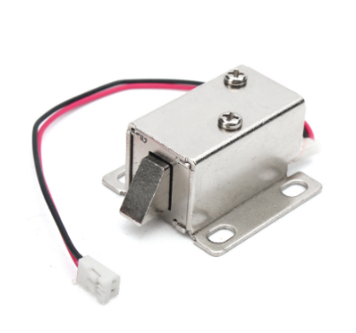For the lid to stay in place without any power, a normally open solenoid latch will be used. This latch will serve as a lock for the lid. Since the servo motor cannot hold a load without drawing power, we will use the latch to conserve energy. While the latch is locked, the servo motor is not required to hold the lid anymore as the latch will be stopping the lid from opening. In this manner, we can save power by turning off the servo motor and let the latch hold the lid and objects on top of the lid all without drawing power. The solenoid latch will have an input voltage of 9 to 12 volts. Since our battery is only capable of delivering 9 volts, we will power the latch with 9 volts instead. The solenoid latch can be seen in Figure 3-15.

Figure 3‑15: Solenoid Latch

## Software Development

The software design of the MR BIN is also divided into three parts: the (1) RFID scanning module, (2) PET bottle processor module, and the (3) Storing module. The three modules will work together to form an interconnected system in which each phase must be completed before proceeding to the next. In such manner, this would follow the waterfall software development model. Figure 3-16 shows the basic operation of MR BIN.

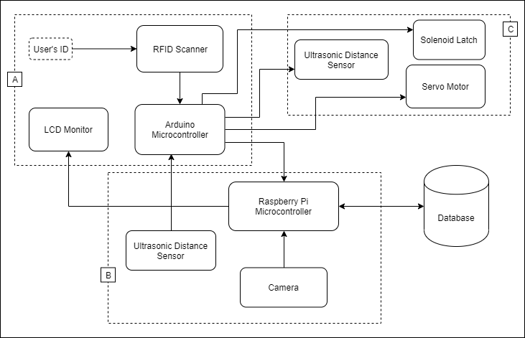

Figure 3‑16: Operation of MR BIN

Group A will be used in programming the RFID scanning module. Group B will be programmed for the PET bottle processor module, and Group C will be used for the Storing module. The controllers to be used in the device will be a Raspberry Pi 3 Model B+ microcontroller and an Arduino Uno microcontroller. The Raspberry PI will mainly be used for the processing and calculation of data collected from the sensor and to connect to the database by using its inbuilt ethernet port and the Arduino will be used for other sensors and motors to be used in our device. Group A and Group C can be simply implemented with minimal software development. Group B, which is the PET bottle processor module, is the main module of this device. The operation of the PET bottle processor module will be elaborated later.

### RFID Scanning Module

The RFID Scanning Module will consist of an RFID Scanner to scan the ID, the microcontroller for the database and authentication. The output of the RFID Scanning Module will be a current flow for the sensors and the opening of the trash bin for the user to deposit the object. The software can be implemented in a simple manner. An Arduino UNO microcontroller is suitable for the purpose of this module. A user with an RFID will scan his/her ID to the RFID scanner. This provides us with a 64-bit read-only unique ID that the microcontroller can store in the database. The purpose of storing the user’s ID is for incentive rewarding, given that the user successfully transacts using the device. After the user has scanned his/her ID successfully, the Arduino UNO will send out a signal to a relay which will give power to the other components of the device. The LCD will then display a message instructing the user to insert a PET bottle inside the enclosure. Failure to deposit an object inside the enclosure upon a given time will cancel the operation. If the operation is cancelled, the device will now listen for new ID to be scanned. Listing 3-1 shows the pseudo code that will explain the process of the RFID Scanning Module.

Listing 3‑1: RFID Scanning Module Pseudocode

START:

LOOP WHILE no ID being scanned:

Wait for USER to scan ID

IF ID is scanned:

CONNECT to SQL Database

MATCH scanned UID to existing entries from DATABASE

IF UID has no match:

Save new UID to the database

IF UID matches as REG_USER:

Display current incentive points

Turn on power for sensors

Display “Please insert PET bottle into the device.”

IF NO PET BOTTLE IS DETECTED BY SENSORS FOR x SECONDS:

GOTO START

binFull():

IF ID is scanned:

IF UID matches as AUTH_USER:

ELECTRONIC LATCH UNLOCK

OPEN trash lid

END LOOP

### PET Bottle Processor Module

This section explains the function of the PET Bottle Processor Module and its submodules. The PET Bottle Processor Module comprises of sensors and the data from those sensors will be fed to the microcontroller unit with software capable of detecting the object’s material and its properties; namely the height, diameter and volume. To get these properties, a camera will be the means of acquiring data from the object and an image processing software library called OpenCV which is an open source computer image processing library will be used to process these data. The programming language to be used to utilize the functions of OpenCV is Python programming language running inside a Raspberry Pi 3 Model B+.

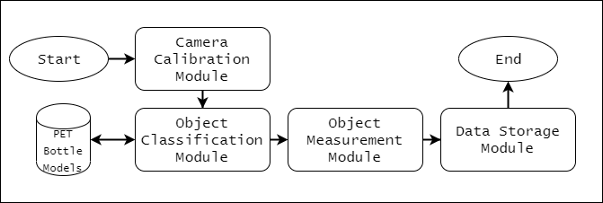

Figure 3‑17: PET Bottle Processor Module Software Diagram

Figure 3-17 shows the software diagram of the PET bottle processor module. The operation starts at the camera calibration module which will calibrate itself given its intrinsic properties and set up the field of view of the camera to accurately determine the pixel per metric, which is our unit of measurement used in images. After successfully calibrating the camera, the device will then classify the object deposited, whether it is a PET bottle or another object by comparing the object with our PET bottle models. If the device successfully classified the object as PET bottle, the device will then start measuring the physical dimensions of the PET bottle, namely the height and the diameter, to get the approximate volume of the PET bottle. The equation used to get the volume of the PET bottle is the circular cylinder volume equation as it only requires the radius and the height of an object. When all the other modules are done, it will proceed to the storing module which is a simple module that stores all the acquired data from the previous module to a database.

All these modules require a camera and the microcontroller capable of utilizing the OpenCV library. Detailed explanation of each module will be discussed onwards. Ultimately, the output of this module will be whether the object is a PET bottle or not, and the normalized value of the volume in liters. Listing 3-2 shows the pseudo code that will explain the process of the PET Bottle Processor Module.

Listing 3‑2: PET Bottle Processor Module Pseudocode

IF OBJECT IN PROXIMITY:

Camera ON

CAPTURE image of the object

COMPARE captured image with existing PET bottle models

IF object IS a PET BOTTLE:

PREPROCESS the image of the PET bottle

DETECT edges of the PET bottle

ENCAPSULATE the PET bottle within a rectangle given 4 approximate points from detected edges

CALCULATE the Euclidean distance of the drawn rectangle to get the HEIGHT and DIAMETER of the PET bottle

CALCULATE the VOLUME of the PET bottle using the circular cylinder equation

SAVE Volume Measurement AS *pbVolume*

NORMALIZE analog *pbVolume* to a digital value

CALCULATE *incentivePoints* using *pbVolume*

SAVE *incentivePoints* to DATABASE

SLEEP until RESET

IF object IS NOT a PET BOTTLE:

DISPLAY to LCD: “OBJECT IS NOT A PET BOTTLE, RETREIVE OBJECT”

#### Image Processing

Image processing is the use of computer algorithms applied to the captured image of an object which will filter out unnecessary factors from image and gather data. Specifically, we use image processing to measure the physical dimensions of the captured image of an object. Unlike human eyes, computers see images as series of matrices with different corresponding values; they see colors as three different channels of a two-dimensional matrix. In order to work with images, an image processing software must be used that is equipped with the ability to work with arrays. Throughout the PET bottle detection module, an open source image processing software called OpenCV will be used and all references and functions pertaining to image processing will be from the image processing software aforementioned.

#### Camera Calibration Module

This module calibrates the camera based on its intrinsic parameters. Cameras only capture light reflections and arranges them in matrices according to the magnitude of reflection in either the blue, red, or green spectrum. Computers do not see images similarly as how humans perceive images, instead computers look at these images as a three-dimensional matrix that contains the pixel values. Since computers can’t really ‘see’ images, they can’t measure objects just as humans do.

In order to accurately measure objects using a camera, we must first calibrate it to correct for lens distortion, noise reduction and to measure the size of an object in world units. Since images are not in terms of metric scale, we must first devise our own unit of measurement called pixel per metric. It is a scale that converts pixels distance to metric distance. For us to get the pixel per metric, we need to have a reference object and must have the following parameters: the actual dimensions of the reference object and the distance of the camera from the object. We can get the pixel per metric value using the equation, , where Actual Distance is the true distance of the object and the computer distance is the measured distance using image processing. The pixel per metric value will be used in the Object Measurement Module.

#### Object Classification Module

This module uses the camera and image processing to classify whether the sensing object is a PET bottle or not. A dataset of actual PET bottle models will be used as a reference for successful distinguishing. The camera captures an image of the deposited object and compares it to several actual PET bottle models. This is done by comparing certain features of the PET bottle, such as transparency, shape of the object, and colors with the existing dataset. Once the object is successfully classified as a PET bottle, the captured image of the object will then be stored inside the PET bottle models to improve accuracy.

This is done through the utilization of image processing with deep learning. Deep learning is a class of machine learning algorithms that is capable of unsupervised learning from data that is unknown or newly introduced. (Hargrave, 2019)

#### Object Measurement Module

This module also uses the camera and image processing to determine the volume of the PET bottle. In order to have an accurate measurement of the physical dimensions of the PET bottle, the camera must first be calibrated to get the pixel per metric value. This process is already done in the Camera Calibration Module and given that the calibration is successful, we now have our pixel per metric coefficient that we can use to measure the dimensions. Before any measurement will take place, the device’s software must first preprocess the PET bottle. Preprocessing is done to get rid of unwanted details and only get what is necessary for our goal. Open CV will be utilized throughout this module.

First, we must load the PET bottle’s image to the processor and convert from BGR colored image to grayscale image. We will also use Gaussian Blur with a specified kernel and magnitude to smoothen the image and eliminate noise. We then find the edges of the PET bottle using Canny edge detection along with eroding and dilating the image, which are all image processing algorithm techniques. We can now find the contours of the PET bottle, or the region of interest. In this module, we are interested in finding the diameter and height of the PET bottle so we can just find the external contours to which we can encapsulate with a rectangle. Given the contour mask, we can find four points encapsulating the contour with the minimum rectangle area function. We can now draw the rectangle that encapsulate the PET bottle and can measure the Euclidean distance of the length and width of the rectangle or height and diameter respectively of the PET bottle. Now that we defined our pixel per metric, we can calculate the dimensions in metric unit by dividing the Euclidean distances from the computer by our pixel per metric coefficient.

After getting the height and diameter of the PET bottle, we can calculate the volume using the right cylinder volume equation: . After the volume of the PET bottle has been successfully calculated, the microcontroller then computes the incentive points to be given to the user who deposited the PET bottle and stores it in the database.

#### Data Normalization

Normalization is used for the purpose of adjusting values measured on different scales to an acceptable common scale. The purpose of normalization is to map the acquired data, namely the height value, diameter value and volume value, into a scale that is suitable for calculation of the incentives. Since the sensors will give a reading of analog values, we need to digitize it within the microcontroller to a certain value using normalization. By mapping the height, diameter and volume value, it will then be used in the incentive calculation module for actual calculation.

### Storing Module

The storing module is the final process to be accomplished by the device. After the scanning process is completed and the PET bottle is ready for storage, the Storing Module comes into play. The microcontroller first sends a signal that will unlock the latch and open the lid using the servo motor inside the trash bin and the PET bottle will be deposited inside the trash bin conveniently. Inside the actual trash bin, there will be sensors indicating if the bin is full. If the bin is full, the device will stop accepting PET bottles and it will print a warning to the display of the device and will disable the previous modules. The bin can be manually accessed by authorized personnel using their RFID. Once authorized personnel scan their ID in the RFID Scanning Module, the electronic latch locking the bin will be unlocked and the contents can be accessed. Listing 3-3 is the pseudo code of how the Storing Module works:

Listing 3‑3: PET Bottle Storage Module Pseudocode

ELECTRONIC LATCH UNLOCK

SERVO MOTOR ROTATE to open lid

DISPLAY to LCD: “PET Bottle Stored! Points: “ + *incentivePoints*

LOOP:

ACTIVATE BIN ULTRASONIC SENSOR

IF ULTRASONIC SENSOR detects OBJECT for 5 seconds:

LOCK ELECTRONIC LATCH

DENY ACCESS TO NORMAL USERS

DISPLAY: “Warning! Bin is full”

CALL RFIDScanner::binFull()

END LOOP

SERVO MOTOR ROTATE to close lid

ELECTRONIC LATCH LOCK

RESET

## Hardware and Software Integration

The hardware of this device is strongly dependent on the software. A specific software will be used for the computation, processing and calculation of necessary data for the incentives system. The Raspberry PI microcontroller will be integrated with an image processing software for the purpose of object classification, volume measurement, incentive calculation and database network interfacing. The integration between hardware and software will begin when both hardware and software modules are completed. The integration can be done by uploading the software modules into the microcontrollers used in the device.

## Test Plan

The tests that will be conducted will be according to specific objectives that MR BIN must accomplish. Table 3-1 will summarize the evaluation being conducted and its expected results.

|  |  |  |
| --- | --- | --- |
| Tests | Parameters | Expected Output |
| Microcontrollers Test | * Cables used * Power input * Speed of Transmission * Speed of Processor * Memory Capacity | The microcontrollers must successfully interface and transmit data between them. The microcontrollers must also handle the tasks continuously. |
| RFID Scanning Test | * Type of RFID * Distance of ID from scanner * Frequency of RFID transmitter | Must be able to successfully scan and authorize user ID. After authorization, power should be distributed to the components. |
| Camera Calibration Test | * Focal Length of the Lens * Optical Center of the Lens * Height of Camera from device * Brightness of the enclosure | Must correctly calibrate the camera’s field of view and provide the correct pixel per metric value. |
| PET Bottle Detection Test | * Size of object * Transparency of the object * Shape of object * Distance of sensor from the object * Field of view of the sensor * Material of the object | Must be able to correctly detect whether the object detected is a PET bottle or not. |
| PET Bottle Height Measurement Test | * Area of the enclosure * Distance of the sensor relative to the base of the enclosure * Field of View of the sensor * Position of the PET bottle * Light intensity inside the enclosure | This test will measure the PET bottle’s approximate distance from the base to the top of the lid of the bottle relative to the sensor’s location. For this test, different bottles with different heights shall be used. |
| PET Bottle Diameter Measurement Test | * Area of the enclosure * Distance of the sensor relative to the base of the enclosure * Field of View of the sensor * Position of the PET bottle * Light intensity inside the enclosure | The sensor will measure the PET bottle’s approximate distance across its sides relative to the sensor’s location. For this test, different bottles with different diameters shall be used. |
| PET Bottle Volume Calculation Test | * Output of the Height Measurement * Output of the Diameter Measurement | The microcontroller must be able to provide an approximate volume value for the PET bottle inside the enclosure. |
| PET Bottle Storage Test | * Torque of Servo Motor * Size of PET bottle | Must be able to properly store the PET bottle into the trash bin. |
| Bin Storage Monitor Test | * Amount of PET bottle stored in the container * Inclination of the ground | If bin is full, device must display a message that the storage is full |
| Incentive Calculation Test | * Bottle volume value * Bottle height value * Bottle diameter value | Calculates the correct total incentive to be given to the user based on the acquired data. |
| Database Storing Test | * Connectivity * Speed of transmission | Successfully stores the data to the database |

Table 3‑1: Summary Table of Test Plan

### Microcontrollers Test

This test will evaluate if the microcontrollers used in the device can successfully run its given tasks without failure and with the most efficiency. One of the main microcontrollers that the device will be using is the Raspberry Pi 3 Model B+ microcontroller which will handle the heaviest task to achieve our goal. The Raspberry Pi 3 Model B+ microcontroller is the one responsible for processing the images fed by the camera and for this, it requires sufficient memory and processing speed.

The other microcontroller that we will be using is the Arduino UNO microcontroller. The Arduino will handle the switching of components and controlling the other sensors. The Arduino does not need a large amount of memory and processing speed, so it is suitable for simple tasks such as controlling servo motors, solenoid latch, RFID reader, ultrasonic distance sensors and sending signals to relays to pass power to other components. Both microcontrollers will interface with each other via the Universal Serial Bus connection to pass data between them. For example, when the Arduino gets the UID of a user’s RFID, it will send this data to the Raspberry Pi through the Serial interface for the Raspberry Pi to store the data to the database connected to its ethernet port.

### RFID Scanning Test

As the starting point of the system, the RFID scanner will be tested and evaluated based on its performance given the parameters in Table 3.3. Different kinds of RFID scanners will be tested to see whether it meets our expected outcome. For the RFID scanner, we will be looking on the speed of the scan, the maximum distance it can detect the transmitter, and the frequency range of RFID it can detect.

The speed of the scan is not really a big factor affecting the system. Basically, the RFID scanner must be able to scan the ID within a second after the user places his or her ID near the scanner. This test ensures that the user will not struggle to scan his or her ID.

The test will also determine the maximum distance that the RFID scanner can detect the RFID chip. The scannable distance is for convenience of the user; they can scan their ID without getting too close to the scanner.

The frequency of the RFID scanner must support the frequency used in the RFID chip of the ID. This test will assure that the scanner will work for our intended scope.

### Camera Calibration Test

In order to achieve accuracy and precision in processing the image, we must first calibrate the camera to be used in this study. The first step is to determine the properties of the camera, which would be its focal length and the optical center of the lens. By getting these properties, we can adjust the camera to make it suitable for processing images. We can also determine our pixel per metric by calibrating the camera, which will increase the accuracy of our measurement.

This test will determine if the camera can handle image processing tasks and if its specifications are suitable for our study. If we do not test the camera, then all the other modules cannot function correctly or as desired.

### PET Bottle Detection Test

The accuracy of the PET bottle detection is a significant factor in our device. The sensor must be able to distinguish PET bottle among other objects. This will be a crucial test for our study as it is the main framework of our system. The PET bottle detection sensor will be tested for its accuracy and speed of detection. As objects come in different shapes and sizes, it must work as intended regardless of the parameters of the sensing object. The expected outcome of the sensor is to tell whether the object deposited in the device is a PET bottle or not.

A series of tests will be conducted to determine if the PET bottle detector is suitable for our study. Different types of object will be placed inside the sensing area and the sensor must consistently distinguish PET bottles from other types of objects. PET bottles of different shapes, transparency, material and content will also be included in the testing of the module. This will ensure that all objects can be sensed by the module.

### PET Bottle Height Measurement Test

The height value of the PET bottle is required to calculate the volume of the PET bottle. The height is an essential factor for recycling as volume is directly proportional to the height and diameter of a cylindrical object, in this case a PET bottle. The greater the height of the bottle, the greater the volume of the bottle.

Different PET bottles with different heights will be introduced to the sensor with heights ranging up to 40cm, which is the total length of our enclosure. A mere rough approximate of the height will be acceptable as the incentive will be based on tiers and not an exact value. We will first measure the PET bottle’s height using rulers, or we can simply determine the PET bottle’s exact height by looking at its dimensions in the label. The PET bottle’s exact height will be the true value and we shall compare the true value with our measured value using the image processing software to get the percentage error and with the error, we can adjust the calculation techniques to be used.

### PET Bottle Diameter Measurement Test

The diameter value of the PET bottle is required to calculate the volume of the PET bottle. The diameter is an essential factor for recycling as volume is directly proportional to the height and diameter of a cylindrical object, in this case a PET bottle. The greater the diameter of the bottle, the greater the volume of the bottle.

Different PET bottles with different diameters will be introduced to the sensor with diameters ranging up to 40cm, which is the total width of our enclosure. A mere rough approximate of the diameter will be acceptable as the incentive will be based on tiers and not an exact value. We will first measure the PET bottle’s diameter using rulers, or we can simply determine the PET bottle’s exact diameter by looking at its dimensions in the label. The PET bottle’s exact diameter will be the true value and we shall compare the true value with our measured diameter using the image processing software to get the percentage error and with the error, we can adjust the calculation techniques to be used.

### PET Bottle Volume Calculation Test

The volume of a PET bottle tells how much it can store. This will be essential for recycling purposes and is a good recycling factor. Values gathered from the height measurement and diameter measurement will be used to calculate the approximate volume of a cylindrical object, in this case a PET bottle. Since the volume measurement is based from distance, it will be a rough approximate of the total volume, which is fine as the volume is just for the incentive generation.

Different sizes of PET bottles will be introduced to the module. We will base the volume of the PET bottle from an online database and we will compare the true volume and the measured volume to determine the percentage error we will get using ultrasonic sensors.

### PET Bottle Storage Test

This device would be worthless if it cannot store PET bottles into the trash bin. After detecting and measuring the PET bottle, the device must be able to successfully store PET bottles seamlessly into the trash bin. This test will determine if the servo motor is powerful enough to rotate the lid in order for the PET bottle to slide into the trash bin.

PET bottles with different sizes will be tested if they can all fit into the lid. With this, we can determine the limitations and the maximum size of the PET bottle that can be inserted into the device. It will evaluate if a PET bottle of a given height and diameter can successfully be deposited without jamming the device.

### Bin Storage Monitor Test

This test will evaluate the functionality and operation of this module. The module is basically a monitoring system in which it will track the capacity of the bin and will warn users if the bin is nearing full or actually full.

For this test, we will fill the bin with PET bottles of different shapes and sizes. The bin will be first filled by a quarter, then half, and so forth until such time the sensors within the module will detect the bottles nearing full and eventually the bin being full, after which it will display a message saying that the bin is full.

We will also introduce external factors such as movement of the bin or inclination of the ground. This way, we will station the device on a suitable environment, away from external factors.

### Incentive Calculation Test

Different manually inputted values of height and diameter will be used for the calculation of incentives. The volume of the PET bottle is the primary factor of the incentive to be generated. This is to ensure that the incentive calculation will correspond to the properties of the PET bottle. The incentive calculation is software-based, that is why it is flexible, and we can reprogram the algorithm for the calculation anytime if needed.

### Database Storing Test

For the database storing, we will test if the microcontroller can connect to the database server and access the tables within that database. Manual storage of rows can be tested to see if it actually stores the data to the database. Insertion of incentive points will also be tested for existing users in the table of the database.

This module will also be software-based and can be flexible for different variety of tests that will be conducted. Our primary concern is only of the microcontroller which will be used to connect to the database, and we will test different microcontrollers to determine which is suitable for our application.

REFERENCES

Delgado, E. (2019, July 17). PET Bottle Problems in San Roque. (R. C. Endozo, & J. R. Navarro, Interviewers)

Hargrave, M. (2019, April 30). *Deep Learning*. Retrieved from Investopedia: https://www.investopedia.com/terms/d/deep-learning.asp

Hopewell, J., Dvorak, R., & Kosior, E. (2009, July 27). Plastics recycling: challenges and opportunities. *Philosophical transactions of the Royal Society of London. Series B, Biological sciences, 364*(1526), 2115-2126. doi:10.1098/rstb.2008.0311

James. (2017, May 21). *How Does The German Pfand System Work, And Is It Effective?* Retrieved from https://liveworkgermany.com/2017/05/how-does-the-german-pfand-system-work-and-is-it-effective/

Lei. (2017, July 3). *Amazing German Machine Trades in Plastic Bottles for Money or Groceries*. Retrieved from https://www.elitereaders.com/amazing-german-machine-trades-plastic-bottles-money-groceries/

Vincent, S. (2012, November 1). *This segregation by colour will save us*. Retrieved January 22, 2019, from http://bengaluru.citizenmatters.in/4639-segregating-waste-is-the-key-4639

Welle, F. (2011, June 8). Twenty years of PET bottle to bottle recycling-An overview. *Resources, Conservation and Recycling, 55*(11), 865-875. Retrieved from Science Direct: https://www.sciencedirect.com/science/article/pii/S0921344911000656