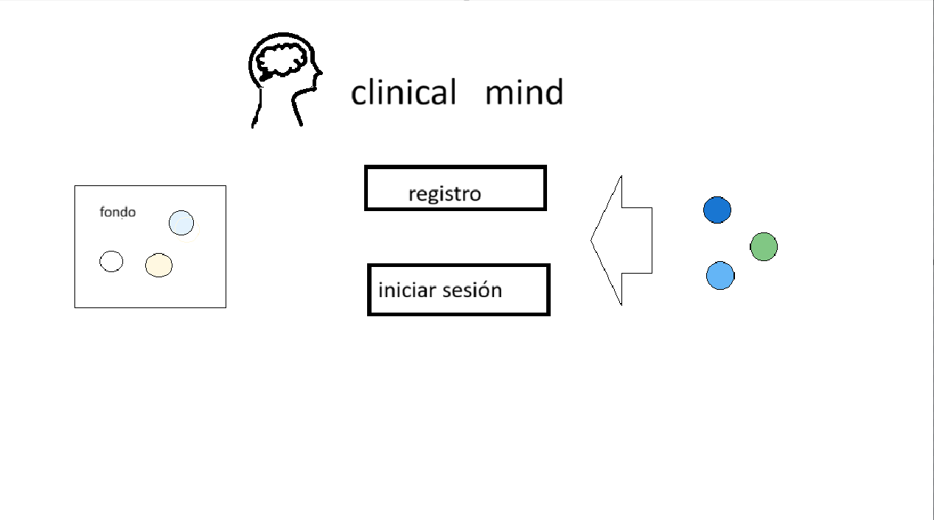
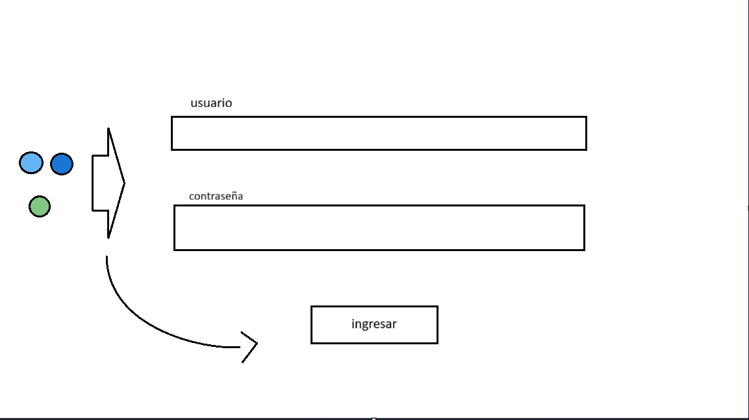
Enlace de interfaz | https://www.figma.com/design/sZwpxcl1Gv933jkKLrjupp/ClinicalMind?node-id=0-1&t=Av0j4s1HkoBPwNVD-1
