**Evaluation Only. Created with Aspose.Words. Copyright 2003-2014 Aspose Pty Ltd.**

test

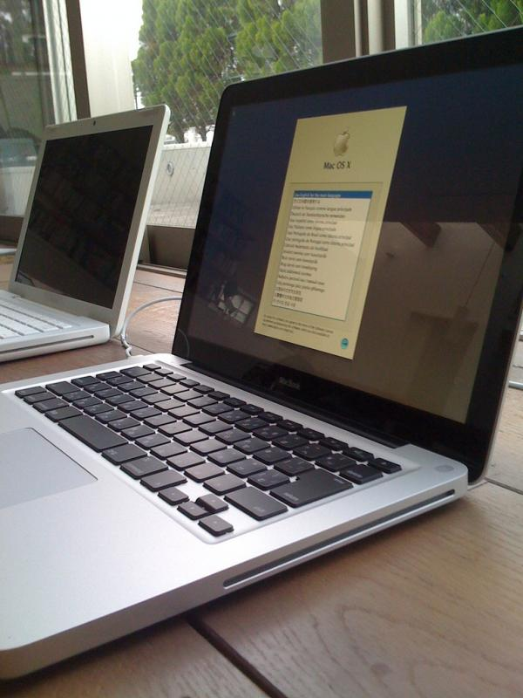

This image was 600x800. If you do a Save As on the image in the Word doc, it will be smaller because of the 92dpi conversion. The Word doc will enlarge it to be 600x800, which will create fuzziness. You can also go to format picture and see that it is scaled to 75%