IBRAHIM INDEX OF AFRICAN GOVERNANCE
COMPREHENSIVE ANALYTICAL REPORT

Analysis Period: 2014-2023

Dataset Overview
Countries Analyzed: 54
Years Covered: 2014 - 2023
Total Observations: 540
Governance Categories: 4 Main Categories, 16 Subcategories

Author: Cyprian Fusi Binati AInalytics (https://binati-ai.com)
Date: October 11, 2025
For: Mo Ibrahim Foundation

EXECUTIVE SUMMARY
This report presents a comprehensive analysis of governance performance across African nations from 2014 to 2023, based on the Ibrahim Index of African Governance (IIAG).

KEY FINDINGS

1. Overall Governance Landscape (2023)
- Continental Mean Score: 49.3/100
- Median Score: 49.0/100
- Score Range: 19.0 to 75.3
- Standard Deviation: 12.3

2. Top Performers (2023)
These top five countries demonstrate exceptional governance:
- Seychelles: 75.3
- Mauritius: 72.8
- Cabo Verde: 69.6
- South Africa: 65.9
- Botswana: 65.8

3. Significant Improvers (2014-2023)
Countries showing the greatest governance improvements:
- Seychelles: +10.0 points
- Gambia: +7.2 points
- Somalia: +6.8 points
- Sierra Leone: +6.4 points
- Angola: +5.8 points

4. Regional Patterns
- Southern Africa: 54.6
- North Africa: 53.7
- West Africa: 50.8
- East Africa: 46.5

5. Category Performance
Average scores across main governance categories:
- SECURITY & RULE OF LAW: 47.9
- PARTICIPATION, RIGHTS & INCLUSION: 48.7
- FOUNDATIONS FOR ECONOMIC OPPORTUNITY: 48.9
- HUMAN DEVELOPMENT: 51.6

METHODOLOGY: KEY AREAS OF ASSESSMENT
The IIAG assesses governance across four main categories:
- Security & Rule of Law,
- Participation, Rights & Inclusion,
- Foundations for Economic Opportunity, and
- Human Development
Each category comprises multiple subcategories, creating a comprehensive governance assessment framework.

1. GOVERNANCE DISTRIBUTION AND REGIONAL COMPARISON

Figure 1 illustrates the distribution of governance scores across all African countries in 2023.
The histogram (on the left) reveals the central tendency and spreads of governance performance, while the boxplot (on the right) compares regional variations. The continental mean of 49.3 and median of 49.0 indicate the typical governance behavior – with some countries well governed, some poorly governed and the rest fairly or averagely governed. This is a strong indication that the data was collected using a sound statistical approach and that it represents a real-world environment.
The regional data also depicts a normal environment except the Central Africa region which is skewed to the left (the lower end) by many of the countries facing acute governance challenges.

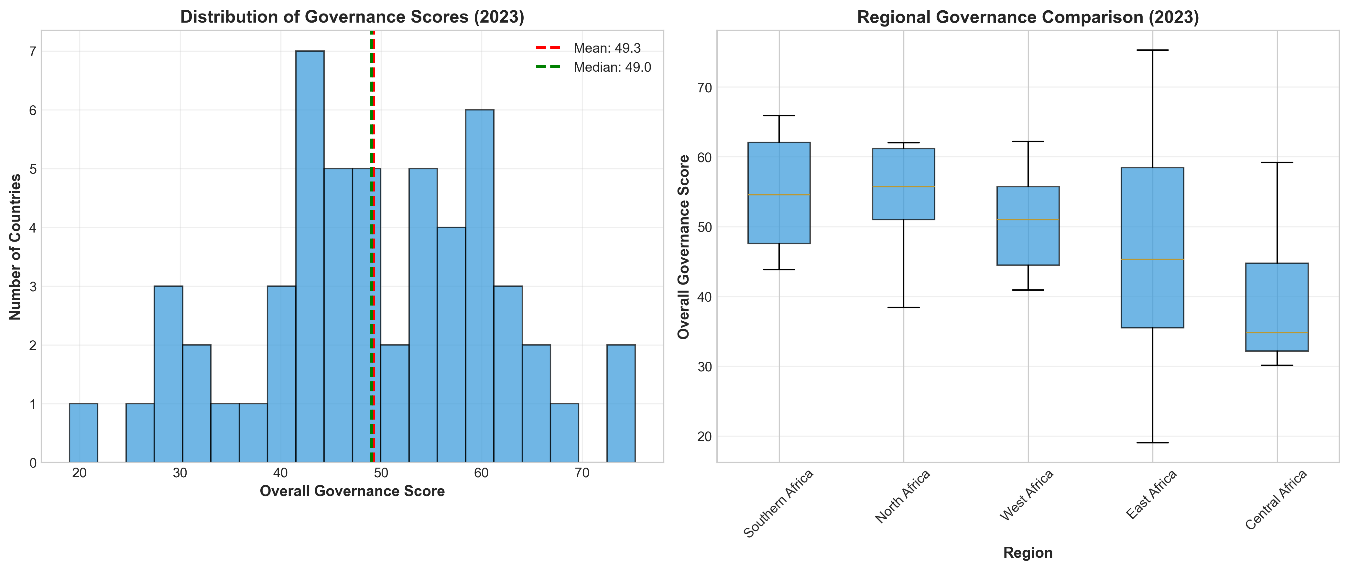
Figure 1: distribution of governance scores across all African countries in 2023

2. TOP AND BOTTOM PERFORMING COUNTRIES

Figure 2 presents the top 15 and bottom 15 countries by overall governance score in 2023. This visualization reveals the significant governance gap across the continent. The color coding highlights different performance levels:
- Green indicates strong governance (60+)
- Orange represents moderate performance (50-60), and
- Red signifies governance challenges (below 50).
Also notice that there's a middle group not shown here - the 24 countries in the middle - which represent the majority of Africa. They're making progress but have significant room for improvement.

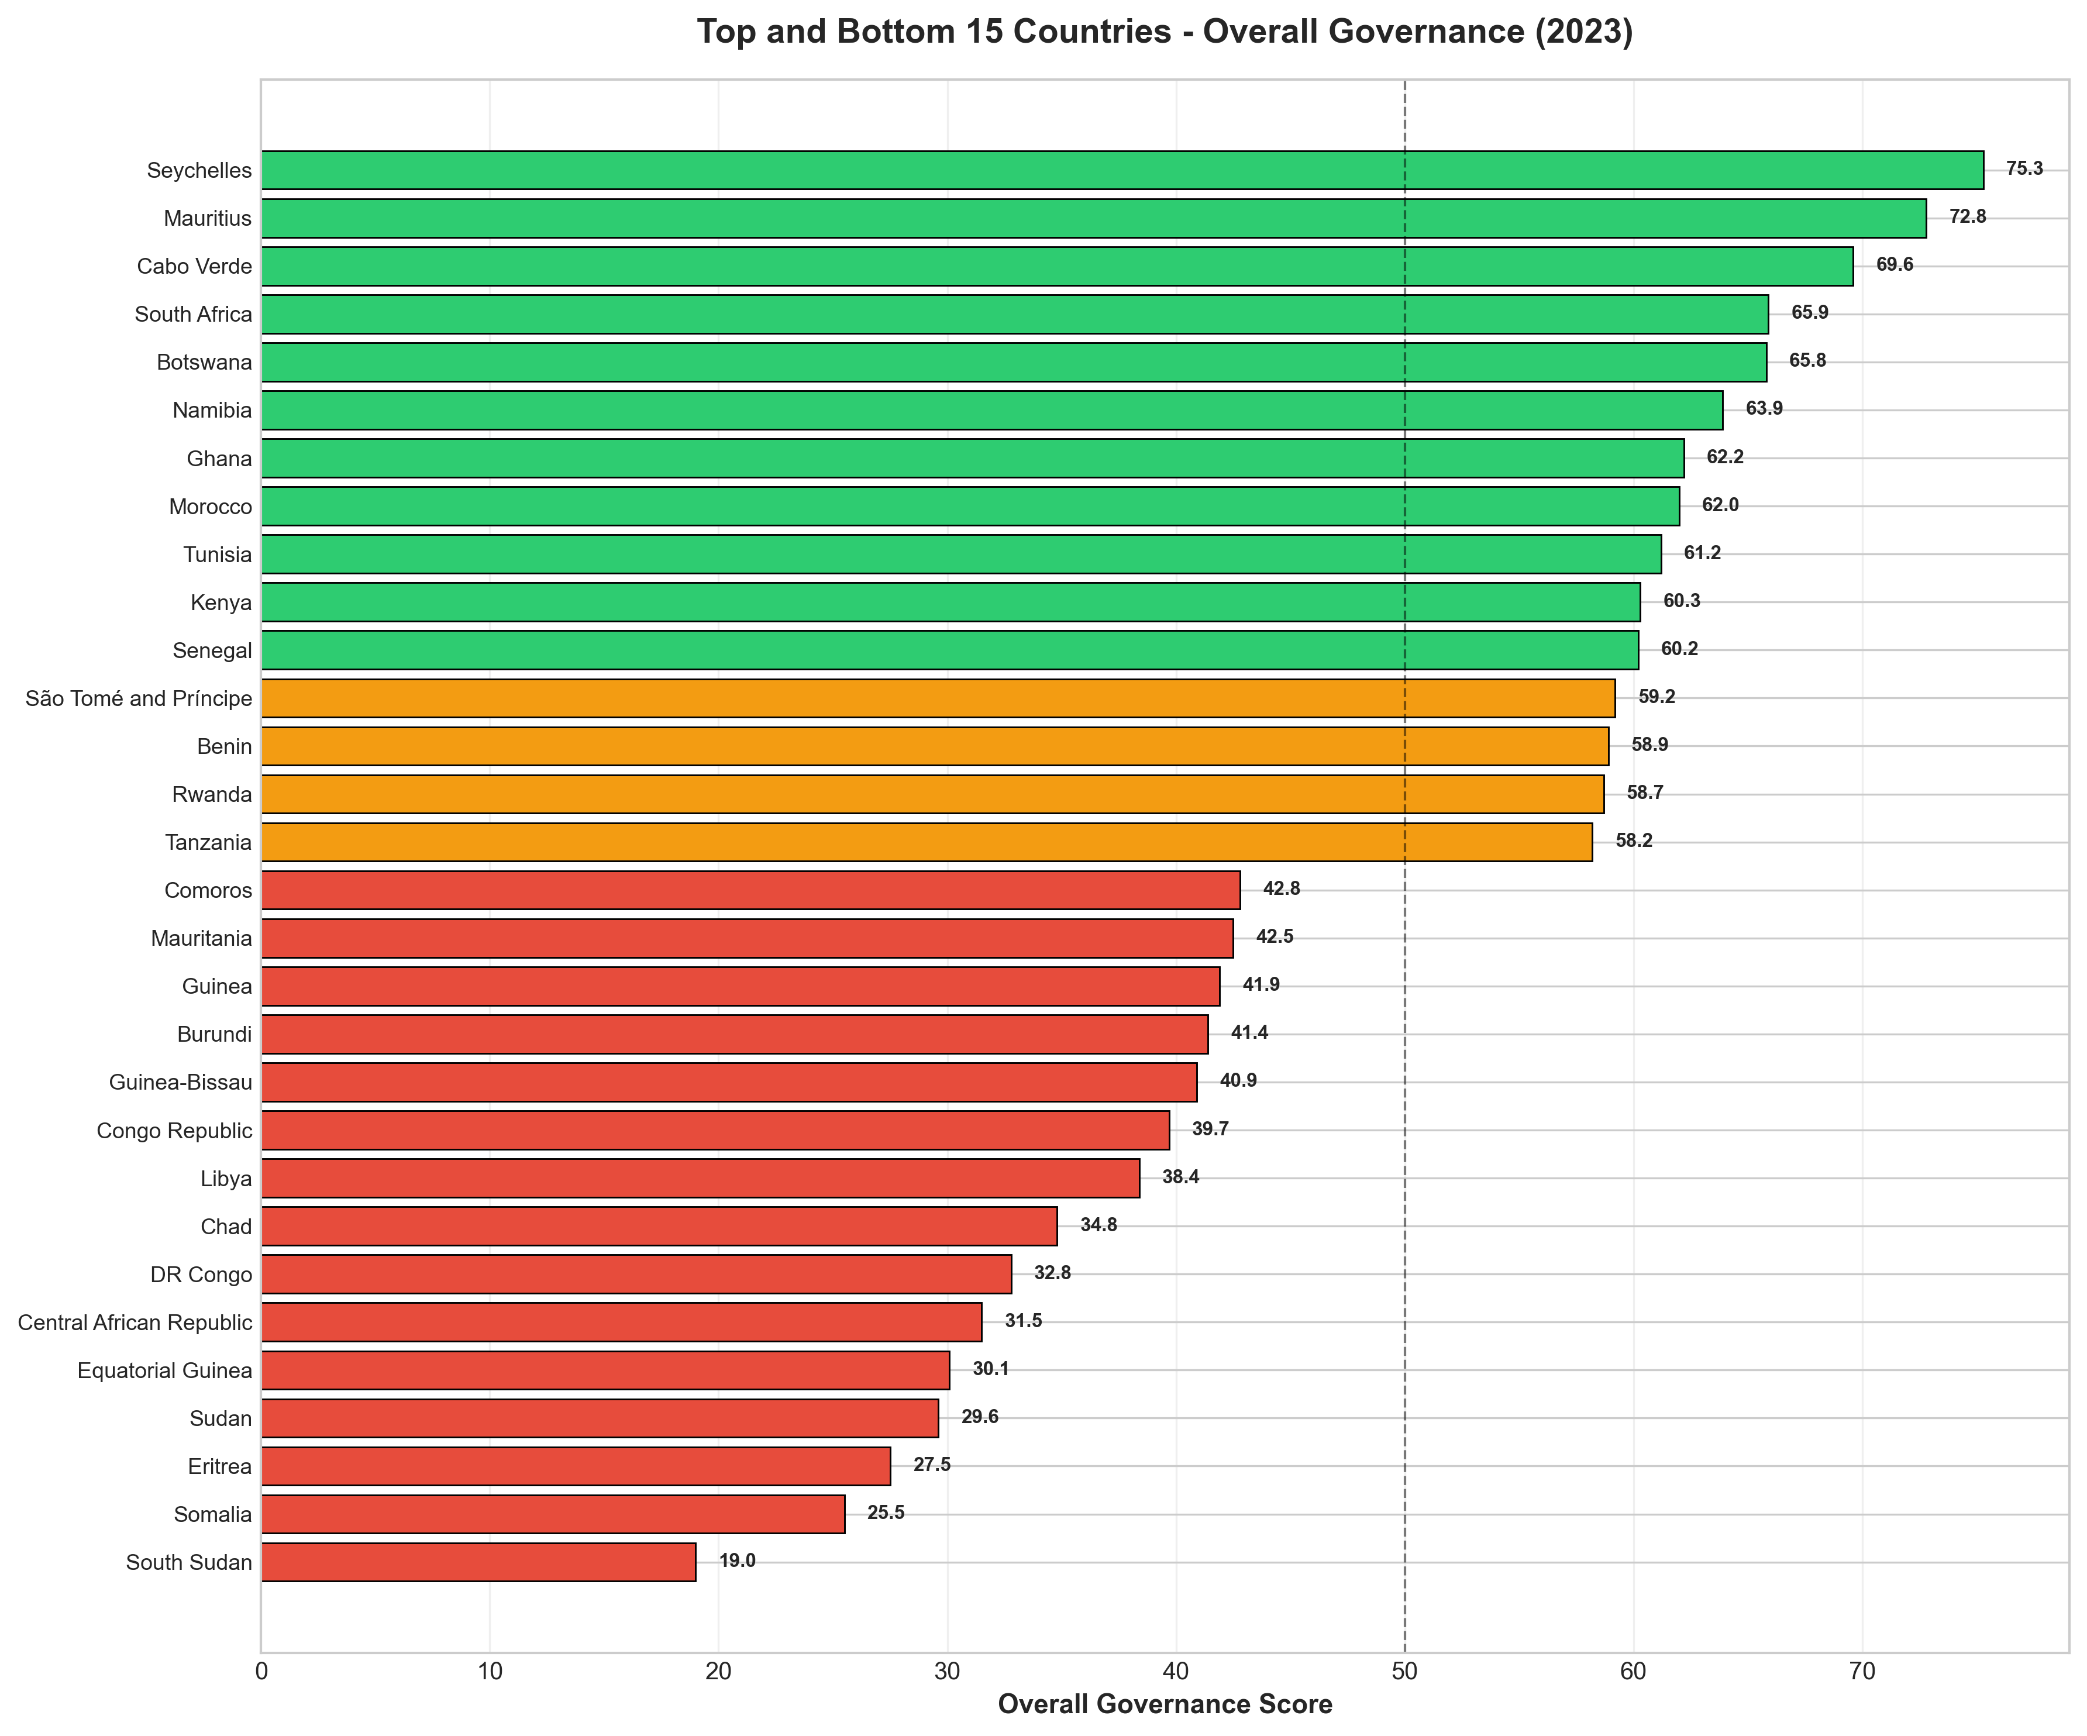
Figure 2: the top 15 and bottom 15 countries by overall governance score in 2023

3. CONTINENTAL GOVERNANCE TRENDS

Figure 3 tracks the evolution of overall governance and its four main categories from 2014 to 2023. This temporal analysis reveals long-term trends and patterns in African governance. The data shows that overall governance has been remarkably stable (stagnant) over the analysis period.
- Continental average stable (neither improving nor declining dramatically)
- Human Development showing positive trajectory. Africa is making progress in health, education, and social protection
- Security & Rule of Law more volatile with a concerning dip around 2021-2022, likely reflecting COVID impacts and democratic backsliding in some countries.
- Country-level stories more important than continental average

While Some countries have improved dramatically, others have declined. The continental averages mask significant country-level variation making the average to remain flat because these offset each other.

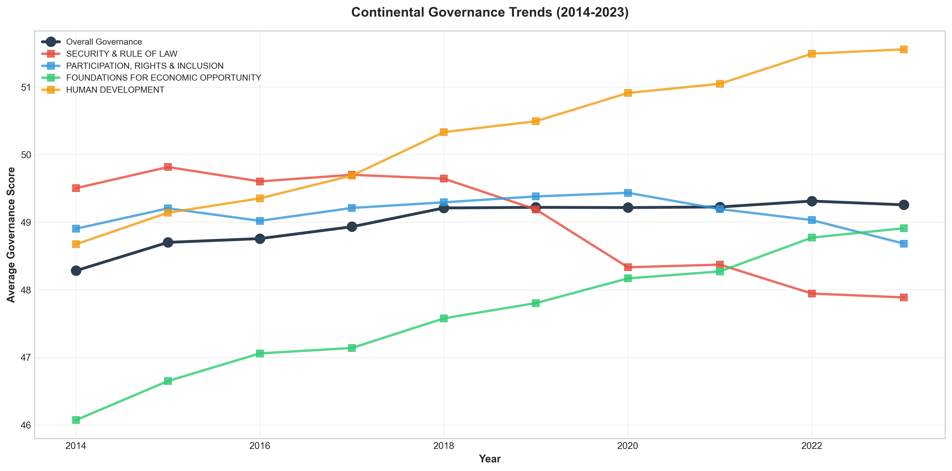
Figure 3: evolution of overall governance and its four main categories from 2014 to 2023

4. CATEGORY PERFORMANCE HEATMAP

Figure 4 displays a detailed heatmap of category performance for the top 20 countries in 2023. This visualization enables identification of governance strengths and weaknesses across different dimensions. Green cells indicate strong performance, yellow represents moderate scores, and red highlights areas requiring improvement.
- No country is full green across the board. Seychelles comes closest, but even they have yellow cells. This tells us that achieving excellence in governance requires balanced progress – a country can't excel in just one area.
- Notice some countries are strong in Human Development (right column) but weaker in Security or Economic Foundations. This suggests different reform pathways and priorities.

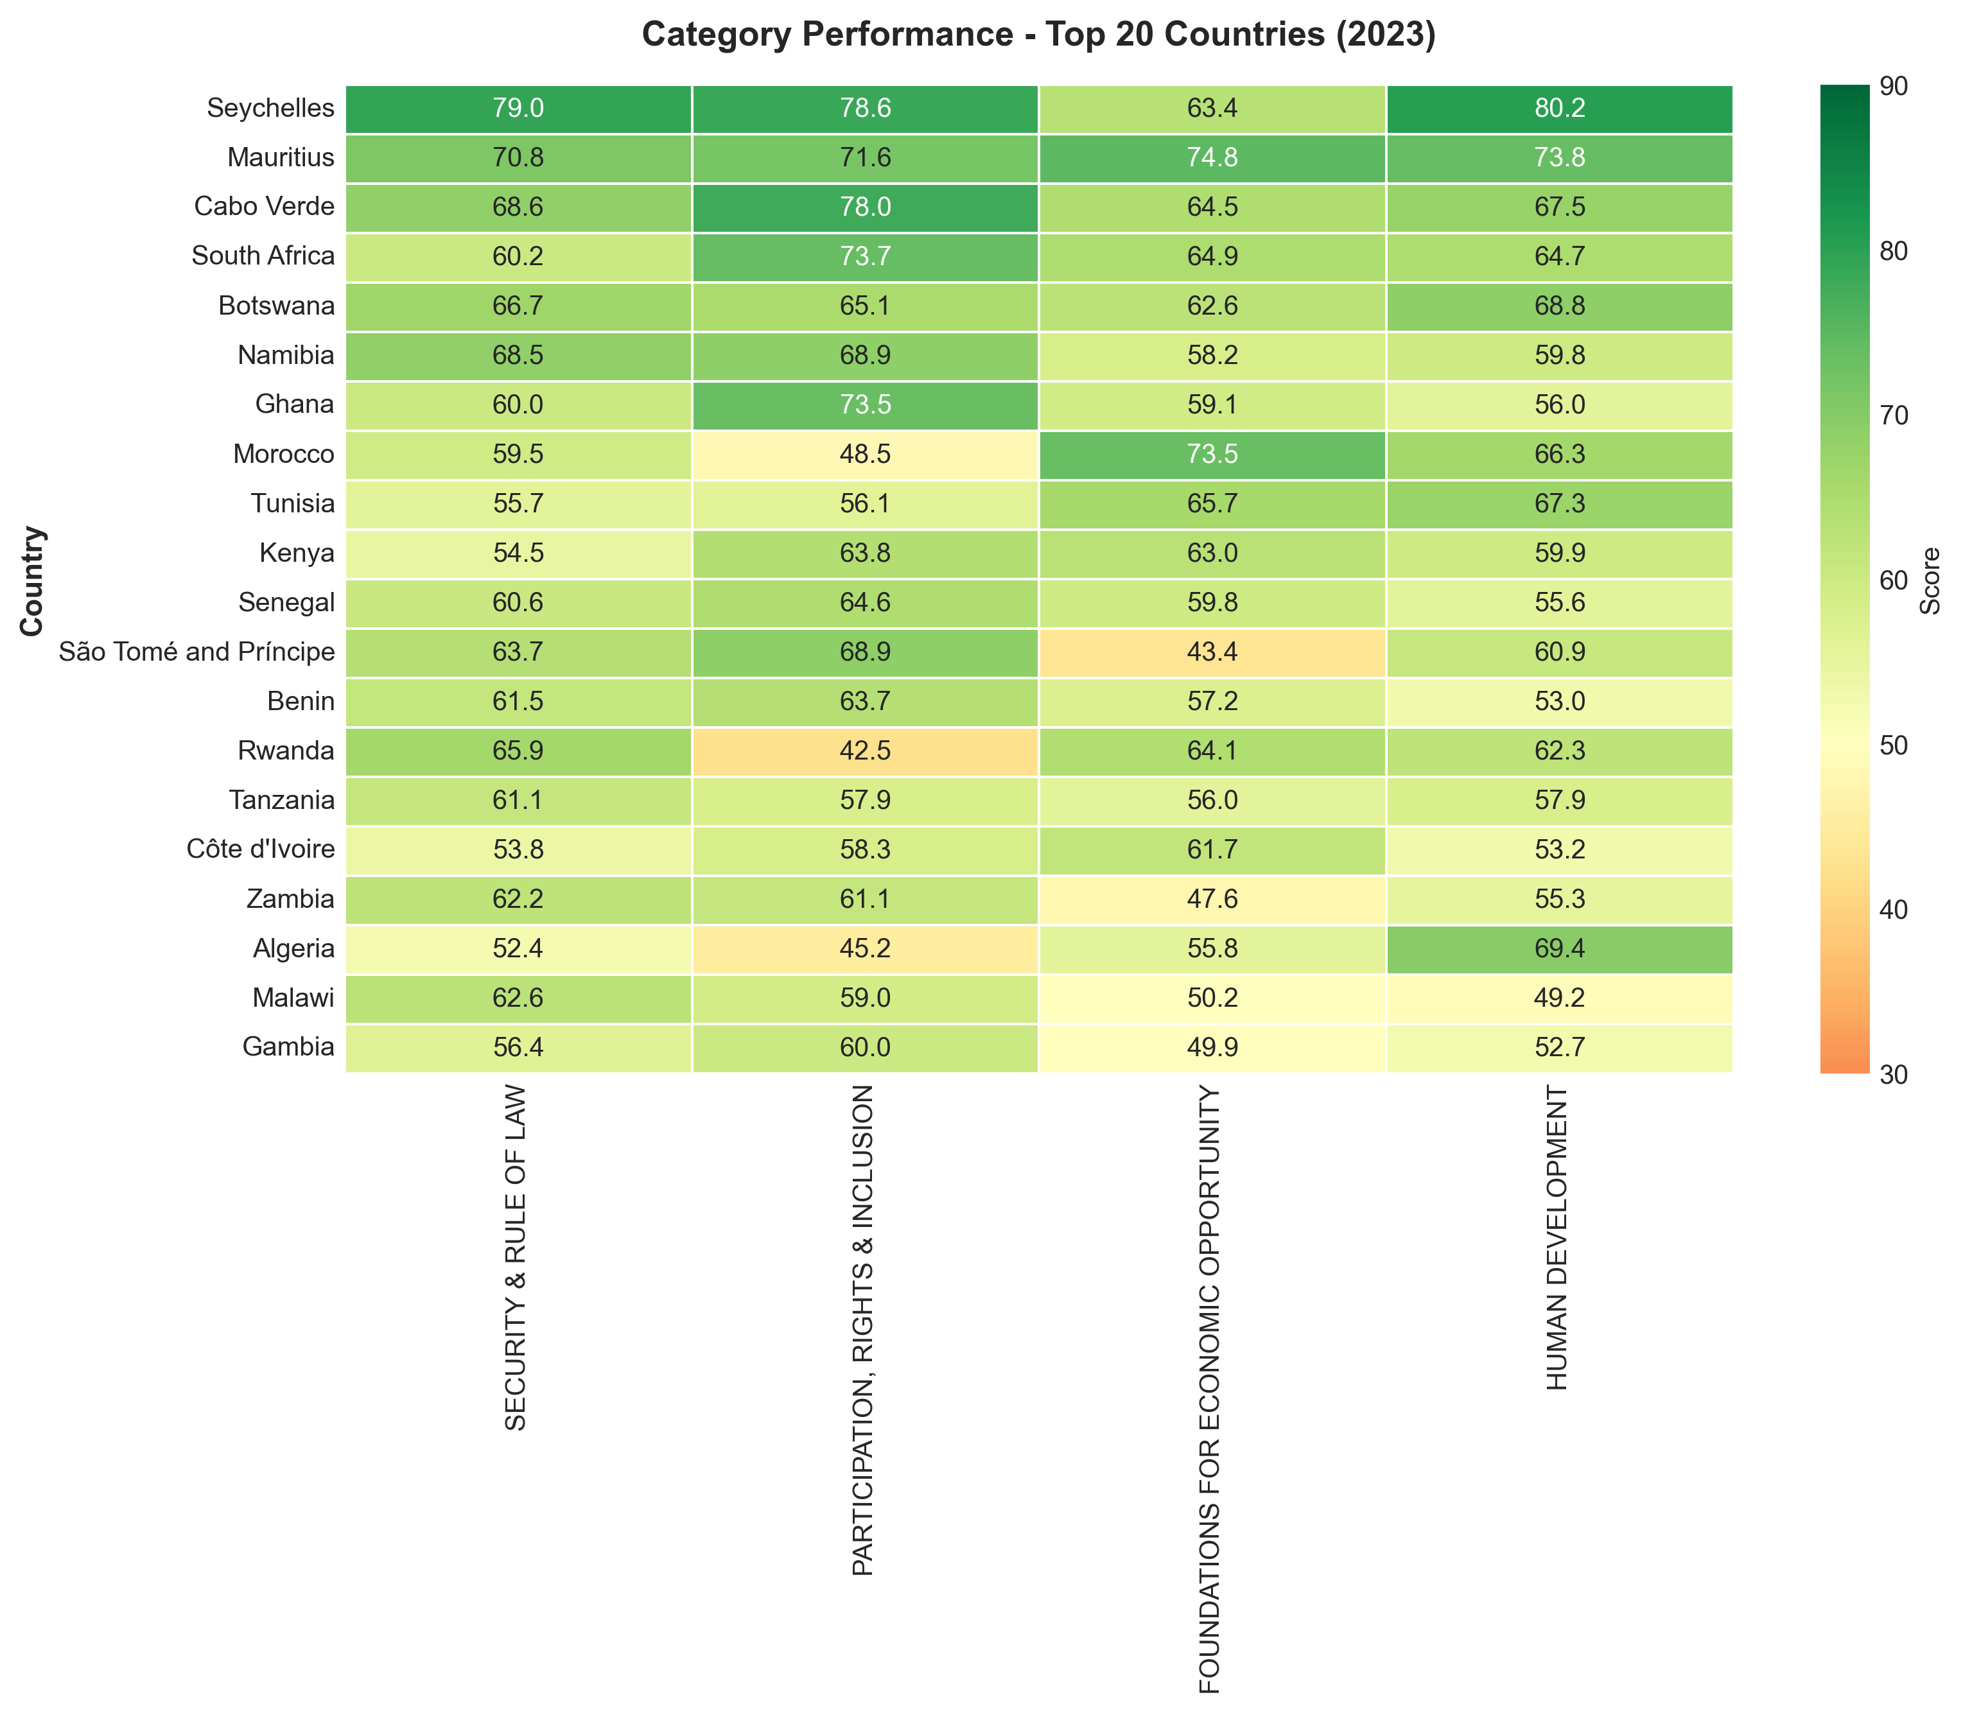
Figure 4: detailed heatmap of category performance for the top 20 countries in 2023

5. GOVERNANCE CHANGE ANALYSIS

Figure 5 presents governance changes for all countries from 2014 to 2023. Green bars indicate improvement, while red bars show decline. Of the 54 countries analyzed, 33 (61.1%) showed improvement, while 21 (38.9%) experienced decline.
These six countries have seen concerning declines: Tunisia down 4.7 points, Comoros down 4.7, Mali down 4.6, Mauritius down 4.0, Burkina Faso down 3.9, Botswana down 3.6.
- Tunisia was celebrated as the Arab Spring's only success story but a decade later, democratic gains are eroding.
- Mauritius and Botswana have been governance stars for decades, yet both are declining. There's evidence of institutional complacency in these countries after years of strong performance.
- In Tunisia and Mali, we're seeing democratic backsliding - erosion of civil liberties and consolidation of power.
- In the Sahel (Mali and Burkina Faso) security has deteriorated dramatically.

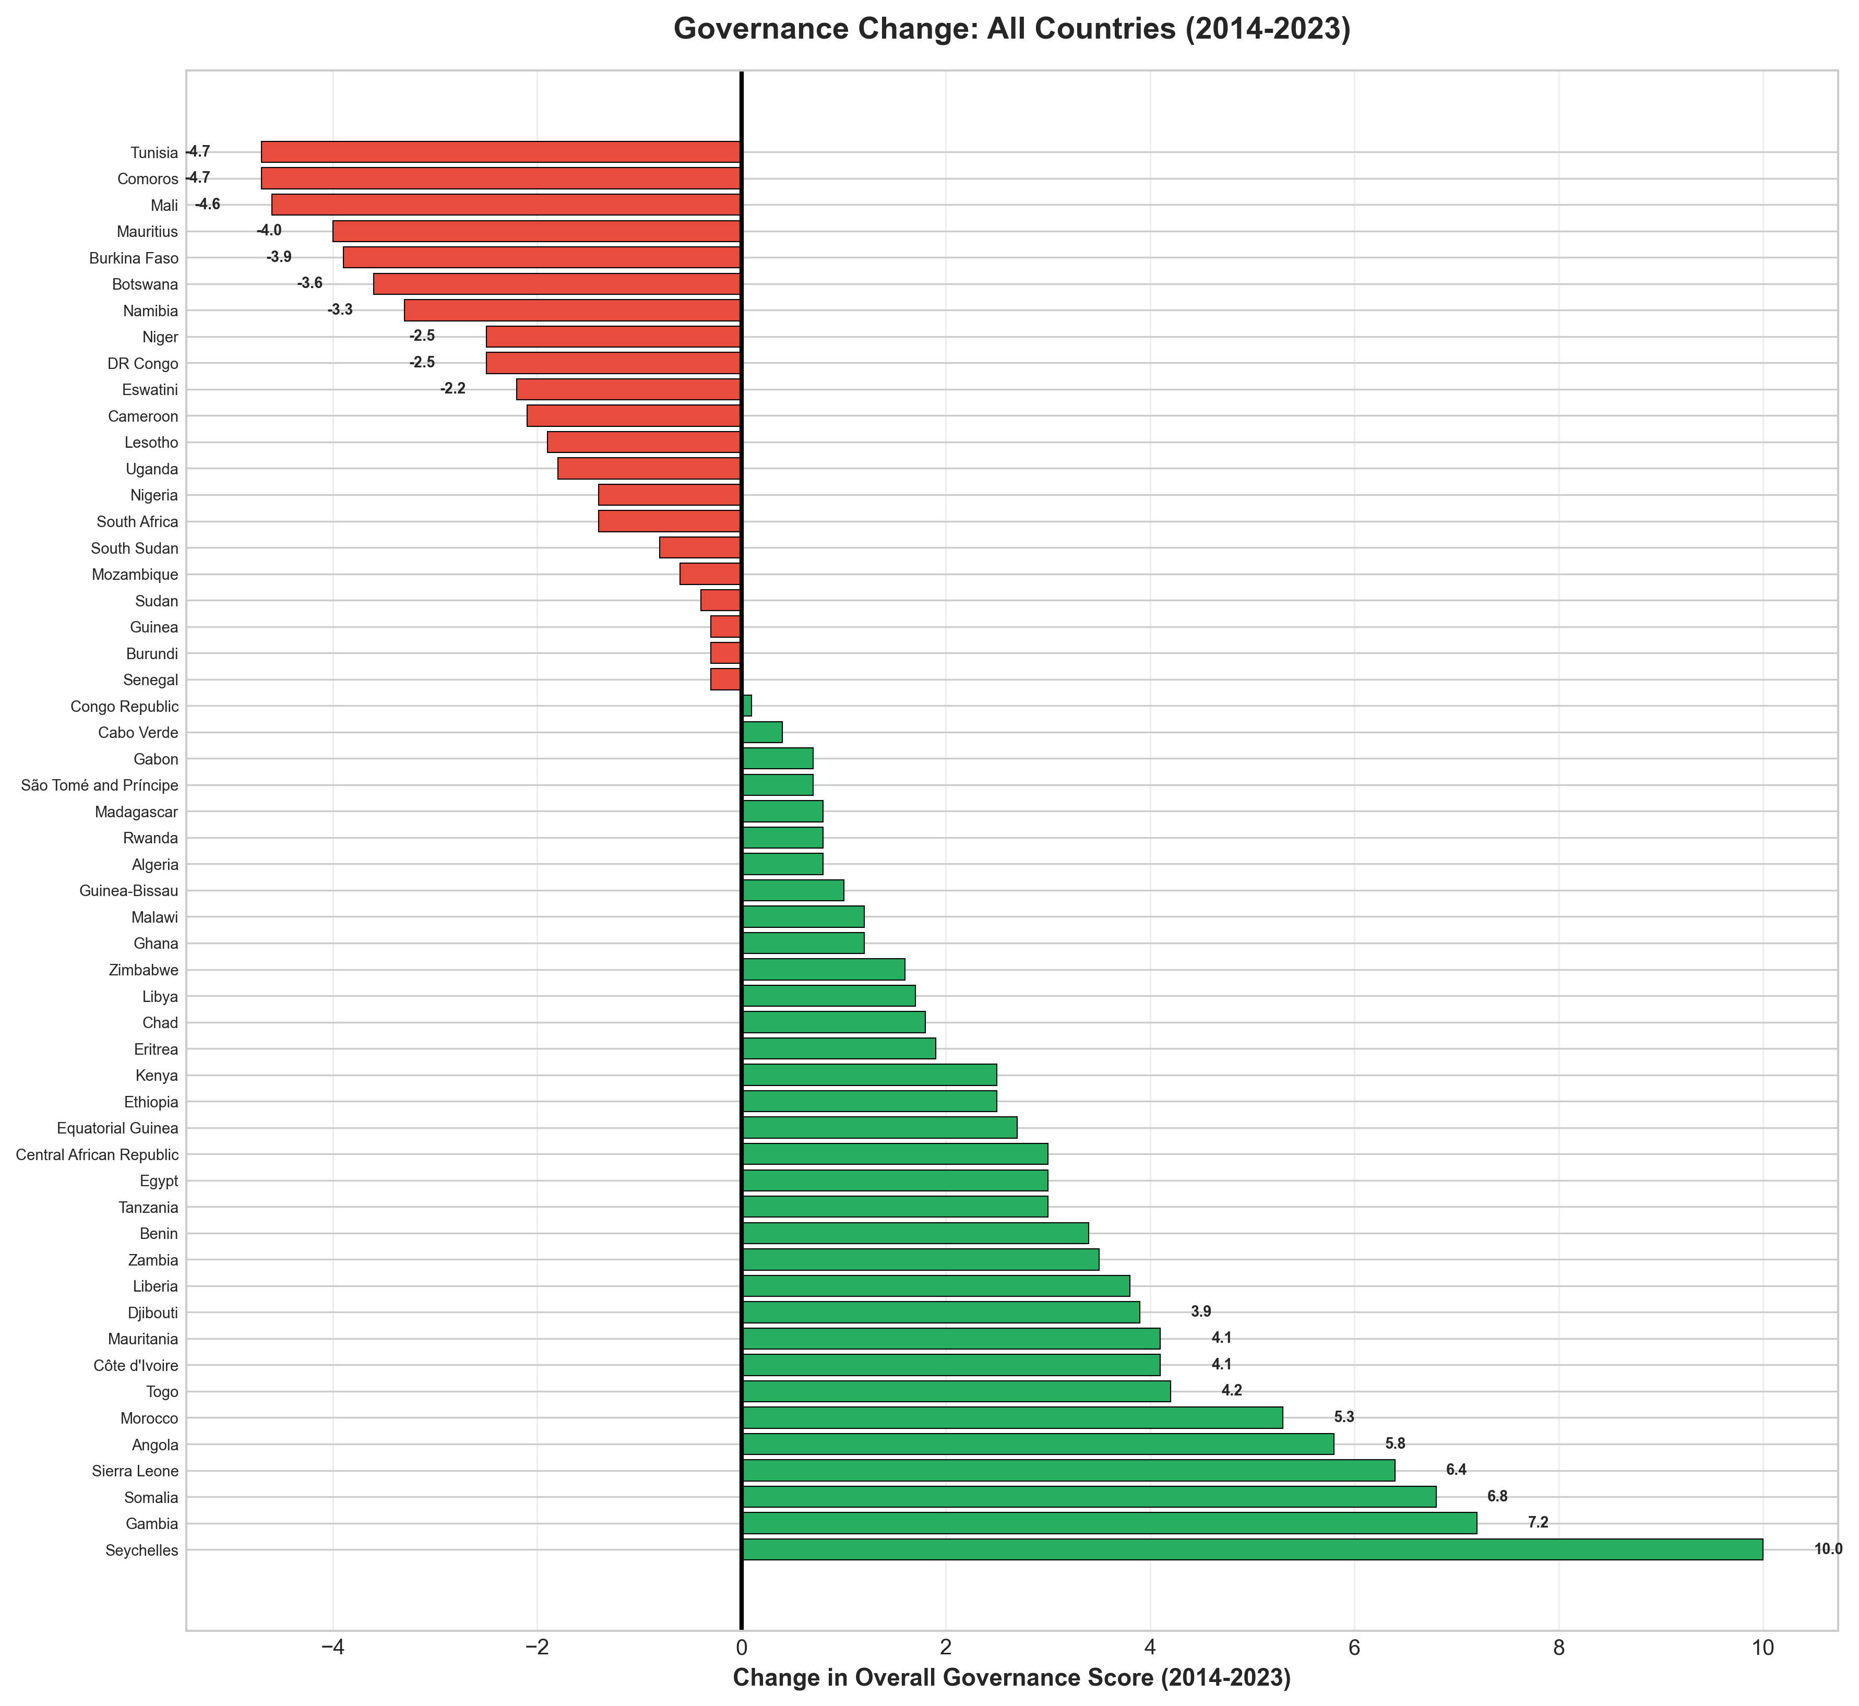
Figure 5: governance changes for all countries from 2014 to 2023

6. REGIONAL PERFORMANCE COMPARISON

Figure 6 compares regional performance across all governance categories in 2023. This clustered bar chart reveals regional patterns and highlights which regions excel in specific governance dimensions. The comparison facilitates understanding of regional strengths and areas for targeted improvement. Southern Africa leads at 54.6 average - driven by countries like Botswana, Namibia, and South Africa. This regional success can be explained by three factors:
- The SADC - Southern African Development Community - has promoted regional integration and democratic norms. Regional institutions matter.
- This region benefited from negotiated transitions from colonialism and apartheid that, while imperfect, built stronger institutions than elsewhere.
- There's been relative peace - conflicts have been less frequent and less severe.
At the other extreme, Central Africa averages just 39.7 - a full 15 points lower. This region has been plagued by persistent conflicts, resource curse dynamics especially around oil and minerals, and some of Africa's most entrenched autocracies.
East Africa is fascinating because it shows the highest variation - it includes both Seychelles at 75.3 and South Sudan at 19.0. This tells us region isn't destiny - individual country circumstances matter enormously.
It can be concluded that regional cooperation and integration correlate with better governance. Regions that work together govern better.

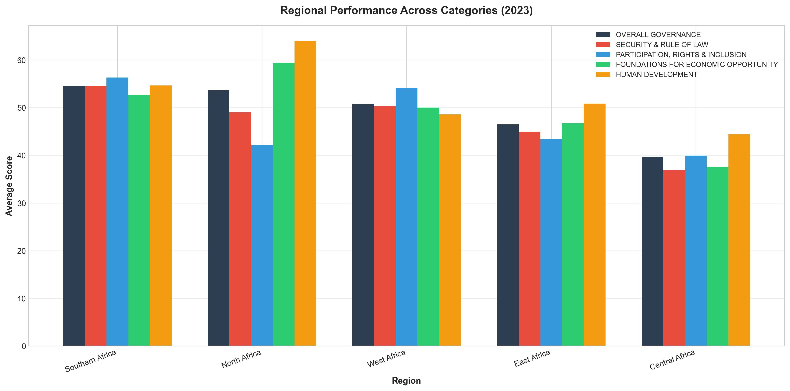
Figure 6: regional performance across all governance categories in 2023

7. CATEGORY CORRELATION ANALYSIS

Figure 7 presents scatter plots examining the relationship between each main category and overall governance scores in 2023. The correlation coefficients (shown in each title) range from 0.88 to 0.94. They quantify the strength of these relationships, while trend lines visualize the associations. These correlations indicate which governance dimensions most strongly influence overall performance. Overall, we see very strong correlations (0.88 - 0.94) across all categories. This suggests an interconnected system – no category can improve governance in isolation. An integrated reform approach encompassing all categories is necessary. Security & Rule of Law may be foundational for good governance. This means it's hard to achieve good governance in other areas if a country does not have basic security and rule of law. The policy implication is therefore clear – a country needs integrated reform efforts. You can't fix corruption without also improving judicial systems. You can't improve business environment without also investing in infrastructure. It's all connected.

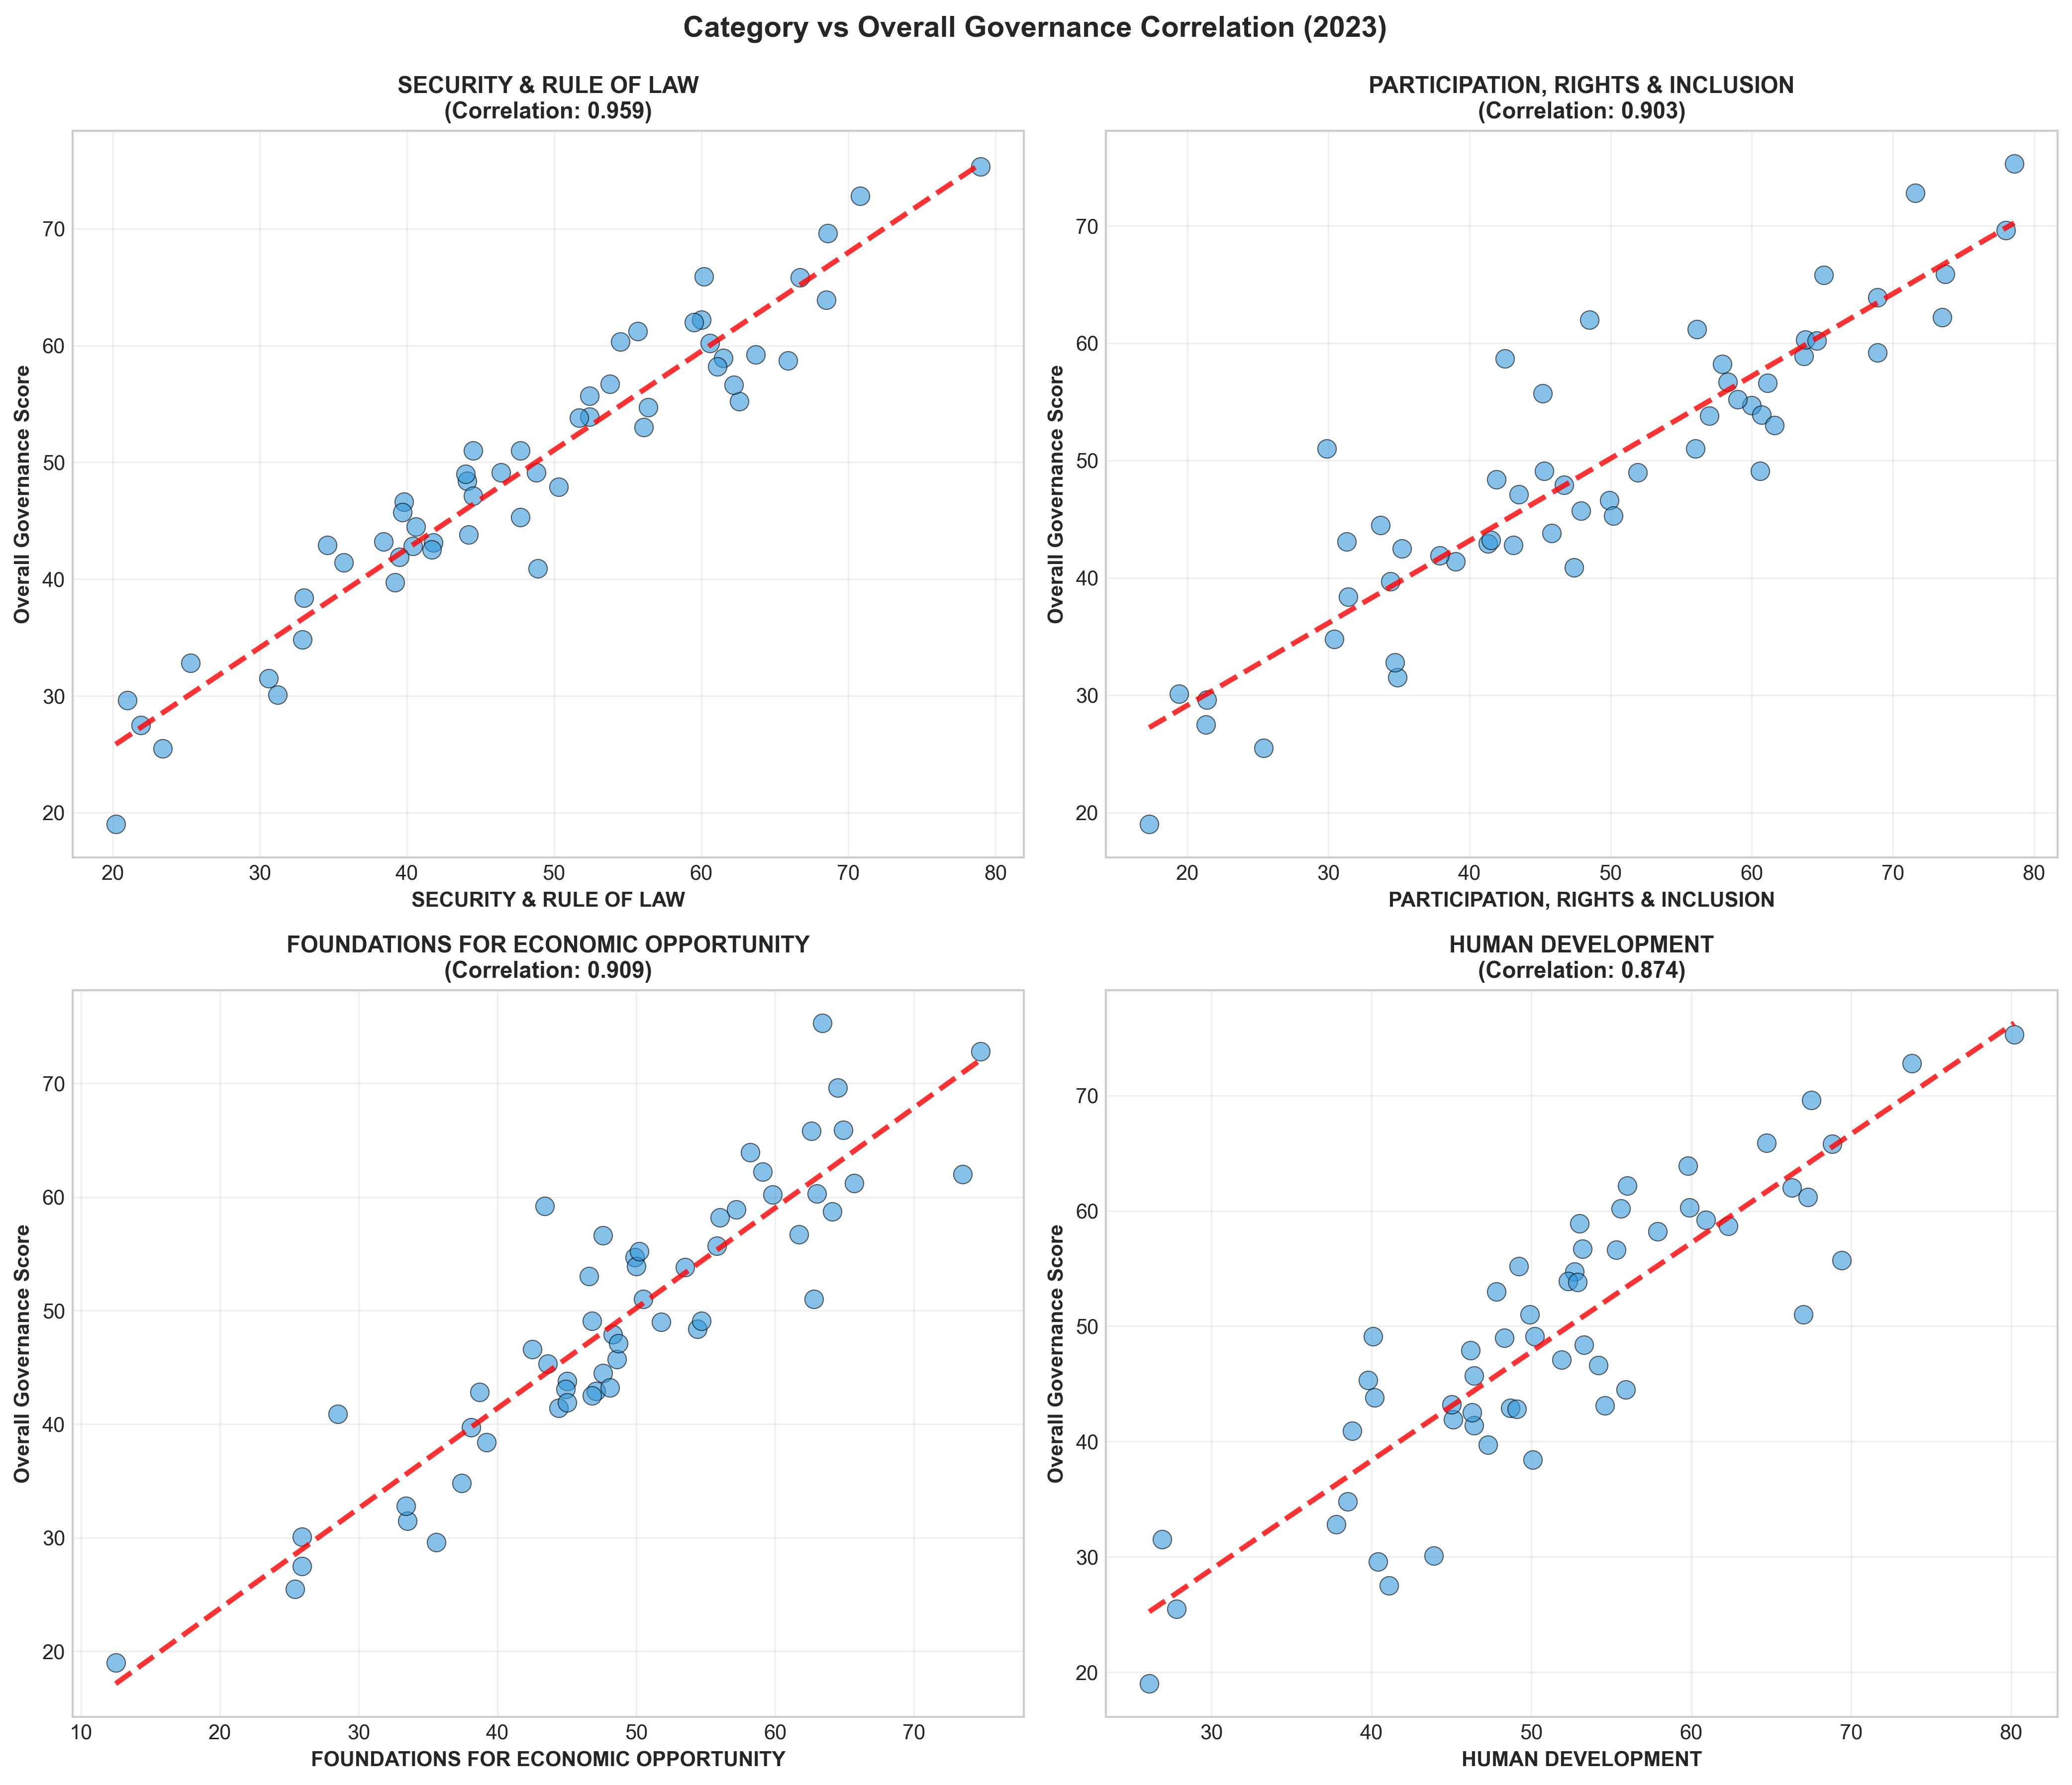
Figure 7: relationship between each main category and overall governance scores in 2023

8. TOP AND BOTTOM COUNTRY TRENDS

Figure 8 tracks the governance trajectories of the top 5 and bottom 5 performing countries from 2014 to 2023. These trend lines reveal the following:
- Whether high performers maintain their positions: Mautitius, Botswana and Cabo Verde have witnessed declines while Seychelles has seen significant improvement in governance. This shows that governance gains aren't permanent. Even strong performers can fall short without constant vigilance and renewal.

- Whether struggling countries show improvement: Somalia shows that even countries emerging from complete state failure can make progress. Federal government formation, security sector development, and international support combined to enable recovery. They're still low in absolute terms at 25.5, but the trajectory is encouraging.

- The stability or volatility of governance scores over time: Governance isn't fixed and governance is not destiny - countries can transform. There are different pathways to good governance: democracy (Gambia), post-conflict (Somalia), incremental reform (Morocco).

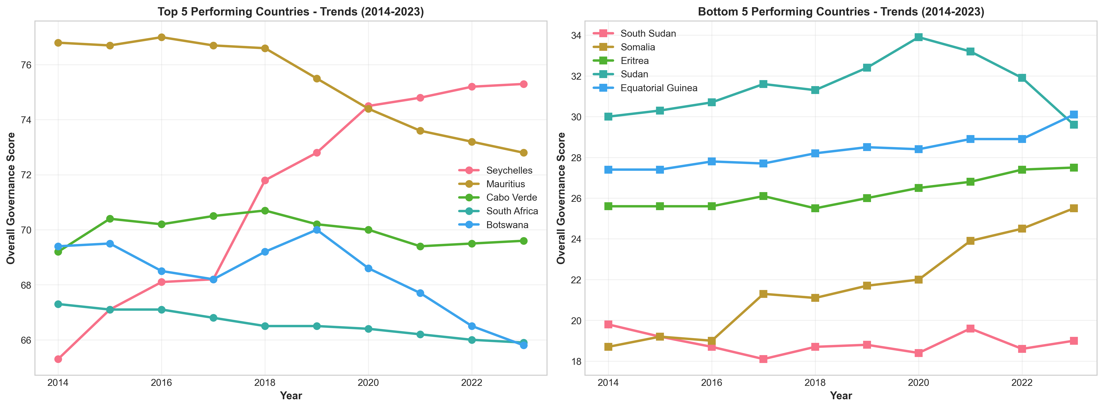
Figure 8: governance trajectories top 5 and bottom 5 performing countries from 2014 to 2023

DETAILED ANALYSIS AND INSIGHTS

1. Temporal Dynamics (2014-2023)
Continental Trend:
  - Overall governance score changed from 48.3 (2014) to 49.3 (2023)
  - Net change: 0.97 points
  - Countries improving: 33 (61.1%)
  - Countries declining: 21 (38.9%)

2. Category-Specific Insights (2023)
Strongest Category (Continental Average):
• HUMAN DEVELOPMENT: 51.6
Weakest Category (Continental Average):
• SECURITY & RULE OF LAW: 47.9
Category Variability (Standard Deviation): These standard deviations indicate by how much these categories differ from the continental scores on average.
- SECURITY & RULE OF LAW: 13.9
- PARTICIPATION, RIGHTS & INCLUSION: 15.8
- FOUNDATIONS FOR ECONOMIC OPPORTUNITY: 12.6
- HUMAN DEVELOPMENT: 11.4

3. Regional Performance Dynamics
Regional Rankings by Average Change (2014-2023): The regions have seen some improvements over the decade under assessment except Southern Africa.
- West Africa: +1.49 points
- East Africa: +1.35 points
- North Africa: +1.22 points
- Central Africa: +0.61 points
- Southern Africa: -0.09 points

4. Notable Patterns and Observations
  - The correlation between 'Security & Rule of Law' and 'Overall Governance' is 0.959, indicating strong relationship

  - 11 countries (20.4%) achieved governance scores above 60/100
  - 29 countries (53.7%) scored below 50/100, indicating significant governance challenges

5. Methodology Notes
The Ibrahim Index of African Governance (IIAG) provides a comprehensive assessment framework:
  - Covers 54 African countries
  - Uses approximately 100 indicators from approximately 30 independent sources
  - Scores range from 0-100 (higher is better)
  - Four main categories with equal weighting
  - Annual updates reflecting latest available data

ABOUT THE IBRAHIM INDEX OF AFRICAN GOVERNANCE (IIAG)

The IIAG is the most comprehensive assessment of African governance, providing an annual statistical measure of governance performance in every African country. Launched in 2007 by the Mo Ibrahim Foundation, it covers all 54 African countries and is based on data from over 30 independent African and global institutions.
The Index measures governance performance across four main categories:
- Security & Rule of Law
- Participation, Rights & Inclusion
- Foundations for Economic Opportunity
- Human Development
Each category comprises subcategories and indicators that assess different dimensions of governance, from civil liberties to infrastructure development.

METHODOLOGY
Data Sources: The IIAG uses approximately 100 indicators from reputable independent sources including international organizations, research institutes, and African institutions.
Scoring: All indicators are converted to a 0 - 100 scale where 100 represents the best possible outcome. Country scores are calculated as weighted averages of indicator values.
Coverage: The analysis in this report covers 2014-2023, examining trends across 54 countries and providing insights into governance performance at continental, regional, and national levels.

ACKNOWLEDGMENTS
This report utilizes data provided by the Mo Ibrahim Foundation under their open data policy. The analysis, interpretations, and conclusions presented are those of the report author, based on the data assessed, and do not necessarily reflect the views of the Mo Ibrahim Foundation.

REFERENCES
Mo Ibrahim Foundation (2024). Ibrahim Index of African Governance (IIAG) 2024. Available at: https://mo.ibrahim.foundation/iiag [Accessed: 11 October 2025].
Mo Ibrahim Foundation (2024). '2024 IIAG Composite Scores Dataset'. Mo Ibrahim Foundation Data Portal.
Mo Ibrahim Foundation (2023). 2023 Ibrahim Index of African Governance: Index Report. London: Mo Ibrahim Foundation.
African Development Bank (2023). African Economic Outlook 2023. Abidjan: African Development Bank Group.
United Nations Development Programme (2023). Human Development Report 2023. New York: UNDP.
World Bank (2023). Worldwide Governance Indicators 2023. Washington DC: World Bank Group.

