CITCI GradeTrack — Admin Manual
Screenshots captured automatically from seeded demo data (tools/generate_user_manuals.py). Account names and sample data shown are demo content, not real CITCI records.

1. Logging in
Go to the login page and sign in with your admin username and password. First-time accounts are forced to change their password and accept the Data Privacy notice before reaching any other page.
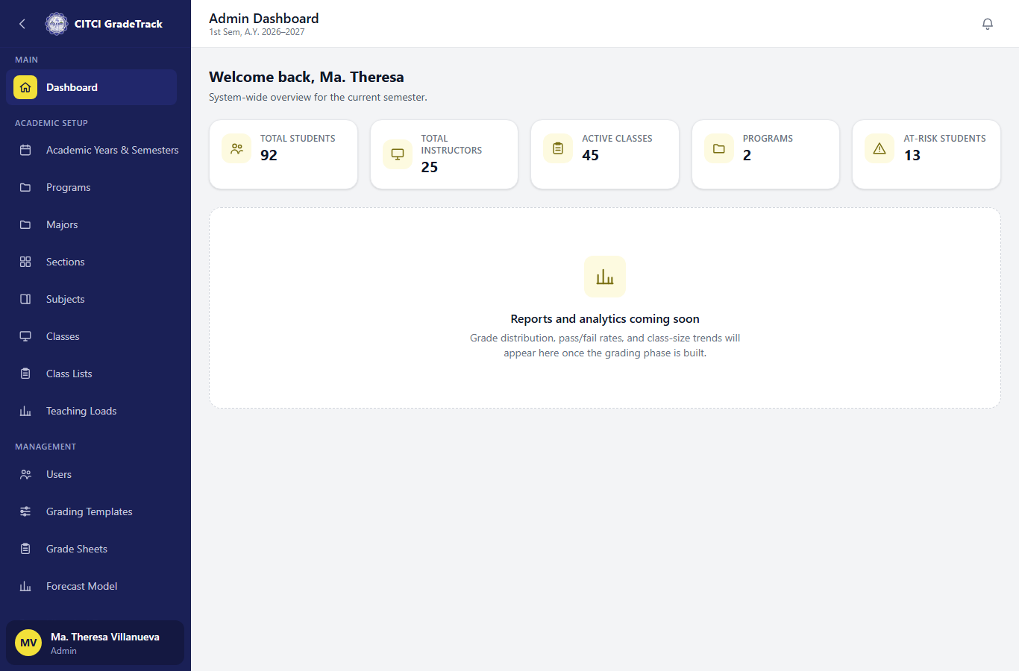

2. Dashboard
After logging in, the Dashboard shows live counts of active students, instructors, classes, and programs — not placeholder data.

3. Managing users
Users -> tabs for Admins/Program Heads/Instructors/Students, with search and filters. Use 'Add' to create an account, or the bulk import for students/instructors from a spreadsheet.
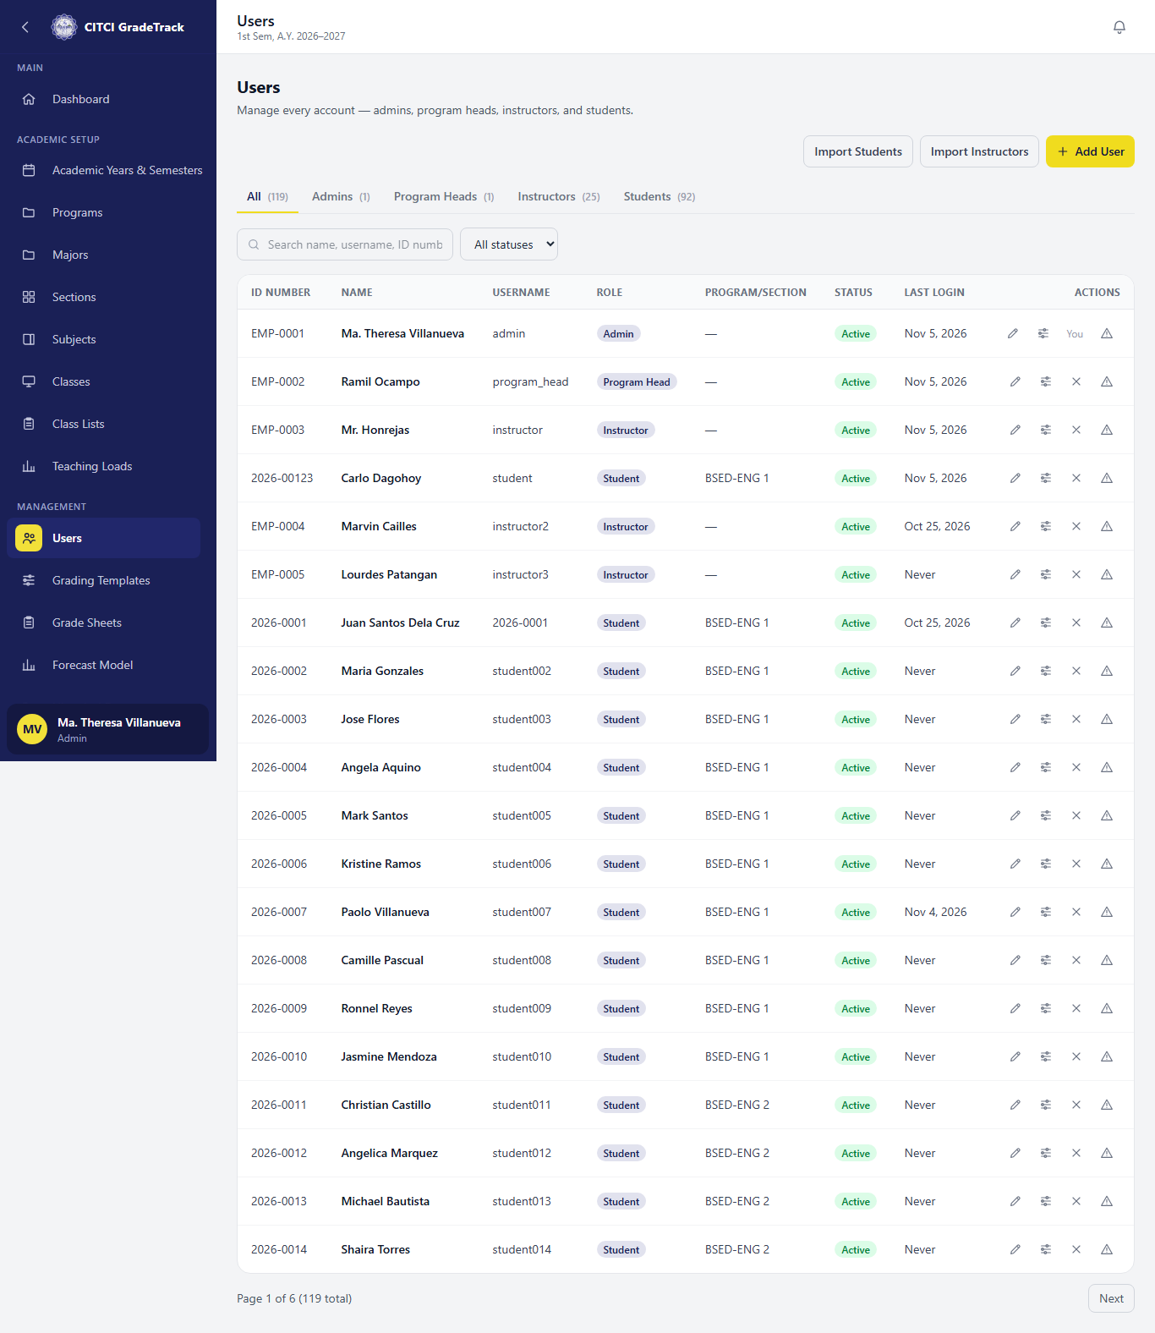

4. Managing classes
Academic Setup -> Classes lists every class offering for the active semester, with filters by program/semester/instructor.
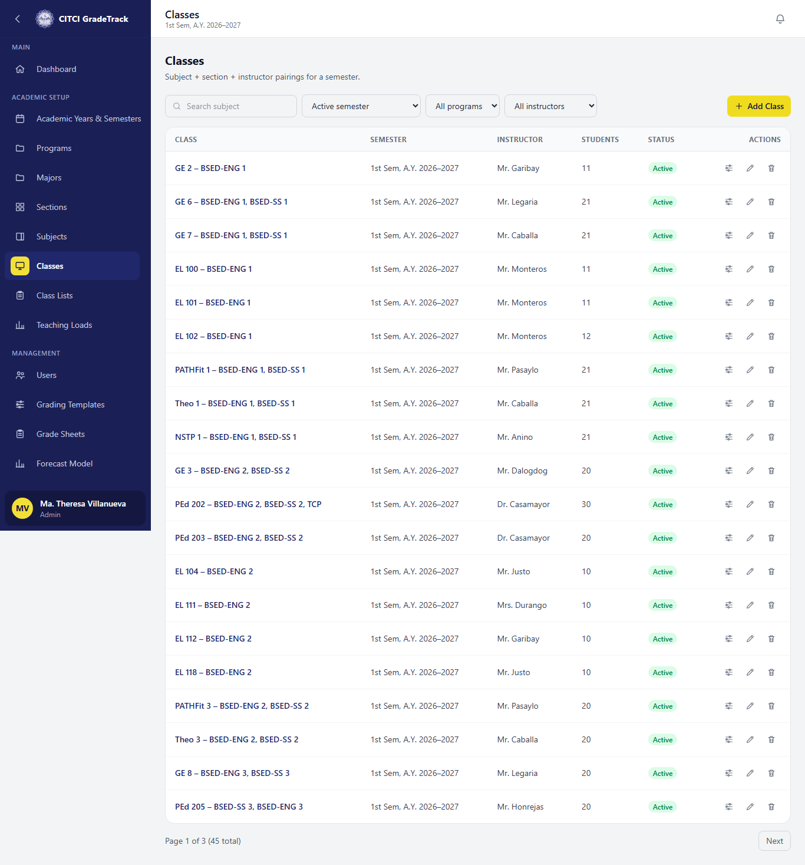

5. Teaching Loads
Academic Setup -> Teaching Loads shows per-instructor totals (classes, units, students) for the active semester, plus any unassigned classes. Admin can override an instructor assignment from the Classes page, logged as an override.
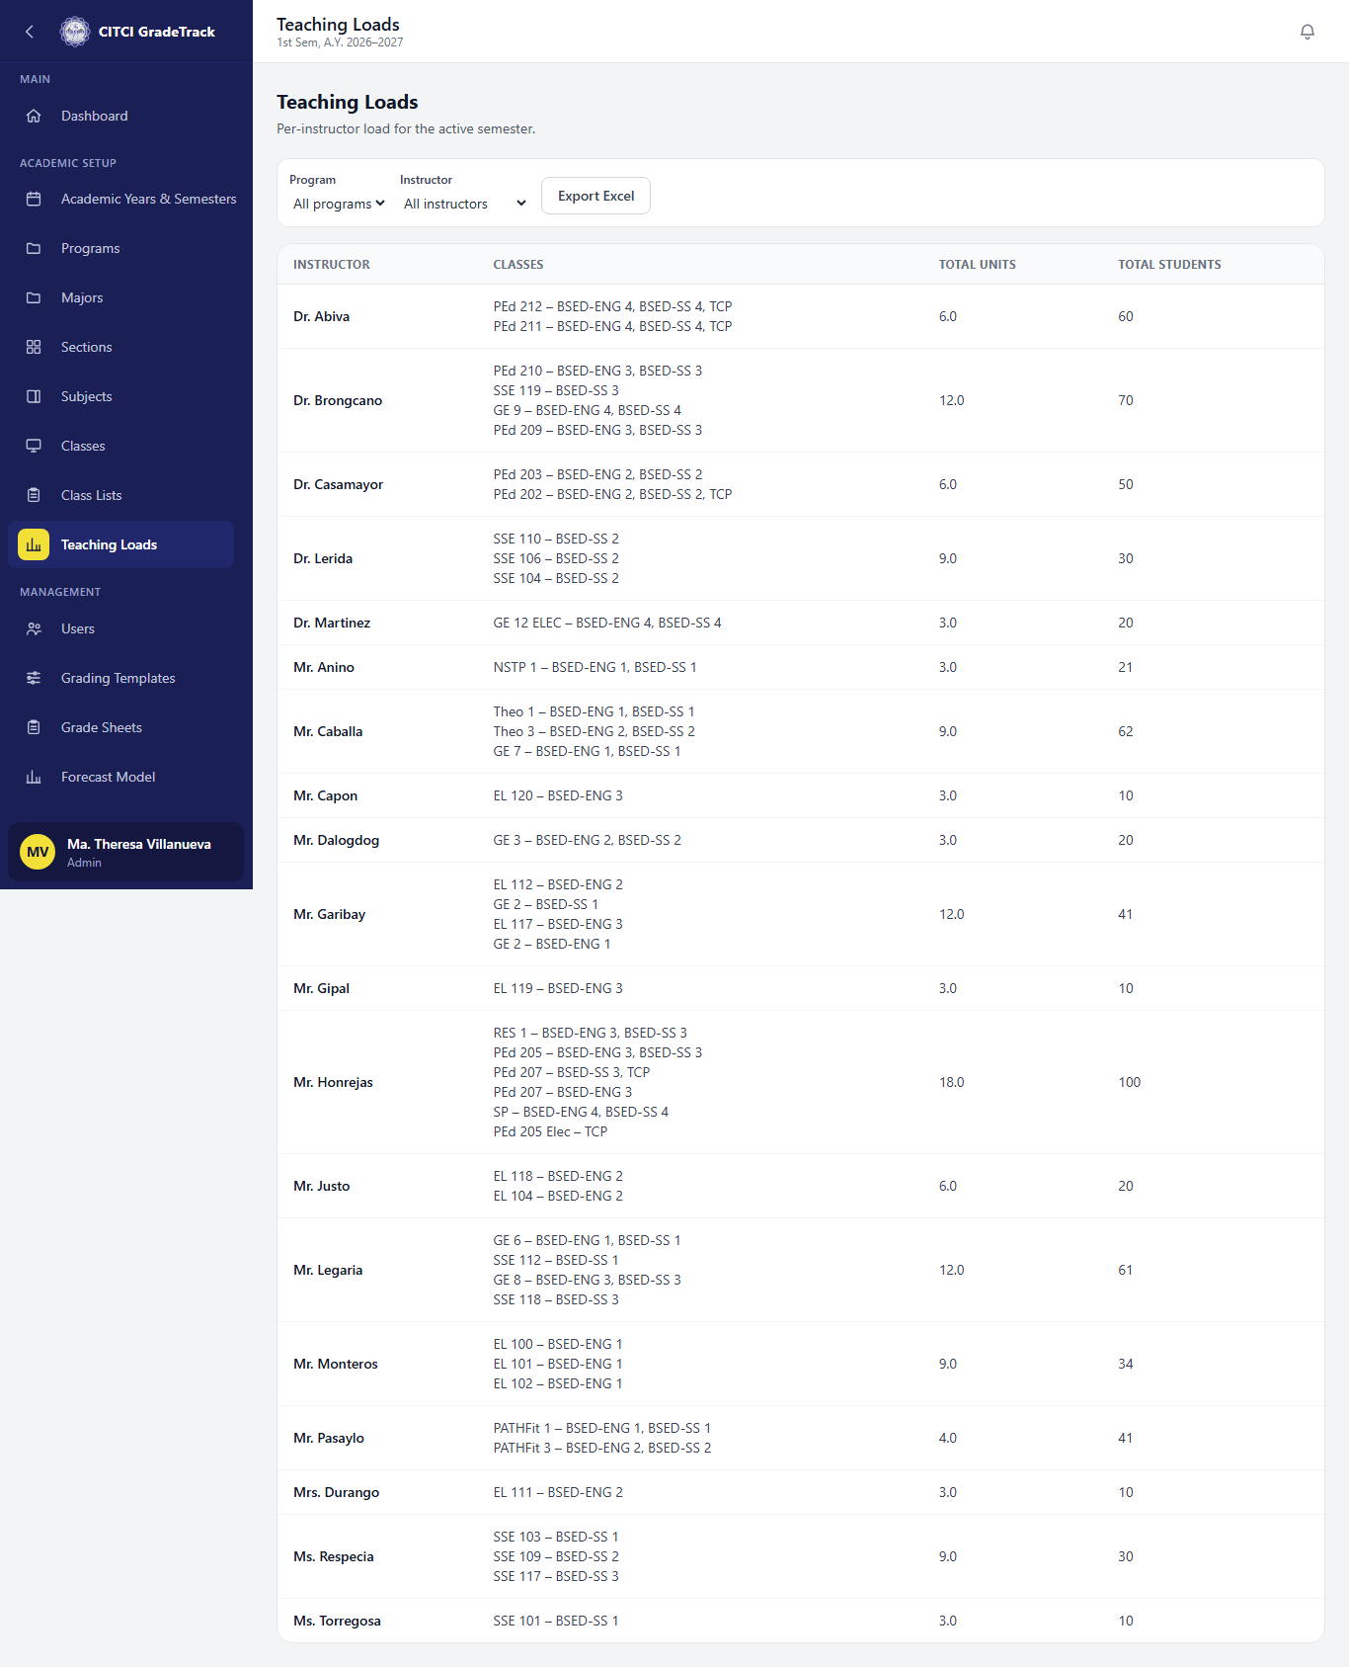

6. Grading templates
Management -> Grading Templates: the CITCI Default template and its components, including the school-locked Examination weight.
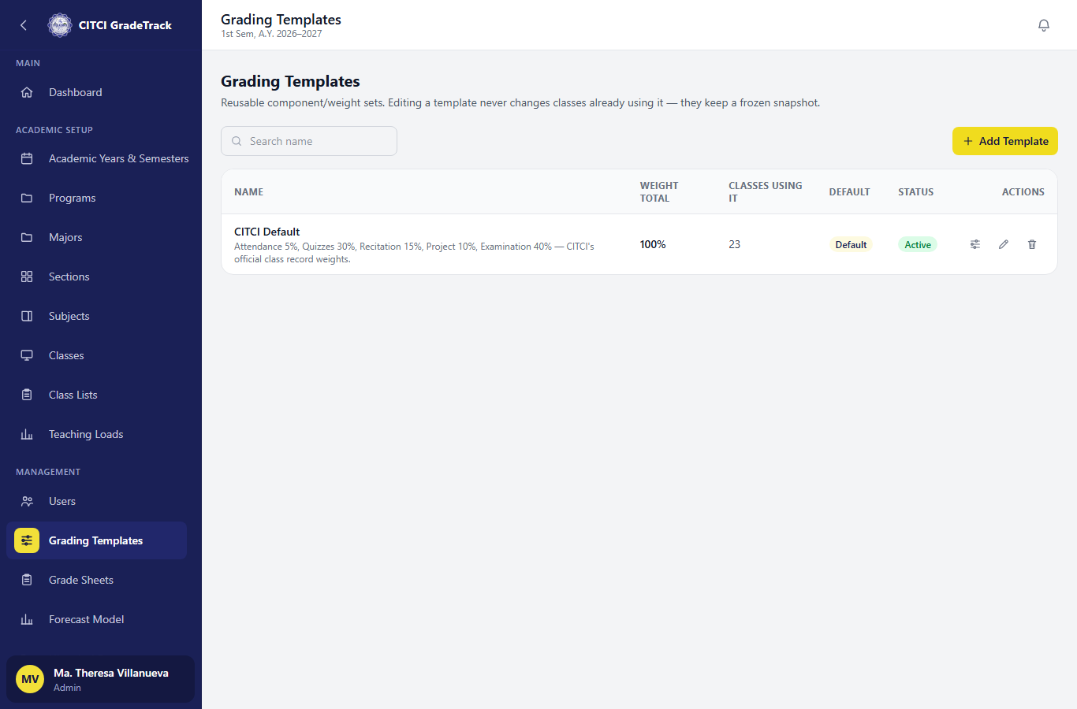

7. Grade Sheets oversight
Management -> Grade Sheets: every grade sheet in the active semester with a submission/approval/release progress summary, and a 'Lock Term' action.
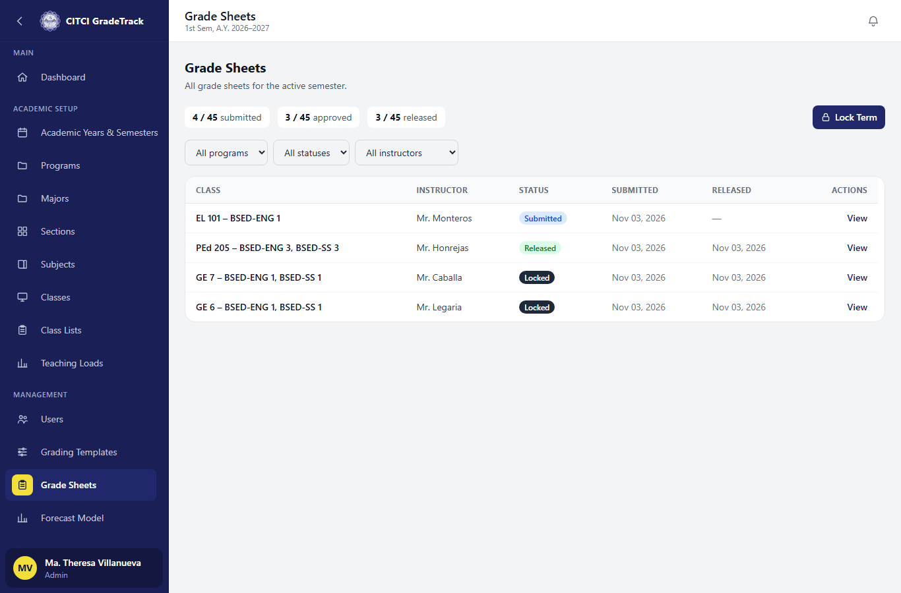

8. Forecast Model
Management -> Forecast Model: metrics (accuracy/precision/recall/F1/ROC-AUC), the threshold trade-off table, and version history with an Activate action.
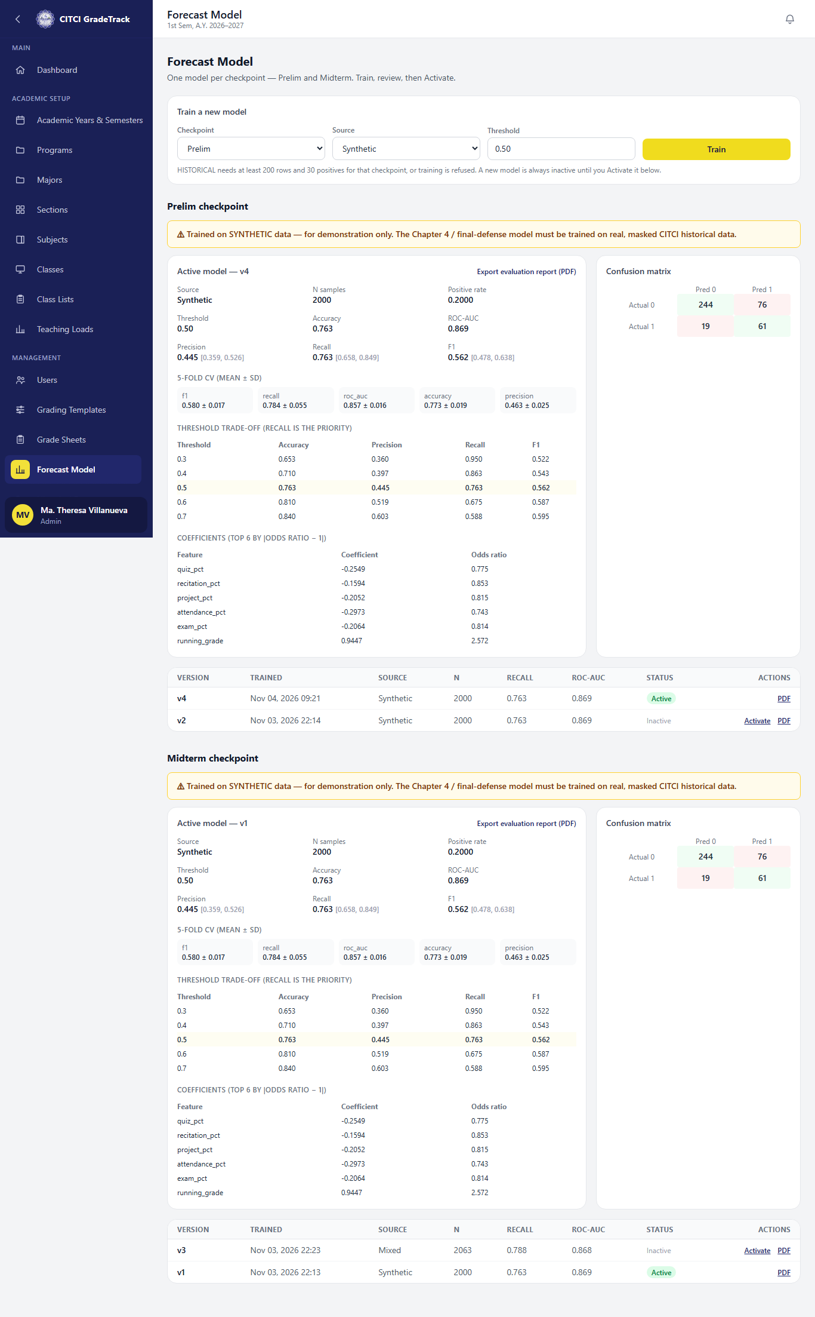

9. Reports
Reports: system-wide submission status, class performance, and failing/INC lists, each exportable to Excel.


