CITCI GradeTrack — Instructor Manual
Screenshots captured automatically from seeded demo data (tools/generate_user_manuals.py). Account names and sample data shown are demo content, not real CITCI records.

1. Logging in
Sign in with your instructor account.
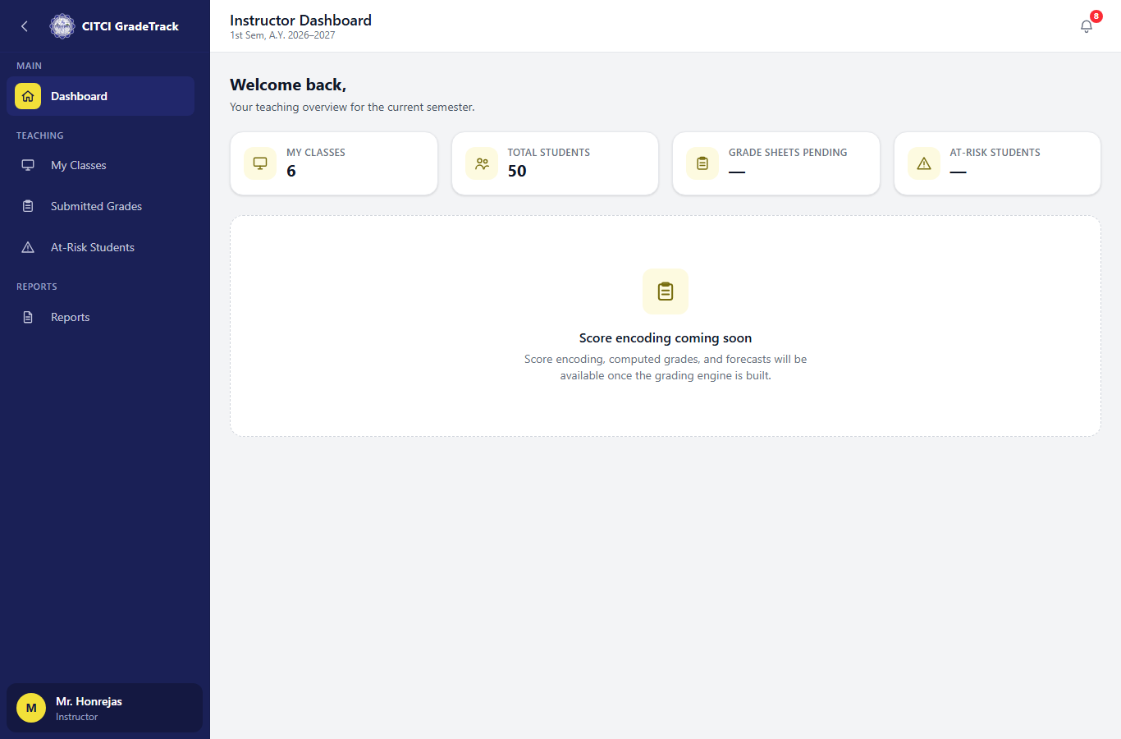

2. My Classes
Every class assigned to you for the active semester. Click 'Encode Grades' to open a class's grading page.
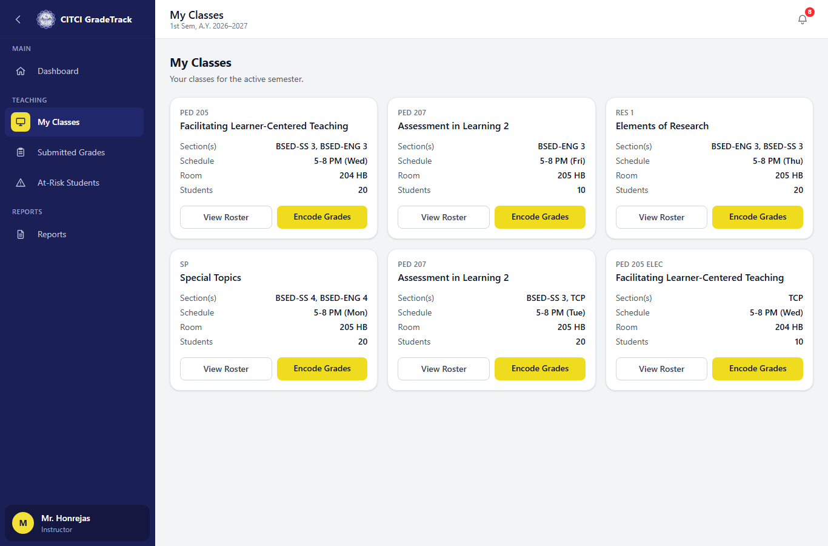

3. Setup tab — grading components
Add/rename/reweight your own (unlocked) grading components; the school-locked Examination weight is shown read-only.
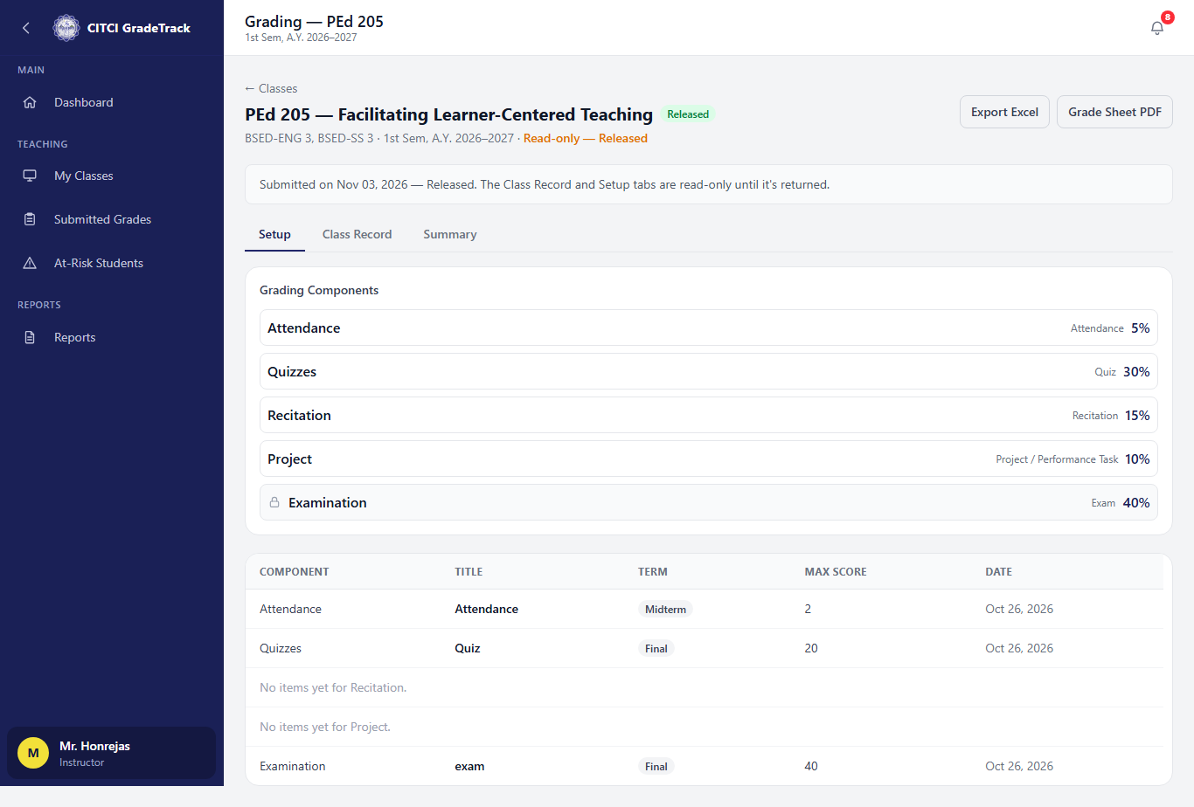

4. Submitted Grades
Your own grade sheets across the active semester, filterable by status.
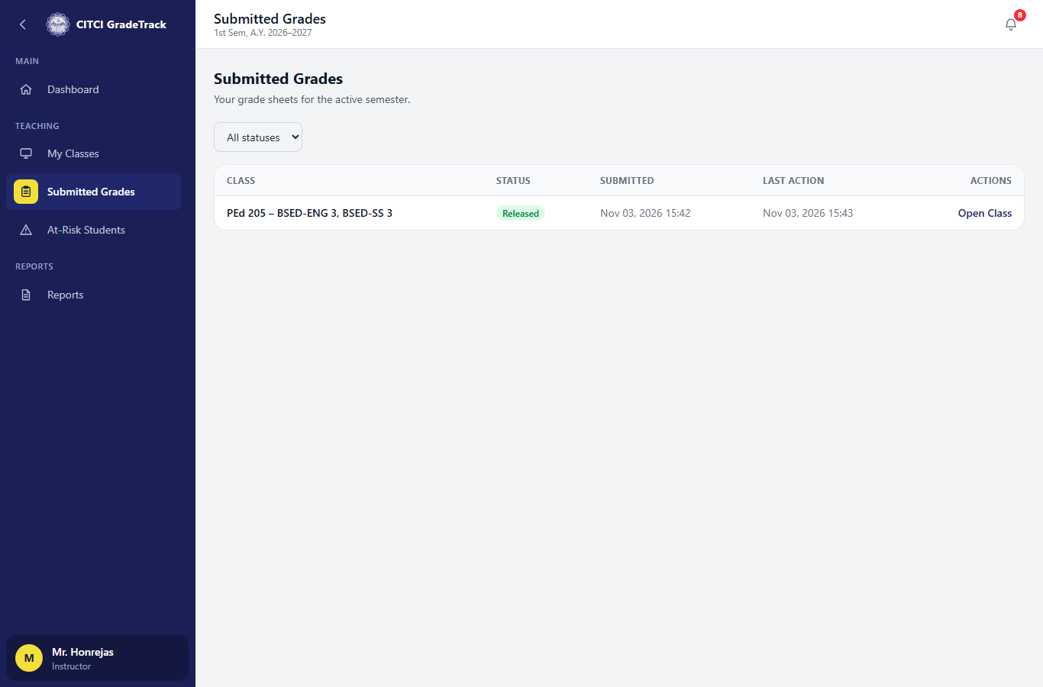

5. At-Risk Students
Students flagged at-risk or watch across your classes, with plain-language reasons and an intervention log.
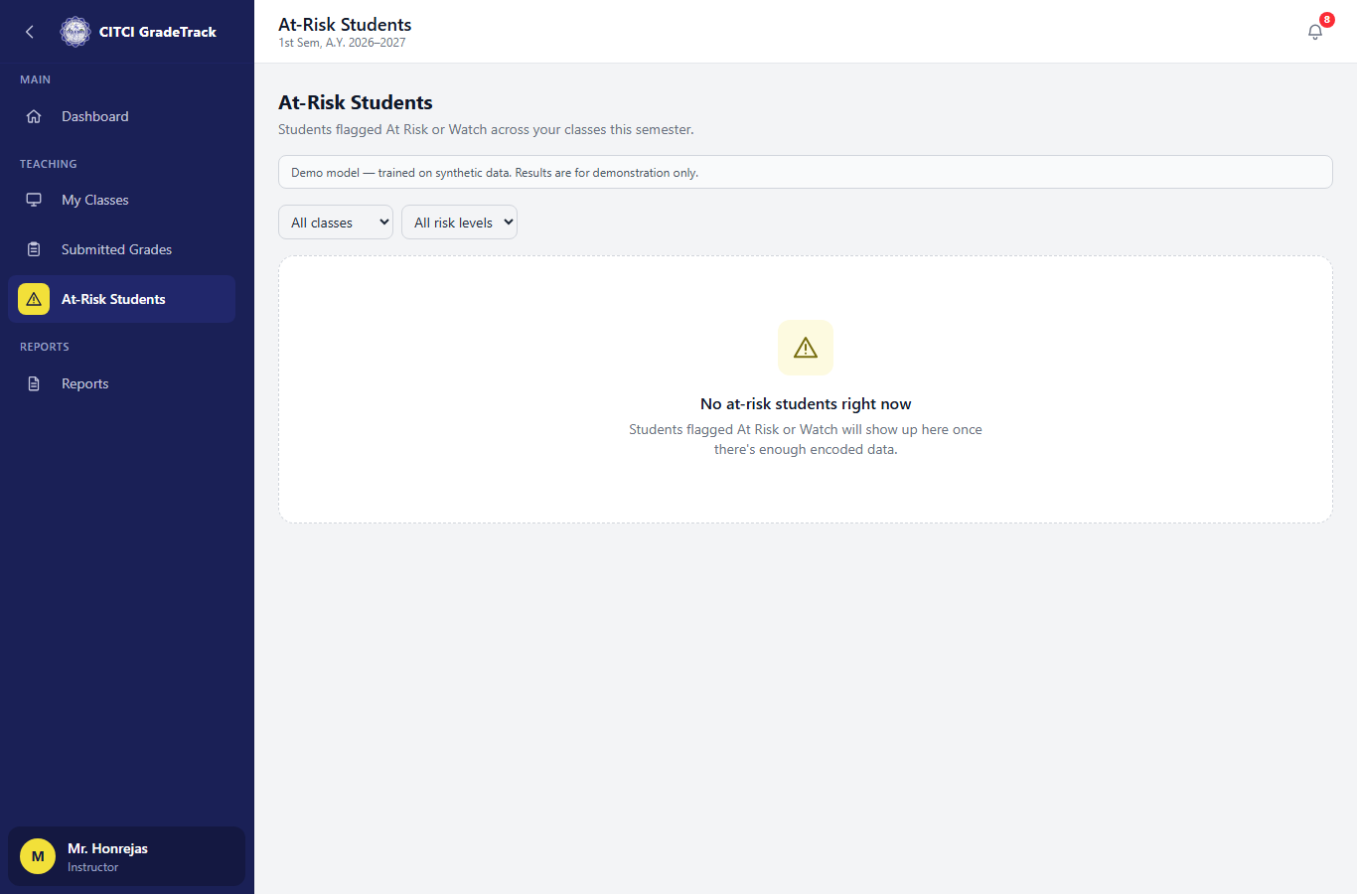

6. Reports
Per-class PDF/Excel grade-sheet exports.


