CITCI GradeTrack — Program Head Manual
Screenshots captured automatically from seeded demo data (tools/generate_user_manuals.py). Account names and sample data shown are demo content, not real CITCI records.

1. Logging in
Sign in with your Program Head account.
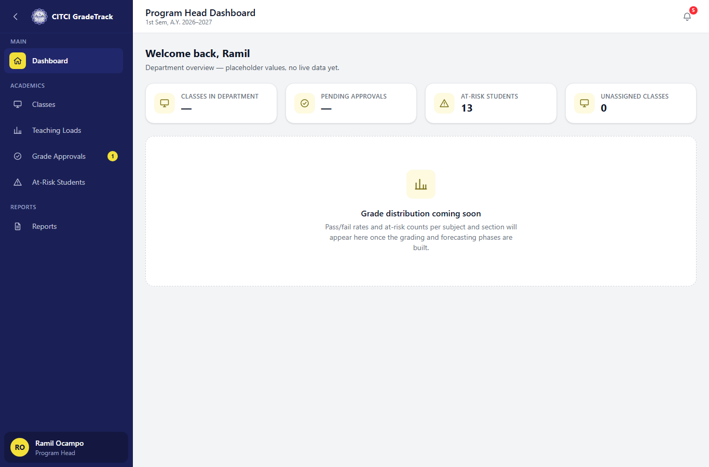

2. Dashboard
The dashboard shows at-risk student counts and an 'Unassigned Classes' card for your program(s), linking straight to the filtered list.

3. Assigning teaching loads
Classes shows every class under your program(s). Use 'Assign/Change Instructor' per class, the 'Unassigned only' filter, and the bulk-assign action for several classes at once.
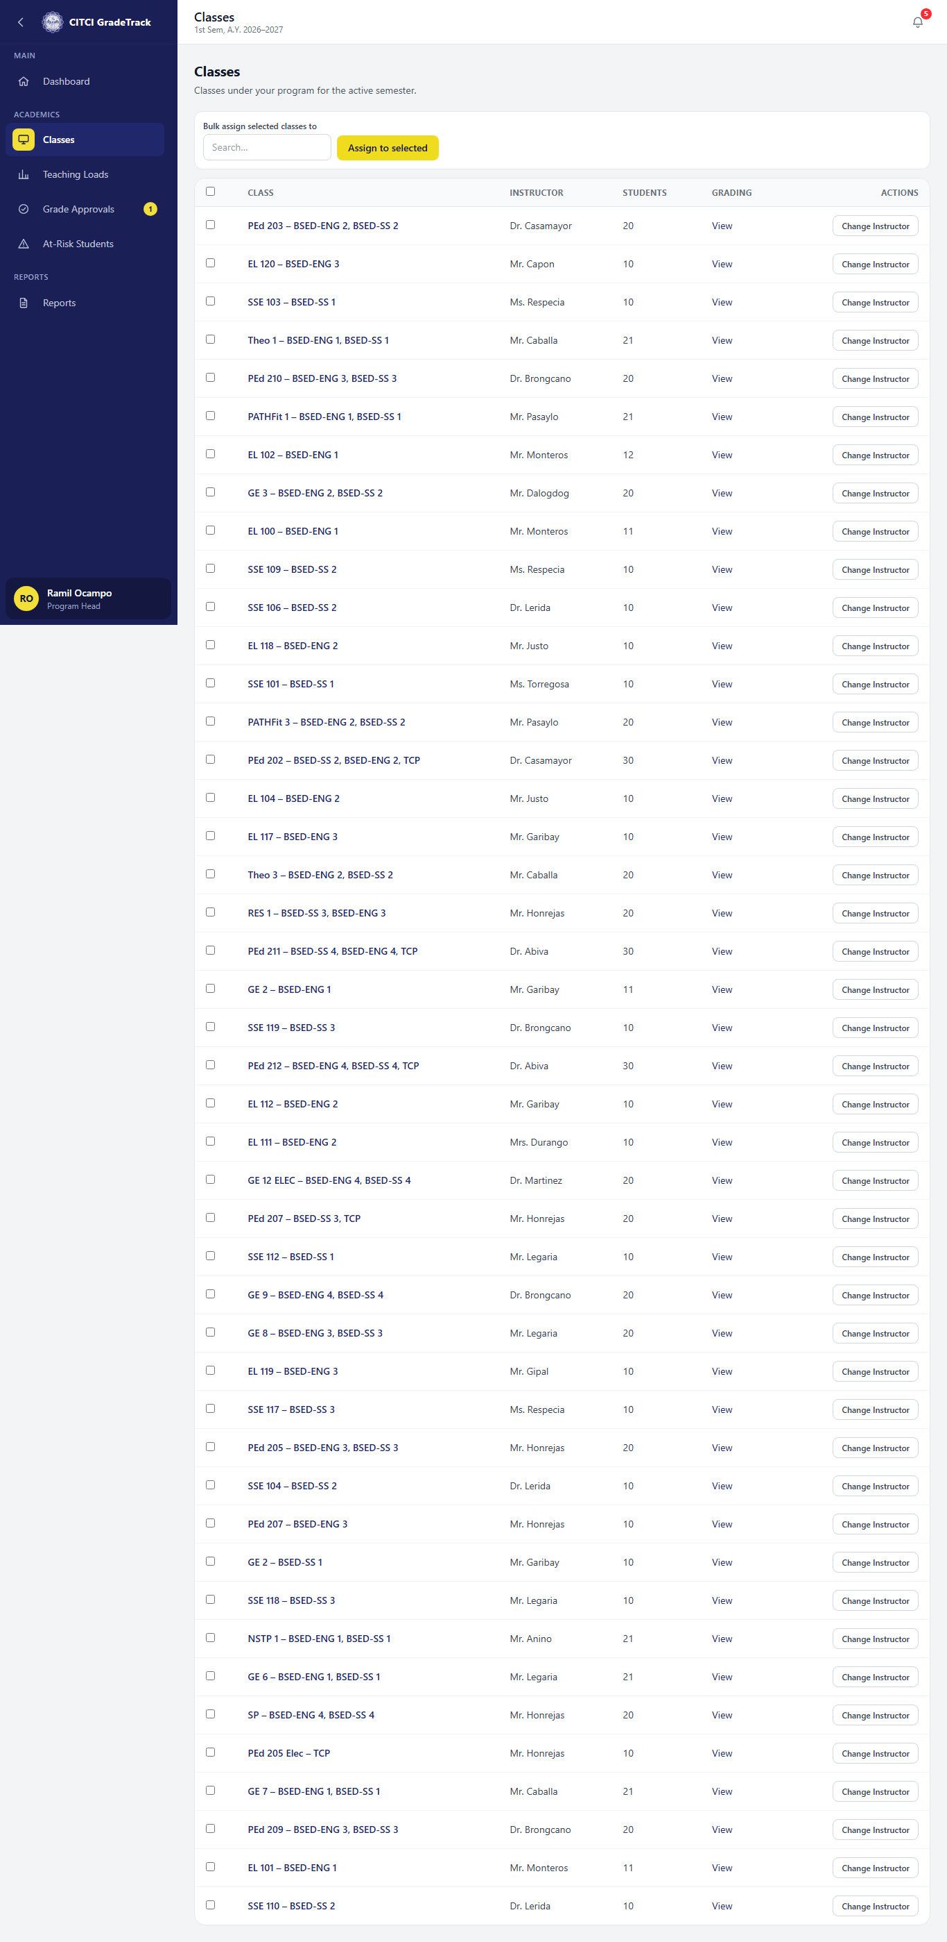

4. Teaching Loads summary
Per-instructor totals (classes, units, students) for your program(s), plus any classes still unassigned.
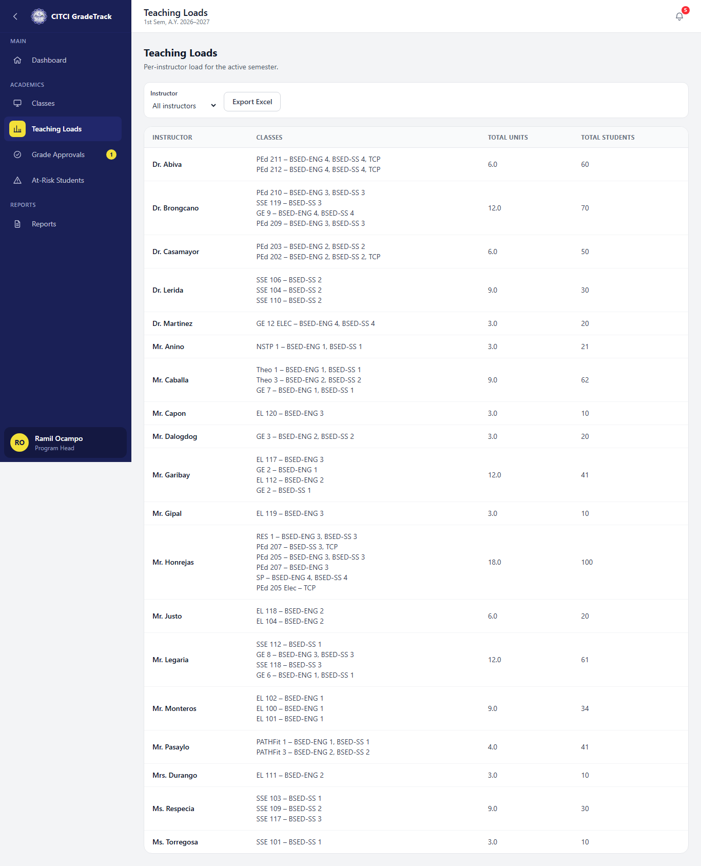

5. Grade Approvals
Review a submitted grade sheet's frozen snapshot, class distribution chart, and transition timeline, then Approve, Return (with remarks), or Release.
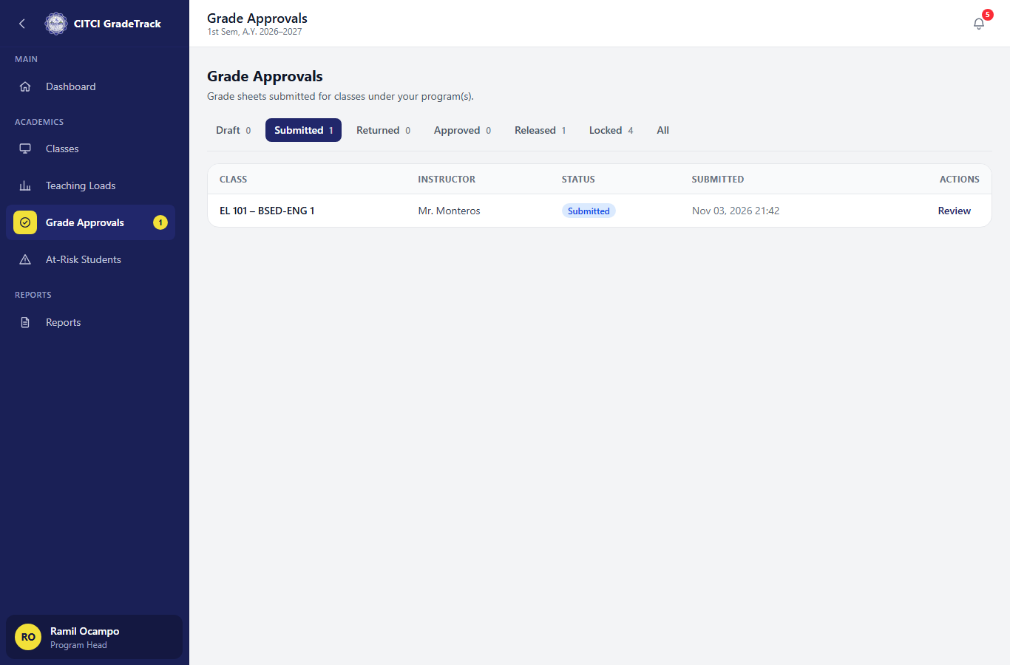

6. At-Risk Students
Summary cards (at risk/watch/classes affected/interventions), a by-class breakdown, and the same student-level detail instructors see.


