CITCI GradeTrack — Student Manual
Screenshots captured automatically from seeded demo data (tools/generate_user_manuals.py). Account names and sample data shown are demo content, not real CITCI records.

1. Logging in
Sign in with your student number/username and password.
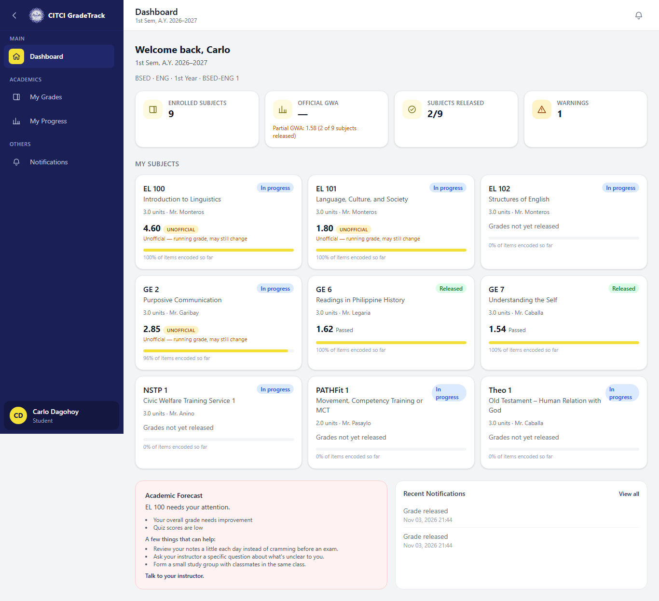

2. Dashboard
Your subjects this term, Official/Partial GWA, and a supportive forecast card (never a number, never the words 'at risk') when enabled.

3. My Grades
A semester selector, your grades per subject, and total units + GWA — official once released, clearly marked 'Unofficial' before that.
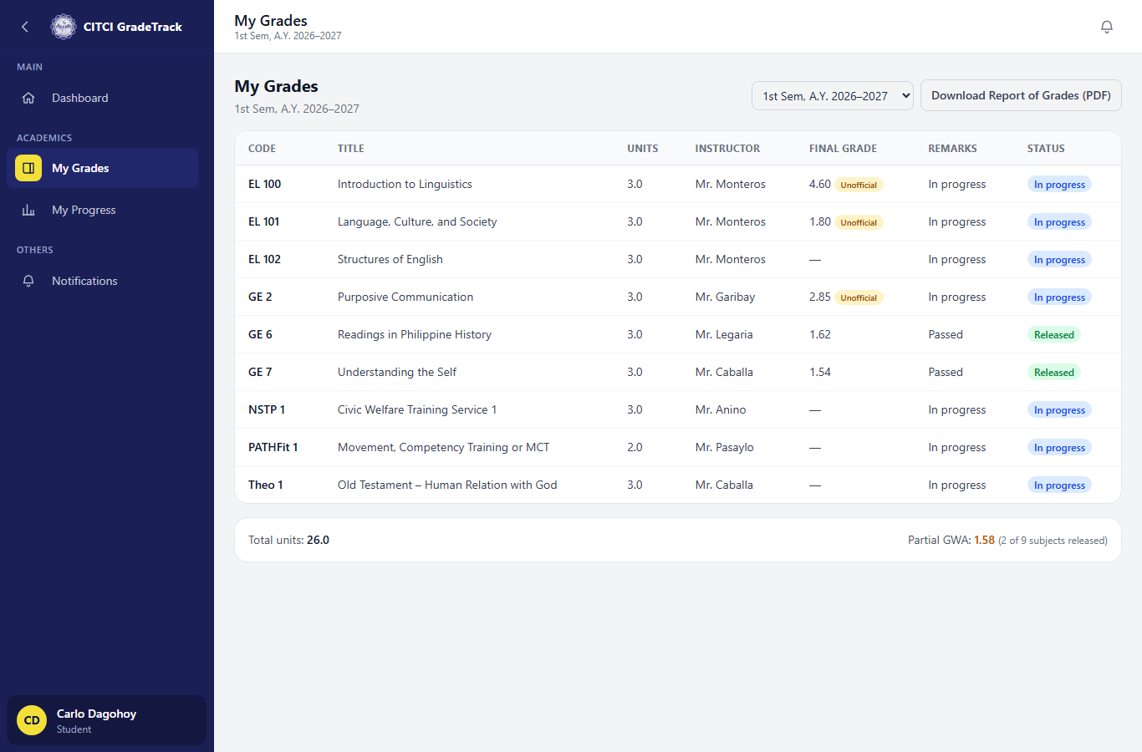

4. Subject detail
Component breakdown, item list by grading period, and progression charts for one subject.
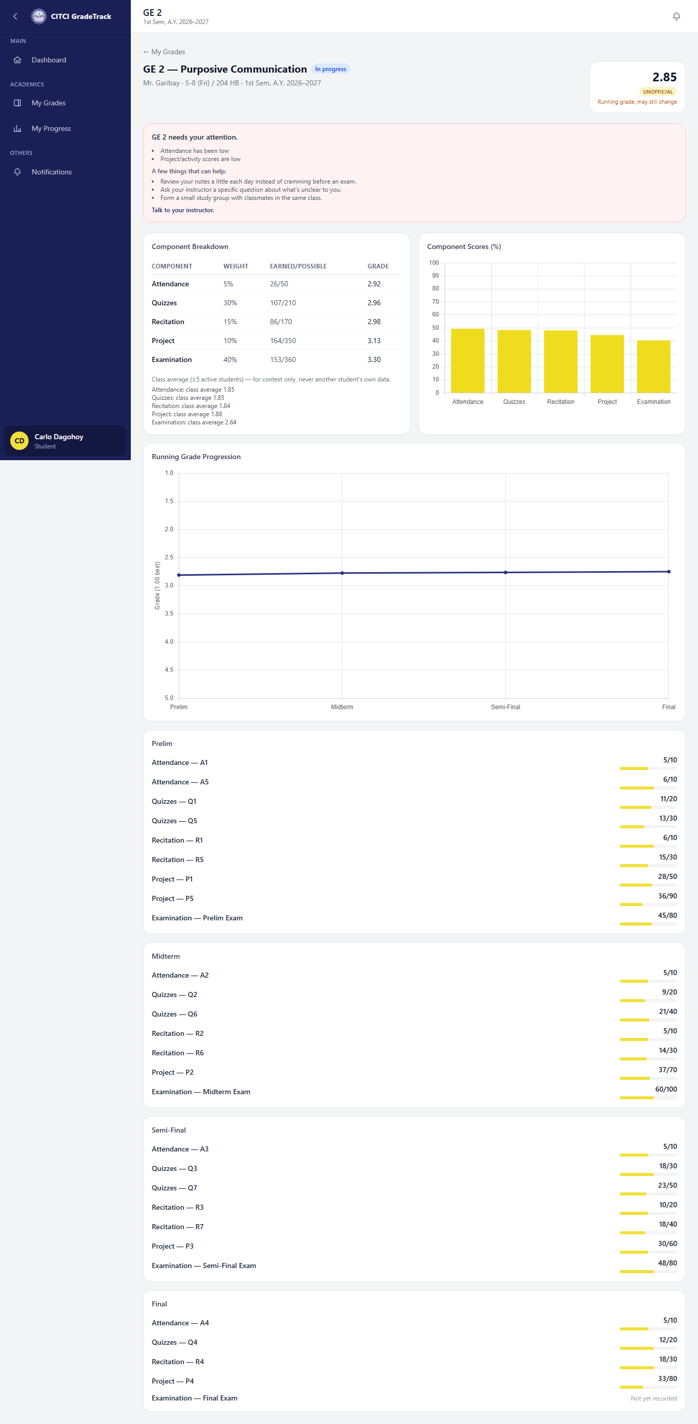

5. My Progress
A GWA-history line chart across every semester, plus the current semester's subjects by grade.


